Question:
Solve the Transportation Problem using the Northwest Corner Method to find the initial basic feasible solution.
Given:
- Supply: [2000, 2500]
- Demand: [1500, 2000, 1000]
- Cost matrix:
$$[\begin{matrix}8 & 6 & 10 \\ 10 & 4 & 9\end{matrix}]$$
Aim:
Write a Python program to demonstrate to find the initial basic feasible solution of a transportation problem using the Northwest Corner Method.
Program:
# Transportation Problem using Northwest Corner Method

def northwest_corner(costs, supply, demand):
"""Return allocation matrix and total cost using NW-corner method."""
m, n = len(supply), len(demand)
sup = supply.copy()
dem = demand.copy()
alloc = [[0]*n for _ in range(m)]
i = j = 0

while i < m and j < n:
qty = min(sup[i], dem[j])
alloc[i][j] = qty
sup[i] -= qty
dem[j] -= qty

# Move to next cell
if sup[i] == 0 and i + 1 < m and dem[j] == 0 and j + 1 < n:
i += 1
j += 1
elif sup[i] == 0:
i += 1
elif dem[j] == 0:
j += 1
else:
break

# Compute total cost
total_cost = sum(alloc[r][c] * costs[r][c] for r in range(m) for c in range(n))
return alloc, total_cost

# Example data
costs = [
[8, 6, 10],
[10, 4, 9]
]
supply = [2000, 2500]
demand = [1500, 2000, 1000]

# Solve using Northwest Corner Method
allocation, cost = northwest_corner(costs, supply, demand)

# Display results
print("=== Northwest Corner Method ===")
print("\nAllocation matrix (rows = origins, cols = destinations):")
for row in allocation:
print(row)

print(f"\nTotal transportation cost (initial NW-corner solution) = {cost}")
Result:
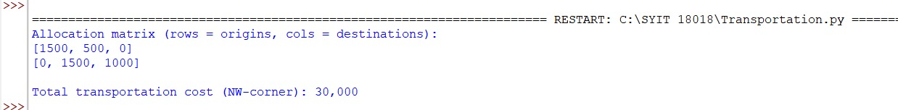
Conclusion:
The above Python program has been executed successfully

