Symptoms

1. You can't log in to the VM, and you receive a message that indicates that the password that you used is incorrect. Additionally, you can't use VMAgent to reset your password on the Azure portal.

Solution: Linux machine without lvm

* Take a snapshot for the OS disk of the affected VM, create a disk from the snapshot, and then attach the disk to a Rescue VM
* Run the following SSH command on the troubleshooting VM
* **fdisk -l** and identifynewly attached disk
* Create a mount point called **tempmount**
  + mkdir /tempmount
  + mount /dev/sdc1 /tempmount
* Create copies of the core credential files before making any changes:
  + cp /etc/passwd /etc/passwd_orig
  + cp /etc/shadow /etc/shadow_orig
  + cp /tempmount/etc/passwd /etc/passwd
  + cp /tempmount/etc/shadow /etc/shadow
  + cp /tempmount/etc/passwd /tempmount/etc/passwd_orig
  + cp /tempmount/etc/shadow /tempmount/etc/shadow_orig
* Reset the user’s password that you need
  + passwd <<USER>>
* Move the modified files to the correct location on the broken machine's disk.
  + cp /etc/passwd /tempmount/etc/passwd
  + cp /etc/shadow /tempmount/etc/shadow
  + cp /etc/passwd_orig /etc/passwd
  + cp /etc/shadow_orig /etc/shadow
* Go back to the root and unmount the disk.
  + cd /
  + umount /tempmount
* In Azure portal, detach the disk from the troubleshooting VM and swap the osdisk.

Solution: Linux machine with lvm partitions

* Take snapshot of the failing VM
* Create a rescue VM
* Create a mount point for the attached disk.

mkdir /rescue

fdisk -l

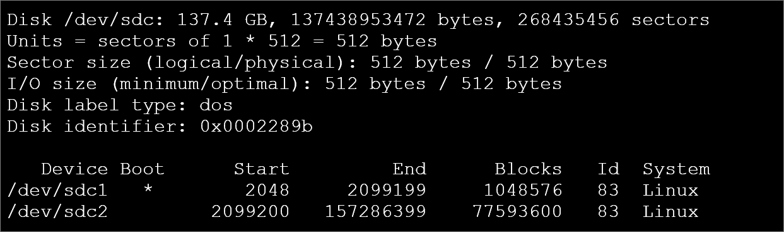

The **\*** indicates a boot partition, both partitions are to be mounted.

lsblk

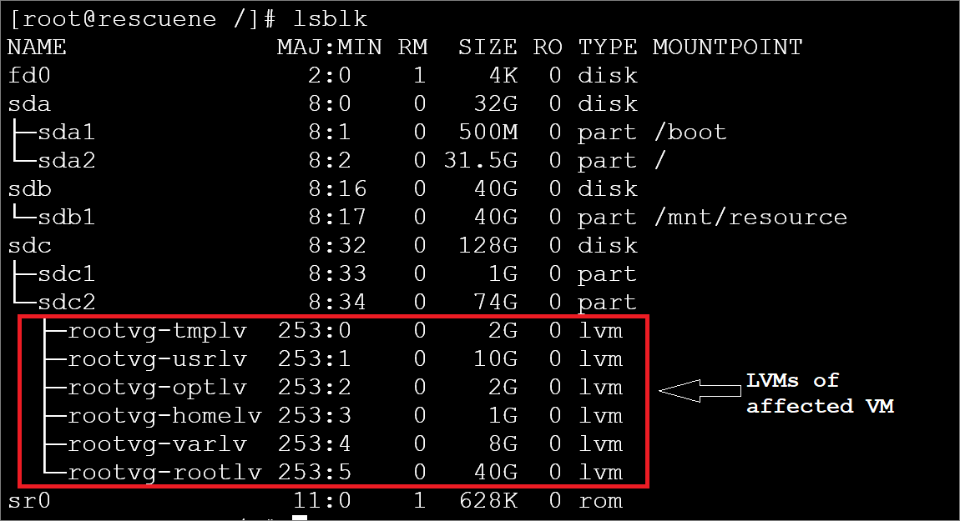

vgscan --mknodes

vgchange -ay

lvscan

mount –a

lsblk

* The output of the next command will show the path to mount for the **root** LV

pvdisplay -m | grep -i rootlv

* Proceed to mount this device on the directory /rescue

mount /dev/rootvg/rootlv /rescue

* Mount the partition that has the Boot flag set on /rescue/boot

mount /dev/sdc1 /rescue/boot

* Verify the file systems of the attached disk are now correctly mounted using the  **df -Th** command

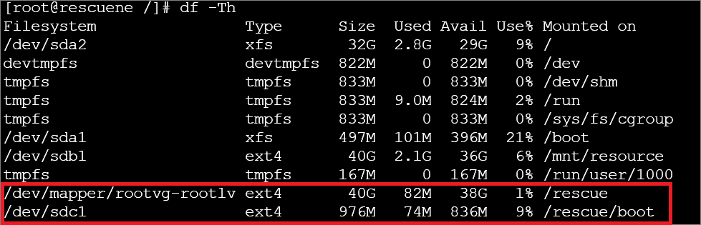

* Gain **chroot** access, which will enable you to perform various fixes, slight variations exist for each Linux distribution.

cd /rescue​

mount -t proc proc proc

mount -t sysfs sys sys/​

mount -o bind /dev dev/​

mount -o bind /dev/pts dev/pts/​

chroot /rescue​

after gaining chroot access into affected vm disk.

Reset the password using below commands.

Sudo su

useradd -d /home/rescue-usr rescue-usr

echo rescue-usr:U6aMy0wojraho | sudo chpasswd -e

visudo #add user into sudoers

exit

## Exit chroot and swap the OS disk

exit

cd /

umount /rescue/proc/

umount /rescue/sys/

umount /rescue/dev/pts

umount /rescue/dev/

umount /rescue/boot

umount /rescue

1. No access to serial console (few VM’s deployed using custom images won’t have access to serial console) and you are not able to ssh into vm externally.
2. Linux VM is not booting and ssh is not possible due to kernel issues.
3. Pass/run system commands (perform various fixes, slight variations exist for each Linux distribution) to datadisk from rescue vm.

You can use the below steps to resolve all the above scenarios.

* Takesnapshot , create disk out out it , mount it on rescue vm.
* Run below commands to mount the datadisk and pass/run system commands to datadisk.
  + Mkdir /rescue
  + mount /dev/sdc1 /rescue
  + cd /rescue
  + mount -t proc proc proc
  + mount -t sysfs sys sys/
  + mount -o bind /dev dev/
  + mount -o bind /dev/pts dev/pts/
  + chroot /rescue
* Now you have gained access to the affected VM (mounted as datadisk)
* Now you can run various commands to fix the issues .