* **Increasing OS-Disk in Linux (Redhat and CentOS)**

We are not going to consider Ubuntu based Versions because it uses Ext4 file system where increasing OS-Disk for Ubuntu machine will automatically reflect inside the VM

**Considerations:**

1. VM– CentOS 7.5
2. OS-Disk- default (30 GB)
3. Increased size (100 GB)
4. Understanding on the **fdisk** command and its parameters
5. Basic understanding on XFS file system
6. Check your Disk space in Linux VM using df -hT command

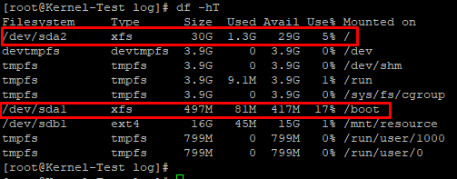

**Note:** Here /dev/sda2 is our actual partition where our configuration files and other data is stored. /dev/sda1 is our boot partition where initramfs (Temporary filesystem) and Kernel configuration and Boot loader info is available.

1. Use fdisk -l command to check the increased size of the OS-disk /dev/sda

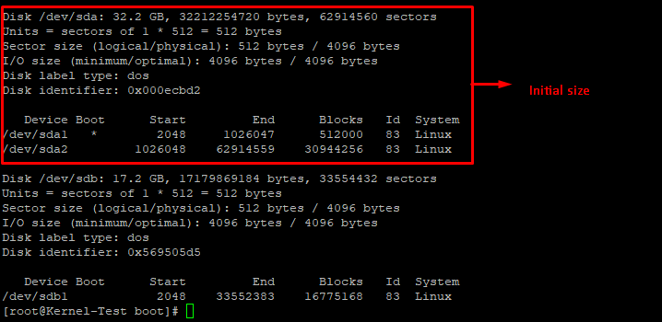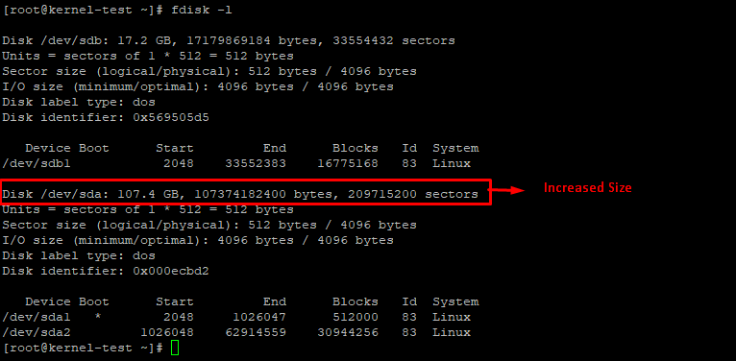

1. To Increase the disk space of /dev/sda2 we need to use fdisk utility menu using fdisk /dev/sda

type: p  
this will show both partitions /dev/sda1 and /dev/sda2 which are basically partitions 1 and 2

type: d then 2 (to delete partition 2)  
type: n then p, 2 (to recreate partition 2) you can accept the default values  
type: w (to save the new partition)  
type: q (to exit fdisk)  
sudo reboot (to reboot the VM so the partition is updated)

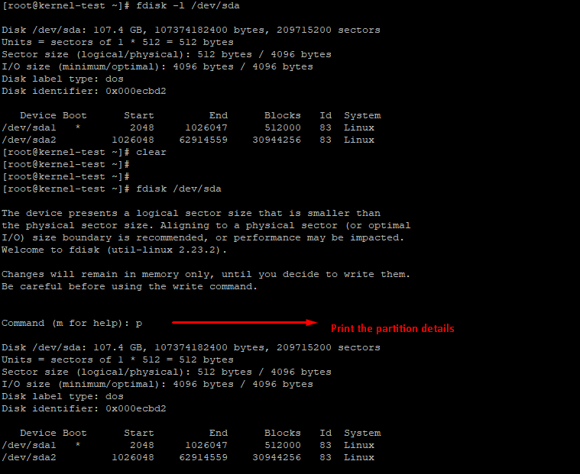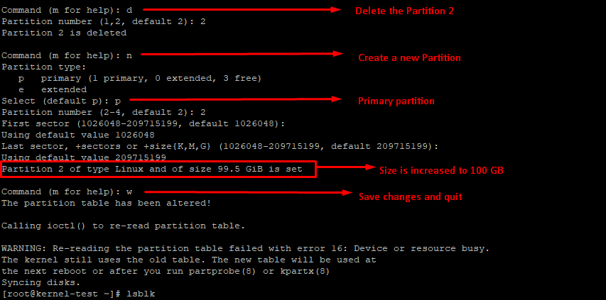

Reboot the server, changes to take effect

[root@kernel-test ~]# sudo reboot

1. Fire df -hT to check size has been increased, but it will still shows old size

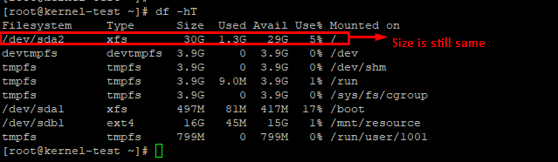

1. To finalize the resize, after the reboot, execute the command **sudo xfs_growfs /dev/sda2** and you wll see the increased size

