**XRDP on SUSELinux**

**Note:** SUSE Linux uses zypper package management system please find the below link to find basic zypper commands

<https://en.opensuse.org/images/1/17/Zypper-cheat-sheet-1.pdf>

1. Install the XRDP package

# Zypper install xrdp or zipper in xrdp

1. Start the service of xrdp

# Systemctl start xrdp

1. For installing GNOME desktop use following commands

# zypper install yast2*

# yast --qt or yast –gtk

1. Select "Software Management" and click enter

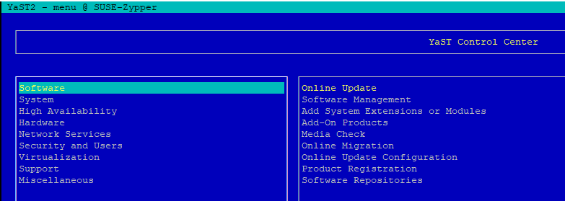

1. Select Installation Summery option and press down arrow to get the dropdown list

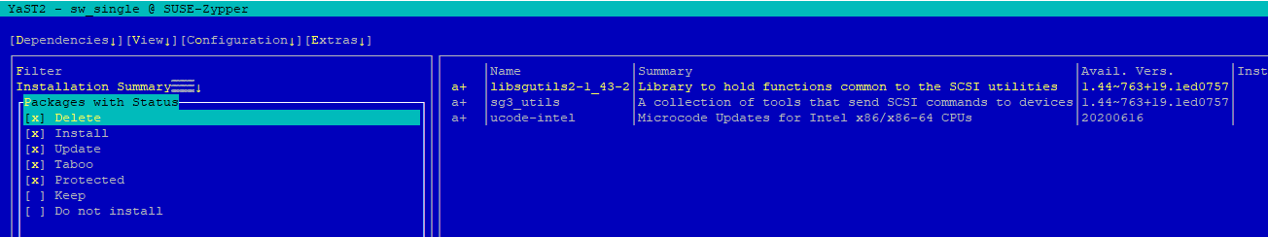

1. Select "Patterns" Select "GNOME Desktop Environment (Basic)" Select "Accept"

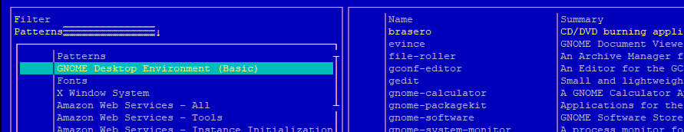

1. Open Port 3389 on NSG and check in machine if it is listening globally or not and restart the service xrdp

# systemctl restart xrdp

# Netstat -tulpn | grep 3389 or sudo lsof -i -P -n | grep LISTEN

1. Use RDP to login to Machine

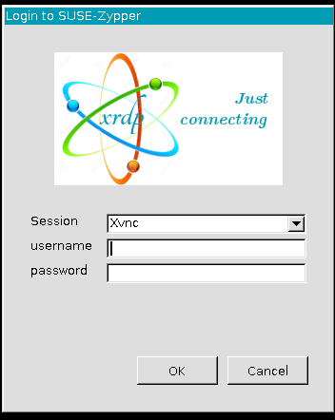

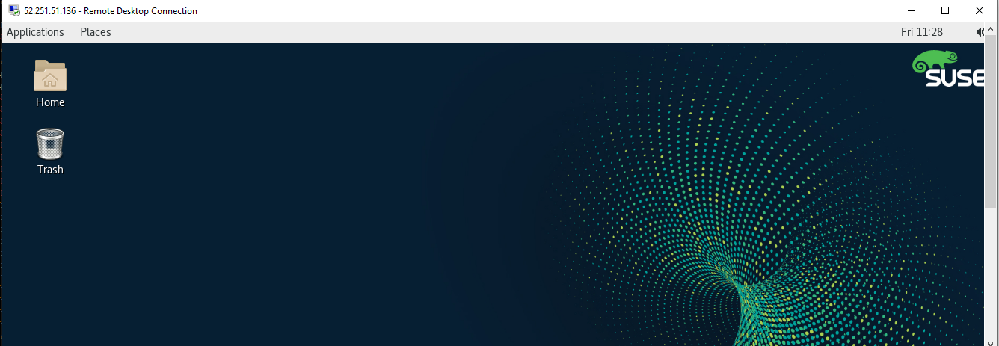

**Important Links:**

<http://www.scalingbits.com/aws/sap/suse/gnome>

<https://www.server-world.info/en/note?os=SUSE_Linux_Enterprise_15&p=desktop&f=1>

<https://en.opensuse.org/images/1/17/Zypper-cheat-sheet-1.pdf>