Product Specification Document

***Product Name***:- LockedMe.com

***Developer****:-* XYZ Company Limited.

***Sprints****:-* Total of 2 sprints were planned for the project. And in that, the prototype of the application was designed and developed.

1. The first sprint was used for the detailed planning and design of the application. The same was achieved in that week and also development activities were started.
2. In the initial days of the second sprint, the application was implemented and testing of the application was also completed. And the application was ready to be shipped.
3. The standard protocol for the sprints planning was followed.

# Flowchart of the application:-

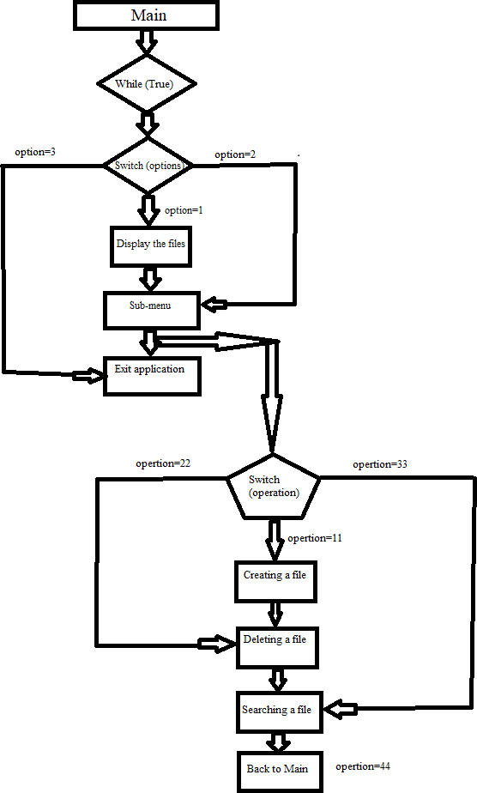

***Core Java Concepts Used****:-*

* 1. Control flow statements - while loop, if else statemets and switch statements.
  2. Collections - ArrayList.
  3. Sorting algorithm - Java inbuilt sort method.

# Github Link:-

[https://github.com/srjk18/ph1_assmnt/blob/dd55cccf7b00c20ae44e2688d150717](https://github.com/srjk18/ph1_assmnt/blob/dd55cccf7b00c20ae44e2688d15071763c454721/Simplilearn_Phase1_Project.java) [63c454721/Simplilearn_Phase1_Project.java](https://github.com/srjk18/ph1_assmnt/blob/dd55cccf7b00c20ae44e2688d15071763c454721/Simplilearn_Phase1_Project.java)

***Conclusion****:-* The project works as per the requirement given by the Company. Each feature has been implemented and tested. Produces the exact result as required.

1. The project can be enhance with features like, by adding the functinality to read the file or open the folder at command promt.