IZWS

To invoke IZWS production screen- TSO IZWSP (in command)
- 0 (option) -> 1 (subsystem)
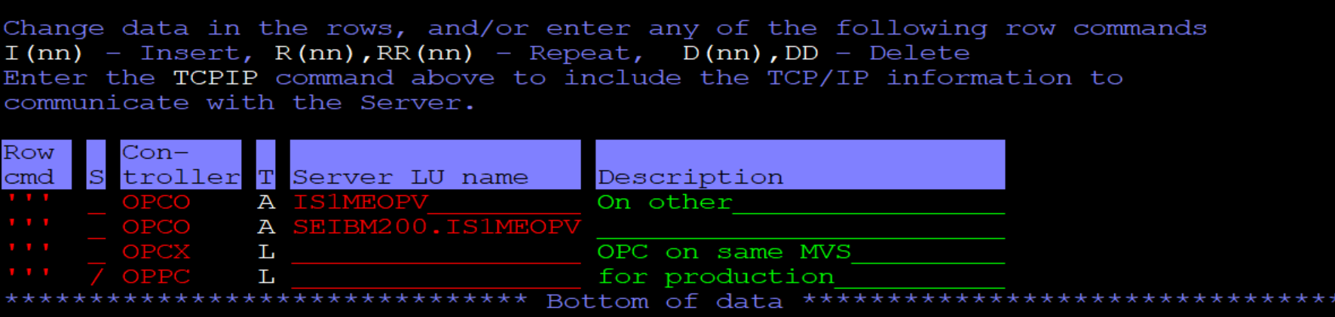
For production – OPPC is used as a controller

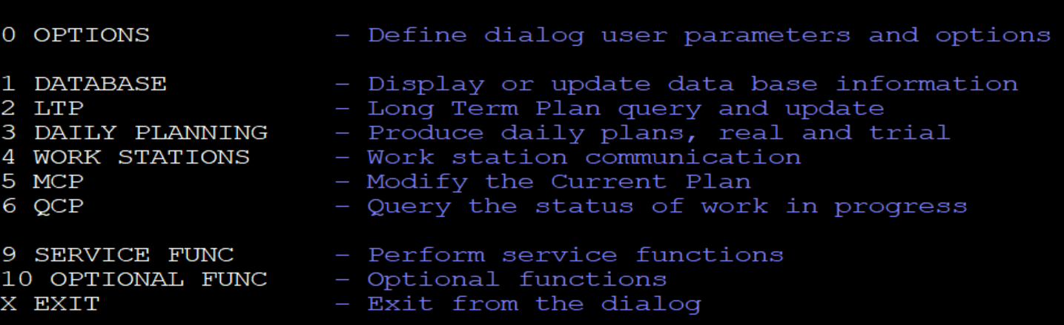

- 1 (Database)– In database we check calendar, application description(AD)
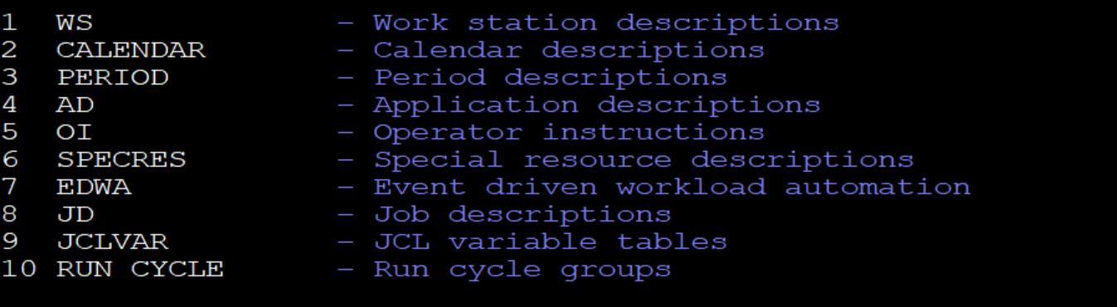

  - Calendar- Here we can see all the calendar for your running batch.
Browse the calendar with option 1.
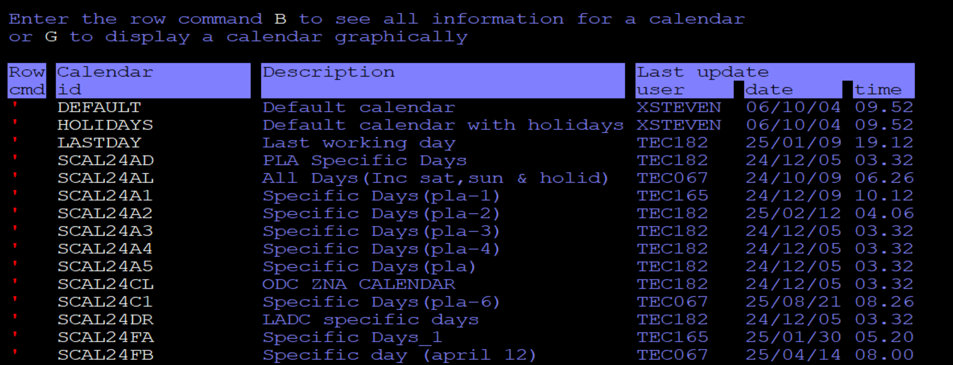
  - Period
  - AD- Application Description: Browse (1)
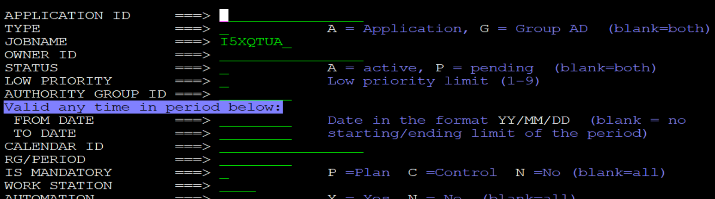
Provide the Job name or Application ID:

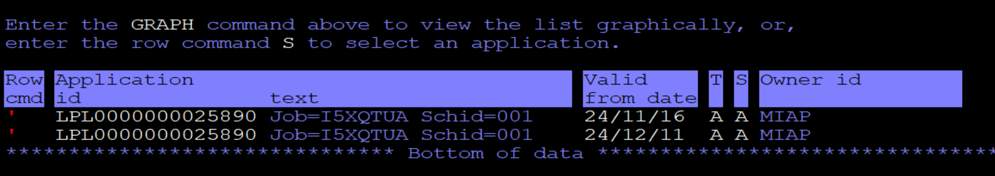
Here we need to select the row of recent date (valid from date)

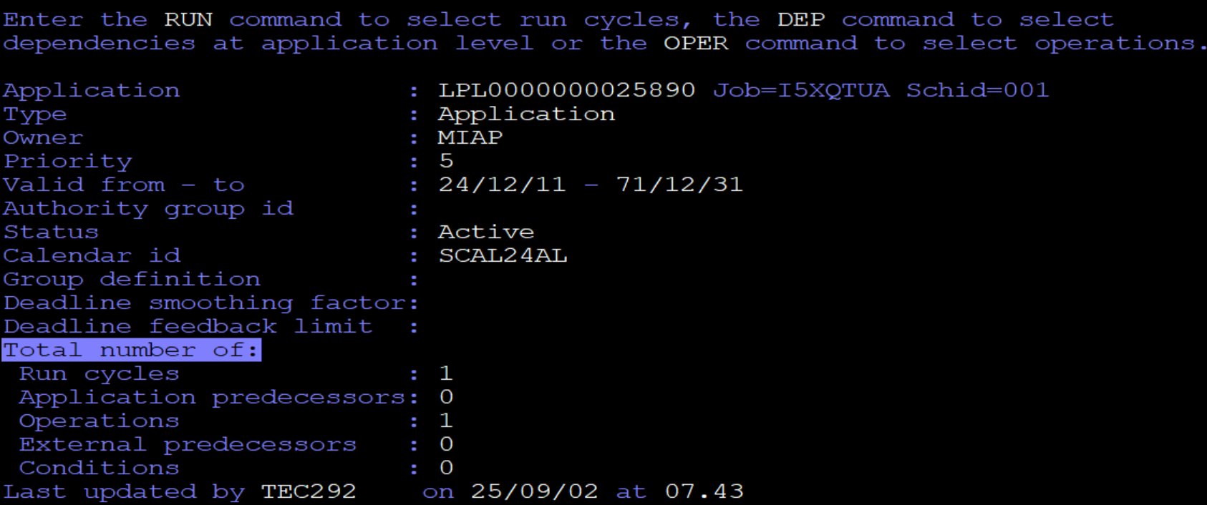
In the above screen we can select the Run cycle, dependencies, operation.
In RUN:
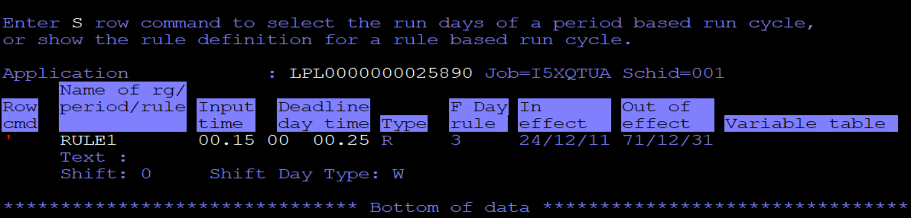
Select row command : S
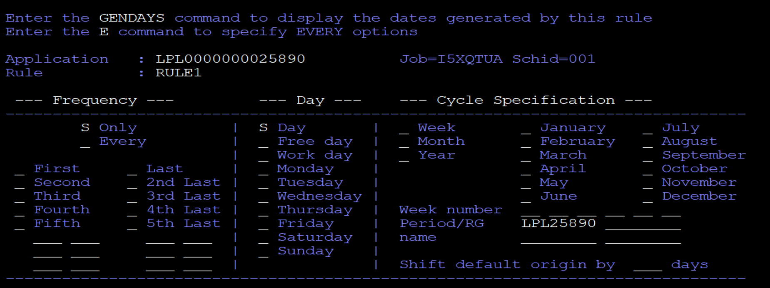
GENDAYS: This will give all the calendar with date and month for particular job that has been scheduled.
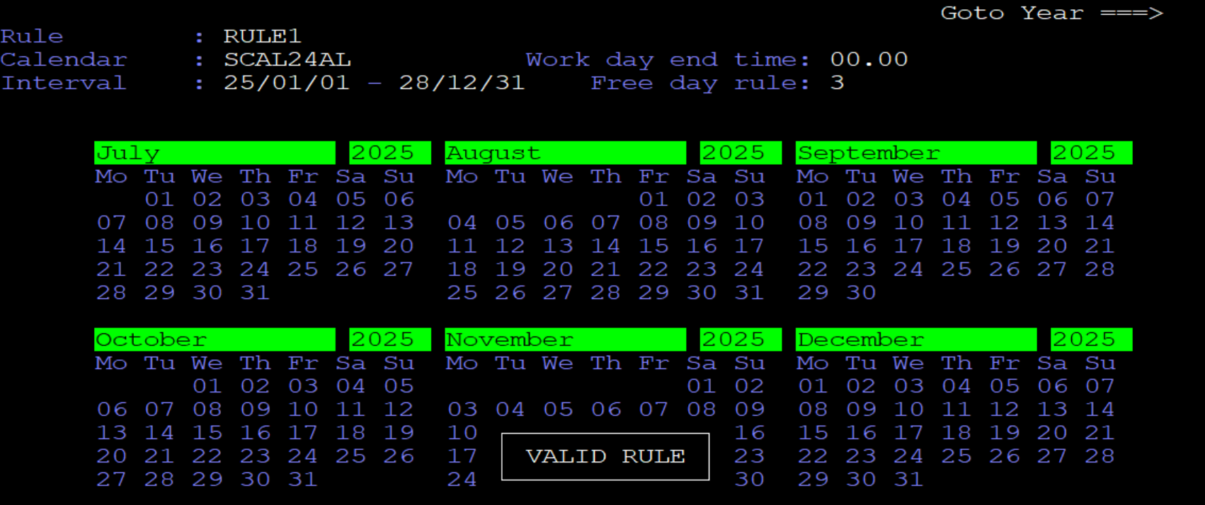
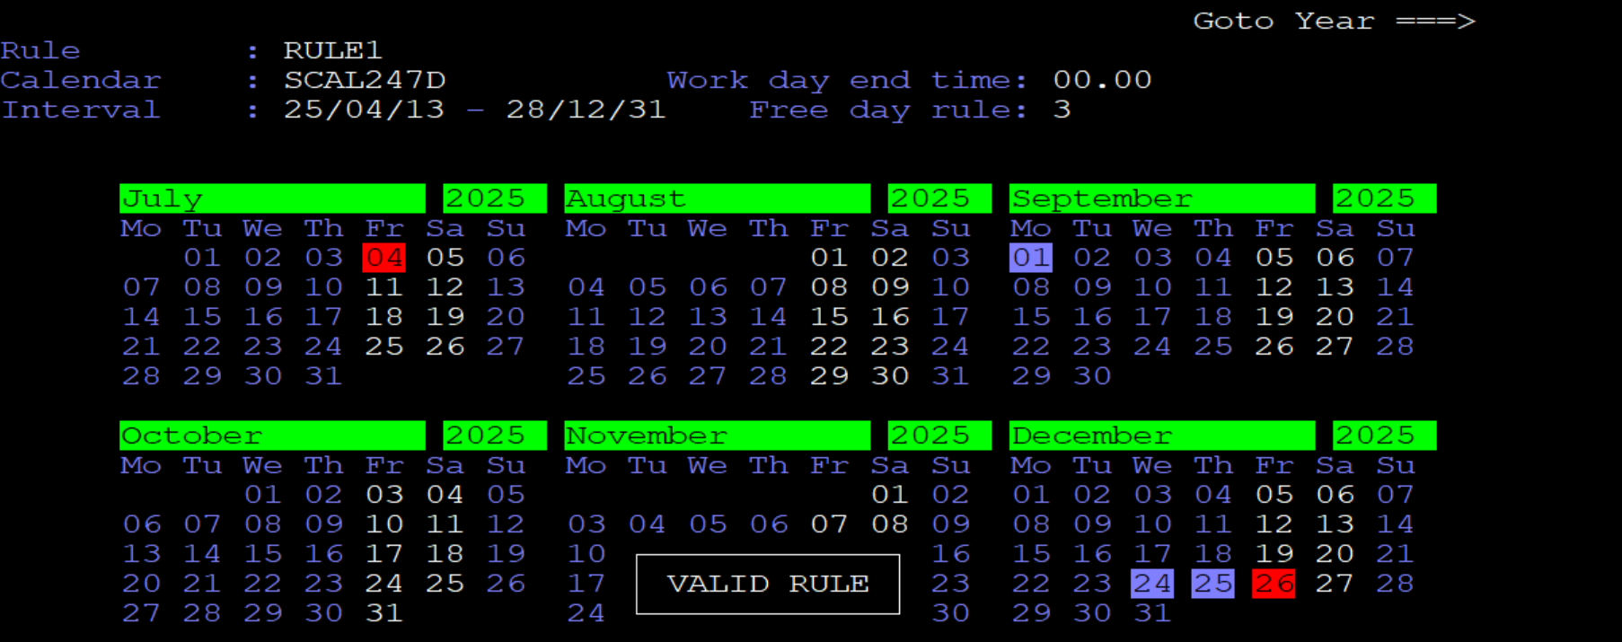
Blue- Scheduled
White- Not scheduled
Red- Holiday

OPER: this will give immediate preds and successor, also total no. of internal or external preds are there.

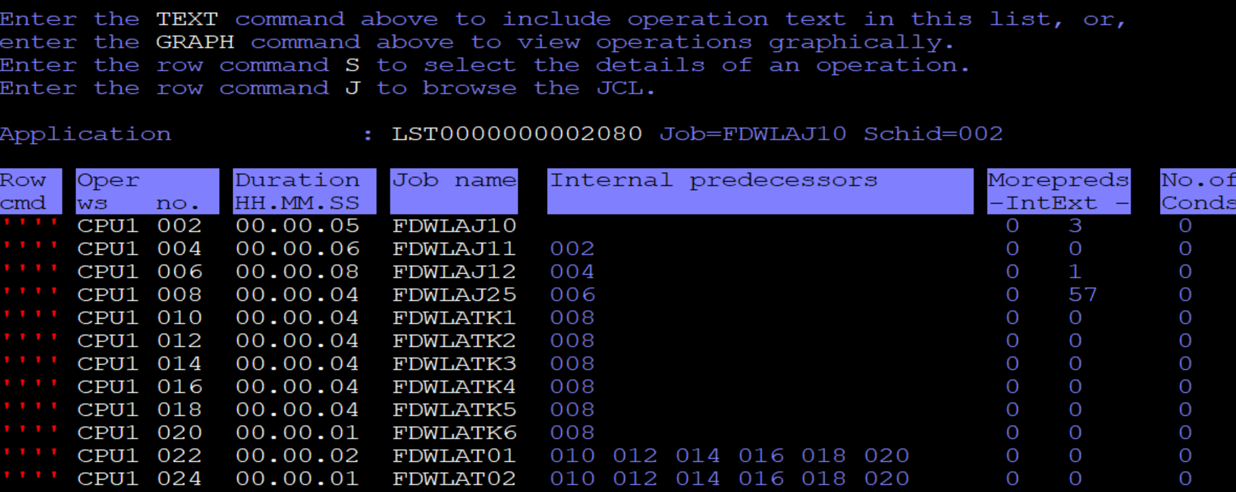
If you select any job- S (below row command)
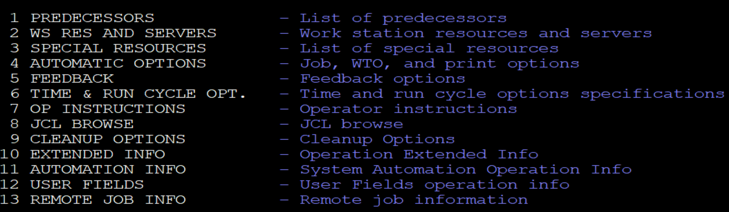
To check the predecessors type 1 – you will get the preds.
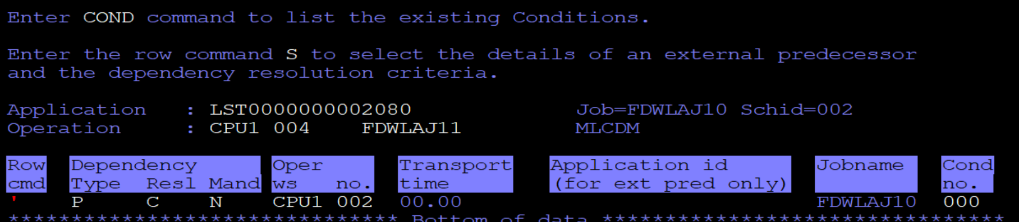
5. MCP (MODIFY THE CURRENT PLAN) -> 3 (OPERATION) ->
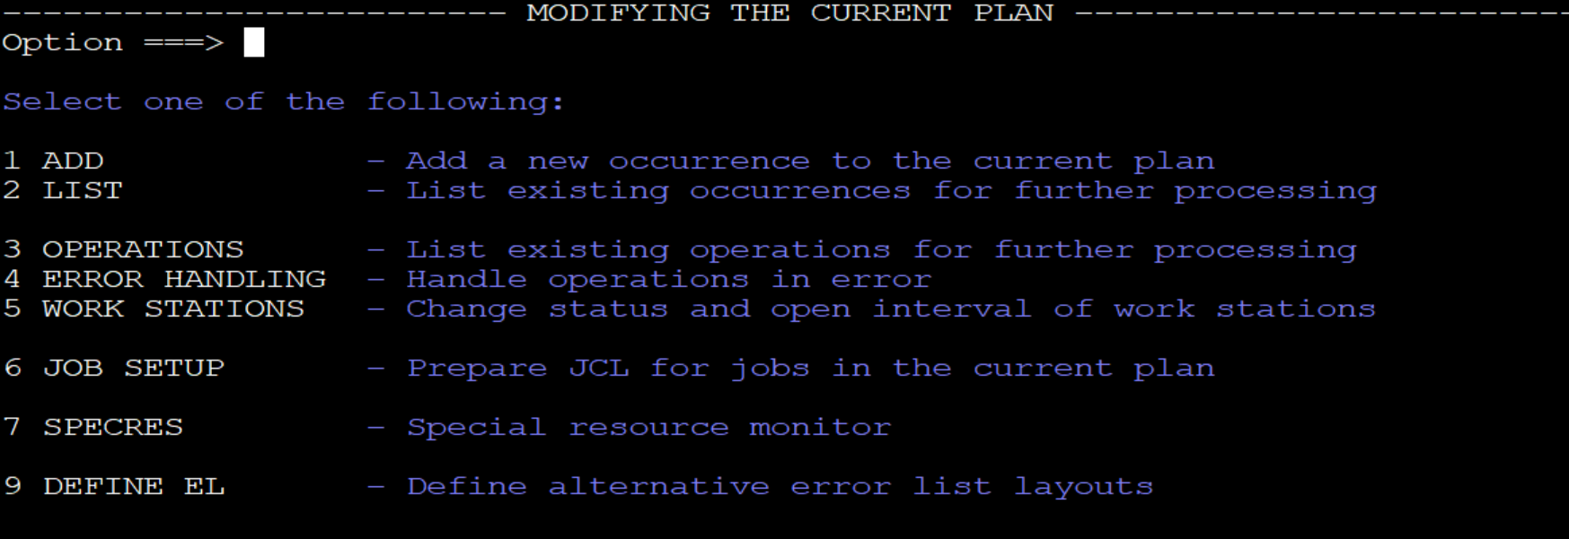
Provide the job name which you want to check -
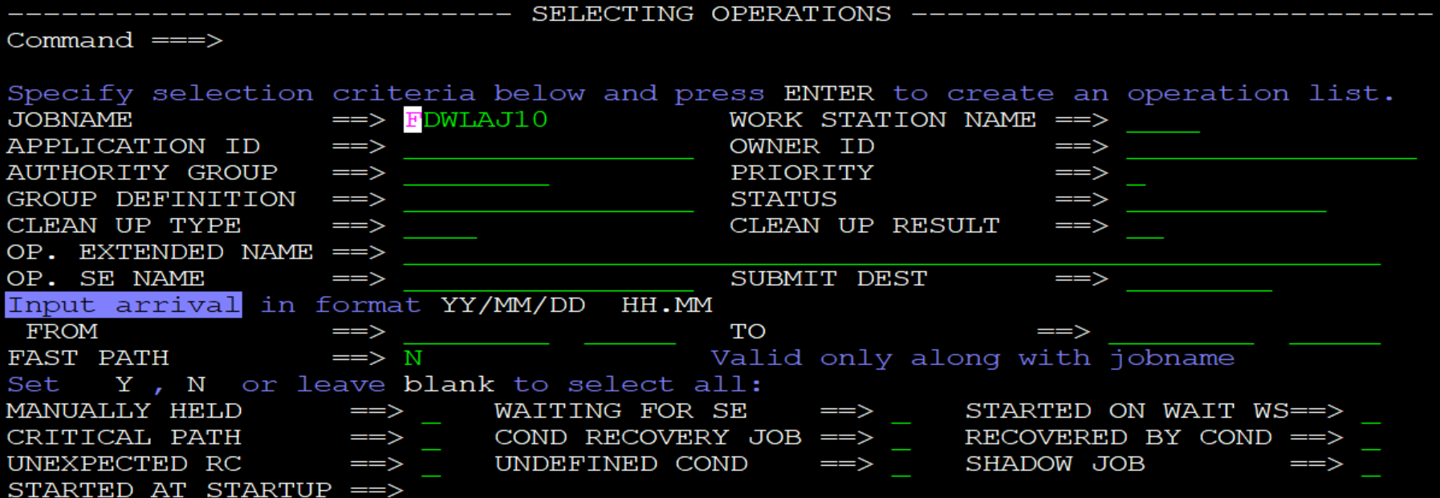
Yor will get input date, arrival timing in queue, successor and preds and status of that job completion.(S- started, C- completed, E- error, W-waiting for preds)
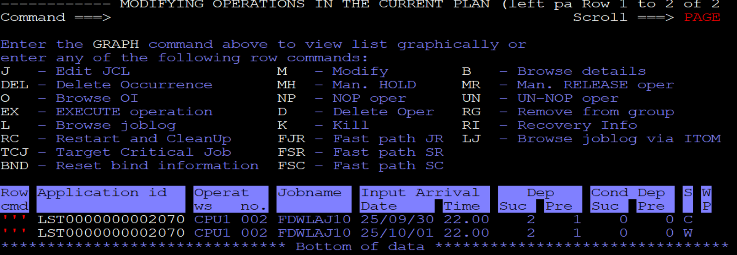
To check the JCL if it is adhoc job – type B to browse job
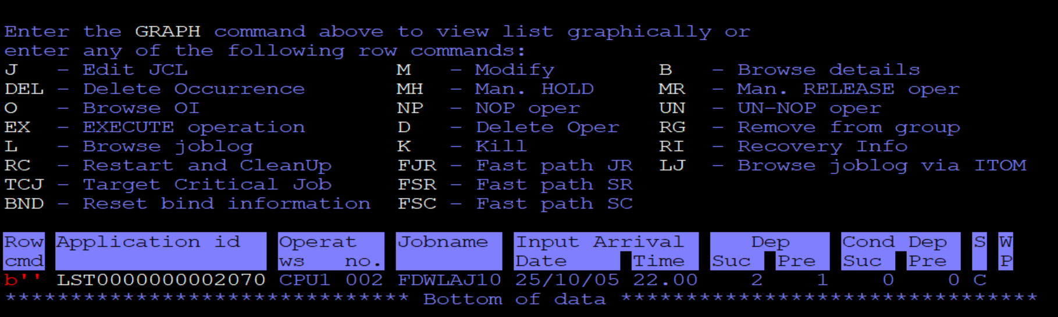
press 6 to check the JCL
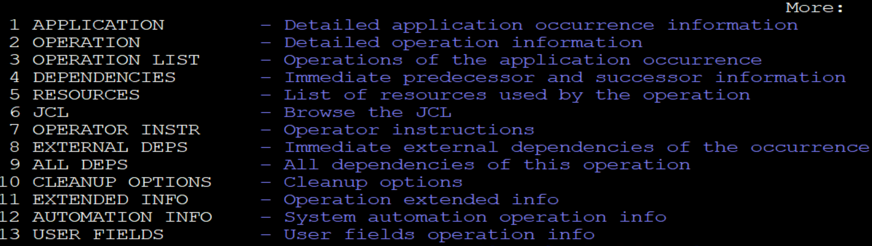
To check the dependencies – 9 (all deps)
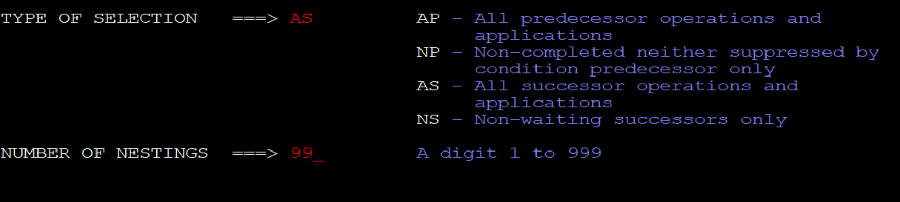
AS- all successors, AP- all predecessor
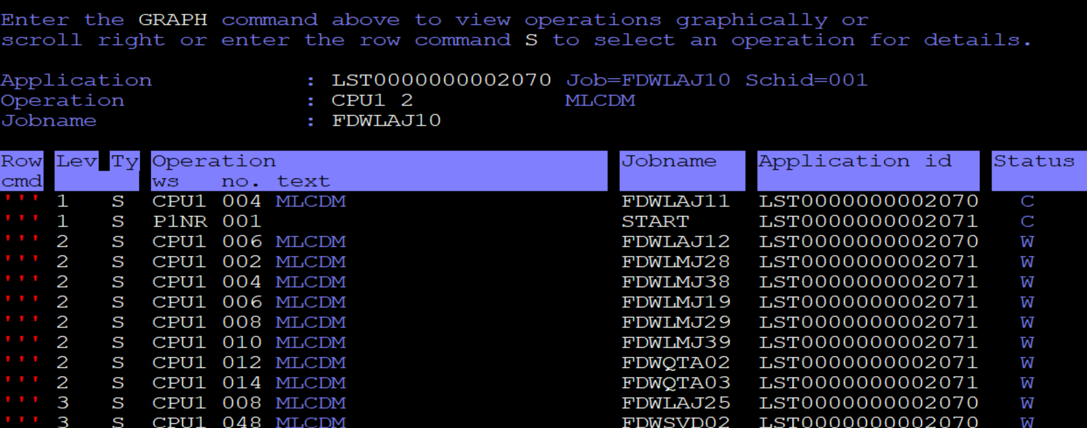
You will get all the list of jobs which are successors of that job( means all these jobs are dependent on this job)
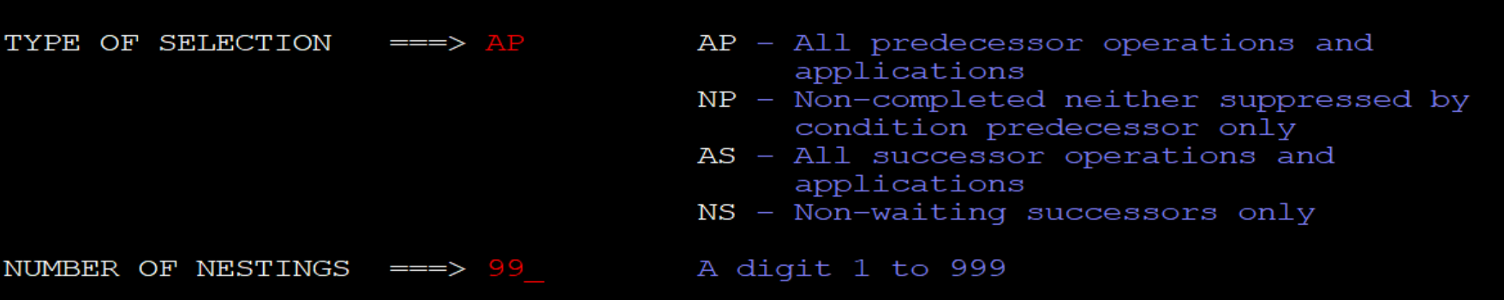
You will get all the list of jobs which are predecessors of that job( means all these jobs are requirements of this job)



Option 4 gives all the immediate preds and successors, P means preds, S means successors.
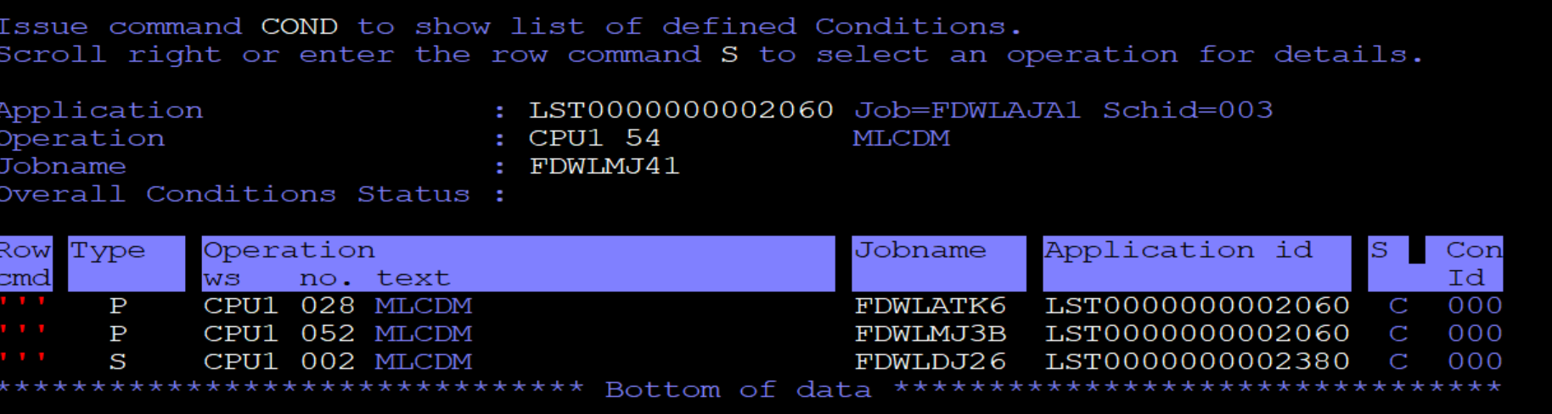
If you want to check jobs which are on hold, 5 -> 3 , give MANUALLY HOLD=Y
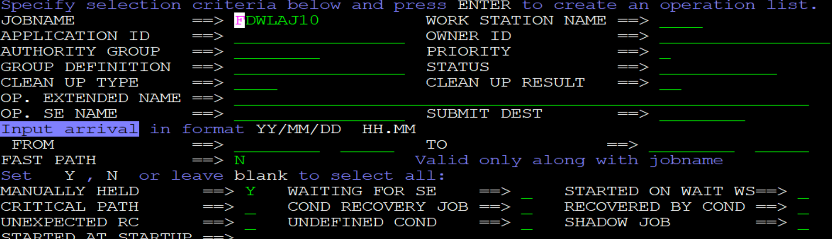
from screen 6 -> 3 (OPERATION)
