Alejandro Verri Kozlowski
Diana Reyes

Crawford Project,Location. Site-Specific Probabilistic Seismic Hazard Assessment (PSHA)

Introduction
The present document provides an estimate of the seismic hazard of the Crawford Project project site located in Location. and presents seismic design criteria and design guidance for embankments in terms of ground acceleration, spectral accelerations and horizontal seismic coefficients for use in performance-based seismic stability analysis.
The main objectives of the study are as follows:
- Define the tectonic framework of the study area, identify and characterize seismogenic sources capable of generating significant ground motion within a 500 km radius of the site, and select an appropriate source (seismogenic) model.
- Select a suite of ground motion prediction equations (GMPEs) and develop a logic tree framework that addresses epistemic uncertainty by integrating the full range of tectonic regimes represented in the adopted seismogenic source model.
- Perform a full probabilistic seismic hazard assessment (PSHA) for the site, estimating the annual probability of exceeding specified seismic intensity levels due to potential earthquakes from all identified sources (Section 1.2.1).
- Determine service levels by selecting target annual exceedance probabilities (AEP) in accordance with the Global Industry Standard on Tailings Management (GISTM).
- Provide uniform hazard spectra (UHS) for the selected service levels and return periods, considering the full range of spectral periods relevant to the site (Section 1.3.3).
- Estimate the expected site amplification for different geotechnical conditions, expressed in terms of ta multi-period amplification factor. Provide the site response spectra for the site, considering the target service levels and geotechnical site conditions (Section 1.2.7).
- Estimate fundamental periods (Section 1.2.8) and seismic coefficients ($k_{max}$) (Section 1.2.9) for performance-based stability analysis, considering different service levels (AEP), geotechnical conditions and performance levels expressed in terms of residual displacements ($D_{a}$) of an equivalent Newmark Sliding block.

Disclaimer
The opinions expressed in this Report have been based on the information supplied to (SRK) by Canada Nickel Co (). The opinions in this Report are provided in response to a specific request from to do so. SRK has exercised all due care in reviewing the supplied information. Whilst SRK has compared key supplied data with expected values, the accuracy of the results and conclusions from the review are entirely reliant on the accuracy and completeness of the supplied data. SRK does not accept responsibility for any errors or omissions in the supplied information and does not accept any consequential liability arising from commercial decisions or actions resulting from them. Opinions presented in this report apply to the site conditions and features as they existed at the time of SRK’s investigations, and those reasonably foreseeable. These opinions do not necessarily apply to conditions and features that may arise after the date of this Report, about which SRK had no prior knowledge nor had the opportunity to evaluate.

Methodology

Probabilistic Seismic Hazard Assessment
The probability of exceeding a certain level of seismic intensity $i^{*}$ at a given location is known as the seismic hazard of the site and can be estimated from the contribution of intensities from the different active faults of interest in the region. A probabilistic seismic hazard assessment (PSHA) quantifies the contributions of all sources for all possible magnitudes within the affected area. The PSHA stages identify all earthquake sources capable of producing significant ground-motion at the site and captures the expected range of all possible ground-motions in the target region. For a given source $\left(s\right)$
PI>i*s≈all m*​all r*​PI>i*/m*,r*,θ* PM=m*,R=r* 1
The spatial variability is given by all possible locations of the hypocentres of future seismic events that may affect the site. Temporal variability, on the other hand, is associated with the number of events per unit time that we should expect in a given region and can be linked to the seismic magnitude and rupture area through the Gutenberg-Richter (Gutenberg and Richter 1944) probability model. The fundamental difference between PSHA and DSHA methodologies is the inclusion of random uncertainty in the calculation of the spatial and temporal distribution of earthquakes, as well as the (aleatory) uncertainty associated with the ground-motion models.
In a probabilistic framework, service levels are expressed in terms of annual exceedance probability (AEP) of ground-motion accelerations ($pga$, $S_{a}$). The AEP is the rate of exceedance of a specific level of seismic intensity due to the potential occurrence of earthquakes from that source over a one-year period. The Return Period $T_{R}$ is defined as the inverse of the AEP:
$$T_{R}=1/λ_{I}\left(i^{*}\right)=-T_{e}/ln⁡\left(1-P_{T_{e}}\left[I>i^{*}\right]\right) \left(2\right)$$
The methodology employed for estimating the AEP is based on the Cornell-McGuire methodology Cornell (1968), McGuire (1993), Kramer (1997) which combines earthquake occurrence models, seismic source zone models, magnitude-recurrence relationships, and ground-motion intensity models through the total probability theorem. Assuming the occurrence of earthquakes follows a Poisson process, the probability that a certain strong motion intensity $I$ exceeds a certain value $i^{*}$ during a time interval $T_{e}$ is given by:
$$P_{T_{e}}\left[I>i^{*}\right]=1-exp\left(-λ_{I}\left(i^{*}\right) T_{e}\right) \left(3\right)$$
where $λ_{I}\left(i^{*}\right)$ is the annual rate of exceedance and $T_{e}$ is the exposure time. For a given source, the annual rate of exceedance of an intensity target level $i^{*}$ $λ_{I}\left(i^{*}\right)$ can be expressed by the Total Probability Theorem (TPT):
λIsi*≃νosNR​NM​PI>i*|mj,rksfMsmj Δm fR|Msrk|mjΔr 4
where $M_{max}^{\left(s\right)}$ is the maximum earthquake size of the source $\left(s\right)$ and $ν_{o}=P\left[M>M_{o}^{\left(s\right)}\right]$ is the annual frequency of occurrence of earthquakes with magnitude greater than a minimum value $M_{o}$. The conditional probability $P\left[I>i^{*}\right]$ can be obtained by assuming a probability distribution law for the seismic intensity $I$.

Source Models
The earthquake sources capable of producing significant ground-motion at the site are identified and characterised through source models. Source characterisation includes definition of source geometry and probability distributions of potential rupture locations within the source. The source models are grouped into the following four seismic source models classes:
- Background area-source models that use broad geographic zones within which earthquakes can occur anywhere with equal probability.
- Regional area-source models that assume the spatial distribution of seismicity is not uniform at the scale of background source models and that the distribution of historical seismicity is useful to forecast future earthquake occurrence.
- Seismotectonic models that combine regional source models with fault-source models.
- Smoothed seismicity models: data-driven models that assume that historical seismicity is a good predictor of future seismic hazard and combine short-term information from the instrumental catalogue with long-term geological information from the fault-source model.
Each model type contributes different information towards probabilistic hazard assessments. Additional epistemic uncertainty is accounted for during the model parameterisation.

Ground Motion Intensity Models
Seismic ground motion is generally characterised by a scalar (spectral) measure of intensity $I=i^{*}$. The seismic intensity of site $i^{*}$ will generally depend on the distance from the site to the nearest point on fault $r^{*}$ and the magnitude $m^{*}$ of the seismic event, which is directly related to the size of the fault rupture area. For a given event of magnitude $m^{*}$ located at some distance $r^{*}$, the strong motion intensity $i^{*}=f\left(m^{*},r^{*},θ\right)$ can be estimated in terms of a probabilistic model expressed in terms of its conditional $η_{I|M,R}$ mean and an error term $ε$
$$η_{I|M,R}=ϕ_{I}\left(m^{*},r^{*},θ\right)+ε_{I}$$
where $ϕ\left(M=m^{*},R=r^{*},θ\right)$ is a regression model defined in terms of earthquake magnitudes $\left(m^{*}\right)$, source-to-site distances $\left(r^{*}\right)$ and geological/geotechnical site conditions $\left(θ\right)$ and $ε_{I}$ is a random variable with mean $E\left[log\left(ε_{I}\right)\right]≈0$ and variance $var\left[ε_{I}\right]≈{\left(σ_{ln I}\right)}^{2}$.
Intensity models are suites of model prediction equations (GMPE) that capture the random variability of the seismic motion. These prediction equations are statistical models calibrated with seismic records from around the world, obtained from seismic events of a given tectonic mechanism. The particular tectonic regime of the study region determines the selection of a suitable family of GMPEs that can capture the particular ground motion characteristics of the project site. Three predominant tectonic regimes can be identified: active shallow crustal, stable (continental) shallow crustal and subduction regimes. The Global Earthquake Model (Pagani et al. 2018) brought together ground-motion experts from various institutions around the world to develop recommendations on what GMPE should be used when conducting global seismic hazard assessments (J. Stewart et al. 2013).
The transformation usually performed on random variables associated with the occurrence of seismic events is the logarithmic transformation, which is equivalent to assuming a normal distribution law for the intensity logarithms. Under this transformation, the seismic intensity is determined according to a new normalized random variable $β_{I}$, with mean value $E\left[β_{I}\right]=0$ and variance $var\left[β_{I}\right]=1$ with null expectation and unit variance.
$$β_{I}\left(i,m,r\right)≈\frac{ln i-ln\left[η_{I}\left(i,m,r\right)\right]}{σ_{ln I}}$$
From this transformation the CDFs $P\left[I>i^{*}/m^{*},r^{*}\right]$ can be defined explicitly in terms of the cumulative normal density function $Φ_{C}\left(β_{I}^{*}\right)=1-Φ\left(β_{I}^{*}\right)$ the seismic intensity exceedance probability for a given scenario $r_{s}^{*},m_{s}^{*}$ can be obtained from:
$$P\left[I>i^{*}\right]≈ Φ_{C}\left[β_{I}\left(i^{*},r_{s}^{*},m_{s}^{*}\right)\right]$$
Using the TPT the annual exceedance rate of earthquakes with magnitude greater than $m^{*}$ can be expressed in terms of an asymptotically truncated Gutenberg-Richter magnitude-frequency distribution. The discrete mass probability for magnitudes $P{\left[M=m_{j}\right]}^{\left(s\right)}=f_{M}^{\left(s\right)}\left(m_{j}\right) dM$ can be obtained from the first derivative of the magnitudes cumulative-density function $F_{M}^{\left(s\right)}\left(m_{j}\right)$ valid for $M_{max}^{\left(s\right)}<m^{*}<M_{o}^{\left(s\right)}$:
$$λ^{\left(s\right)}\left[M>m^{*}\right]=λ_{M}^{\left(s\right)}\left(m^{*}\right)=ν_{o}^{\left(s\right)}\left(1-F_{M}^{\left(s\right)}\left(m^{*}\right)\right)≃ν_{o}^{\left(s\right)}\frac{e^{-β\left(m^{*}-M_{o}^{\left(s\right)}\right)}}{1-e^{-β\left(M_{max}^{\left(s\right)}-M_{o}^{\left(s\right)}\right)}}$$
The discrete mass probability function for distances $f_{R⁄M}^{\left(s\right)}\left(r^{*}|m^{*}\right)dr^{*}=P{\left[R=r^{*}|m^{*}\right]}^{\left(s\right)}$ can be obtained numerically from the histogram of an array of epicentres inside the boundaries of each source.
In general, not enough strong ground-motion records are available for a given region to formulate a specific GMPE model for the particular site. To address this epistemic uncertainty, several models defined for similar tectonic regimes are combined by means of logic trees, with weights selected by expert judgement. The ground-motion intensity for a given hazard level $β$ can be obtained by a weighted sum of ground-motion intensities from different models for a given target $\left(M=m^{*},R=r^{*}\right)$
$${\tilde{i}}^{*}≈\sum_{b=1}^{N_{b}}{w_{b} η_{I}^{\left(b\right)}\left(m^{*},r^{*}\right)} {\left(σ_{I}\right)}^{β}$$
where $w_{b}$ is the weight assigned to the $b$-th branch of the logic tree, $η_{I}^{\left(b\right)}\left(m,r\right)$ is the ground-motion intensity model, and $σ_{I}$ is the standard deviation of the ground-motion intensity model. A minimum number $N_{b}$ of independent region-specific ground-motion model were selected to capture the expected range of possible ground-motions in the target region. They are selected following guidelines from Boomer et al. (Bommer and Scherbaum 2008) and weighted in logic trees to address their relative confidence based on the available information.

Hazard Deaggregation
The PSHA combines the probabilities of all earthquake scenarios with predictions of resulting ground motion intensity, as described in previous sections. To identify the contributing events for a given ground motion intensity and AEP (or return period), the seismic hazard deaggregation computes the relative contribution of earthquake parameters magnitude $M$ and distance $R$ to the total hazard. The full deaggregation methodology can be found in references Kramer (1997), Bazzurro and Cornell (1999) . Conceptually, the contribution of a magnitude $\overset{‾}{m}$ and distance $\overset{‾}{r}$ to the total hazard can be obtained from the Bayes’ theorem from the total and marginal AEP :
$$\overset{‾}{m}=m_{l} ; l∈max\left[\frac{λ\left[I>i^{*}|M=m_{1}\right]}{λ_{I}\left(i^{*}\right)},..,\frac{λ\left[I>i^{*}|M=m_{k}\right]}{λ_{I}\left(i^{*}\right)}..,\frac{λ\left[I>i^{*}|M=m_{N}\right]}{λ_{I}\left(i^{*}\right)}\right] \left(5\right)$$
$$\overset{‾}{r}=r_{l} ; l∈max\left[\frac{λ\left[I>i^{*}|R=r_{1}\right]}{λ_{I}\left(i^{*}\right)},..,\frac{λ\left[I>i^{*}|R=r_{j}\right]}{λ_{I}\left(i^{*}\right)},..,\frac{λ\left[I>i^{*}|R=r_{N}\right]}{λ_{I}\left(i^{*}\right)}\right] \left(6\right)$$
where $λ\left[I>i^{*}\right]$ is the total AEP for all sources defined before, and $λ\left[I>i^{*}|M=m_{u}\right]$ and $λ\left[I>i^{*}|R=r_{v}\right]$ are the marginal probabilities for events of magnitude $\overset{‾}{m}$ and distance $\overset{‾}{r}$
λI>i*|M=mu≃NS​νosNR​NM​ΦCsεj,k*fMsm ΔmfR|Msrk|muΔr 7
λI>i*|R=rv≃NS​νosNR​NM​ΦCsεj,k*fMsmj ΔmfR|Msrv|mjΔr 8
With this procedure, the fractional contribution of different subsets of the events with respect to the total hazard is computed. The deaggregation by magnitude and distance bins allows the dominant scenario earthquake (M-R bins) to be identified. When several mechanisms contribute to the total hazard, the deaggregation procedure can be performed for a family of sources and identify the M-R bins for each mechanism, allowing the identification of the dominant seismic source. In a probabilistic framework, the magnitude-distance bins $M_{w}-R$ that control the seismic hazard is defined as the controlling scenario for a given target AEP and structural period $T_{n}$.

Target Service Levels
Design Ground Motions for critical infrastructure will have a target Annual Exceedance Probability (AEP) defined according to the failure consequences rating for a given target service level (construction, operation, closure, or post-closure). Design ground motions can be selected using either a consequence-based (deterministic) or a risk-based (probabilistic) approach. The probabilistic approach evaluates the seismic demand of a wide range of seismic ground motions on the facilities to satisfy a tolerable risk criterion based on failure probabilities. In contrast, the deterministic approach requires the selection of design earthquakes considering the failure consequences of the facility. Under this approach, the target Annual Exceedance Probability (AEP) for critical infrastructure is defined according to the failure consequence rating for a given target service level (construction, operation, closure, or post-closure).
The consequence-based seismic design of a critical facility must ensure a very low probability of failure for a maximum design earthquake and an acceptable level of damage for an earthquake likely to occur during the facility’s service life. The facility’s service life encompass all phases of construction and operation, periods of temporary cessation of operations, and the closure phase (transition phase into post-closure, also referred to as active-care closure). Post-closure refers to permanently closed facilities configured for their perpetual form/state, subjected to the maximum time of exposure irrespective of the facility’s consequence classification.
Many agencies, such as CDA (2007), ANCOLD (2012), and GISTM (2020), have dual performance criteria to address the safety and serviceability of Tailings Storage Facilities. Safety considerations primarily focus on the ultimate limit state, utilizing an upper-level earthquake known as the maximum design earthquake (MDE) or Safety Evaluation Earthquake (SEE). Serviceability analysis ensures that the TSF remains operational after minor seismic events and that any damage is manageable and repairable. For this service level, a lower-level earthquake known as the Operating Basis Earthquake (OBE) is assumed. This dual consideration helps in maintaining the functionality of TSFs and mitigating risks associated with operational interruptions or failures. In regions of moderate-to high seismicity, it is necessary to explicitly consider serviceability conditions, as residual displacements can be significant and affect the operation of the structure.
The Tailings Storage Facilities at Crawford Project site has been classified with grade Very High, according to GISTM (2020), adopting a target AEP of 1/10,000 yr as the maximum design earthquake MDE . For all facilities, the maximum design earthquake (MDE) has been adopted to address both safety and serviceability criteria across all project stages, including post-closure stages.

Uniform Hazard Spectra (UHS)
The spectral ordinate $S_{a}\left(T_{n}\right)$ is the maximum acceleration reported by a single-degree-of-freedom (SDOF) oscillator with fundamental period $T_{n}$ and represents the seismic ground-motion defined of a given target service level for each structural period. The response spectra represent spectral ordinates $S_{a}\left(T_{n}\right)$ expressed in terms of the SDOF’s fundamental period $T_{n}$ for a given target annual exceedance probability (AEP). The uniform hazard spectra (UHS) represents spectral ordinates $S_{a}\left(T_{n}\right)$ with the same probability of exceedance defined for all structural periods $T_{n}$.
The design earthquakes for the project site are defined in terms of the site’s response spectrum. Spectral ordinates defined at the structural period $T_{n}=0$ sec, are the peak ground accelerations $\left(pga\right)$. The $pga$ is the maximum acceleration experienced by a particle at the ground surface during an earthquake It represents the spectral acceleration, Sa(Tn), at a natural period of $T_{n}=0$ seconds, corresponding to an infinitely stiff system. $pga$ is a key parameter in seismic hazard assessment, often used as a primary indicator of earthquake intensity and for designing structures to withstand seismic forces. The peak ground velocity $\left(pgv\right)$ is an intensity measure, often derived from empirical models based on $pga$ and Arias Intensity is a strongly correlated measure with seismic demand in terms of permanent slope displacements and both are frequently used as a proxy for selecting seismic records for dynamic deformation analysis.
The $pgv$ can be obtained from empirical (regression) models [^X2] based on peak ground accelerations. Seed and Idriss (1982) provided an estimate of median $\left(pgv\right)$ values (no error term reported) assuming a linear relationship as $pgv≈\left(55 cm/s\right) pga/g$. A similar expression incorporating random uncertainty from a large dataset of seismic records can be obtained from the expression eq. 9 where $pgv$ is the median peak-ground velocity expressed in $m/s$, $pga^{o}$ are the peak-ground accelerations in rock expressed in units of $g$, and $ϕ_{1}$ , $ϕ_{2}$ are model parameters (2017),(2023).
$$pgv^{o}≈η_{PGV}\left(pga^{o}\right)≈ϕ_{1} {\left(pga^{o}/g\right)}^{ϕ_{2}} \left[m/s\right] \left(9\right)$$
The Arias intensity is an IM strongly correlated with seismic demand in terms of permanent settlement of slopes and are often used as a proxy for the selection of seismic records for dynamic deformation analysis. In similar way as $pgv$, Arias Intensities ($ai$) can be obtained from a probabilistic model based on peak ground accelerations from eq. 10, where $ai$ is the median Arias Intensity in $m/s$, $pga$ are the peak-ground accelerations for rock site conditions in units of $g$ , $ψ_{1}$ , $ψ_{2}$ are model parameters
$$ai\left(pga^{o}\right)≈η_{A}\left(pga^{o}\right)≈ψ_{1} {\left(pga^{o}/g\right)}^{ψ_{2}} \left[m/s\right] \left(10\right)$$

Site Response Spectra
Seismic ground motions will be affected by the geotechnical and dynamic characteristics of the different soil layers overlying the bedrock. The procedure by which the ground motions at the surface level are determined is known as the dynamic site response. The site response spectra must be obtained for the specific geotechnical conditions of the foundation soil of each project facility. The estimation of dynamic site response can be achieved by utilizing a multi-period amplification factor that is dependent on the average shear-wave velocity ${\overset{‾}{v}}_{S}$, as outlined in ASCE/SEI 7-22. The model proposed by J. P. Stewart et al. (2017) is a three-component model dependent on shear-wave velocities ${\overset{‾}{v}}_{S}$ and can be used for both hard rock with $v_{ref}$ of 3000 m/s or soft rock with $v_{ref}$ of 760 m/s reference values.
$$ln F\left(T_{n},{\overset{‾}{v}}_{S}\right)≈β_{BC}+β_{A}+β_{NL}+ε_{F} \left(11\right)$$
where $β_{BC}$ is a scaling term relative to ${\overset{‾}{v}}_{S}$ = 760 m/s, $β_{A}$ is amplification at ${\overset{‾}{v}}_{S}$ = 760 m/s relative to $v_{ref}$ = 3000 m/s and $β_{NL}$ is a factor that considers non-linear effects, which has strong influence in soft-soil conditions. The error term $ε_{F}$ from (J. P. Stewart et al. 2017) is a log-normal random variable, with mean $E\left[ε\right]≈0$ and variance $Var\left[ε\right]≈σ_{F}^{2}$.
The site response spectra are obtained from the combination of the rock response spectra with the multiple period amplification factors, as established in ASCE/SEI 7-22. For a target service level, defined by the Annual Exceedance Probability (AEP), and a given structural period $T_{n}$, the median spectral ordinates $S_{a}\left(T_{n},{\overset{‾}{v}}_{S}\right)$ expected at sites characterized by an average shear-wave velocity ${\overset{‾}{v}}_{S}$, can be derived from the spectral ordinates on rock, denoted as $S_{a}{\left(T_{n}\right)}^{o}$. This approach facilitates a tailored response analysis based on arbitrary geotechnical site conditions.
$$S_{a}\left(T_{n},{\overset{‾}{v}}_{S}\right)≈F\left(T_{n},{\overset{‾}{v}}_{S}\right) S_{a}\left(T_{n},v_{ref}\right) \left(12\right)$$
where $F\left(T_{n},{\overset{‾}{v}}_{S}\right)$ is the multi-period site factor and $S_{a}\left(T_{n},v_{ref}\right)$ is the spectral ordinate for the structural period $T_{n}$ for ${\overset{‾}{v}}_{S}={\overset{‾}{v}}_{ref}$. Following the same approach, Peak-ground velocities $pgv^{sc}$ Arias intensities $a_{i}^{sc}$ and other peak-based intensity measures expected on arbitrary site conditions can be obtained from eq. 13 and eq. 14,(2023), where $F_{o}\left(v_{S}\right)$ is the multi-period site factor (eq. 11) defined for a target site in terms of ${\overset{‾}{v}}_{S}$, $pga^{o}$ is the peak-ground acceleration in rock, $ψ_{1},ψ_{2}$ are model parameters.
$$pgv\left(v_{S}\right)≈F_{o}\left(v_{S}\right) ϕ_{1} {\left(pga^{o}/g\right)}^{ϕ_{2}} \left[m/s\right] \left(13\right)$$
$$ai\left(v_{S}\right)≈F_{o}\left(v_{S}\right) ψ_{1} {\left(pga^{o}/g\right)}^{ψ_{2}} \left[m/s\right] \left(14\right)$$
Spectral ordinates (design spectra) and peak-ground accelerations $pga$ obtained for the maximum design earthquake (MDE) under different site conditions are shown in Section 1.3.4.2.

Slope’s fundamental periods
Fundamental periods of the embankment $T_{s}$, can be obtained from the shear-beam models from (Ambraseys 1960),(Dakoulas and Gazetas 1985), (Dakoulas and Gazetas 1986) assuming a truncated-wedge geometry with a shear module varying as $G_{m}≃G_{o} {\left(z/H_{max}\right)}^{m_{o}}$ where $z$ is the distance from the top, $G_{0}=G_{max}$ is the shear module at the surface, and $H_{max}$ is the truncated-wedge height. The fundamental period of the embankment can be expressed in terms of the shear-wave velocity at the base $v_{S}^{o}$:
$$T_{s}^{\left(j\right)}≃\frac{4 π H_{max}}{a^{\left(j\right)} \left(2-m_{o}\right) v_{S}^{o}} \left(15\right)$$
where, $a^{\left(j\right)}=f\left(m_{o},λ_{o}\right)$ is the $j$th-root of the characteristic equation (eigenvalues) that depend on the homogeneity ratio $m_{o}$ and the truncation ratio $λ_{o}$. The truncation ratio can be defined in terms of the height $H_{max}$, the berm width $b_{o}$ and the average slope $tanβ=1/s$ in the form:
$$λ_{o}=\frac{B_{o}}{B_{max}}=\frac{B_{o}}{2 H_{max} s+B_{o}} \left(16\right)$$
where $B_{max}$ is the base width of the embankment. The truncation ratio $λ_{o}$ is a measure of the influence of the berm width $B_{o}$ on the fundamental period of the embankment. For a given height $H_{max}$, the fundamental period of the embankment increases with the truncation ratio $λ_{o}$. The homogeneity ratio $m_{o}$ reflects the law of variation of the shear modulus $G\left(z\right)≈G_{o}{\left(z/H_{max}\right)}^{m_{o}}$, where $G_{o}$ is the (maximum) shear moduli at the base $\left(z=0\right)$.
The shear Moduli $G\left(z\right)$ of an arbitrary layer at depth $z$ can be estimated in terms of the void ratio $e_{o}$ and the octahedral stresses $σ_{o}\left(z\right)$ from eq. 17, where $A$, $C_{e}$, and $n$ are material-dependent constants and $e_{0}$ is the void ratio of the material, and $σ_{o}\left(z\right)$ is the octahedral stress at depth $z$ (Ishihara 1997).
$$G\left(z,e_{o}\right)≈A\frac{{\left(C_{e}-1\right)}^{2}}{1+e_{o}}{\left(\frac{σ'_{o}\left(z\right)}{p_{ref}}\right)}^{n} \left(17\right)$$
The shear wave velocity at the base $v_{S}^{o}$ can be estimated from the shear stiffness $G_{o}$ at the base $z=H_{s}$ and the density $ρ$ of the material using the relation $v_{S}^{o}=\sqrt{G_{o}/ρ}$. Section 1.6.3 in appendix reports the model parameters of the shear stiffness estimation model from reference (1997).
Section 1.3.5 presents the fundamental periods obtained for the upstream and downstream embankments assuming different geotechnical scenarios and confidence levels.

Seismic (Pseudo-Static) Coefficients
The pseudo-static seismic coefficient represents the maximum horizontal acceleration (${\overset{‾}{a}}_{h.max}$) expected in a failure wedge in slip potential and is obtained by averaging the horizontal (instantaneous) forces in the deformable sliding mass. The horizontal seismic coefficient, measured in units of $g$, is usually expressed in terms of the maximum ground acceleration $pga$ according to $k_{max}=k_{h} pga$. In pseudo-static slope stability analysis, the adoption of seismic coefficients $k<k_{max}$ combined with $FoS=1$ indicates that some residual displacements will be expected. There are a number of models in the literature that enable the estimation of the seismic coefficient $k_{max}$ based on the peak ground acceleration $pga$ and the geometry of the soil mass.The empirical model from Bray, Macedo, and Travasarou (2018), provides an estimate of residual displacements $D_{n}$ for different yield coefficients $k_{y}$ and intensity levels $Sa\left(T_{d}\right)$. The seismic coefficient $k_{max}$ is obtained for that value of the yield coefficient $k_{y}$ such that the (mean) residual displacements $η_{D}$ are less than or equal to a target displacement $D_{a}$ according to the following expression:
$$ln k_{max}≈a_{0}+a_{1} ln S_{a}\left(T_{d}\right)+a_{2} +a_{2} {\left(ln S_{a}\left(T_{d}\right)\right)}^{2} \left(18\right)$$
where $S_{a}\left(T_{d}\right)$ is the intensity level defined at the shifted period $T_{d}=1.3T_{s}$, and $a_{0},a_{1},a_{2}$ are model parameters depending on the target displacement $d_{a}^{*}$, the peak-ground velocity $pgv$, the slope’s fundamental period $T_{d}$ and the moment magnitude $M_{w}$ representative for the maximum considered seismic event. Seismic coefficients from this methodology are based on the condition of rigid plastic yielding deformation on a well-defined failure surface and therefore limited in terms of their application to compacted clayey embankments and dry or dense cohesionless soils that experience very little reduction in strength due to cyclic loading. The proposed methodology should not be applied in cases where embankments or their foundations are susceptible to liquefaction or strain weakening, as the residual displacements will be significantly underestimated.
Section 1.3.6 presents the seismic coefficients obtained for the upstream and downstream embankments assuming different geotechnical scenarios and confidence levels.

Model Results

Multi-period amplification factor

Amplification factors for $T_{n}=0$ (PGA)
TR | poe[%] | p | 220 m/s | 580 m/s | 910 m/s | 1500 m/s
475 | 10.0 | mean | 1.33 | 1.12 | 1.00 | 0.94
975 | 5.0 | mean | 1.28 | 1.10 | 0.99 | 0.94
2,475 | 2.0 | mean | 1.17 | 1.07 | 0.98 | 0.93
5,000 | 1.0 | mean | 1.06 | 1.03 | 0.96 | 0.93
10,000 | 0.5 | mean | 0.92 | 0.98 | 0.94 | 0.93

Annual exceedance probability (AEP)

AEP for hard rocks ($v_{S}$=1500 m/s)
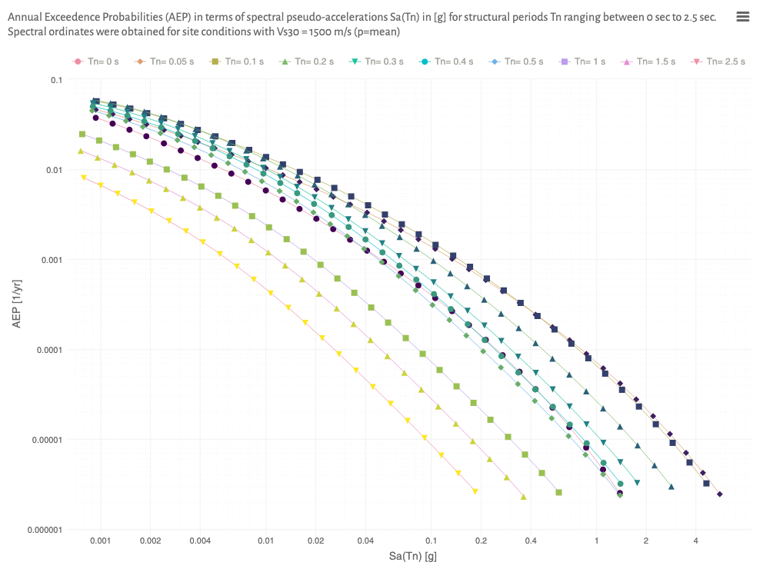

AEP for rocks ($v_{S}$=910 m/s)
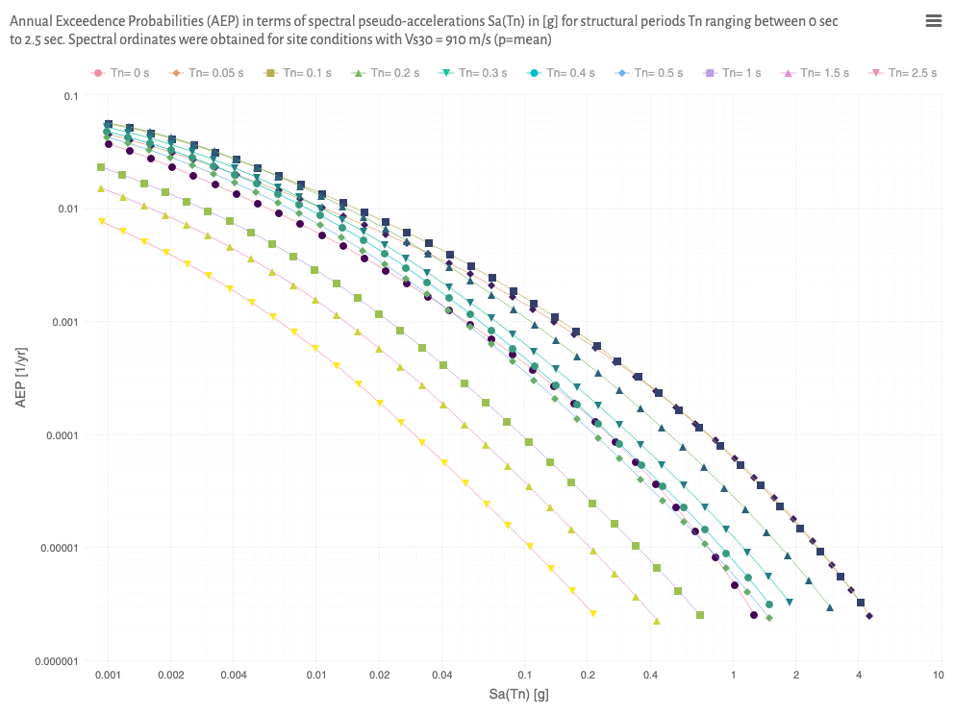

AEP for soft rocks ($v_{S}$=580 m/s)
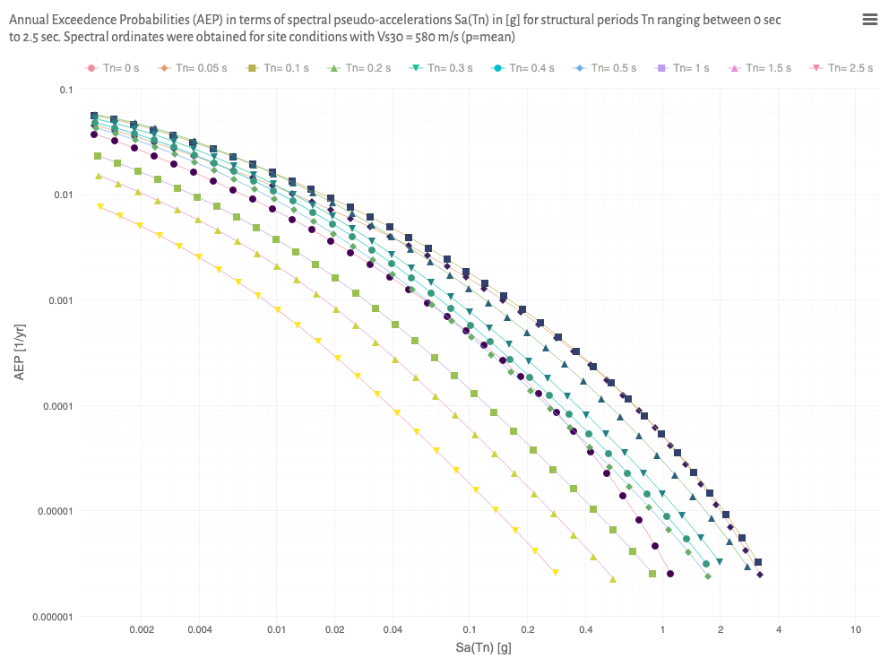

AEP for stiff soils ($v_{S}$=220 m/s)
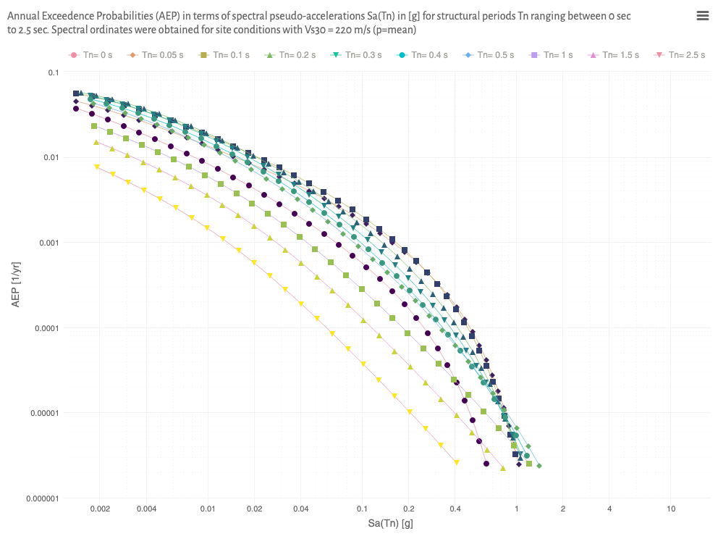

Uniform hazard spectra (UHS)

UHS for hard rocks ($v_{S}$=1500 m/s)
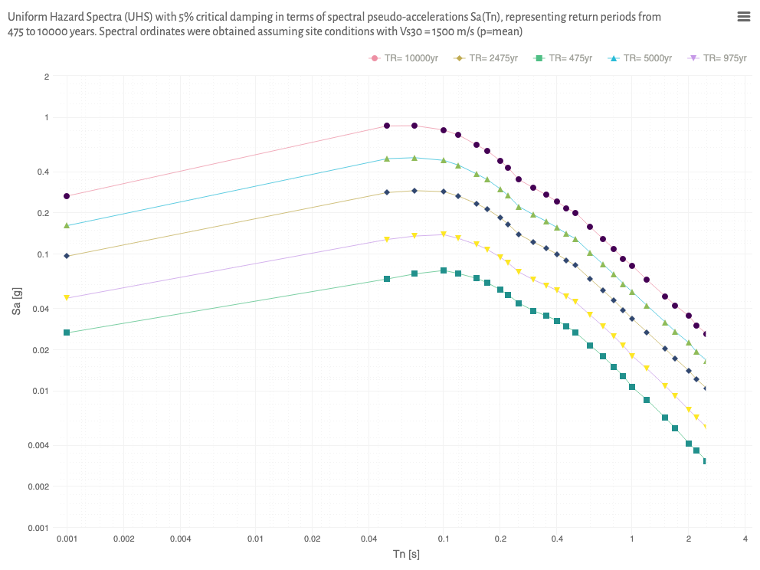

UHS for rocks ($v_{S}$=910 m/s) {
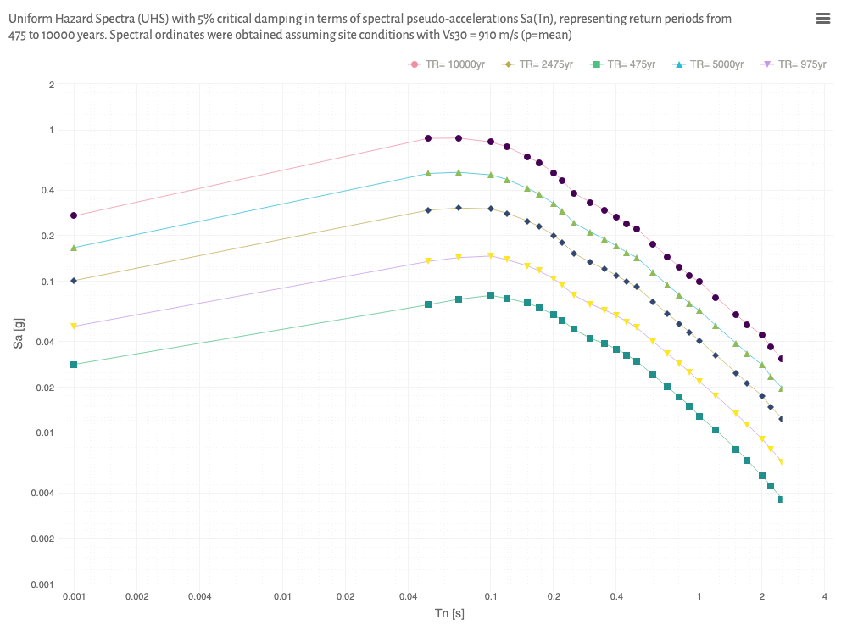

UHS for soft rocks ($v_{S}$=580 m/s)
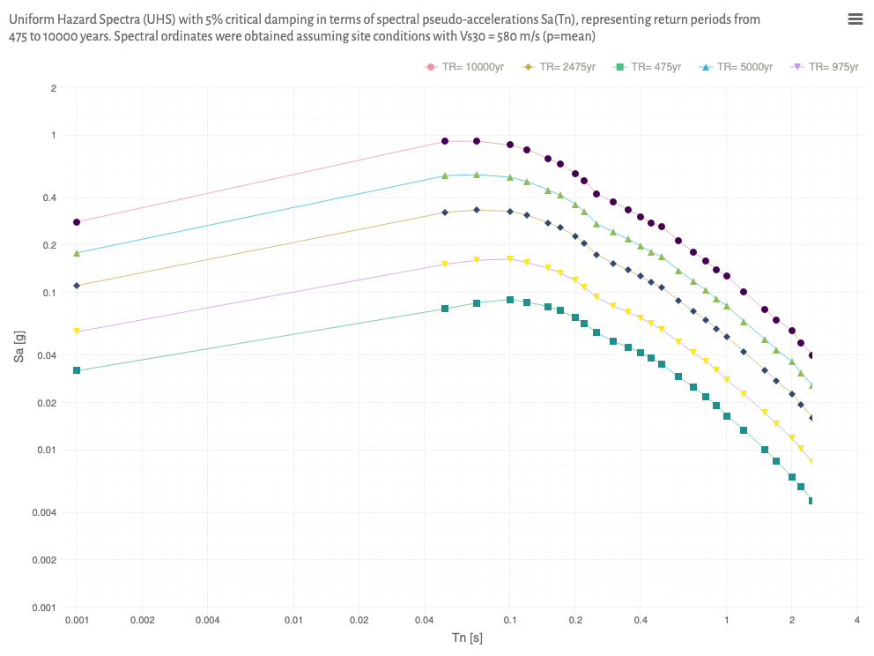

UHS for stiff soils ($v_{S}$=220 m/s)
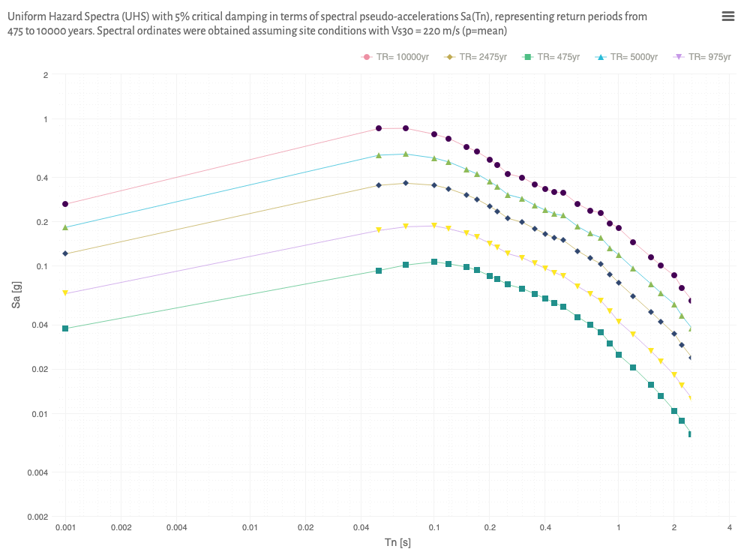

Design earthquakes

Peak-Ground Accelerations (PGA)
TR | poe[%] | p | 220 m/s | 580 m/s | 910 m/s | 1500 m/s
475 | 10.0 | mean | 0.0376 | 0.0316 | 0.0281 | 0.0264
975 | 5.0 | mean | 0.0648 | 0.0559 | 0.0501 | 0.0474
2,475 | 2.0 | mean | 0.1207 | 0.1099 | 0.1005 | 0.0960
5,000 | 1.0 | mean | 0.1828 | 0.1775 | 0.1661 | 0.1605
10,000 | 0.5 | mean | 0.2629 | 0.2787 | 0.2690 | 0.2645

Design Spectra
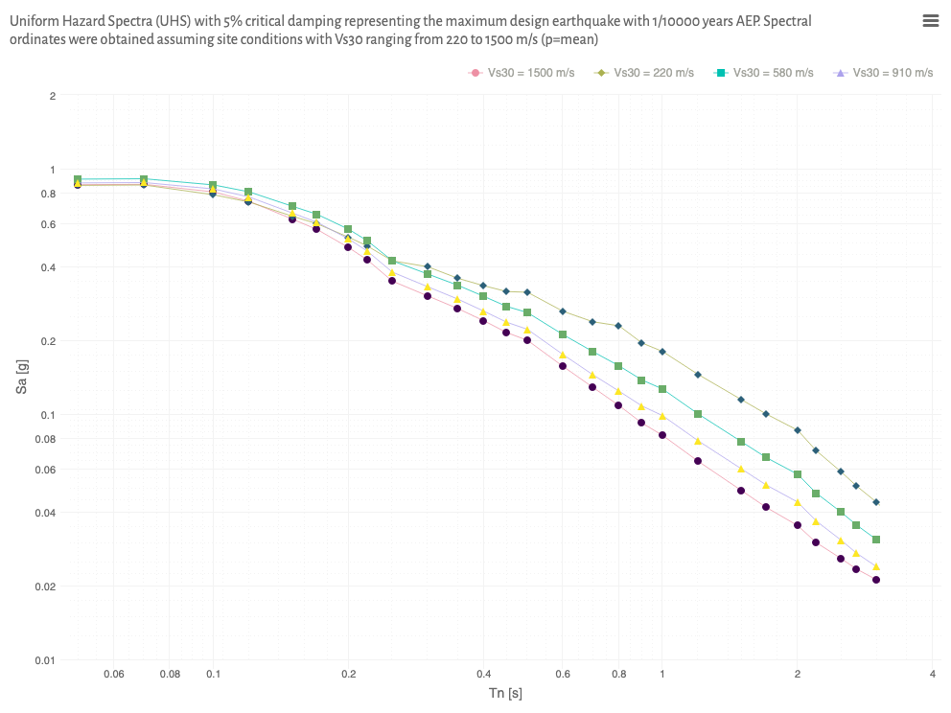

Slope’s fundamental periods
ID | USCS | level | b | s | Hs | Go | VSo | mo | lo | an | Ts
RI | GW GM ML | mean | 2,840 | 6.0 | 115 | 533.0 | 502.2 | 0.553 | 0.673 | 6.0648 | 0.328
SPW | GP GM ML SM | mean | 940 | 6.0 | 100 | 402.3 | 437.6 | 0.528 | 0.439 | 4.2159 | 0.463
SPE | GW GP GM SP | mean | 314 | 6.0 | 100 | 563.5 | 506.2 | 0.551 | 0.207 | 3.2615 | 0.525
RB | GW GP GM | mean | 20 | 2.0 | 50 | 483.8 | 463.7 | 0.565 | 0.091 | 3.0568 | 0.309
SSI | ML SM | mean | 470 | 3.5 | 50 | 168.7 | 293.3 | 0.486 | 0.573 | 4.9932 | 0.283
CI | CL ML SC SM | mean | 1,000 | 2.0 | 34 | 134.1 | 262.1 | 0.463 | 0.880 | 7.8007 | 0.136
TMF | GW GM ML | mean | 15 | 12.0 | 35 | 277.6 | 361.1 | 0.552 | 0.018 | 2.9903 | 0.281

Slope’s seismic coefficients

Hard rocks ($v_{S}$=1500 m/s)
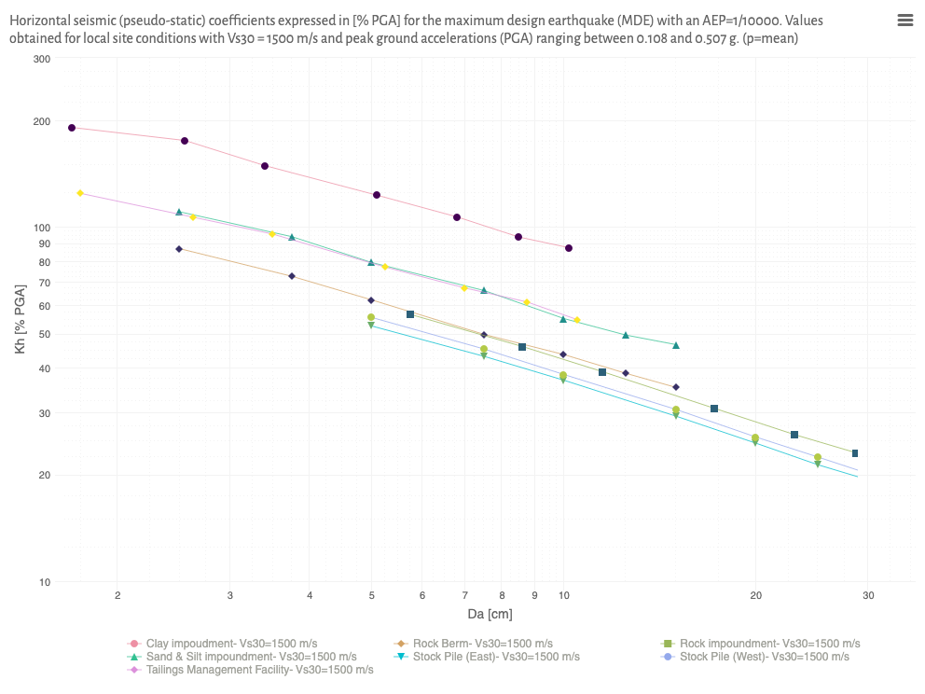

Rocks ($v_{S}$=910 m/s)
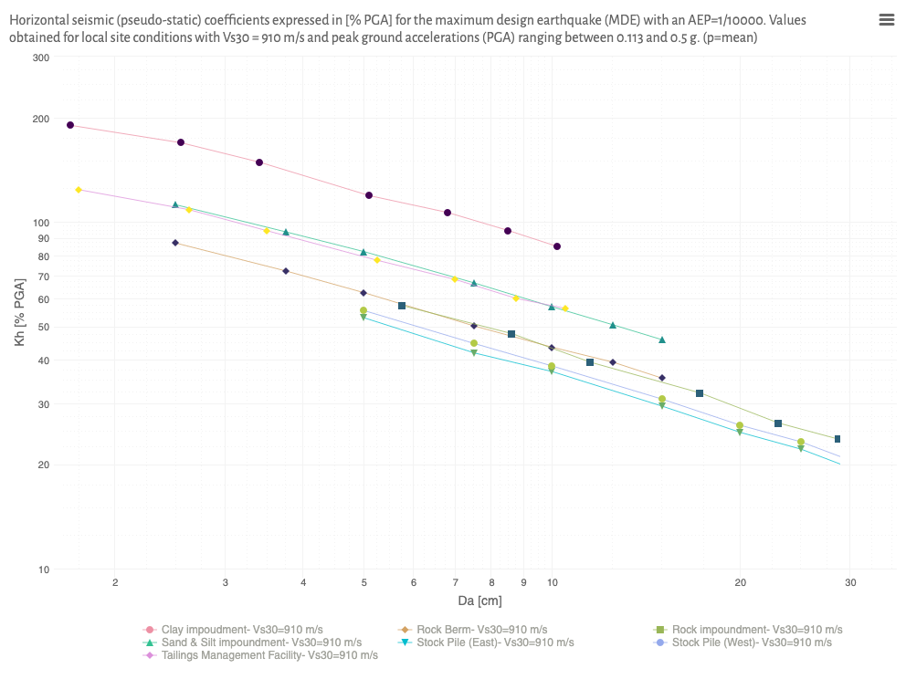

Soft rocks ($v_{S}$=580 m/s)
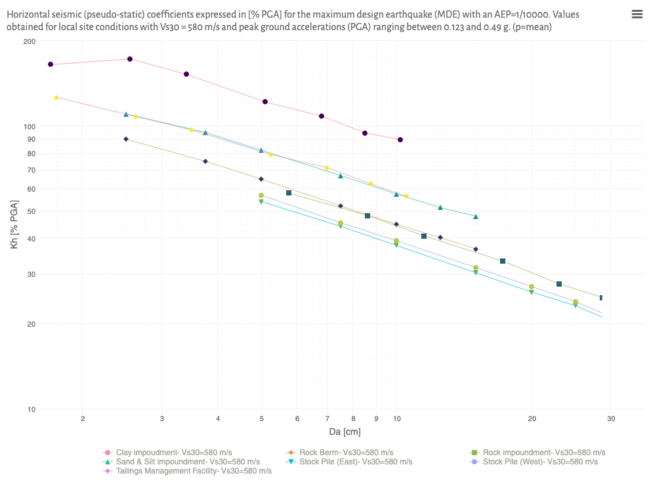

Stiff Soils rocks ($v_{S}$=220 m/s)
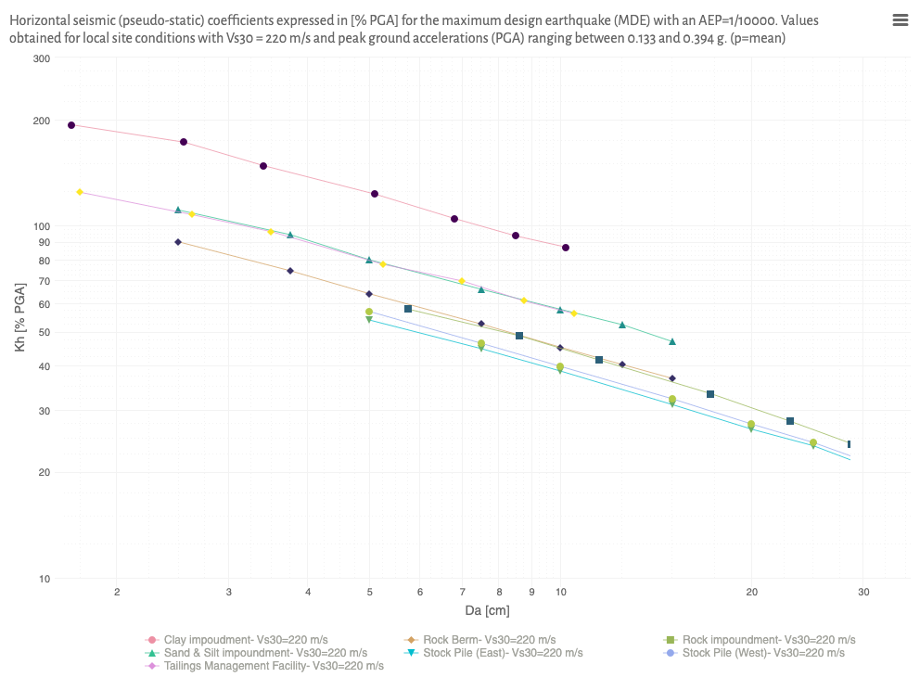

Summary
SRK Consulting (NA) was appointed by Canada Nickel Co (CN) to undertake a site-specific seismic hazard assessment (PSHA) at the Crawford Project in Location. Seismic design criteria and design guidance for the embankments are presented in terms of ground acceleration, spectral accelerations, and horizontal seismic coefficients for use in stability analysis. The following points summarise the most important results and findings of this study.
- Seismogenic sources and ground-motion prediction equations were based on the Global Earthquake Model (GEM) for Canada. The seismic hazard model was computed using the OpenQuake engine (Pagani et al. 2014).
- Spectral ordinates $S_{a}\left(T_{n}\right)$ and uniform hazard spectra (UHS) were computed for annual exceedance probabilities (AEP) ranging from of 1/100 to 1/10,00 years, assuming shear wave velocities ranging from 360 m/s to 800 m/s (see Section 1.3.3).
- Service levels for the TSF have been defined according to the failure’s consequences rating. The facility has been classified with grade Very High, according to GISTM (2020) and a target AEP of 1/10,000 yr has been adopted as the Maximum Design Earthquake MDE. Due to the low seismicity of the study area, an operational basis earthquake (OBE) has not been considered as a separate (dual) service level. Instead, the maximum design earthquake (MDE) has been adopted to address both safety and serviceability criteria across all project stages, including post-closure stages.
- The MDE is expected to produce a horizontal peak ground acceleration (PGA) ranging between 217 $cm/s^{2}$ and 455 $cm/s^{2}$ for 50% and 95% confidence levels, respectively. Spectral ordinates (design spectra) obtained for the maximum design earthquake under different site conditions are shown in Section 1.3.4.2.
- Fundamental periods has been obtained for upstream embankments and downsetream embankments of the TSF (Section 1.3.5). For the upstream embankments the fundamental periods are ranging between and - sec. For the downstream embankments, the fundamental period are ranging between and - sec.
- Seismic coefficients have been defined for the maximum design earthquake (Section 1.3.6), assuming a Newmark-based model. For the upstream embankments, the seismic coefficient ranges between $cm/s^{2}$ ( % PGA) and - $cm/s^{2}$ (- % PGA). For the downsetream embankment, the seismic coefficient ranges between $cm/s^{2}$ ( % PGA) and - $cm/s^{2}$ (- % PGA). Seismic coefficients for all embankments were calibrated to a single perfomance level corresponding to residual deformations below 0.3% of the slope height.
Alejandro Verri Kozlowski, PEng
Corporate Consultant (Geotechnical Earthquake Engineering)
SRK Consulting (AR)
Diana Reyes, MSc, PEng
Principal Consultant (Geotechnical Earthquake Engineering)
SRK Consulting (NA)

References
Ambraseys, NaN. 1960. “On the Shear Response of a Two-Dimensional Truncated Wedge Subjected to an Arbitrary Disturbance.” Bulletin - Seismological Society of America 50 (1): 4556.
American Society of Civil Engineers. 2021. Minimum Design Loads and Associated Criteria for Buildings and Other Structures. 7th ed. Reston, VA: American Society of Civil Engineers. https://doi.org/10.1061/9780784415788.
Bazzurro, Paolo, and C. Allin Cornell. 1999. “Disaggregation of Seismic Hazard.” Bulletin of the Seismological Society of America 89 (2): 501520.
Bommer, J, and F Scherbaum. 2008. “The Use and Misuse of Logic Trees in Probabilistic Seismic Hazard Analysis.” Earthquake Spectra 24 (4): 9971009.
Bray, J. D., J. Macedo, and T. Travasarou. 2018. “Simplified Procedure for Estimating Seismic Slope Displacements for Subduction Zone Earthquakes.” Journal of Geotechnical and Geoenvironmental Engineering 144 (3).
Cornell, Carl Allin. 1968. “Engineering Seismic Risk Analysis.” Bulletin of the Seismological Society of America 58 (5): 15831606. http://bssa.geoscienceworld.org/cgi/content/abstract/58/5/1583%5Cnhttp://bssaonline.org/cgi/content/abstract/58/5/1583.
Dakoulas, Panos, and George Gazetas. 1985. “A Class of Inhomogeneous Shear Models for Seismic Response of Dams and Embankments.” International Journal of Soil Dynamics and Earthquake Engineering 4 (4): 166182. https://doi.org/10.1016/0261-7277(85)90037-3.
———. 1986. “Seismic Shear Vibration of Embankment Dams in Semi-Cylindrical Valleys.” Earthquake Engineering & Structural Dynamics 14 (1): 1940. https://doi.org/10.1002/eqe.4290140103.
Guidelines on the Consequence Categories for Dams. 2012. ANCOLD.
Gutenberg, B., and C. F Richter. 1944. “Frequency of Earthquakes in California. Bulletin of the Seismological Society of America.” Seismological Society of America 34: 185188.
International Council on Miing & Metals (ICMM). 2020. GISTM Global Industry Standard on Tailings Management. International Council on Miing & Metals (ICMM).
Ishihara, Kenji. 1997. Soil Behaviour in Earthquake Geotechnics. Vol. 34.
Kramer, Steven. 1997. Geotechnical Earthquake Engineering.
McGuire, R. K. 1993. “Computations of Seismic Hazard.” Annals of Geophysics XXXVI (3-4).
Pagani, Marco, J Garcia-Pelaez, Robin Gee, K Johnson, Valerio Poggi, R Styron, Graeme Weatherill, et al. 2018. “GEM Global Mosaic of Hazard Models.” https://hazard.openquake.org/gem/models/.
Pagani, Marco, Damiano Monelli, Graeme Weatherill, Laurentiu Danciu, Helen Crowley, V. Silva, P. Henshaw, et al. 2014. “OpenQuake Engine: An Open Hazard (and Risk) Software for the Global Earthquake Model.” Seismological Research Letters 85 (3): 692702.
Seed, H B, and I M Idriss. 1982. “Ground Motions and Soil Liquefaction During Earthquakes.” Oakland, CA.
Stewart, J. P., G. A. Parker, J. A. Harmon, G. M. Atkinson, D. M. Boore, R. B. Darragh, and Y. M. Hashash. 2017. “Expert Panel Recommendations for Ergodic Site Amplification in Central and Eastern North America.”
Stewart, Jonathan, John Douglas, Mohammad Javanbarg, Carola Di Alessandro, Yousef Bozorgnia, N A Abrahamson, David M Boore, et al. 2013. “GEM-PEER Task 3 Project: Selection of a Global Set of Ground Motion Prediction Equations.”
Technical Bulletin - Seismic Hazard Considerations for Dam Safety. 2007. Canadian Dam Association.
Verri Kozlowski, Alejandro. 2017. “Ground-Motion Intensity Measures Based on Peak-Ground Accelerations PGA (SRK Internal Report).”
———. 2023. “IV Seminario de Vinculación y Transferencia (SeVyT).” In. Facultad de Ingeniería FIUBA, Buenos Aires, Argentina. https://sevyt23.srk.ar/article.pdf.
Wair, B. R., J. T. DeJong, and T. Shantz. 2012. “Guidelines for Estimation of Shear Wave Velocity Profiles.”

Appendices

Target AEP and Risk Categories

GISTM
Table 1: Annual Exceedance Probability (AEP) and Risk Categories according to the Global Industry Standard on Tailings Management (GISTM)
Category | OBE | MDE
Low | 1:200 | 1:10,000
Significant | 1:1,000 | 1:10,000
High | 1:2,500 | 1:10,000
Very High | 1:5,000 | 1:10,000
Extreme | 1:10,000 | 1:10,000

ANCOLD
Table 2: Annual Exceedance Probability (AEP) and Risk Categories according to the Australian National Committee on Large Dams (ANCOLD)
Category | OBE | MDE
Low | 1:475 | 1:1,000
Significant | 1:475 | 1:1,000
High A | 1:475 - 1:1,000 | 1:2,000
High B | 1:475 - 1:1,000 | 1:5,000
High C | 1:475 - 1:1,000 | 1:10,000
Extreme | 1:475 - 1:1,000 | 1:10,000

CDA
Table 3: Annual Exceedance Probability (AEP) and Risk Categories according to Canadian Dam Association (CDA)
Category | OBE | MDE
Low | 1:100 | 1:1,000
Significant | 1:100 - 1:1,1000 | 1:2,475
High | 1:2,475 | 1:2,475 - 1:10,000
Very High | 1:2,475 - 1:10,000 | 1:10,000
Extreme | 1:10,000 | 1:10,000

Site Classification according to ASCE/SEI 7-22
The site classification systems for soils are used to categorise the geological and geotechnical properties of a site in order to assess its response to seismic activity. The site soil shall be classified in accordance with SCE/SEI 7-22 (2021) based on the average shear wave velocity parameter, ${\overset{‾}{v}}_{S}$, which is derived from the measured shear wave velocity profile from the ground surface to a depth of 30 m. The average shear wave velocity ${\overset{‾}{v}}_{S}$ is used to characterize the foundation and account for seismic site conditions. N-values from Standard Penetration Test (SPT) or Cone Penetration Test (CPT) can be used to estimate shear wave velocities of the foundation materials. Profiles containing distinct soil and rock layers shall be subdivided into those layers designated by a number that ranges from $1$ to $n$ at the bottom, where there is a total of $n$ distinct layers in the 30 m. The symbol $i$ refers to any one of the layers between $1$ and $n$. The average shear wave velocity, ${\overset{‾}{v}}_{S}$, shall be determined according to the following formula:
$${\overset{‾}{v}}_{S}=\frac{30 m}{\sum_{j=1}^{n}{\frac{d_{j}}{v_{S_{j}}}}}$$
where $d_{i},d_{j}$ is the thickness of any layer between 0 and 30 m, $v_{S_{j}}$ is the shear-wave velocity in $m/s$ and $\sum_{i=1}^{n}{d_{i}}=30 m$ is the profile depth.
The ASCE/SEI 7-22 Standard {American Society of Civil Engineers (2021)} provides guidelines for conducting geotechnical investigations and includes a site classification system that categorises sites into classes based on their soil properties, such as shear wave velocity, depth to bedrock, and soil type. According to ASCE 7-22 (2021), the site soil shall be classified based on the average shear wave velocity parameter, $v_{S}$, which is derived from the measured shear wave velocity profile from the ground surface to a depth of 30 m.
- Site Class F: Where any of the following conditions is satisfied, the site shall be classified as Site Class F and a full site response analysis, in accordance with ASCE/SEI 7-22 (2021) Section 21.1, shall be performed:
  - Soil profile that includes soils vulnerable to potential failure or collapse under seismic loading, such as liquefiable soils, quick and highly sensitive clays, and collapsible weakly cemented soils.
  - Soil profile includes peats and/or highly organic clays ($H>3 m$) where $H_{s}$ = thickness of soil.
  - Soil profile includes very high plasticity clays ($H>8 m$) with PI > 75 in a soil profile that would otherwise be classified as Site Class CD, D, DE, or E.
  - Soil profile includes very thick soft/medium stiff clays ($H>37 m$) with su < 50 kPa.
- Site Class E (Soft Clay): Where a site does not qualify under the criteria for Site Class F and there is a total thickness of soft clay greater than $3 m$, where a soft clay layer is defined by $s_{u}<25 kPa$ , $ω≥40\%$, and $PI>20$, it shall be classified as Site Class E. This classification is made regardless of $v_{S}$
- Site Class C,C,D,DE and E: The assignment of Site Class C, CD, D, DE, and E soils shall be made based on the average shear wave velocity, $v_{S}$, which is derived from the site shear wave velocity profile from the ground surface to a depth of 30 m
- Site Class B and BC (Medium Hard and Soft Rock): Site Class B can only be assigned to a site on the basis of shear wave velocity measured on site. If shear wave velocity data are not available and the site condition is estimated by a geotechnical engineer, engineering geologist, or seismologist as Site Class B or BC on the basis of site geology, consisting of competent rock with moderate fracturing and weathering, the site shall be classified as Site Class BC. Softer and more highly fractured and weathered rock shall either be measured on site for shear wave velocity or classified as Site Class C.
- Site Class A (Hard Rock): The hard rock, Site Class A, category shall be supported by shear wave velocity measurement, either on site or on profiles of the same rock type in the same formation with an equal or greater degree of weathering and fracturing.
Where measured shear-wave velocity data are not available, shear wave velocity shall be estimated as a function of depth using correlations with suitable geotechnical parameters, including standard penetration test (SPT) blow counts, shear strength, overburden pressure, void ratio, or cone penetration test (CPT) tip resistance, measured at the site. Site class based on estimated values of ${\overset{‾}{v}}_{S}$ shall be derived using ${\overset{‾}{v}}_{S}$, $v_{S}/1.3$ and $1.3 v_{S}$ when correlation models are used to derive shear wave velocities.
Where the soil properties are not known in sufficient detail to determine the site class, the most critical site conditions of Site Class C, Site Class CD and Site Class D, as defined before, shall be used unless the Authority Having Jurisdiction or geotechnical data determine that Site Class DE, E, or F soils are present at the site.
SC | Description | Vs30 (m/s) | Vs30 (ft/s)
A | Hard rock | >1500 | >5000
B | Medium hard rock | >910-1500 | >3000-5000
BC | Soft rock | >640-910 | >2100-3000
C | Very dense soil or hard clay | >440-640 | >1450-2100
CD | Dense sand of very stiff clay | >300-440 | >1000-1450
D | Medium dense sand or stiff clay | >210-300 | >700-1000
DE | Loose sand or medium stiff clay | >150-210 | >500-700
E | Very loose sand or soft clay | >=150 | >=500
F | Soils requiring site response analysis (ASCE/SEI 7-22 21.1) | *See section 20.2.1 | *See section 20.2.1

Shear stiffness parameters for gravels, sands and fines
The following table from Ishihara (1997) reports the model parameters of the shear stiffness estimation model together with the range of void ratios in which the correlations were calibrated.
Material | Author | A | Ce | n | emin | emax
Round-grain Ottawa sand | Hardin & Richart (1963) | 7.00 | 2.174 | 0.50 | 0.30 | 0.8
Angular-grain crushed sand | Hardin & Richart (1963) | 3.27 | 2.973 | 0.50 | 0.60 | 1.3
Several sands | Shibata-Soelarno (1975) | 42.00 | 0.670 | 0.50 | 0.60 | 0.9
Several sands | Iwasaki et al.(1978) | 9.00 | 2.174 | 0.38 | 0.60 | 0.9
Toyoura sand | Kokusho (1980) | 8.40 | 2.173 | 0.50 | 0.60 | 0.8
Several sands | Yu-Richart (1984) | 7.00 | 2.173 | 0.50 | 0.60 | 0.9
Ticino sands | Lo Presti et.al (1993) | 7.10 | 2.270 | 0.43 | 0.60 | 0.9
Several undisturbed NC Clays | Hardin & Black (1968) | 3.27 | 2.973 | 0.50 | 0.50 | 1.7
Reconstituted NC Kaoline | Marcuson & Wahls (1972) | 4.50 | 2.973 | 0.50 | 1.10 | 1.3
Reconstituted NC Bentonite | Marcuson & Wahls (1972) | 0.45 | 4.400 | 0.50 | 1.60 | 2.5
Clay remolded IP=0-50% | Zen-Umehara (1978) | 2.00 | 2.973 | 0.50 | 1.60 | 2.5
Clay remolded IP=0-50% | Zen-Umehara (1978) | 3.00 | 2.973 | 0.50 | 1.60 | 2.5
Clay remolded IP=0-50% | Zen-Umehara (1978) | 4.00 | 2.973 | 0.50 | 1.60 | 2.5
Undisturbed NC Clay | Kokusho et al.(1982) | 0.14 | 7.320 | 0.60 | 1.70 | 3.8
Balast | Prange (1981) | 7.23 | 2.970 | 0.38 | 0.25 | 0.7
Crushed Rock | Kokusho-Esashi (1981) | 13.00 | 2.170 | 0.55 | 0.25 | 0.7
Rounded Gravel | Kokusho-Esashi (1981) | 8.40 | 2.170 | 0.60 | 0.25 | 0.7
Gravel | Tanaka et al.(1987) | 3.08 | 2.170 | 0.60 | 0.25 | 0.7
Gravel | Goto et al.(1987) | 1.22 | 2.170 | 0.85 | 0.25 | 0.7
Gravel | Nishio et al.(1985) | 9.36 | 2.170 | 0.44 | 0.25 | 0.7

In regions of low seismicity, compliance with safety considerations (limit states) is generally sufficient to ensure serviceability conditions, due to the magnitude of the residual displacements associated with the maximum design earthquakes.
Because the spectral ordinates in rock are actually random variables, with conditional expectation $s_{a}\left(T_{n}\right)$ and variance $σ_{A}^{2}$, the error term from this model has been adapted to incorporate the seismic hazard’s uncertainty: $$Var\left[ε_{F}\right]≈σ_{F}^{2}+σ_{A}^{2}$$
Numerous correlations have been developed between SPT N values and ${\overset{‾}{v}}_{S}$ and are summarised in a report by the Wair, DeJong, and Shantz (2012)

