Inventive Resources Incorporated
UV-C Vessel
Propulsion Control System
User’s Manual

Author: Alexander Ng
Last modified: 4/1/20

Introduction:

This User’s manual is intended to instruct an operator in the assembly and normal usage of the Propulsion Control System mounted on the IRI UV-C treatment vessel. If you are planning on making changes to either hardware or software, consult the Developer’s manual instead.

The UV-C treatment vessel is rectangular in shape and is propelled by 8 motors – 2 on each side. There are three main modes: Headless, Arduino Manual, and Arduino GPS/Manual. Each mode has its own assembly direction.

Hardware Components:

This section provides documentation for each physical component in the Propulsion Control System. Note that not every component is user-serviceable and not every component is used in every mode.

Motor
Each of the 8 motors on the UV-C treatment vessel is identical and controlled via Sabertooth 2x60 motor drivers. The user should not make changes to the wiring between the motors and motor drivers.

Sabertooth 2x60 Motor Driver
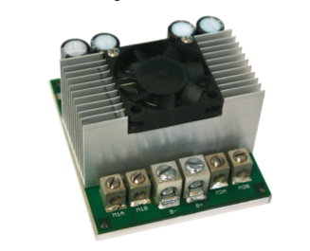
These motor drivers power and control the motors. Each motor driver controls a pair of motors, making for a total of 4 motor drivers. Motor and power leads are connected on one side (pictured) and signal leads and DIP switches are located on the opposite side. The user should not make changes to the wiring directly connected to the motor drivers.

The motor drivers are located in a cluster and are tied together and to the control inputs via 16-pin connector.

See the below link for a more detailed datasheet
http://www.dimensionengineering.com/datasheets/Sabertooth2x60.pdf

Analog 3-Axis Joystick
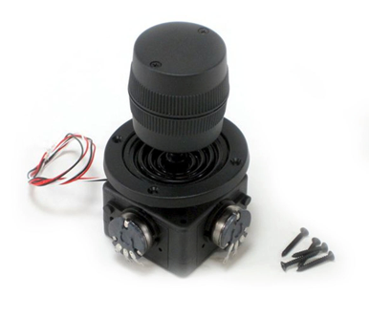
There are three axes of control on this joystick: X, Y, and Z (twist). In all modes, X controls lateral translation of the vessel, Y controls forward and reverse, and Z controls rotation. The user will not need to manually wire the joystick – a pre-assembled control box will be made to interface via 16-pin connector to the motor driver cluster.

Arduino Mega
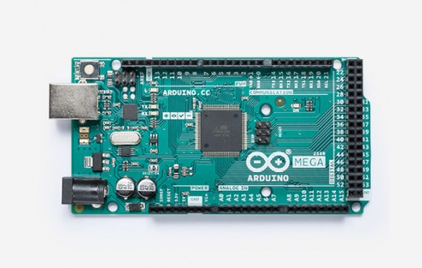
This board interfaces with control inputs (joystick and GPS) and motor drivers in Arduino Manual and Arduino GPS/Manual modes. Since these two modes are differently implemented, different wiring setups may be required. DETAILS TBD

Headless:

Headless mode utilizes the fewest electronic components and is intended as a fallback measure in the event that the Arduino board is non-functional. To configure the Propulsion Control System for Headless mode, first ensure that power is disconnected from all components. Attach the Headless Control Box via its 16-pin connector to the 16-pin connector on the motor driver cluster. On each of the 4 motor drivers, set the DIP switches to analog mode. Switches 1, 2, 3, 4, and 6 should be in the ON position. Switch 5 controls an optional exponential response mode and can be either ON or OFF (consult Sabertooth datasheet for more info).

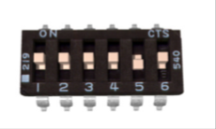
DIP switches set to analog mode with switch 5 set to exponential response

With the motor drivers configured to analog mode and the Headless Control Box attached, power can be turned on and the vessel is ready.

