MATH.py:

Here, is a list of all functions identified in math.py program and the test cases for the all the Functions:

Functions TestCases
def add(self, a: int, b: int):  '''calculates and returns a plus b'''  return a + b | def test_add_two_positive_numbers(self):  result = self._math.add(10, 20)  self.assertEqual(result, 30)
def multiply(self, a: int, b: int):  '''calculates and returns a multiplied by b'''  return a * b | def test_multiply_2_positive_Numbers(self):  self.assertEqual(self._math.multiply(2, 10), 20)
def divide(self, a: int, b: int):  ''' calculates a divided by b, raises ValueError on division by Zero'''  if b == 0:  raise ValueError  return a/b | def test_divide_no_error(self):  self.assertEqual(self._math.divide(10, 5), 2)  def test_division_by_zero(self):  with self.assertRaises(ValueError):  self._math.divide(10, 0)
def is_even(self, a: int):  return a // 2 == 0 | def test_even_is_given_number(self):  self.assertFalse(self._math.is_even
def power(self, a: int, b: int):  '''calculates a to the power of b'''  prod = 1  for i in range(abs(b)):  prod *= a  return prod | def test_power(self):  self.assertEqual(self._math.power(2, 3), 8
def is_prime(self, num: int):  '''finds out if num is a prime or not'''  if num < 0:  raise(ValueError())  if num == 0:  return False  if num <=3:  return True  for i in range(2, num):  if num % i == 0:  return False  return True | def test_prime_less_than_zero(self):  with self.assertRaises(ValueError):  self._math.is_prime(-2)  def test_prime_with_zero(self):  self.assertFalse(self._math.is_prime(0))  def test_prime_less_greater_3(self):  self.assertTrue(self._math.is_prime(71))  self.assertFalse(self._math.is_prime(70))  def test_prime_less_equal_than_3(self):  self.assertTrue(self._math.is_prime(2))
def factorial(self, n: int):  '''calculates n! = 1 * 2 * 3 * ... * n'''  prod = 1  for i in range(1, n+1):  prod *= i  return prod | def test_factorial(self):  self.assertEqual(self._math.factorial(5), 120)
def factors(self, number: int):  '''finds and returns list of factors for number'''  if number <= 0:  raise (ValueError())  if number == 1 or number == 2:  return list(range(1, number+1))  factors = [1, number]  for factor in range(3, number):  if number % factor == 0:  factors.append(factor)  return factors | def test_factors_less_than_zero(self):  with self.assertRaises(ValueError):  self._math.factors(-2)  def test_factors_with_1_2(self):  self.assertEqual(self._math.factors(2), [1, 2])  def test_factors_greater_than_3(self):  self.assertEqual(self._math.factors(5), [1, 5])

Python Unit Test Case Code for Math.py:

from unittest import TestCase
from App.math import Math

class TestMath(TestCase):
def setUp(self):
self._math = Math()

def test_add_two_positive_numbers(self):
result = self._math.add(10, 20)
self.assertEqual(result, 30)

def test_multiply_2_positive_Numbers(self):
self.assertEqual(self._math.multiply(2, 10), 20)

def test_divide_no_error(self):
self.assertEqual(self._math.divide(10, 5), 2)

def test_division_by_zero(self):
with self.assertRaises(ValueError):
self._math.divide(10, 0)

def test_even_is_given_number(self):
self.assertFalse(self._math.is_even(9))

def test_power(self):
self.assertEqual(self._math.power(2, 3), 8)

def test_prime_less_than_zero(self):
with self.assertRaises(ValueError):
self._math.is_prime(-2)

def test_prime_with_zero(self):
self.assertFalse(self._math.is_prime(0))

def test_prime_less_greater_3(self):
self.assertTrue(self._math.is_prime(71))
self.assertFalse(self._math.is_prime(70))

def test_factorial(self):
self.assertEqual(self._math.factorial(5), 120)

def test_factors_less_than_zero(self):
with self.assertRaises(ValueError):
self._math.factors(-2)

def test_factors_with_1_2(self):
self.assertEqual(self._math.factors(2), [1, 2])

def test_factors_greater_than_3(self):
self.assertEqual(self._math.factors(5), [1, 5])

def test_prime_less_equal_than_3(self):
self.assertTrue(self._math.is_prime(2))

Screenshot showing successful run of all unit tests:

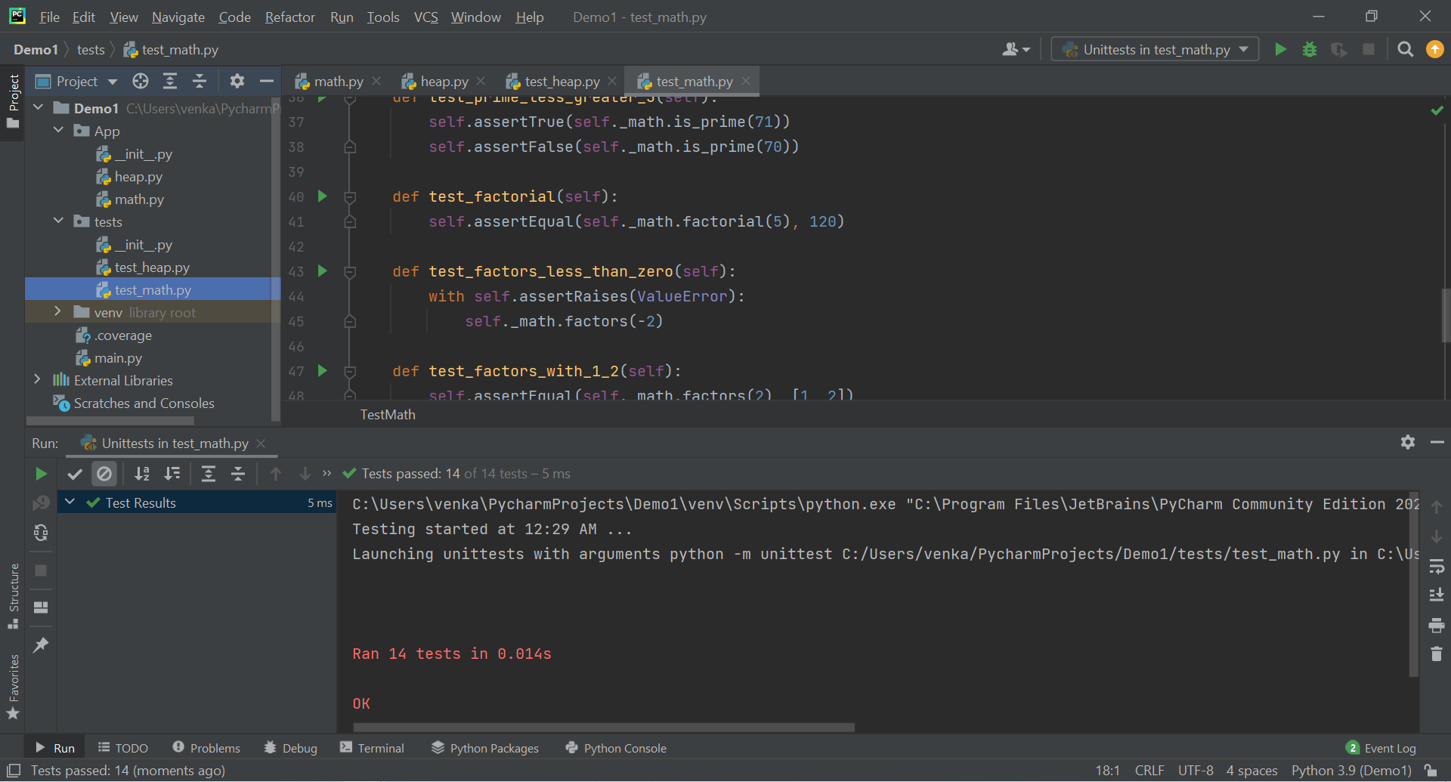

The report generated by the coverage tool:

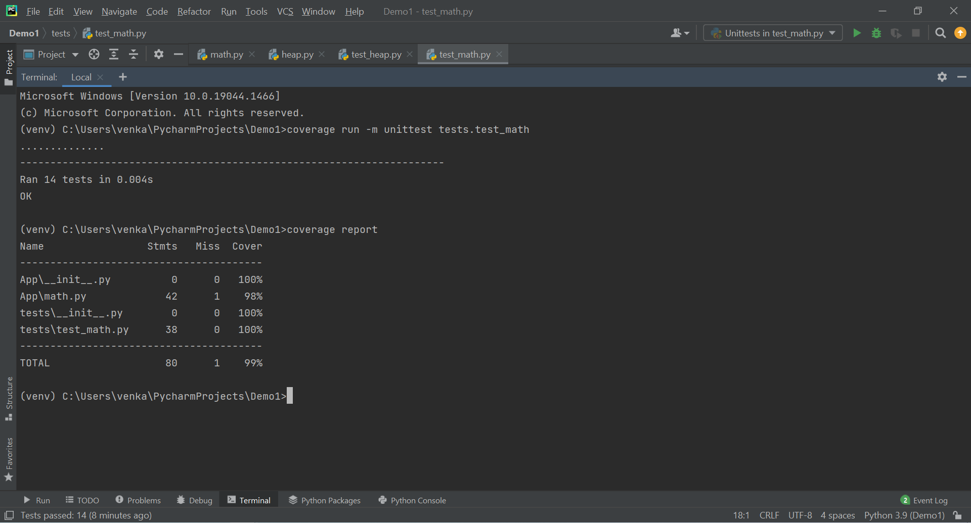

HEAP.py:
Functions | TestCases
def empty(self):  return len(self._heap) == 1  def add(self, key):  self._heap.append(key)  j = self._last_idx()  while j > 1 and self._heap[j] < self._heap[self._parent(j)]:  self._swap(j, self._parent(j))  j = self._parent(j) | def test_empty(self):  self.assertEqual(self._heap.empty(), True)  def test_heap_is_not_empty(self):  self._heap.add(10)  self.assertEqual(self._heap.empty(), False)
def remove_min(self):  if self.empty():  raise Exception()  self._swap(1, self._last_idx())  result = self._heap[-1]  self._heap.pop()  # push new element down the heap  j = 1  while True:  min = j  if self._has_left(j) and self._heap[self._left(j)] < self._heap[min]:  min = self._left(j)  if self._has_right(j) and self._heap[self._right(j)] < self._heap[min]:  min = self._right(j)  if min == j:  #found right location for min, break  break  self._swap(j, min)  j = min  return result | def test_remove_min(self):  self._heap.add(1)  self._heap.add(2)  self._heap.add(3)  self._heap.add(4)  self.assertEqual(self._heap.remove_min(), 1)  def test_remove_empty_heap(self):  with self.assertRaises(Exception):  self._heap.remove_min()

Python Unit test code for Heap.py:

from unittest import TestCase
from App.heap import Heap

class TestHeap(TestCase):
def setUp(self):
self._heap = Heap()

def test_empty(self):
self.assertEqual(self._heap.empty(), True)

def test_heap_is_not_empty(self):
self._heap.add(10)
self.assertEqual(self._heap.empty(), False)

def test_remove_min(self):
self._heap.add(1)
self._heap.add(2)
self._heap.add(3)
self._heap.add(4)

self.assertEqual(self._heap.remove_min(), 1)

def test_remove_empty_heap(self):
with self.assertRaises(Exception):
self._heap.remove_min()

Screenshot showing successful run of all unit tests:

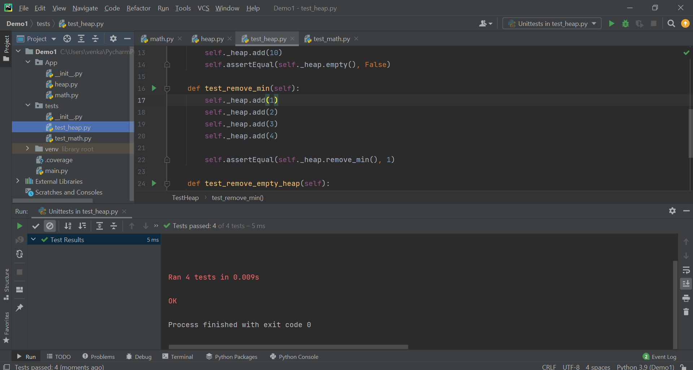

The report generated by the coverage tool:

