WordPress Kubernetes Demo

This section will guide you to:

* Clone repo from Git and then build docker image using Dockerfile

This lab has 4 sub-sections, namely:

* + 1. Create Jenkins job to prepare CI CD workflow

In order to work with Demo we need docker and git installed on Ubuntu instance.

Step 3.2.1: Create Jenkins job to prepare CI CD workflow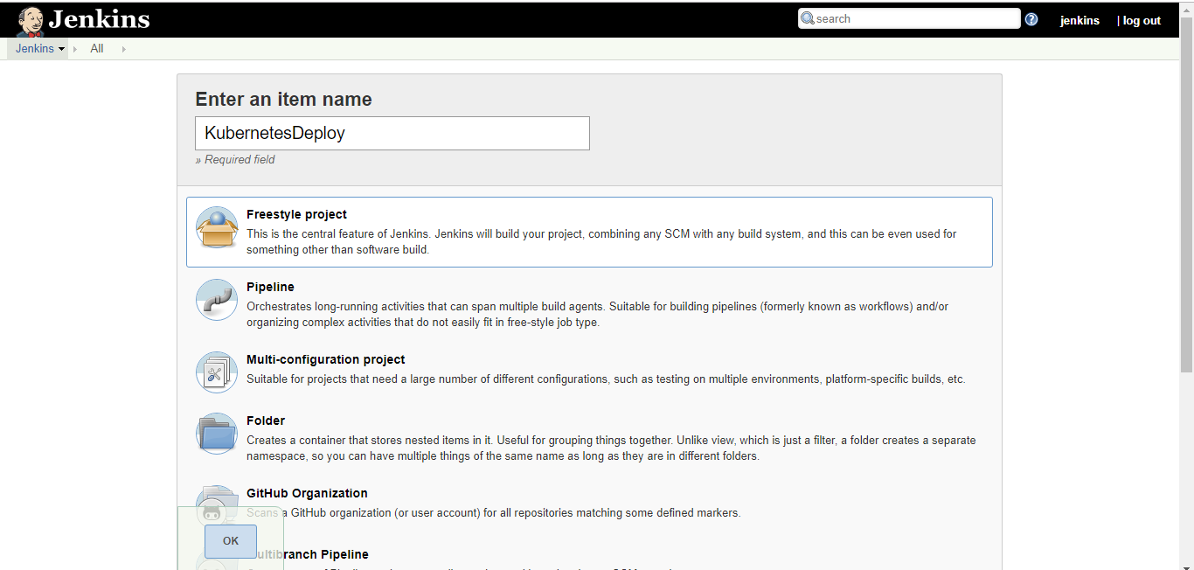

Once Job created please provide Git Repo and Build details in Jenkins CI CD job as below:

<https://github.com/anujdevopslearn/WordpressDocker.git>

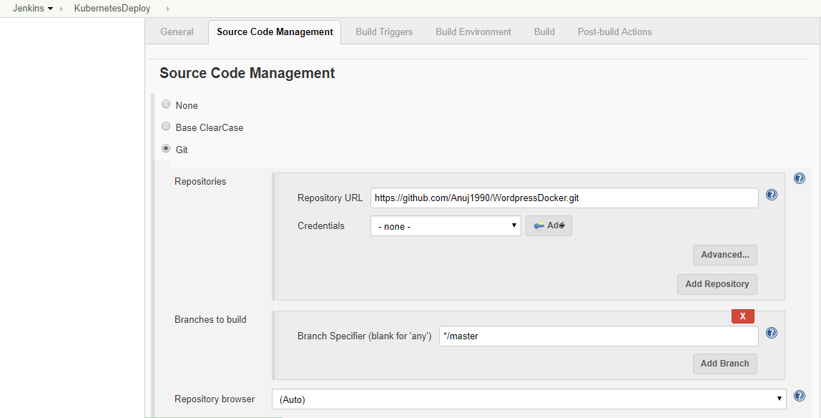

Host dockerapp docker image to Kubernetes using below command:

docker build –t wordpress .

kubectl run wordpress --image=wordpress:latest --port=80 --image-pull-policy=Never

kubectl expose deployment/ wordpress --port=80 --target-port=80 --type=NodePort

kubectl describe services wordpress | grep -i port

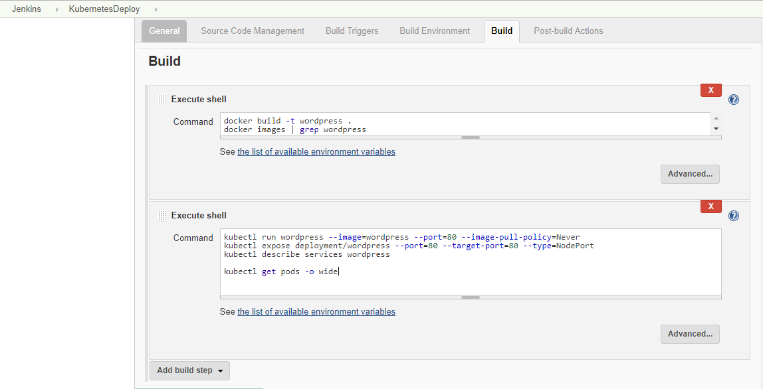

Once Job Details are mentioned please run the job using **Build Now** option as below:

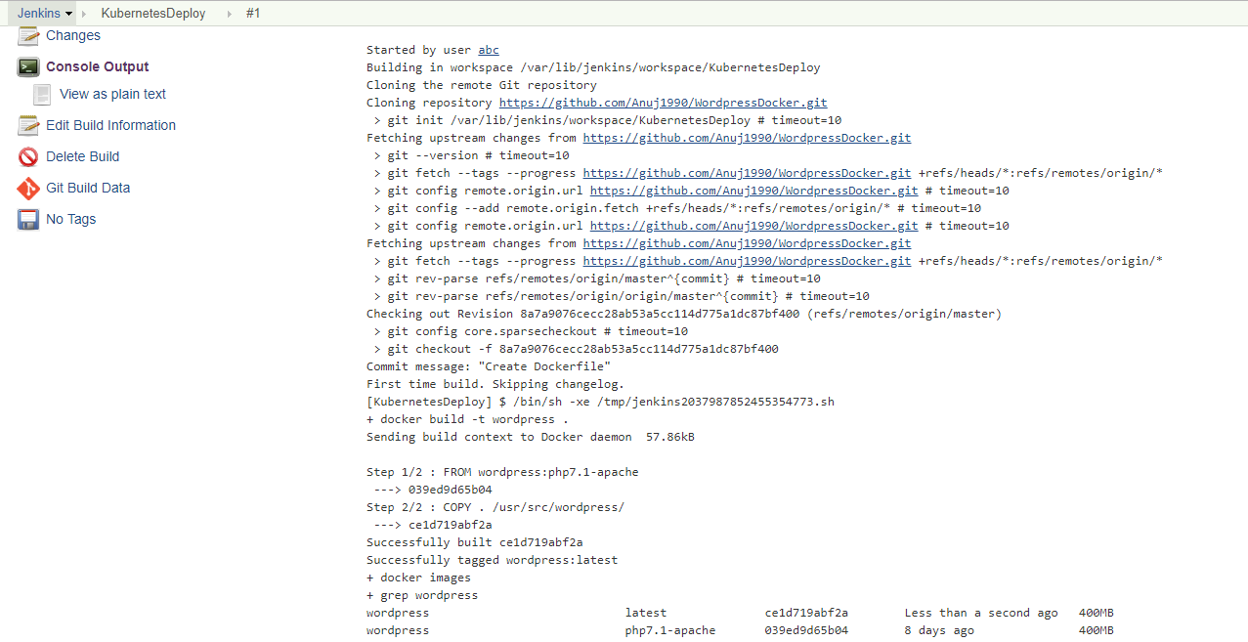

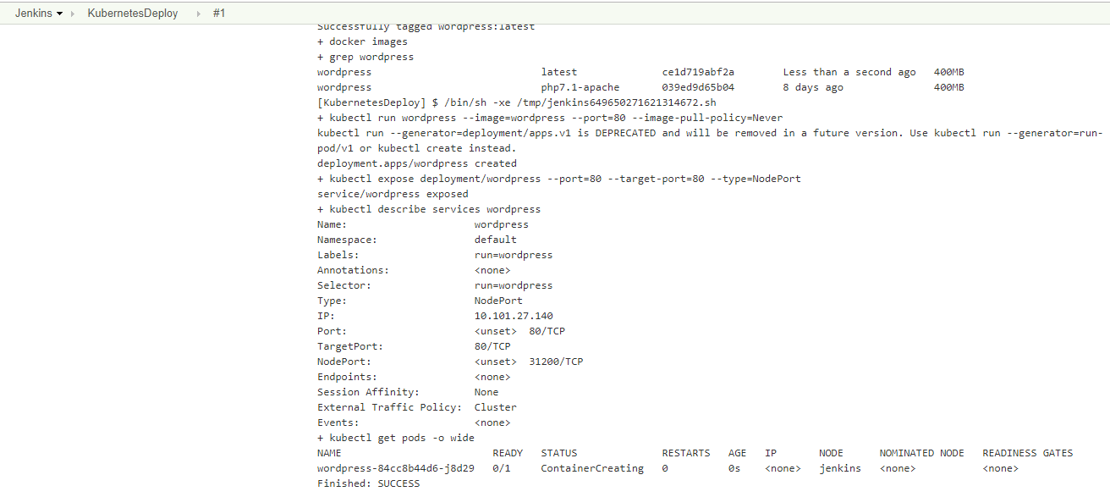

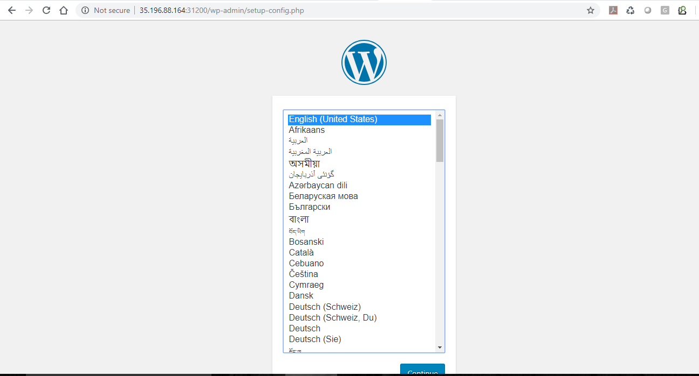

Once application is successfully rolled out we can access it using Web Browser easily.