**Displaying Output on OLED of ULTRASONIC sensor**

**Diagram**

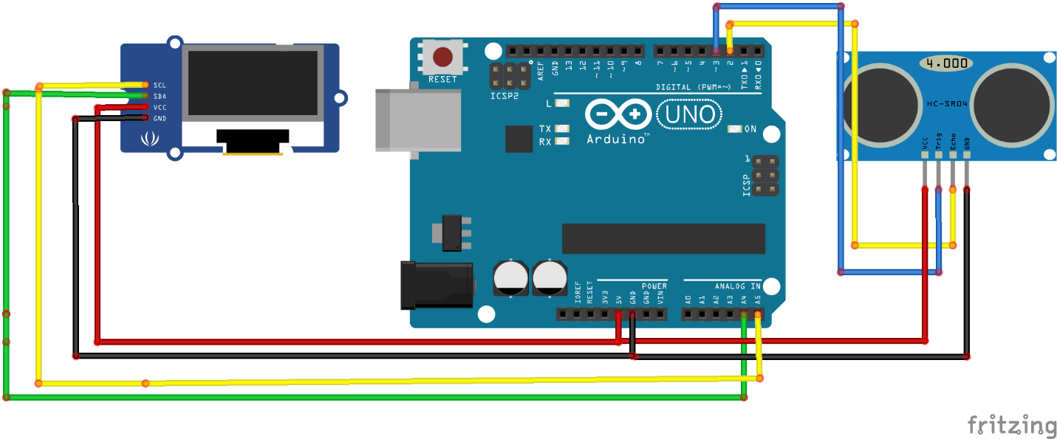

**Requirements:**

1 x HC-SR04 Ultrasonic Sensor

1 x OLED

Arduino UNO or MEGA

Jumper Wires

**Working**

We are required to display output on OLED of sensor HC-SR04. For that it is important to first implement circuit of OLED as shown above then run the following code just to display hello or any text

**OLED HEADER FILES:**

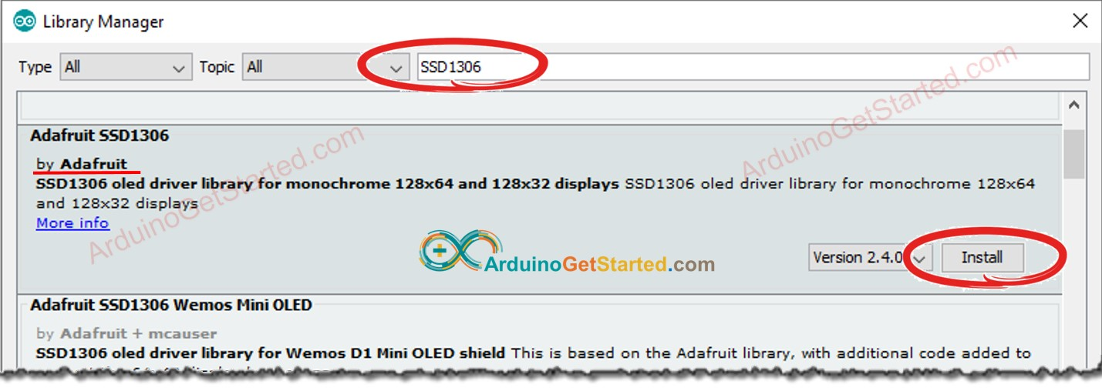

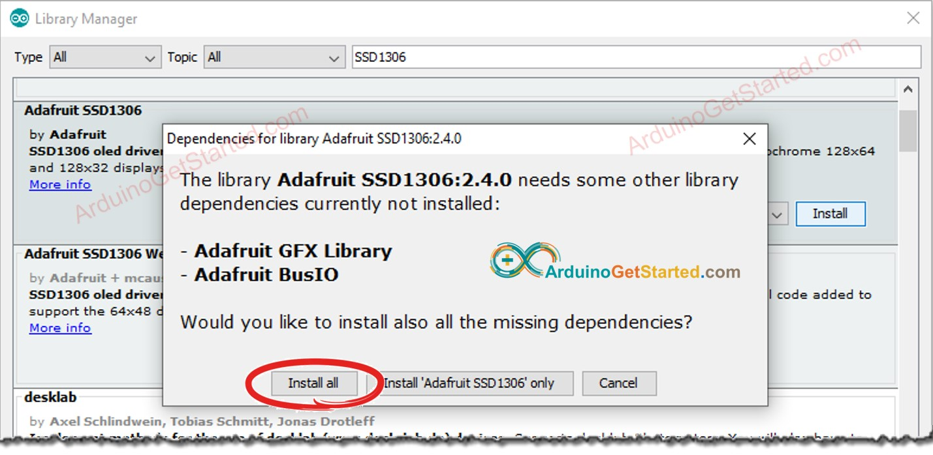

**OLED CODE**

#include <Wire.h>

#include <Adafruit_GFX.h>

#include <Adafruit_SSD1306.h>

#define SCREEN_WIDTH 128 // OLED display width, in pixels

#define SCREEN_HEIGHT 64 // OLED display height, in pixels

// declare an SSD1306 display object connected to I2C

Adafruit_SSD1306 oled(SCREEN_WIDTH, SCREEN_HEIGHT, &Wire, -1);

void setup() {

Serial.begin(9600);

// initialize OLED display with address 0x3C for 128x64

if (!oled.begin(SSD1306_SWITCHCAPVCC, 0x3C)) {

Serial.println(F("SSD1306 allocation failed"));

while (true);

} // show on OLED

}

void loop() {

oled.clearDisplay();

oled.setTextSize(2); // text size

oled.setTextColor(WHITE); // text color

oled.setCursor(0, 10); // position to display

oled.println("H"); // text to display

oled.display();

}

**HC-SR04 CODE**

// ---------------------------------------------------------------- //

// Arduino Ultrasoninc Sensor HC-SR04

// Re-writed by Arbi Abdul Jabbaar

// Using Arduino IDE 1.8.7

// Using HC-SR04 Module

// Tested on 17 September 2019

// ---------------------------------------------------------------- //

#define echoPin 2 // attach pin D2 Arduino to pin Echo of HC-SR04

#define trigPin 3 //attach pin D3 Arduino to pin Trig of HC-SR04

// defines variables

long duration; // variable for the duration of sound wave travel

int distance; // variable for the distance measurement

void setup() {

pinMode(trigPin, OUTPUT); // Sets the trigPin as an OUTPUT

pinMode(echoPin, INPUT); // Sets the echoPin as an INPUT

Serial.begin(9600); // // Serial Communication is starting with 9600 of baudrate speed

Serial.println("Ultrasonic Sensor HC-SR04 Test"); // print some text in Serial Monitor

Serial.println("with Arduino UNO R3");

}

void loop() {

// Clears the trigPin condition

digitalWrite(trigPin, LOW);

delayMicroseconds(2);

// Sets the trigPin HIGH (ACTIVE) for 10 microseconds

digitalWrite(trigPin, HIGH);

delayMicroseconds(10);

digitalWrite(trigPin, LOW);

// Reads the echoPin, returns the sound wave travel time in microseconds

duration = pulseIn(echoPin, HIGH);

// Calculating the distance

distance = duration * 0.034 / 2; // Speed of sound wave divided by 2 (go and back)

// Displays the distance on the Serial Monitor

Serial.print("Distance: ");

Serial.print(distance);

Serial.println(" cm");

}

**HC-SR04 with OLED CODE**

#include<Wire.h>

#include<Adafruit_GFX.h>

#include<Adafruit_SSD1306.h>

#define SCREEN_WIDTH 128

#define SCREEN_HEIGHT 64

Adafruit_SSD1306 oled(SCREEN_WIDTH, SCREEN_HEIGHT, &Wire, -1);

int const trigger_pin = 3;

int const echo_pin = 2;

long dur;

float dist;

void setup() {

// put your setup code here, to run once:

Serial.begin(115200);

if (!oled.begin(SSD1306_SWITCHCAPVCC, 0x3C)) {

Serial.println(F("SSD1306 allocation failed"));

while (true);

}

pinMode(trigger_pin,OUTPUT);

pinMode(echo_pin,INPUT);

}

void loop() {

oled.clearDisplay();

digitalWrite(trigger_pin,LOW);

delayMicroseconds(2);

digitalWrite(trigger_pin,HIGH);

delayMicroseconds(10);

digitalWrite(trigger_pin,LOW);

dur = pulseIn(echo_pin,HIGH);

dist = ((dur*0.034)/2);

oled.setTextSize(1.80);

oled.setTextColor(WHITE);

oled.setCursor(1,10);

Serial.print(dist);

oled.print("Distance= ");

oled.print(dist);

oled.display();

Serial.println(dist);

// put your main code here, to run repeatedly:

delay(1000);

}