**SPI Communication between Master and Slave**

**Image**

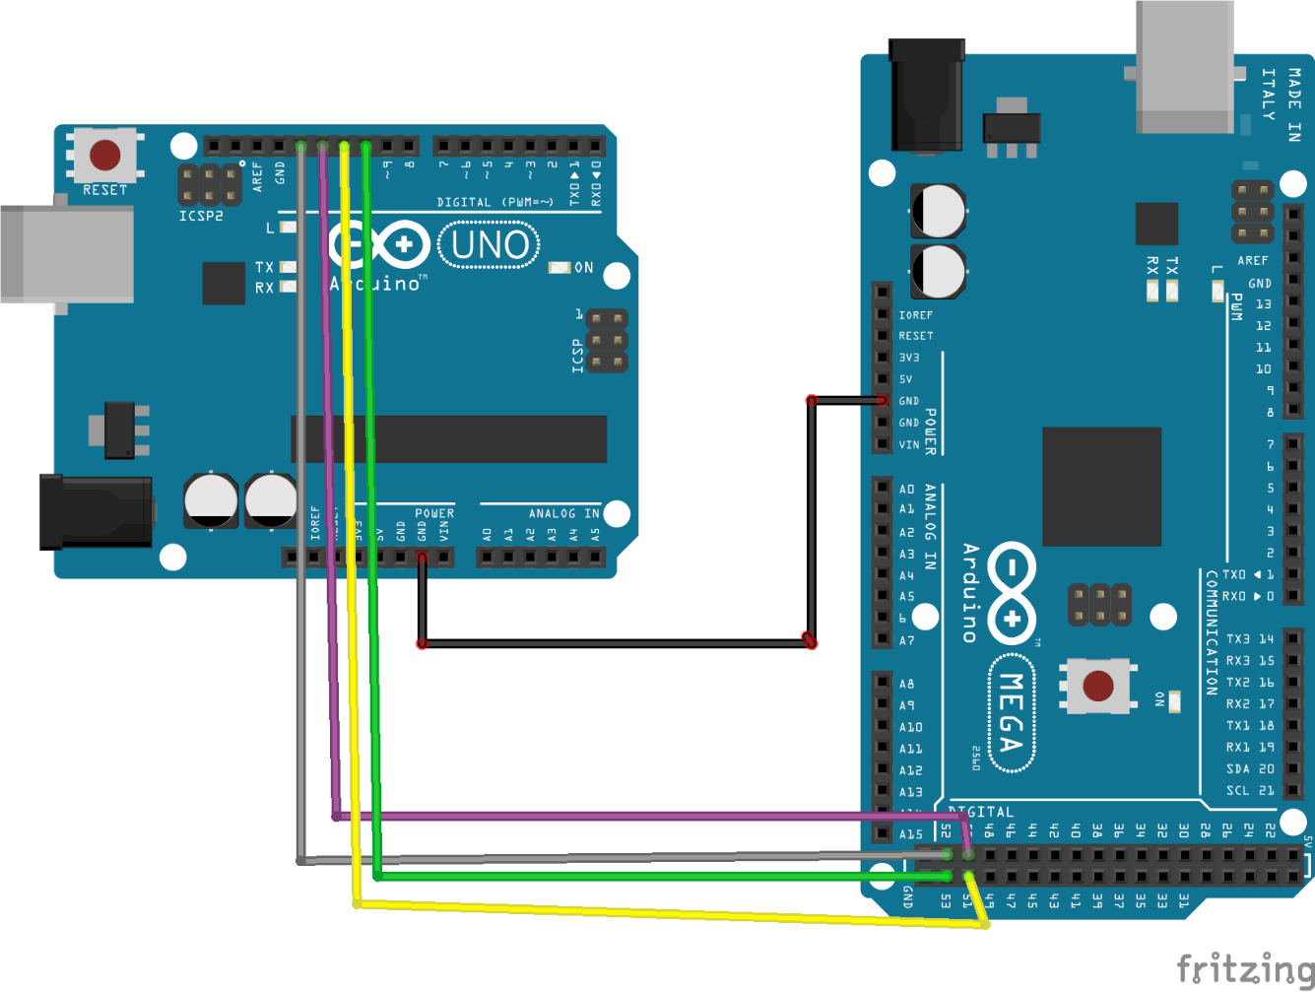

**Requirements:**

1. Arduino UNO
2. Arduino Mega or UNO
3. Jumper Wires

**Execution and Process**

Serial Peripheral Interface is one of communication protocols like I2C and UART. The major issue I faced was having limited knowledge of commands, functions and its actual working. Internet is not a good place to just solve the problem, learn the problem first then solve it.

Write down the algo on a paper

Code in last

Also this link was helpful since it explained with example and defining each and every working.

<https://arduino.stackexchange.com/questions/16348/how-do-you-use-spi-on-an-arduino>

Code uploaded is useful functioning with sending string from master to slave which is one way. But this is not very helpful. Unfortunately proper documentation is not available but with certain tries I was able to do it.

Website to look for help in similar context:

<https://arduino.stackexchange.com/questions/33086/how-do-i-send-a-string-from-an-arduino-slave-using-spi>

and

<https://arduino.stackexchange.com/questions/65315/send-strings-via-spi-both-ways-using-two-arduino-unosmaster-to-slave-slave-to>

Main issue was in code with string to char and SPDR to char. It is suggested to take byte and covert it in char. Before writing code or copy pasting from net try to write it on paper. Understand what you want to do write or label functions then write code.