MILESTONE-1 PPT CONTENT GUIDE
EEG-Based ADHD Detection Using a Multi-Model Deep Learning Framework
Detailed slide-wise content, explanation, visual guidance and speaker preparation

How to Use This Document
This document is a detailed preparation guide for the seven-slide Milestone-1 presentation. It is intentionally more detailed than the final PowerPoint so that the presenter can decide what to place on the slide and what to explain verbally. The wording follows the project's abstract and introduction and uses the three implemented model branches—CNN + Transformer, EEGNet, and PSD + XGBoost—together with the ensemble strategy. The final PPT should be visually clean; do not copy every sentence into the slide. Use the longer paragraphs here as speaker preparation and convert the most important sentences into concise slide text.

Slide 1 — Introduction
The project is titled “EEG-Based ADHD Detection Using a Multi-Model Deep Learning Framework.” The study investigates whether electroencephalography (EEG) recordings can be processed computationally to identify patterns that distinguish ADHD from control recordings. ADHD is a neurodevelopmental disorder associated with symptoms such as inattention, impulsivity and hyperactivity, and its assessment commonly involves clinical history, behavioural observations, rating scales and psychological evaluation. EEG provides a physiological signal with high temporal resolution, so it has been investigated as an additional source of information for computational analysis of ADHD.¹ Previous research has explored both frequency-domain EEG characteristics and deep-learning approaches for ADHD classification.²⁻⁵
The main contribution of this project is a multi-model framework rather than a single classifier. Three complementary branches are considered: CNN + Transformer, EEGNet, and PSD + XGBoost. The CNN + Transformer branch is designed to learn local signal patterns followed by longer-range relationships using self-attention. EEGNet provides a compact EEG-oriented architecture for temporal and spatial feature learning. The PSD + XGBoost branch represents EEG explicitly in the frequency domain and uses gradient-boosted decision trees for classification. Their probability outputs are combined through an ensemble layer to produce a final ADHD/Control prediction.²⁻⁷
For the PPT, show the project title, the ADHD/Control classification problem, EEG as the input, the three model names, and the ensemble as the final strategy. A simple visual showing “EEG → Three Models → Ensemble → ADHD/Control” is useful. Add small citation numbers such as (1), (2), (3), (5), (6) immediately after research-based statements. Keep the clinical limitation clear: this is a research and decision-support prototype, not a standalone diagnostic system.
What to use in the actual PPT: project title, team names, guide/institution details, one EEG-to-output workflow graphic, and small citation numbers next to literature-based statements.

Slide 2 — Understanding of the Base Paper
The base research direction demonstrates that EEG can be analysed with machine-learning and deep-learning methods to identify differences between ADHD and control groups. The important idea is that EEG contains temporal, spatial and spectral information that can be difficult to summarize manually, while computational methods can learn patterns from the recorded signal. Research using hybrid deep learning has shown the potential of combining local feature extraction with temporal modelling for ADHD EEG classification.² Transformer-based EEG work further motivates the use of attention mechanisms to model relationships between positions in a learned EEG representation.³ CNN-based work has also shown that spectral EEG representations can contain information useful for distinguishing adult ADHD from healthy individuals.⁴
The base-paper discussion should not be presented as if one paper implemented the exact architecture used in this project. Instead, explain that the selected research papers motivate different parts of the proposed framework. Chugh et al. support the hybrid deep-learning direction for ADHD EEG classification.² He et al. motivate EEG-Transformer-style attention.³ Dubreuil-Vall et al. support CNN-based EEG analysis for adult ADHD.⁴ Tenev et al. support the use of EEG power-spectrum information and machine learning for ADHD classification.⁵ Lawhern et al. provide the basis for EEGNet as a compact EEG-oriented architecture.⁶ Sarker et al. provide recent motivation for combining Transformer-style representations with XGBoost.⁷
For the PPT, use a short research-flow visual rather than copying a whole paper. You can show “Existing EEG research → CNN / Transformer / spectral features → proposed multi-model extension.” Mention that the project's novelty is the comparative and fusion framework that brings these complementary representations together. Do not claim that the ensemble is automatically better; its advantage must be demonstrated using the actual held-out evaluation results.
What to use in the actual PPT: a compact related-work diagram or three-column comparison showing hybrid deep learning, Transformer/attention, CNN/spectral EEG analysis, EEGNet, and Transformer-XGBoost motivation.

Slide 3 — Problem Definition
The problem addressed by the project is the development of a computational pipeline that can process multichannel EEG recordings and classify them into ADHD and Control categories. EEG is time-varying, multichannel and sensitive to noise, artifacts, differences between individuals and differences between recording sessions. These characteristics make it difficult to rely on a single representation or a single classifier. A model that performs strongly on randomly divided EEG windows may also give an overly optimistic estimate if windows from the same participant appear in both training and test sets. Therefore, subject-level separation and participant-level aggregation are important considerations for a reliable research evaluation.
The project asks whether complementary modelling strategies can capture different useful properties of EEG. CNN layers can learn local patterns in the signal representation. Transformer attention can model relationships between sequence elements. EEGNet can learn temporal and cross-channel spatial patterns with a compact EEG-specific architecture. PSD provides an explicit representation of frequency-domain power, while XGBoost can learn nonlinear decision boundaries from structured spectral features. The ensemble then combines the probability outputs of these different branches instead of depending entirely on one model.
The motivation can be explained simply in the presentation: “Different models see different aspects of the same EEG signal, so can their complementary predictions be combined into a more useful research classification system?” This should be presented as the project's research question, not as a claim that the ensemble will definitely outperform every individual model.
What to use in the actual PPT: one problem statement, one motivation sentence, and a small visual showing why different EEG characteristics require complementary representations.

Slide 4 — Scope of Project and Objectives
The project scope covers the complete research workflow from EEG input preparation to model inference, probability fusion and evaluation. The implemented pipeline is based on the project's EEG representation, including the 19-channel input configuration and 128 Hz sampling pipeline described in the research draft and project material. The preprocessing workflow includes input validation and channel consistency, resampling or standardization where required, 1–45 Hz preprocessing/filtering, and generation of windows suitable for the model branches. The prepared EEG information is then supplied to the three model branches, and their predictions are aggregated at participant level before the final decision.
The first objective is to implement a reliable EEG preprocessing pipeline for input validation, channel alignment, resampling, filtering and window generation. The second objective is to develop the CNN + Transformer branch so that convolution can learn local EEG patterns and self-attention can model longer-range relationships. The third objective is to incorporate EEGNet as a compact architecture for temporal and spatial learning from multichannel EEG. The fourth objective is to extract frequency-domain PSD features and use XGBoost to classify ADHD and Control recordings. The fifth objective is to combine the predictions from the three branches through probability-level ensemble fusion and obtain participant-level predictions. The sixth objective is to evaluate the framework using accuracy, balanced accuracy, precision, sensitivity, specificity, F1-score, F2-score, ROC-AUC and confusion matrices while maintaining subject-level separation.
For the PPT, present the scope as a continuous workflow rather than a long list. A good visual sequence is “Input EEG → preprocessing → three branches → ensemble → participant-level output → evaluation.” If your faculty expects objectives on this slide, use the six objectives in shortened form. Do not state that an objective has been completed unless the corresponding experiment has actually been run and verified.
What to use in the actual PPT: six short objective statements or a six-step objective flow, plus the project scope in one sentence. Keep the full explanations for your speech.

Slide 5 — Proposed Solution
The proposed solution is a three-branch EEG classification framework followed by probability-level ensemble fusion. The same prepared EEG information is processed through complementary model families. In the first branch, a one-dimensional convolution extracts local patterns from the multichannel sequence. The resulting learned representation is passed to a Transformer-style self-attention mechanism. The simplified convolution operation can be written as y[t,k] = σ(ΣᵢΣⱼ w[j,i,k]x[t+j,i] + b[k]), while the self-attention operation is Attention(Q,K,V) = softmax(QKᵀ/√dₖ)V. Here, Q, K and V are learned query, key and value representations, and dₖ is the key dimension. The purpose is to combine local feature extraction with modelling of relationships across the learned sequence.
The second branch uses EEGNet. EEGNet is compact and was designed for EEG/brain-computer-interface data. Conceptually, the processing can be represented as T = Conv_temporal(X), S = DepthwiseSpatial(T), and Z = SeparableConv(S). Temporal convolution captures useful temporal/frequency structure, depthwise spatial filtering learns relationships across EEG channels, and separable convolution refines the representation while keeping the architecture compact. EEGNet is included because it provides a different inductive bias from the CNN–Transformer branch and is computationally efficient.⁶
The third branch uses Power Spectral Density. PSD represents how signal power is distributed over frequency and therefore provides a frequency-domain view of EEG. The project considers delta (1–4 Hz), theta (4–8 Hz), alpha (8–13 Hz), beta (13–30 Hz) and gamma (30–45 Hz) bands. Relative band power can be expressed as RP_b = [∫_b Pxx(f)df] / [∫_1^45 Pxx(f)df], where Pxx(f) is the estimated PSD. The resulting spectral feature vector is provided to XGBoost. This branch complements the deep-learning branches because it uses explicit spectral descriptors rather than relying entirely on learned time-domain features.⁵⁷
For the PPT, show three clearly separated branches under the same preprocessing stage. Under each model name, write one short phrase describing its role: “local + long-range learning,” “compact EEG-specific learning,” and “frequency-domain learning.” Then show all three probabilities entering the ensemble.
What to use in the actual PPT: three model blocks with one purpose and one advantage under each block, plus only the most important formula for each branch.

Slide 6 — Basic Architecture Diagram and System Workflow
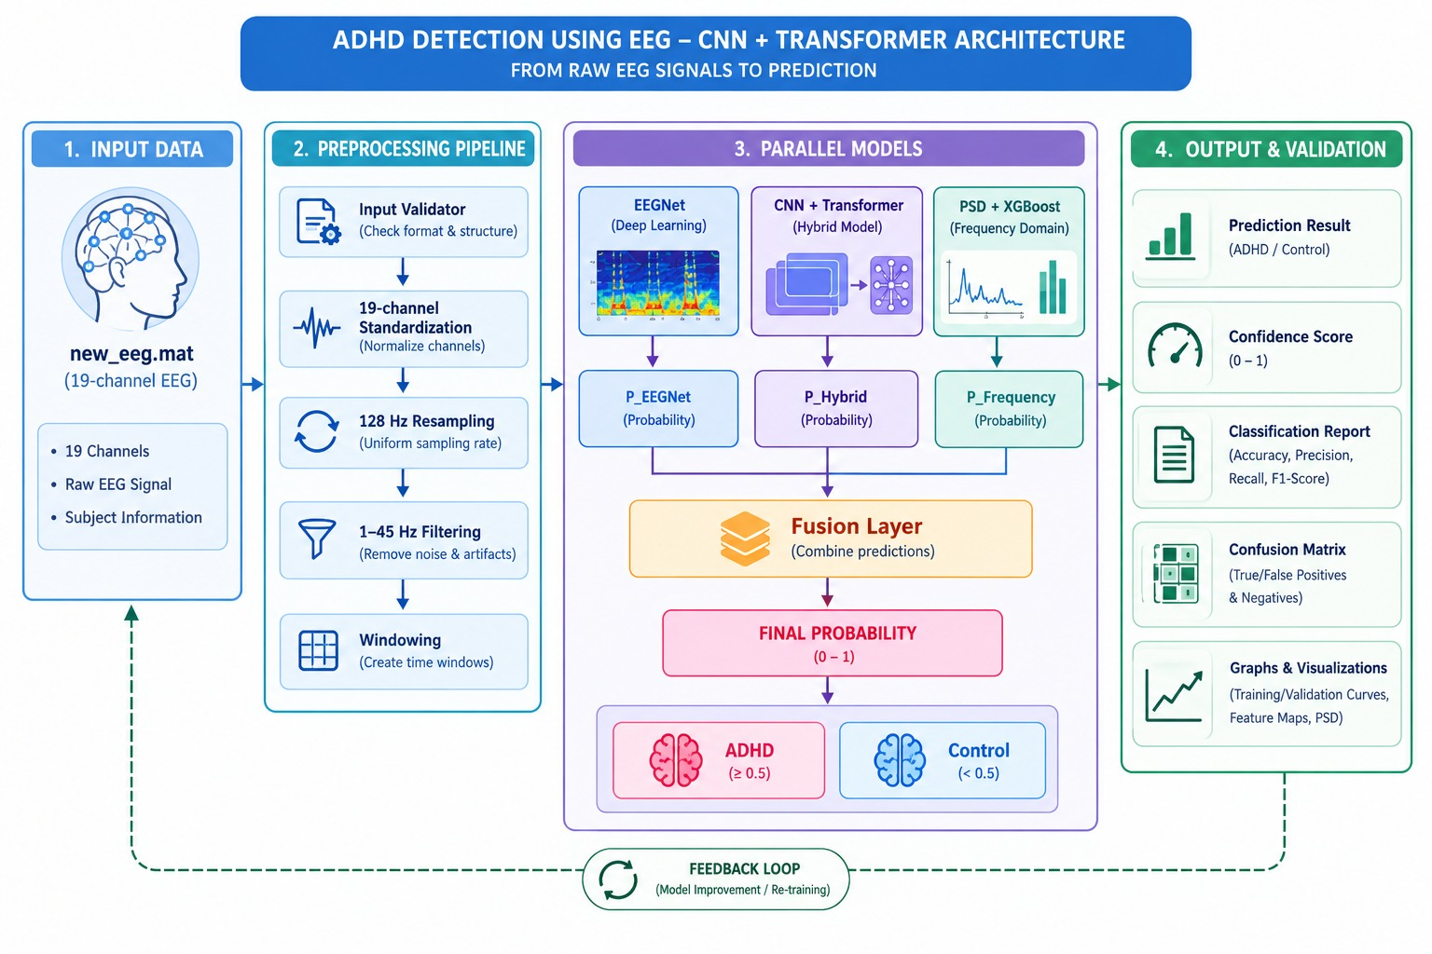
This slide should contain the architecture diagram supplied for the project, together with a short explanation of the workflow. The conceptual architecture begins with a 19-channel EEG recording. The input first passes through validation and channel alignment, followed by resampling to the project sampling configuration, preprocessing/filtering and window generation. The prepared EEG windows then enter three parallel branches.
The first branch is CNN feature extraction followed by Transformer self-attention. The second branch is EEGNet temporal and spatial feature learning. The third branch extracts PSD or band-power features and sends them to XGBoost. Each branch produces a probability associated with the ADHD class. The window-level probabilities can be aggregated for each participant. The ensemble probability is then computed as P_ensemble = w₁p̄_CNN+Transformer + w₂p̄_EEGNet + w₃p̄_PSD+XGBoost, where w₁ + w₂ + w₃ = 1. The final class is ADHD when P_ensemble ≥ τ and Control otherwise. The weights and threshold should be selected using validation participants rather than tuning the final test set.
For the PPT, use your actual architecture image as the main visual. Make sure the diagram clearly shows the common EEG preprocessing stage, the three independent branches, probability fusion, final ADHD/Control output, and evaluation. Under the diagram, add one sentence explaining that the ensemble combines complementary temporal, spatial and frequency-domain information. Do not overcrowd the diagram with all mathematical equations; place only the ensemble equation beside or below it if there is sufficient space.
What to use in the actual PPT: your supplied architecture diagram as the main figure. Label the three branches, ensemble/fusion, final prediction and evaluation. Keep the diagram readable from a distance.

Slide 7 — Closing
The project begins from the established research direction of analysing EEG for computational ADHD classification and extends it through a multi-model framework. The proposed system uses CNN + Transformer to learn local patterns and longer-range relationships, EEGNet to provide compact temporal and spatial EEG learning, and PSD + XGBoost to provide an explicit frequency-domain classification branch. Their predictions are combined through probability-level ensemble fusion, with participant-level aggregation used for the final decision. The evaluation framework considers multiple measures rather than relying on accuracy alone, because sensitivity, specificity, precision and F-score provide additional information about classification behaviour.
For the closing of the Milestone-1 video, briefly recap the research problem, the three branches and the ensemble. Then state what will be demonstrated in the next milestone: the finalized preprocessing and modelling pipeline, individual model predictions, the ensemble implementation, participant-level evaluation, and comparison of the models on the selected datasets. The final statement should remain conservative: the project develops and evaluates an AI-based EEG classification research prototype; it does not establish that the system can independently diagnose ADHD. Thank the audience and invite questions.
A suitable final sentence for the video is: “By the next milestone, we plan to demonstrate the completed multi-model EEG classification pipeline, validate the individual branches and ensemble on participant-level data, and report the resulting evaluation measures.”
What to use in the actual PPT: three recap statements, the next-milestone plan, and one conservative closing statement about the research-prototype scope.

Model and Ensemble Formulas for Speaker Preparation
CNN convolution: y[t,k] = σ(ΣᵢΣⱼ w[j,i,k]x[t+j,i] + b[k]). Transformer attention: Attention(Q,K,V) = softmax(QKᵀ/√dₖ)V. EEGNet conceptual pipeline: T = Conv_temporal(X), S = DepthwiseSpatial(T), Z = SeparableConv(S). Relative band power: RP_b = [∫_b Pxx(f)df] / [∫_1^45 Pxx(f)df]. Ensemble probability: P_ensemble = w₁p̄_CNN+Transformer + w₂p̄_EEGNet + w₃p̄_PSD+XGBoost, with Σwᵢ = 1. Decision rule: ADHD if P_ensemble ≥ τ; otherwise Control.
For evaluation, let TP, TN, FP and FN denote true positives, true negatives, false positives and false negatives. Accuracy = (TP + TN)/(TP + TN + FP + FN). Balanced Accuracy = (Sensitivity + Specificity)/2. Precision = TP/(TP + FP). Sensitivity = TP/(TP + FN). Specificity = TN/(TN + FP). F1 = 2 × Precision × Recall/(Precision + Recall). F2 = 5 × Precision × Recall/(4 × Precision + Recall). ROC-AUC is the area under the receiver operating characteristic curve. These measures should be reported together because accuracy alone does not fully describe false-positive and false-negative behaviour.

References to Use in the PPT
[1] American Psychiatric Association, Diagnostic and Statistical Manual of Mental Disorders, 5th ed., Washington, DC: APA, 2013. DOI: 10.1176/appi.books.9780890425596.
[2] N. Chugh, S. Aggarwal, and A. Balyan, “The Hybrid Deep Learning Model for Identification of Attention-Deficit/Hyperactivity Disorder Using EEG,” Clinical EEG and Neuroscience, vol. 55, no. 1, pp. 22–33, 2024. DOI: 10.1177/15500594231193511.
[3] Z. He et al., “Classification of attention deficit/hyperactivity disorder based on EEG signals using a EEG-Transformer model,” Journal of Neural Engineering, 2023. DOI: 10.1088/1741-2552/acf7f5.
[4] L. Dubreuil-Vall, G. Ruffini, and J. A. Camprodon, “Deep Learning Convolutional Neural Networks Discriminate Adult ADHD From Healthy Individuals on the Basis of Event-Related Spectral EEG,” Frontiers in Neuroscience, vol. 14, 251, 2020. DOI: 10.3389/fnins.2020.00251.
[5] A. Tenev et al., “Machine learning approach for classification of ADHD adults,” International Journal of Psychophysiology, vol. 93, no. 1, pp. 162–166, 2014. DOI: 10.1016/j.ijpsycho.2013.01.008.
[6] V. J. Lawhern et al., “EEGNet: A compact convolutional neural network for EEG-based brain-computer interfaces,” Journal of Neural Engineering, vol. 15, no. 5, 056013, 2018. DOI: 10.1088/1741-2552/aace8c.
[7] M. Sarker et al., “A Hybrid Approach to Attention Deficit Hyperactivity Disorder Detection Leveraging Transformer and XGBoost Models Using XSparseFormerNet,” Scientific Reports, 2025. DOI: 10.1038/s41598-025-24919-3.

Important Presentation Note
Use the citation numbers consistently as small references after the relevant sentence, for example (2)(3) or (4)(5). Do not assign one entire slide to one paper. Mix references where the claim is supported by more than one study. Do not invent numerical results in the Milestone-1 presentation; when results are shown later, copy the exact values from the verified notebook or result screenshots. Similarly, if the final implementation differs from the research draft in sampling rate, filter range, window size, model dimensions, ensemble weights or threshold, the PPT must follow the actual implementation rather than this planning document.

