Location of the original Library :

This repository contains the source code of library Dlib.
it can be found at location : "thirdparty/linux/include/dlib"

Prcedure to compile a program with the given source code :

follow instructions given on the official website of the Dlib library
"http://dlib.net/compile.html"

go to : "thirdparty/linux/include/examples" folder

compile any of the given program by executing following statement

g++ -std=c++11 -O3 -I.. ../dlib/all/source.cpp -lpthread -lX11 example_program_name.cpp

Following are the programes I have added :

The first program given in example folder "3d_point_cloud_ex.cpp" can be executed in scilab software as well.

go to "sci_examples" folder
execute that program in scilab and you will get the same output as it is run in cpp code

this file contains following interfaced functions:
get_random_gaussian()
perspective_window()
colormap_jet()
max_cost_assignment()
xml_parser()
running_stats_ex()

"test.sce" program in the repository which executes the following commands:
ulink
exec builder.sce
exec loader.sce

this will make execution faster

Here I have given screenshots of output of each example file in sci_example folder

3d_point_cloud_ex.sce
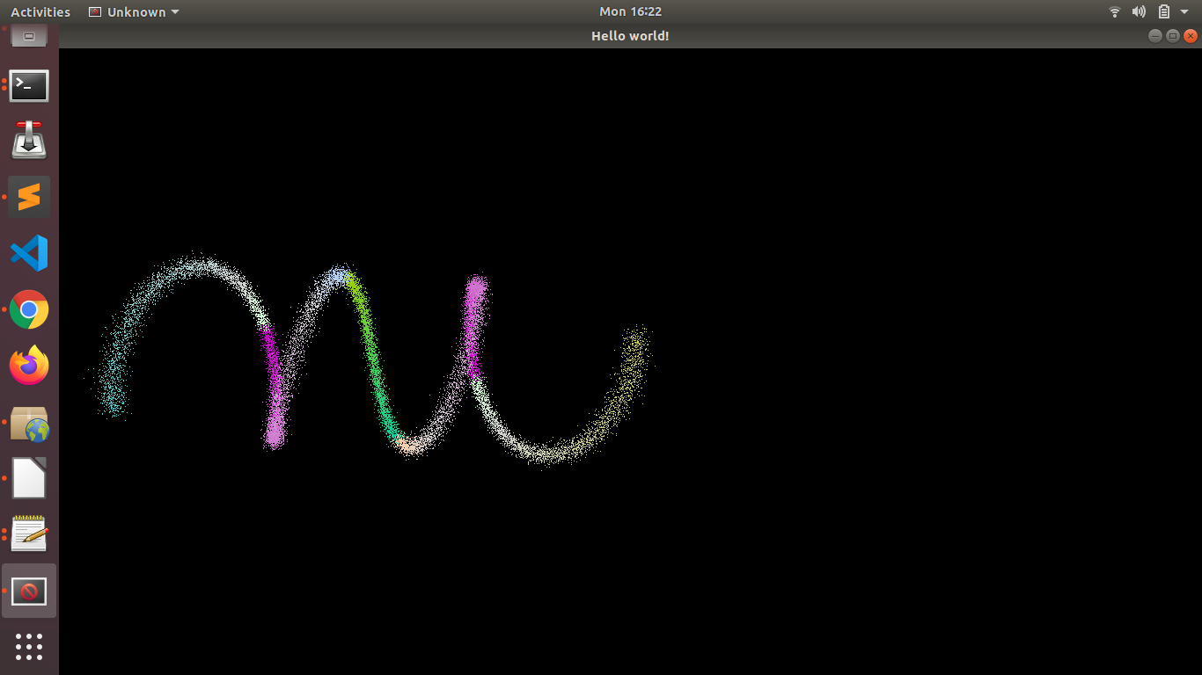
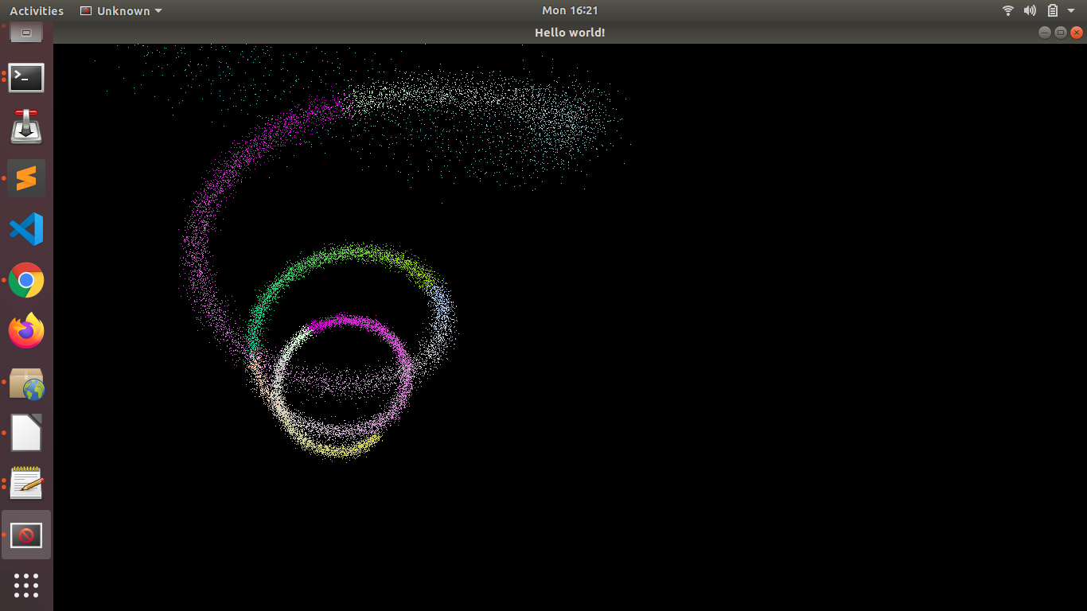

webcam_face_pose.sce

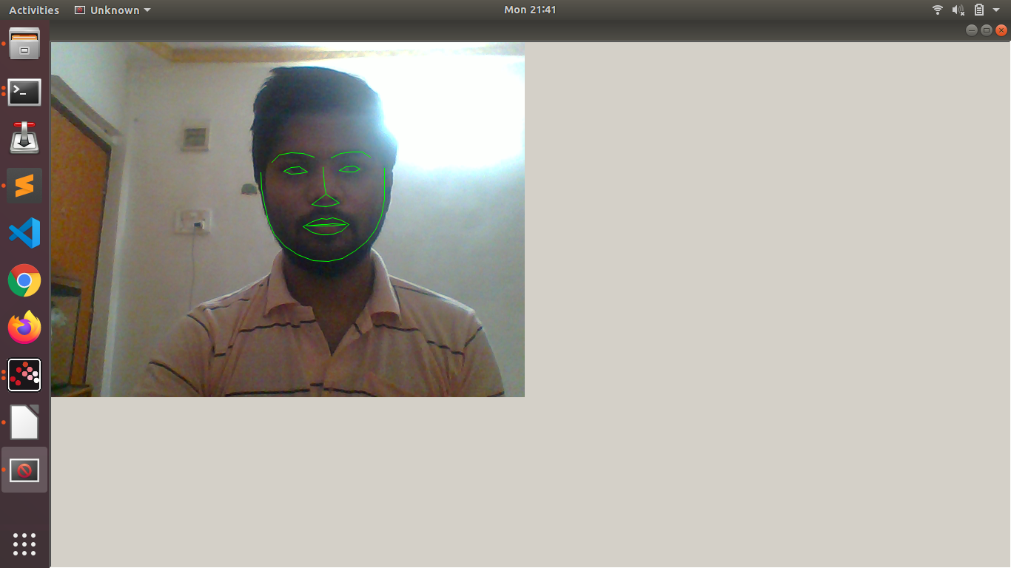

max_cost_asignment_ex.sce

Problem:
There are N jobs needs to be assigned to N people.You have been given with N arrays containing expertise of each person in each Job.
You have to find optimal way to increase the output of overall Job.

Sample Input :

arr = [ 1,2,6;
5,3,6;
4,5,0
];
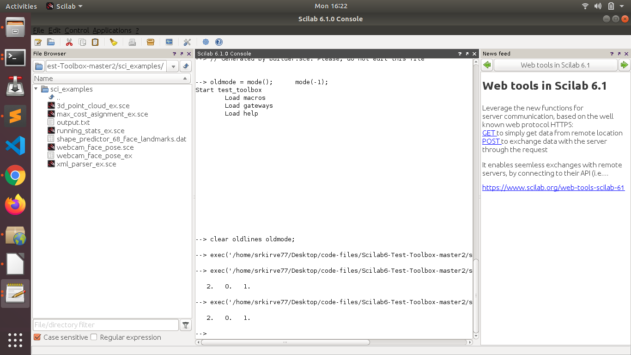

running_stats_ex.sce

This program shows the Mean , Variance , Skewness , Kurtosis values of Given data.

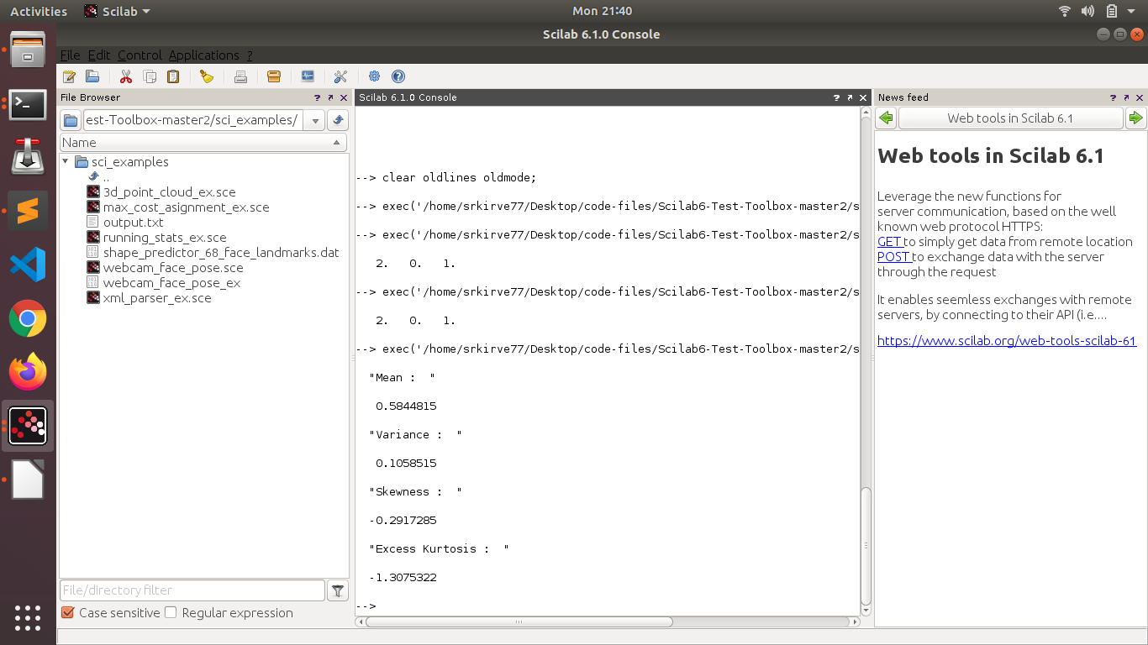

xml_parser_ex.sce

This code takes input as XML file and give output in parsed file in main folder itself.
It takes two arguments as shown in example file.
First argument is xml file and second argument is output file.

