PROJECT:
APPVERSE.AI

Name: Srikant Govind Sharma
Organisation: WIPRO

Introduction:

AppVerse is a comprehensive, full-stack application marketplace designed to bridge the gap between software developers and end-users. The platform provides a secure environment for users to discover, download, and review applications, while offering developers a powerful, real-time analytics dashboard to track monetization and network engagement. Uniquely, AppVerse integrates artificial intelligence to provide predictive market insights, elevating it from a standard app store to a smart, data-driven developer ecosystem.

Objectives
Seamless App Discovery: Create an intuitive marketplace for users to browse, search, and download applications.

Dynamic Feedback Loop: Implement a robust community review system that mathematically recalculates global app ratings in real-time.

Developer Empowerment: Build an interactive analytics dashboard for developers to track total downloads, calculate gross revenue, and monitor average engagement.

AI-Driven Forecasting: Utilize deep learning APIs to generate predictive 6-month download forecasts based on app descriptions and category metrics.

Robust Security: Ensure all endpoints and user data are protected using industry-standard stateless authentication.

Technology Stack
Frontend Architecture:
- Core Framework: React.js (Bootstrapped with Vite for optimized performance)

- UI & Styling: Tailwind CSS for responsive, modern design

- Data Visualization: Recharts (Used for the interactive developer dashboard)

- State Management & Routing: React Context API and React Router DOM

- API Integration: Axios

Backend Architecture:

- Core Framework: Java Spring Boot

- Security: Spring Security with custom JWT (JSON Web Token) filters

- ORM (Object-Relational Mapping): Spring Data JPA / Hibernate

- Database Engine: MySQL

- AI Integration: Google Gemini API

- Testing & Quality Assurance:

- Unit Testing: JUnit 5

Key System Modules
A. Authentication & Security Module
- Implements Role-Based Access Control (RBAC), distinguishing between standard USER and DEVELOPER/ADMIN accounts.
- Utilizes BCrypt password hashing for secure credential storage.
- Employs a custom JwtAuthenticationFilter to validate stateless tokens on every secure API request, eliminating the need for vulnerable session cookies.
B. Application Marketplace Module
- Allows developers to publish new software, defining pricing structures (Free vs. Paid), categories, and initial versions.
- Supports pushing new version updates, which are cataloged in an app_versions history table to track patch notes and release life cycles without overwriting core app data.
C. Dynamic Review & Rating Engine
- Enables authenticated users to leave 1-to-5 star ratings and written feedback.
- Features an automated background calculation: every time a new review is submitted, the backend fetches all historical reviews, recalculates the exact average, and instantly updates the main App database entity.
D. Developer Analytics Dashboard
- A visual dashboard restricted to application owners.
- Live Metrics: Aggregates database queries to display Total Published Apps, Network Downloads, Gross Revenue (Price × Downloads), and Average Engagement.
- Visualized Data: Uses Recharts to render interactive line graphs for download trends and bar charts for cross-app rating comparisons.

E. AI Prediction Engine
- Sends secure, formatted payloads (including app name, category, and description) to the Google Gemini API.

- Returns natural-language insights and predictive 6-month download forecasts to help developers refine their marketing and development strategies.

Database Schema & Architecture
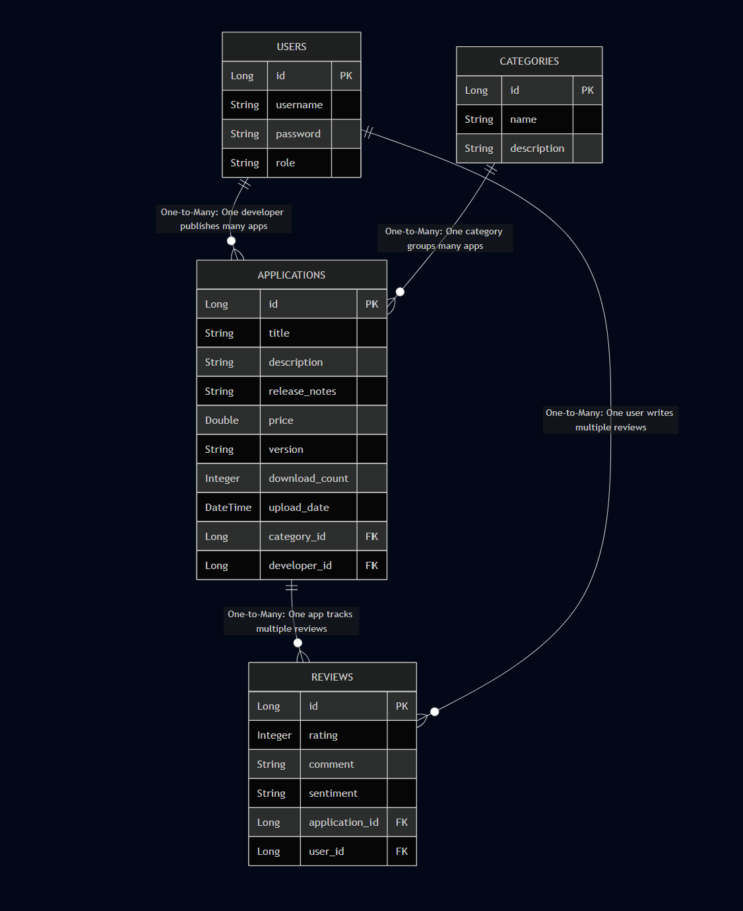
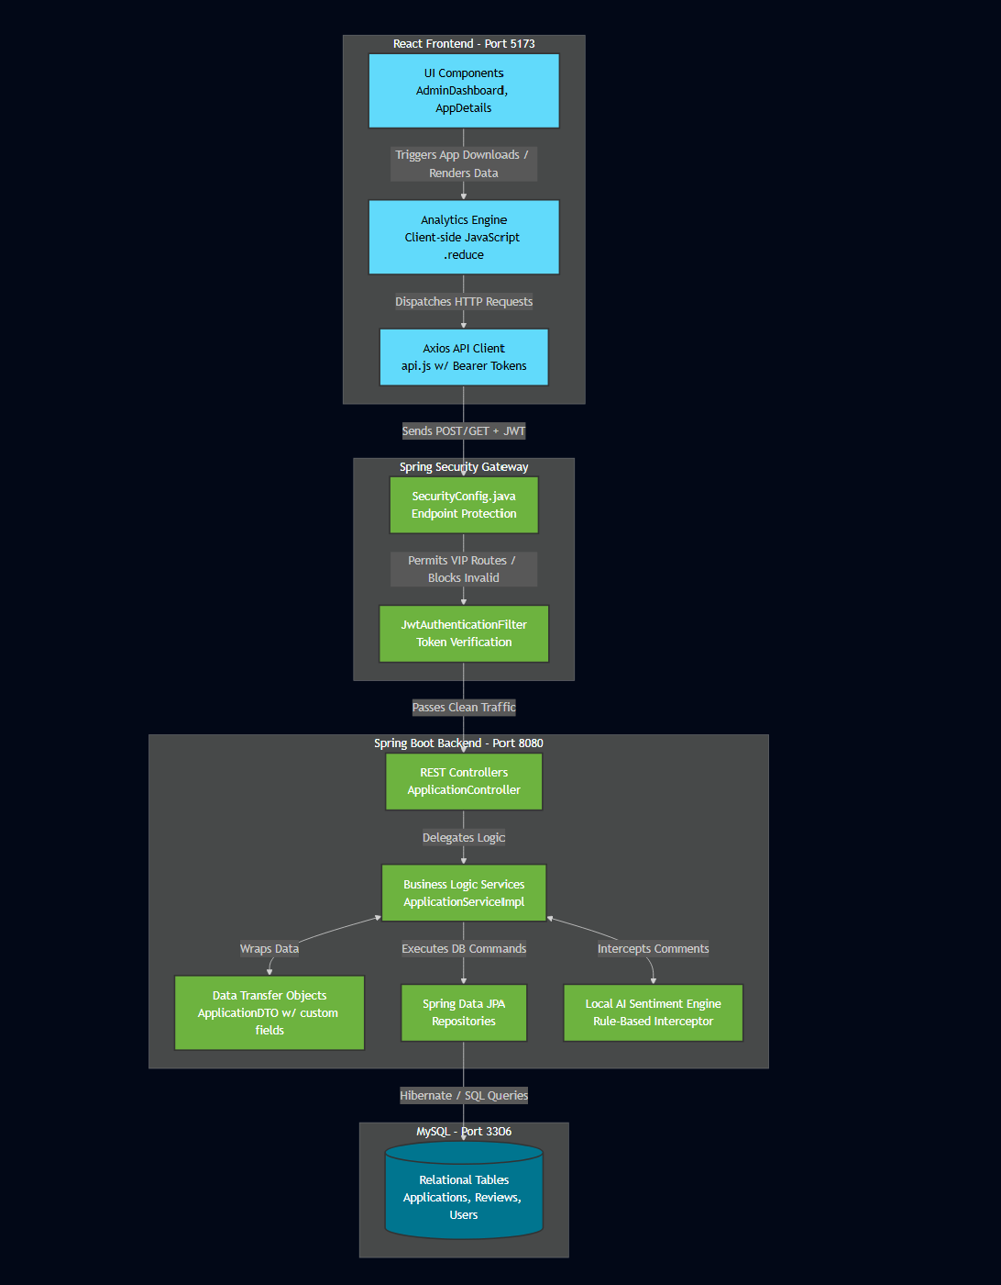

The system relies on a highly normalized relational database structured in MySQL:

Users Table: Stores account identities, encrypted passwords, and role designations. Acts as the primary foreign key for apps and reviews.
Apps Table: The central hub storing app metadata, calculated average ratings, running download counts, and pricing. Linked via Foreign Key to the User (Developer).
Reviews Table: The intersection linking Users to Apps. Stores the numerical rating, text comment, and timestamp,

Role Specific Features:

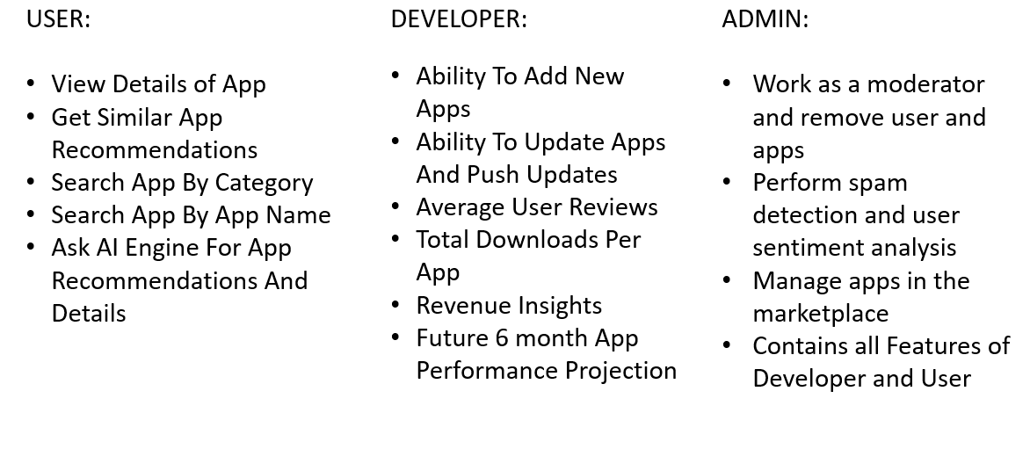

Login Page: 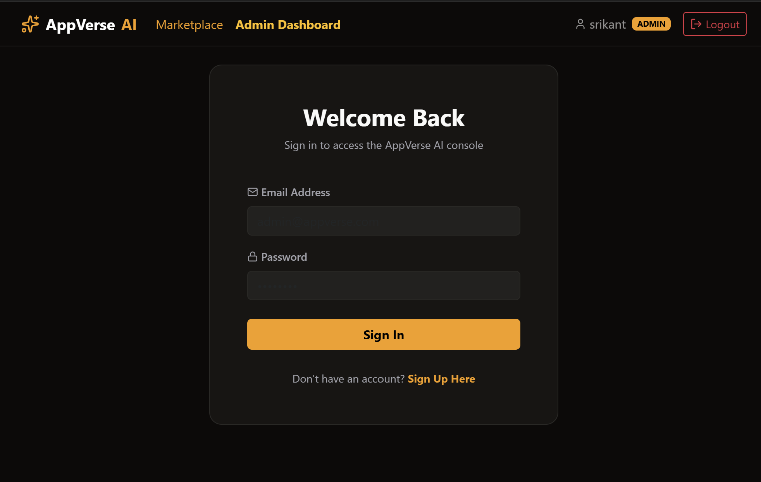

App Marketplace:
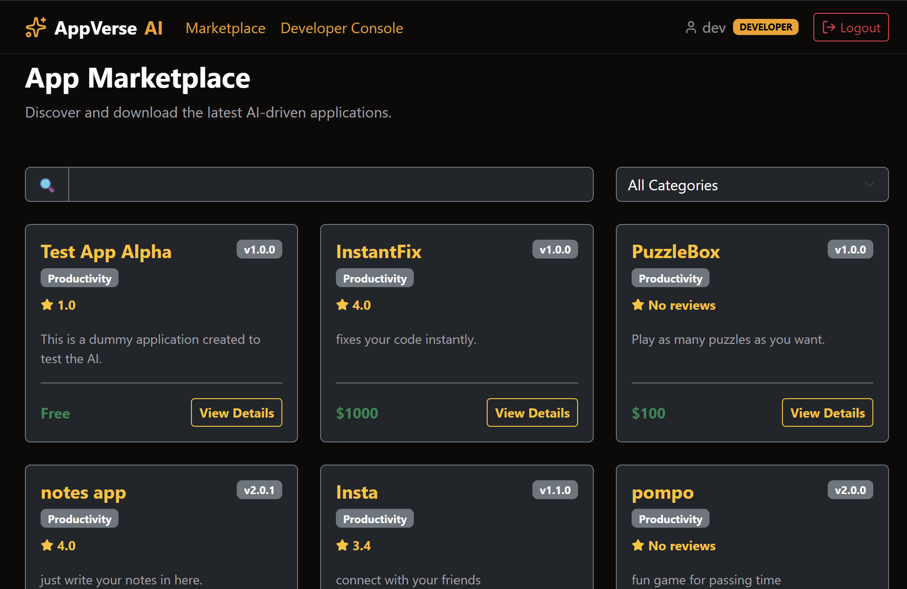

Developer Console:
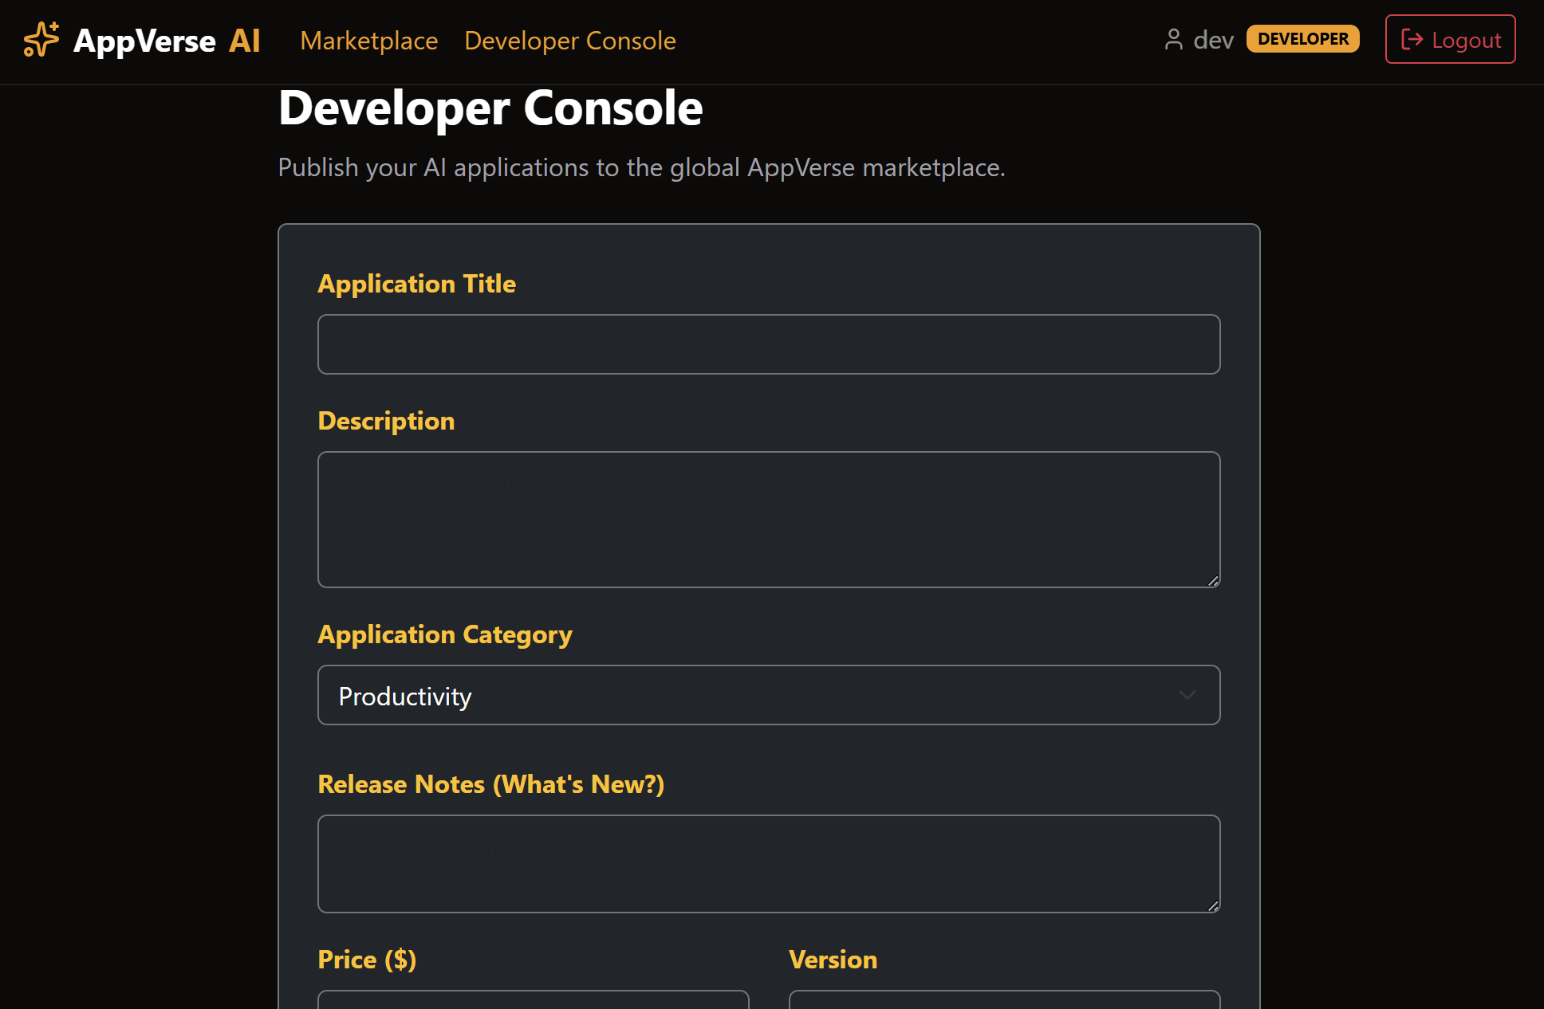

Admin Console:
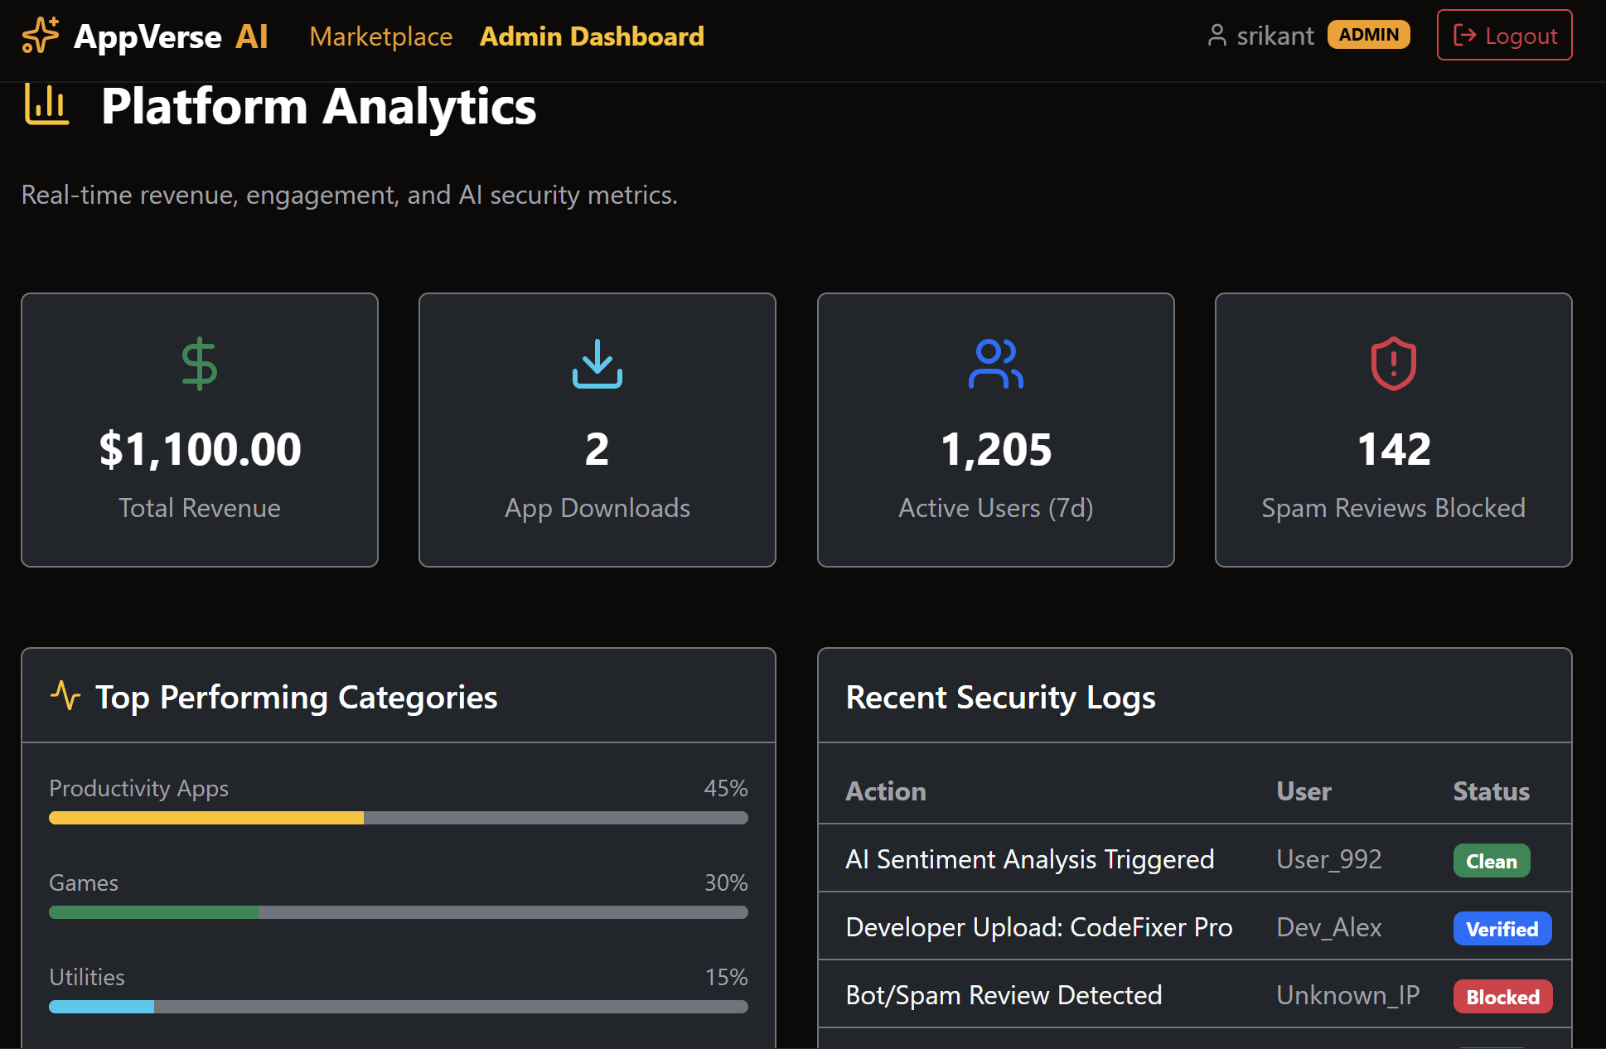
Sentiement Analysis Of User Reviews:
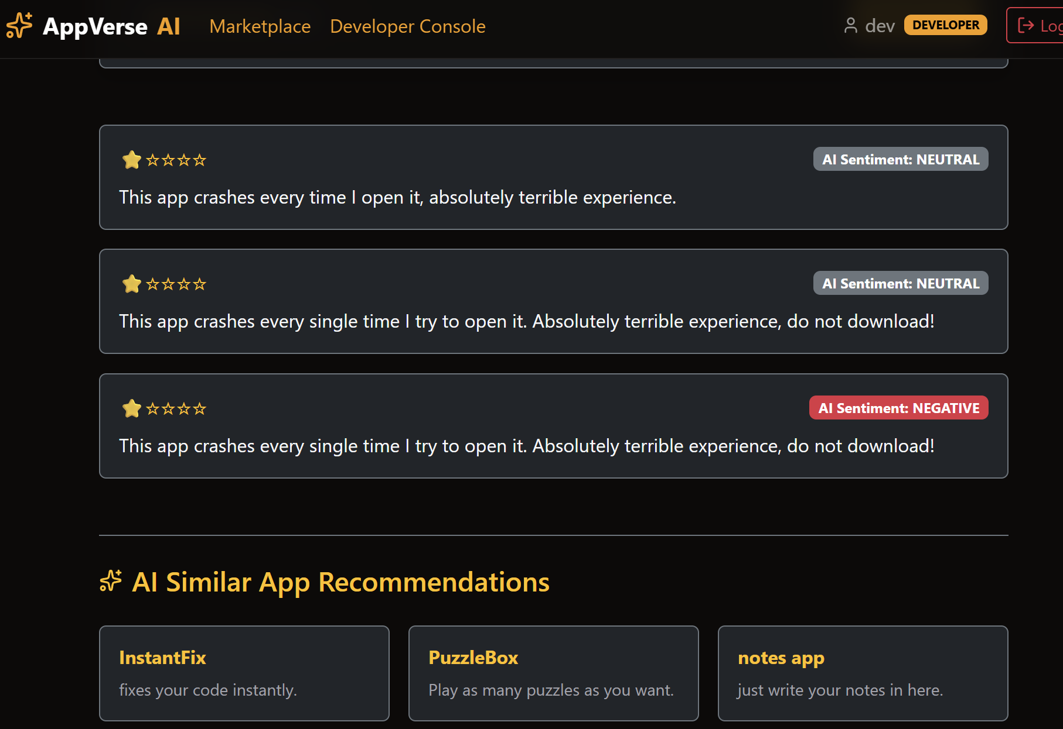

Conclusion:
The development of AppVerse successfully demonstrates the implementation of a modern, highly scalable full-stack web application. By combining the reactive performance of React.js with the robust, secure architecture of Java Spring Boot, the project successfully bridged the gap between software creators and end-users.

The platform achieved its core objectives of providing a secure marketplace for users while empowering developers with real-time, data-driven insights. The implementation of dynamic, mathematically calculated community ratings ensures marketplace trust, while the custom developer dashboard provides critical monetization and engagement metrics. Furthermore, the innovative integration of Google’s Gemini API elevates the platform from a standard repository to a forward-thinking, AI-assisted ecosystem, giving developers predictive forecasts to guide their future updates.

Ultimately, AppVerse proves that complex architectural concepts—such as stateless JWT security, real-time data aggregation, and third-party AI integration—can be seamlessly combined to create a user-friendly, enterprise-grade application.

Future Scope:
- While the current system is fully operational, future iterations of AppVerse could be scaled to include:

- Payment Gateway Integration: Integrating Stripe or Razorpay to process actual transactions for paid applications.

- Cloud Storage for App Binaries: Migrating from basic data storage to integrating AWS S3 for uploading and downloading actual .apk or .exe application files.

- Advanced AI Review Moderation: Using the Gemini API to automatically flag and filter toxic or spam reviews before they are posted to the public marketplace.

- Social Features: Allowing users to follow their favorite developers and receive email notifications when a new app version is released.

