Cartogram Mapping and its Application to Cancer Data Visualisation

Stephanie Kobakian, Jessie Roberts and Dianne Cook

Table of Contents

# Introduction

Maps have been adopted to present geospatial statistics for centuries. These maps connect data and/or statistics to the geographical representation of areas that are generally familiar to the audience. However, it is not enough for areas on maps to be recognisable, if the distribution of the statistic cannot be understood. This is particularly relevant to cancer statistics, as cancer outcomes directly relate to the people living within a geographical area. In situations where the people are of interest, not the land they live on, it is reasonable to explore views that enhance the communication of the cancer statistics. This has spurred innovations over the previous centuries to enhance the shapes and maps presented to effectively communicate cancer outcomes, and health outcomes more broadly.

# Disease mapping methods

## Current best practice map displays for cancer data

A choropleth map is used to show the spatial characteritics of a relationship, or variability, of measurements. Created as a storage device which preserves locations for geographically ordered data, with usage dating back to the 1800s (Berry, Morrill, and Tobler, n.d.). They are constructed by drawing the given geographic or political boundaries, and filling the shapes with colours to represent values of a measured variable (Tufte 1990). Early versions used symbols or patterns instead of colour. Bell et al. (2006) discusses the use of choropleth maps for visualising cancer data, and Walter (2001) gives an overview of the development of the use of choropleth maps for displaying disease data. A choropleth map is a true map of the topology, constructed for visual inspection of spatial patterns across a familiar geographic form. Figure 1 shows a choropleth map where each state of the United States of America is coloured by the average annual rate of new cases of lung and bronchus cancer from years 2012 to 2016.

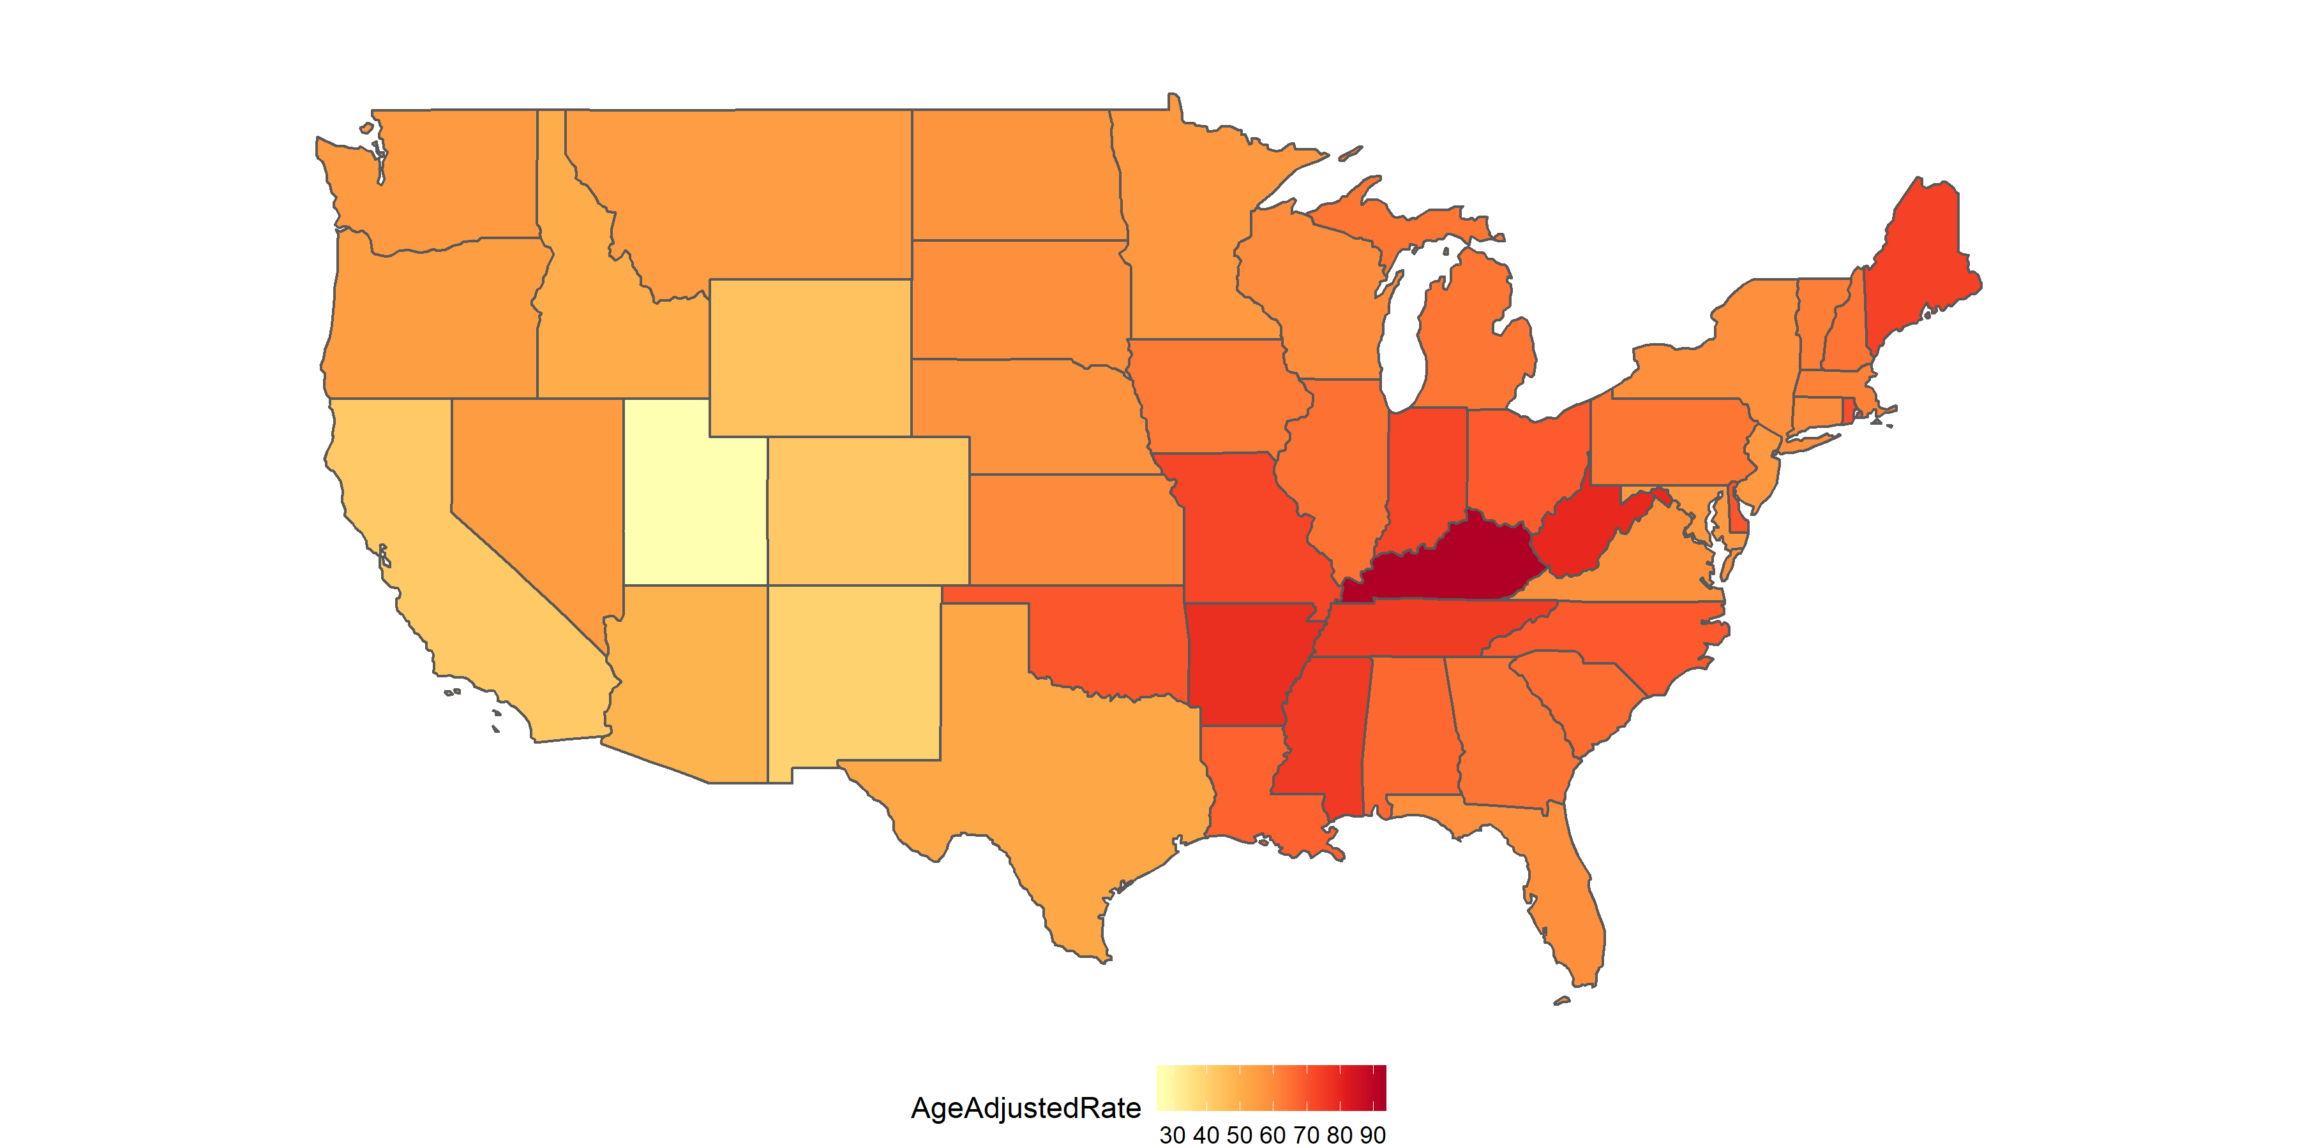

“A choropleth map of the United States of America.”

Utilising the familiar state boundaries can make a map intuitive to read (Brewster and Subramanian 2010), and allow viewers to visually infer the spatial relationships in the data, i.e. how cancer rate differs across the states. The familiarity of the geography is a worthy consideration when presenting results of spatial analysis. Just as geographers are no longer the only creators of maps, Bell et al. (2006) suggests the audiences of spatial health data analysis have extended beyond researchers to the public, policymakers and the media. However, while the areas are recognisable shapes, they are often politically driven boundaries with individual areas being of non-uniform size, containing different population densities and subject to change over time. The different population and geographical sizes of administrative areas can attract attention to the shades of the unpopulated but large areas (Tufte 1990). Choropleths can inhibit visual inference when presenting human related statistics as the display may draw attention from the ‘potentially more important results in the more populous communities’ (Exeter 2017).

In epidemiology, choropleths are often used as a tool to study the spatial distribution of cancer incidence and mortality. Choropleth maps can be useful devices for communicating information to public on a familiar map base. A cancer atlas is a choropleth map, or collection of maps, representing cancer incidence and mortality for a country, or group of countries. d’Onofrio et al. (2016) provide the definition and report that cancer atlases began with Haviland’s maps in 1875. The data collection methods of cancer mortality rates across regions, and administrative control within regions lends itself to choropleth visualisation. The increasing development and use of disease maps can be attributed to the availability of geographic information system software (Exeter 2017). Early work in US cancer atlases can be attributed to Burbank ???, and UK cancer atlases to Howe 1963 ???. The choropleth maps used at this time presented levels via hatchings or dots on a black and white scale. These atlases were key to developing hypotheses regarding areas with unusually high rates, geographic correlations, work related exposures, and high risk diets d’Onofrio et al. (2016).

Almost 100 years of cancer mapping in the United States and the United Kingdom has seen increased effectiveness in the presentation of unbiased rates. Mortality rates are now often presented as relative rates of risk across the population, and age adjusted to correct for the the higher prevalence of cancers in older populations. Howe (1989) describes Stocks development of the standardised mortality ratios through the 1930s.

The list below summarises the measures presented in published cancer atlases, and provides a definition of each measure.

(#tab:measures) Measures used to report cancer statistics

|  |  |
| --- | --- |
| Measure | Details |
| 1. IR (Incidence Ratio) | , |
|  | Cancer incidence rate in region over the average cancer incidence rate for the total region |
| 2. SIR (Standardised Incidence Ratio) | IR standardised by age structure in each region |
| 3. RER |  |
| (Relative Excess Risk) | Represents the estimate of cancer related mortality within five years of diagnosis |
|  | Also referred to as ‘excess hazard ratio’ |
| 4. Age Adjusted Relative Risk | RR standardised by age structure in each region |
| 5. Rate per 100,000 | Cancer incidence per 100,000 population |
| 6. Age Adjusted Rate per 100,000 | #5 standardised by age structure or region |
| 7. New cancer cases per 100,000 | Specific methods could not be found |
| 8. Count | Crude cancer counts |
| 9. Below or above Expected | Alternative expression of the SIR |

Walter (2001) cites Cruickshank’s (1947) discussion of using visuals as ‘formal statistical assessment of the spatial pattern’ as a major advancement.

When presenting cancer atlases, d’Onofrio et al. (2016) believes the intuition that can be derived must be ‘validated by rigorous statistical analyses.’ Additional statistics are often

Examples of atlases: Kraak 1998, Kraak and Ormeling 2011 Bertin 1967

### Supporting material in cancer atlases

Cancer atlases were considered to report uncertainty to the non-expert user if they included a measure of statistical uncertainty either within or alongside the map. Maps that only reported this information within the supplementary material were not considered to have directly attempted to report uncertainty.

The review did not reveal any novel uncertainty visualisation approaches or visualisations. Maps used standard and well known measures including credible intervals and standard deviation, statistical significance, box plots and distributions. These maps ranged from static pdfs or infographics to interactive online resources. The interactivity of the more modern maps enabled uncertainty information to be incorporated without cluttering the screen, such as in a tool tip feature.

## Public face

Cancer maps are effective communication tools for a general or non-expert audience and are commonly used in the public domain to communicate the output of sophisticated statistical analyses to these audiences. The heavy use of chloropleth maps within the research literature is reflected in the types of maps that are found in the public domain. A grey literature review conducted by (ref) identified 33 cancer atlases published on the internet between 01/01/2010 to 11/11/2015 all of which were chloropleth maps. These maps were mostly published by non-commercial organisations, including not-for-profits (NFPs), government, research organisations, advocacy groups or a partnership between an NFP & government. Only one map was published by a commercial entity (Maps of Cancer Mortality Rates in Spain), published by the media organisation El Pais[1].

### Geographical coverage

Identified cancer atlases covered geographies from all around the world, four were global atlases. Most focussed on single nations, the United States was considered by eleven atlases. The United Kingdom was considered by seven, followed by three of Australia, two of Canada, and one of each from Switzerland, Germany, Norway. One atlas covered the European Union. Not all maps had a national focus and ten covered a region or state rather than an entire nation. The states or counties/regions covered were South Australia (AUS), Queensland (AUS), Ontario (CAN), Valencia (Spain), Pennsylvania county Massachusetts (US), New Hampshire (US), Cape Cod (US), Missouri (US), Florida (US), New York State (US) and Arizona (US).

### Statistical uncertainty in public facing atlases

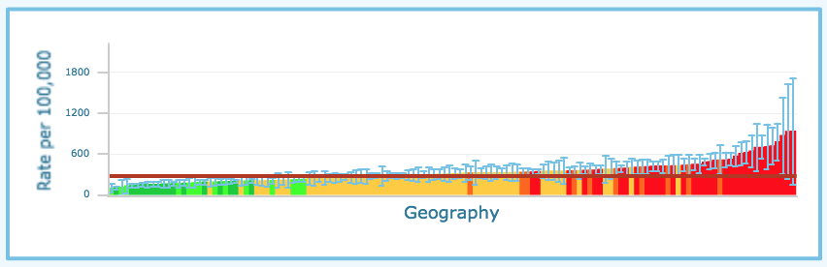

Example of CI visualisation for uncertainty representation in cancer mapping (1/3). Source: Alberta Health IHDA Geographic. (2012)

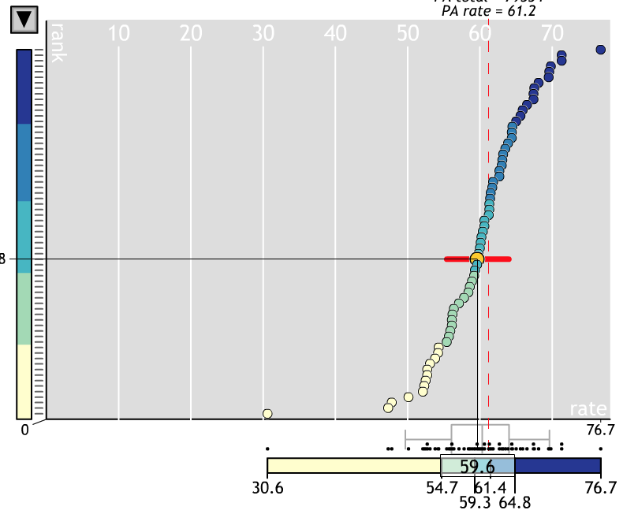

Example of CI visualisation for uncertainty representation in cancer mapping (2/3). Source: Pensylvania Cancer Atlas

Close to half of the atlases identified (42%, n=14) included some measure of uncertainty. The most common measure used to represent uncertainty were credible or confidence intervals (CIs). CIs were either visualised by including their bounds in a scatterplot or graph of estimates vs region (see Figures @ref(fig:ci-viz2)[2], and @ref(fig:ci-viz3)[3] positioned next to the map, or reported numerically through the CI upper and lower bounds listed in a data table (see Figure 3.4[4]). Of those that visualised the CIs, 30% (n=10) embedded the visualisation within a tool tip function which visualised the CI when the mouse hovered over the relevant area (see Figure 3.5[5]).

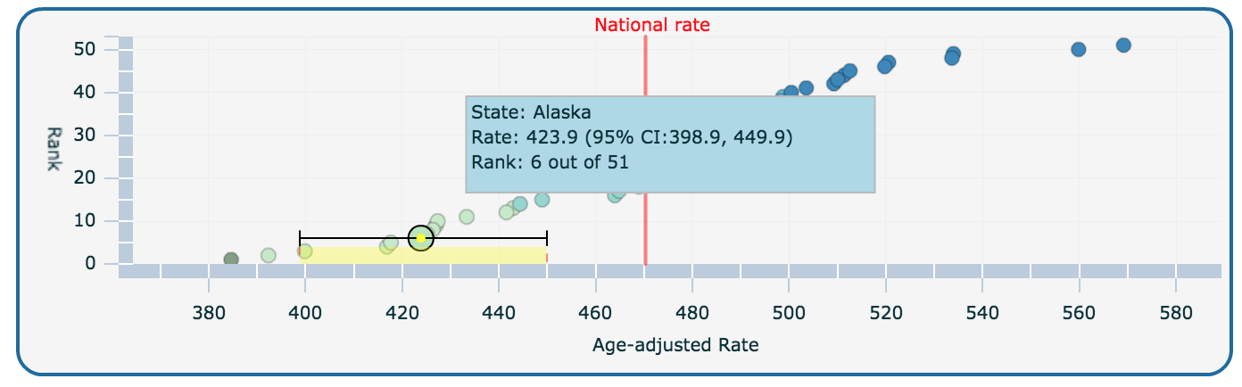

Example of CI visualisation for uncertainty representation in cancer mapping (3/3). Source: Centres for Disease Control and Prevention (CDC). United States Cancer Statistics: An Interactive Cancer Atlas (InCA)

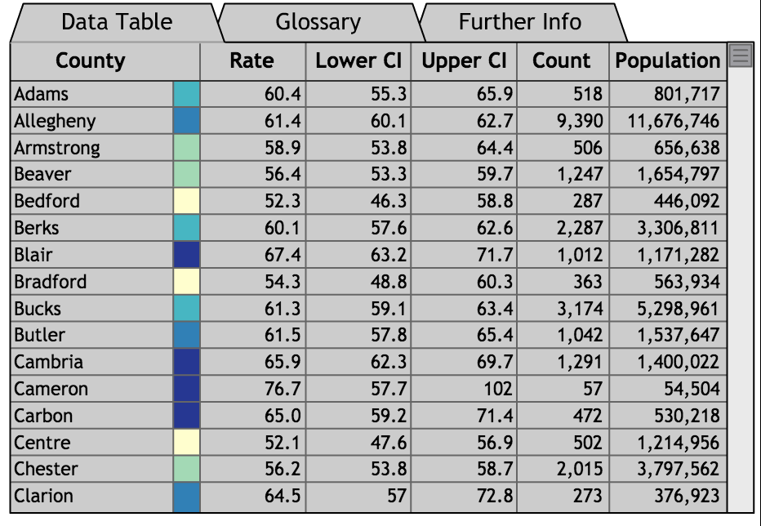

Example of an interactive data table with CI upper and lower bounds used in cancer mapping. Source: Pennsylvania Cancer Atlas

Methods for representing sources of uncertainty information can be visualised or communicated in different ways, examples identified through this grey literature review are listed below.

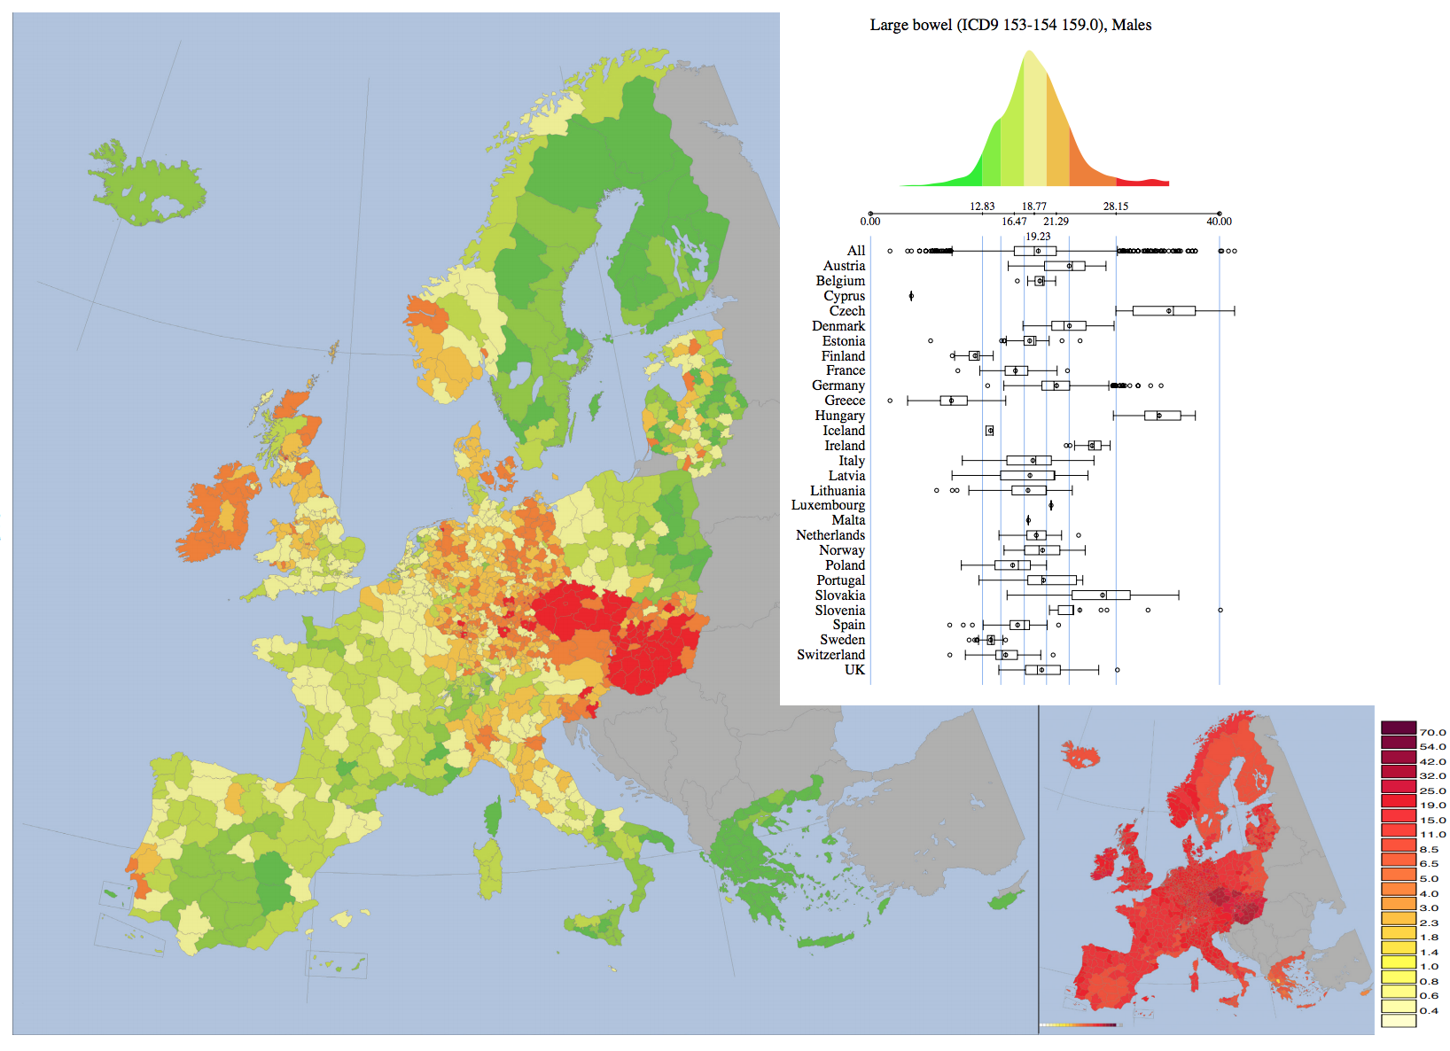

Example of standard deviation visualised in cancer mapping

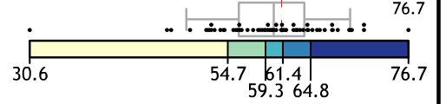

Example of boxplot used in cancer mapping. Source: Source: Pensylvania Cancer Atlas

(#tab:method-exp) Implicit and explicit measures of uncertainty.

|  |  |
| --- | --- |
| Measure | Example |
| CI Interval | Figures 3.1, 3.2, 3.3 |
| Statistical Significance | Textured overlay on top of coloured regions used to indicate statistical significance |
| Distribution | Figure 3.4 |
| Boxplots | Figures 3.4, 3.5 |
| Sample Size | Textured overlay or lack of colour on a region, was used to show regions with small sample size |
| Standard deviation | Figure 3.6 - the second map in the bottom right corner shows standard deviation |

## Cartograms

Choropleths may be considered true topological maps, however, if the land mass presented covers enough of the globe, there must be a transformation or distortion to display in 2D. The amount of distortion is related to the distance displayed Tobler (1963). The world projections reflect the frequent distortions seen from altering perspectives. Choropleth maps will always be distorted if they cover enough of the globe, as will photographs of the globe from space. Choropleth creation requires choosing a map projection that shows a favourable distortion of the geography for presenting the set of spatial information. Diagrams that do not specify a projection can be considered to have some unknown projection.

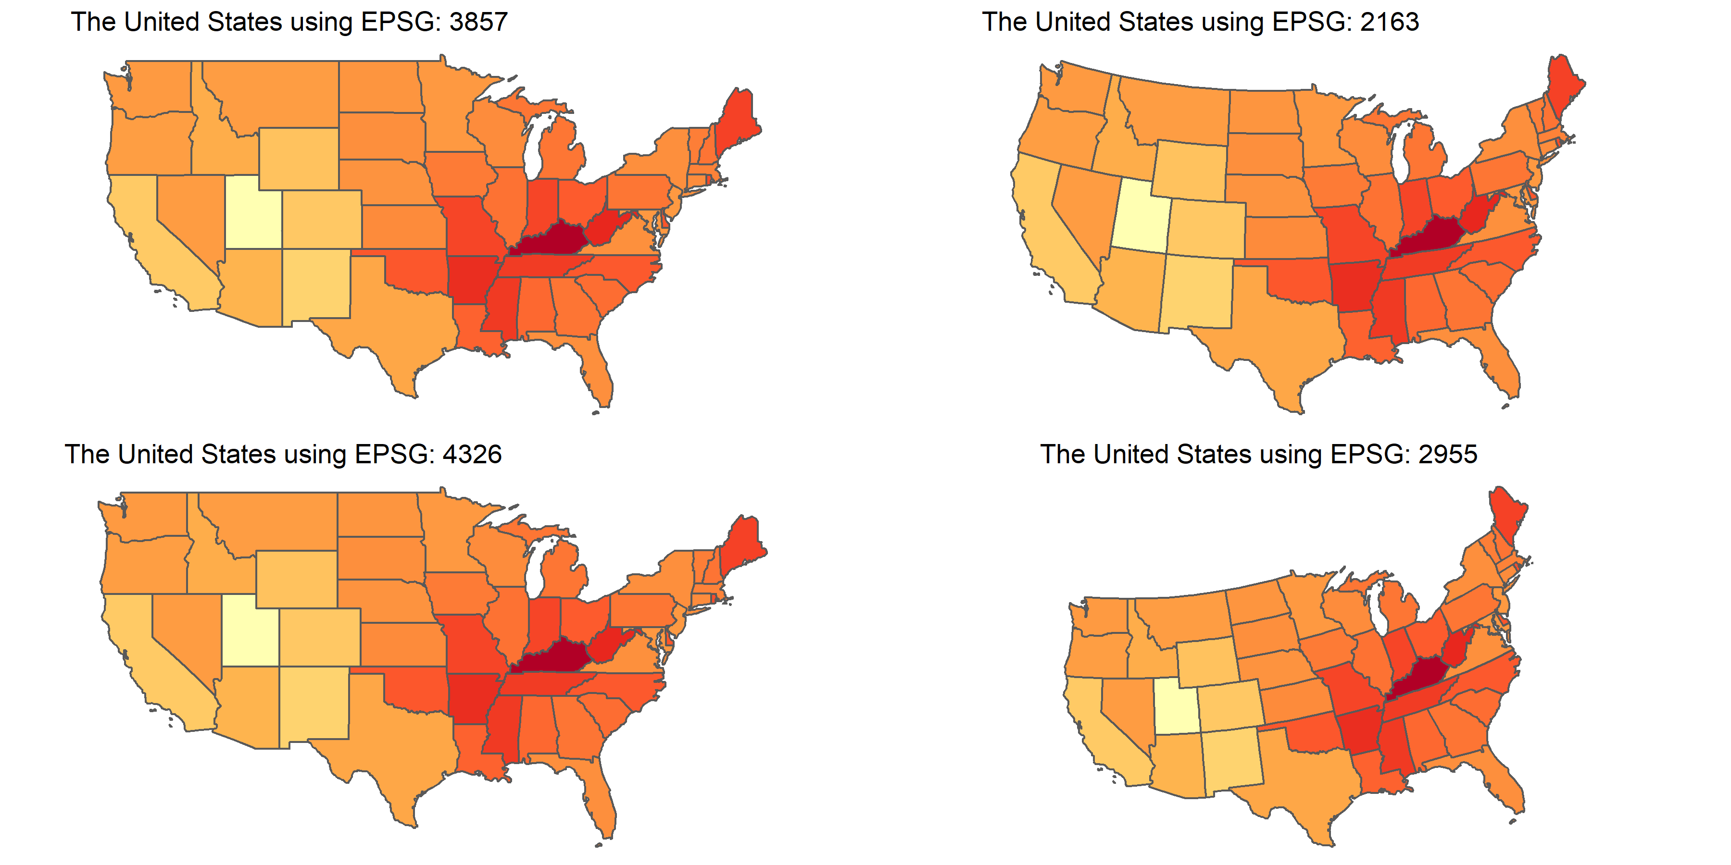

“Choropleth maps of the United States of America using four coordinate reference systems.”

Waldo Tobler (2012) explores many graphical techniques, and suggests there are particular methods for particular purposes. Cartograms provide an alternative visualisation method for statistical and geographical information. The key difference between a choropleth and a cartogram is the desirable augmentation of the size, shape or distance of geographical areas (Dorling 2011). Cartograms may be seen as an extension of map transformations and projections. The favourable distortion is proportional to a value other other than actual earth size area (Olson 1976).

Using choropleth maps for population characteristics requires graphic distortions when the population concerned varies greatly in density (Griffin 1980). When implementing a distortion of the geographical shape according to population, an area cartogram (Olson 1976), or iso-demographic map is the result. When visualising population statistics Dorling (2011) considers this equitable representation design ‘more socially just, giving due attention to all members of the population and reducing the visual impact of large areas with small populations (Walter 2001). Griffin (1980) suggest that spatial socio-economic data is best presented on a cartogram for urban areas. Howe (1989) agrees that ’cancer occurs in people, not in geographical areas’ and the map bases of population reflect this and avoid allocating ‘undue prominence’ to rural areas. Jahan et al. (2018) encourage the use of cartograms to highlight small areas and uncover local-level inequalities. Using health estimates from large areas can prevent drawing attention to the inequalities.

The area on the map space can also be used represent a value. There have been many algorithms presented, Nusrat and Kobourov (2016) provided a framework to investigate implementations and the “statistical accuracy, geographical accuracy, and topological accuracy”. The spatial transformation of map regions relative to the data emphasises the data distribution instead of land size (Kocmoud and House 1998).

Cancer statistics and atlases

The creation of cartograms was largely in the hands of cartographers. Dorling (2011) discusses early approaches including John Hunter and Jonathan Young (1968) and Durham’s wooden tile method, Skoda and Robertson’s (1972) steel ball bearing approach and Tobler’s (1973) computer programs.

There are many alternatives to consider, the intended audience of the map, and its purpose are key points in cartogram use and creation. Dorling (2011) reiterates: ‘There is no “best” cartogram or method of creating cartograms just as there is no “best” map’ (Monmonier and Schnell, 1988).

‘Firstly, that no such transformation has a unique solution, leaving the subjective choice in the hands of the individual map designer.’

Design goals: - to maintain as much as possible of the intricate detail - to maximize the simplicity of the transformation - maintenance of directional accuracy - attempt to influence and direct the map user’s attention,

1. that the size of the electoral subdivisions should be made proportional to their respective electoral populations,
2. that the contiguity relationships between the DCU’s should be maintained,
3. that true directions should be retained from the centre of the transformation,
4. that the main shape characteristics of the DCU’s should be preserved, and
5. that the map should possess the overall shape of the built-up area.

### Contiguous

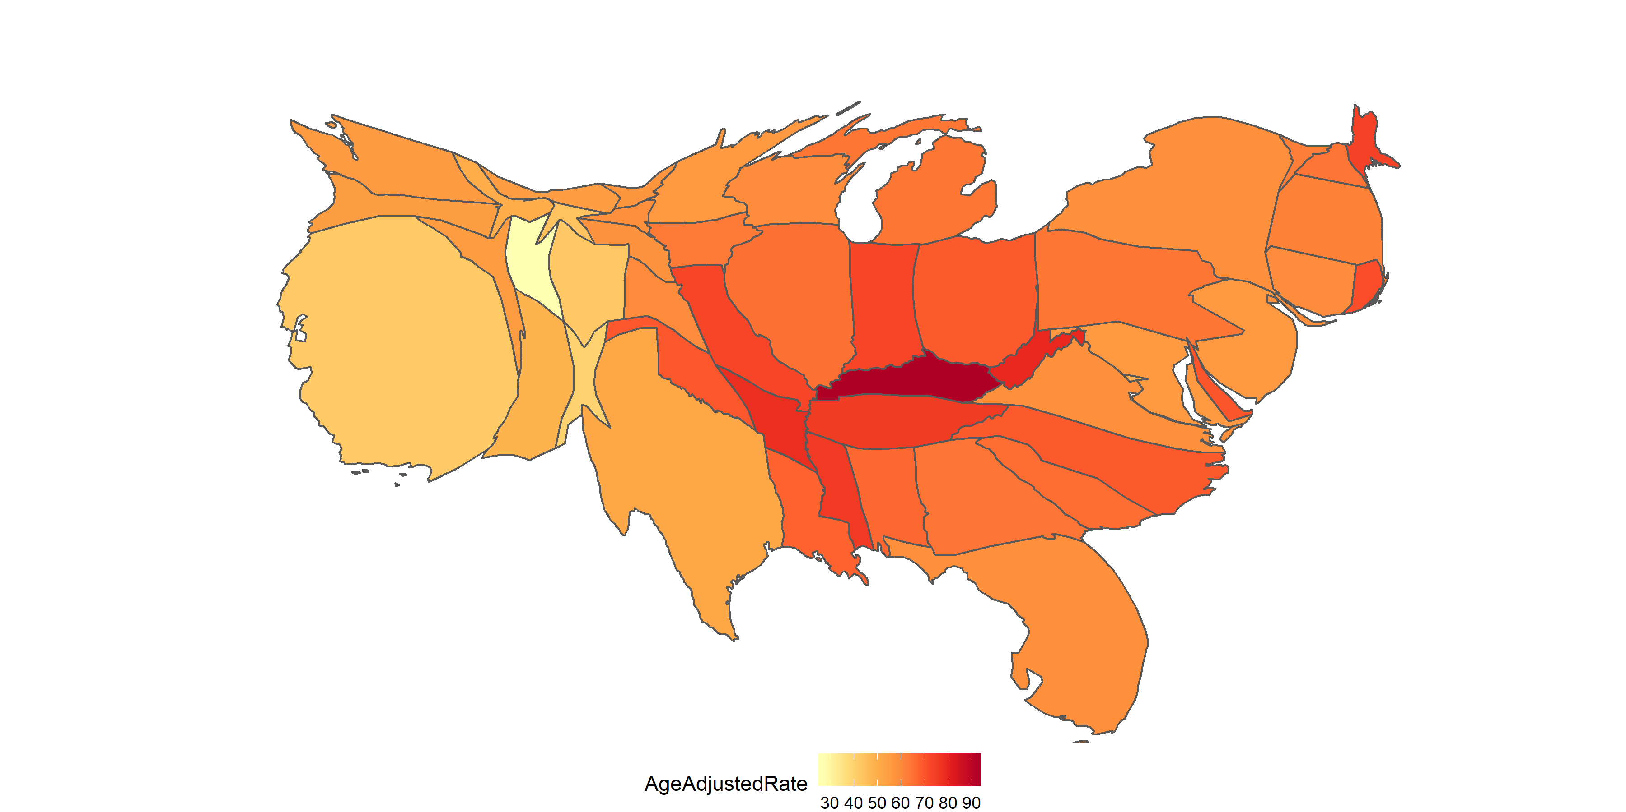

“A contiguous cartogram of the Unites States of America”

A contiguous cartogram allows the map space to highlight the distribution of the variable. These cartograms maintain connectivity of the map regions while areas are resized according to a statistic, this often must occur at the expense of the shape (Kocmoud and House 1998,@NAC, @TAAM). From a computer graphics perspective, Min Ouyang and Revesz (2000) believe it is a problem of ‘map deformation’ to account for the value assigned to each area, they provide three methods for creating value-by-area cartograms. Examples include Tobler’s Pseudo-Cartogram Method, Dorling’s Cellular Automaton Method (2011), Radial Expansion Method of Selvin et al., Rubber Sheet Method of Dougenik et al., Gusein-Zade and Tikunov’s Line Integral Method, Constraint-Based Method (Kocmoud and House) (1998).

describes the process of creating a population cartogram for Canada, using the 1966 Census. An intentional goal of this project was to maintain contiguity, while attempting to keep the actual shape of places. The end result was a ‘very accurate isodemo-graphic map of Canada’. This intentional design goal coincided with the rising interest in urban geography.

To be able to recognise the significant changes, a reader will usually have to know the initial geography to find the differences in the new cartogram layout (Olson 1976). Tobler’s Conformal mapping means to preserve angles locally so that the shapes of very small areas on a traditional map and a cartogram would be similar. Kocmoud and House (1998) presents this issue as conflicting tasks or aims, to adjust region sizes and retain region shapes. Distortion of region shapes on the contiguous cartogram presents an additional hurdle to visual recognition and this hurdle is not only eliminated on the noncontiguous cartogram but is replaced by the meaningful empty-space property (Olson 1976, @ECGC).

### Non-Contiguous

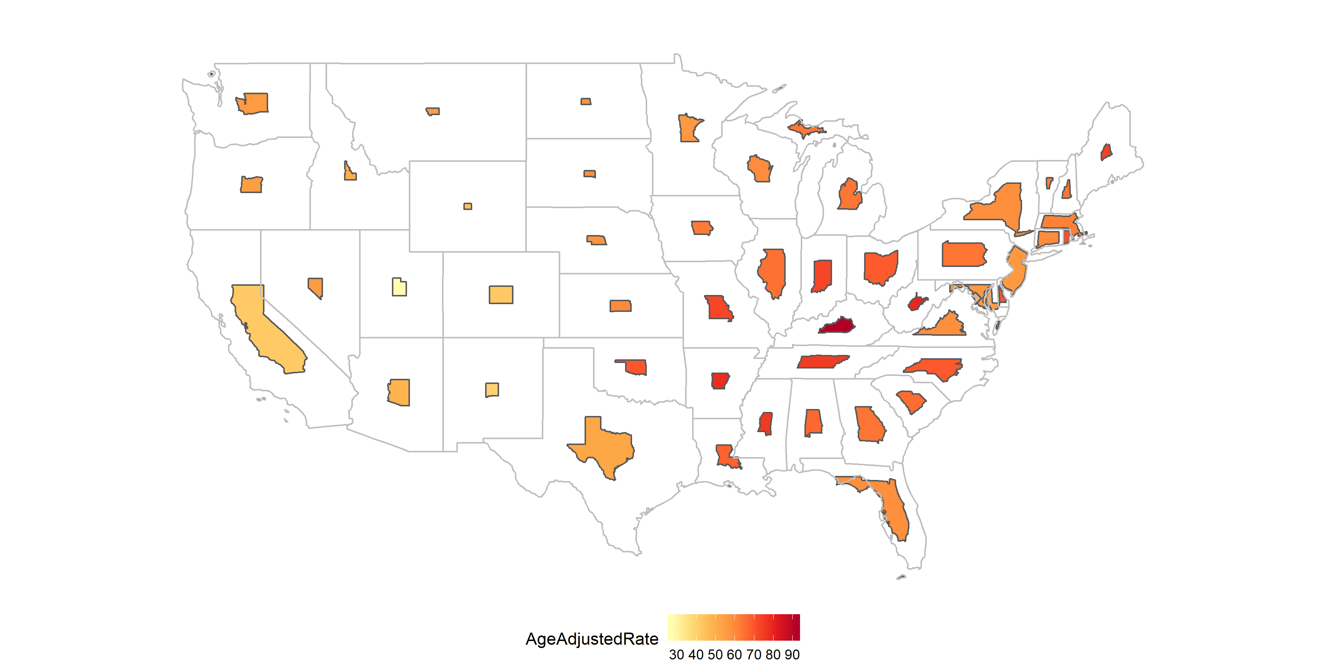

“A Non - contiguous cartogram of the Unites States of America”

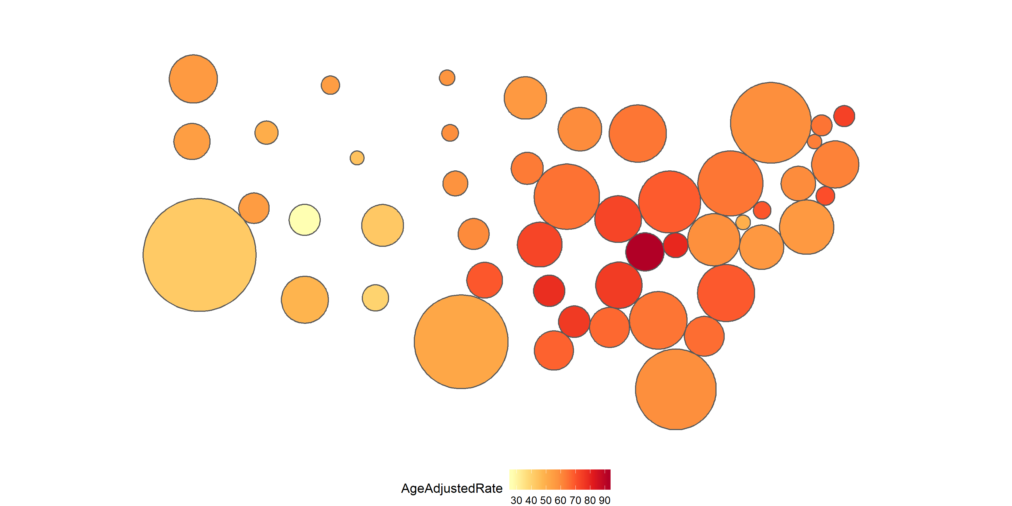

“A dorling cartogram of the Unites States of America”

Dorling (2011) puts forward a simple question:

If, for instance, it is desirable that areas on a map have boundaries which are as simple as possible, why not draw the areas as simple shapes in the first place?

He answers this with his implementation of maps created with ‘the simplest of all shapes’. While contiguous cartograms may be a ‘more sophisticated’ method, they produce ‘very complex shapes’. Circular cartograms use the same shape for every region represented, and size them according to the statistic represented or the population for a base map. To produce a compelling map, a gravity model is applied to avoid overlaps, and keep spatial relationships with neighbouring areas over many iterations. This implementation can work for up to ‘one hundred thousand’ areas.

Dorling (2011) suggests ‘population distribution is often extremely uneven in former British colonies’.

‘In Australia the urban federal constituencies occupy only a tenth of the land, but contain nine tenths of the people. It would be almost unthinkable to show election results for that country on a conventional equal land area map.’ This 1966 cartogram uses mostly straight lines, and the result looks very little like the geographical shape of Australia.

‘Given the increasingly uneven population distribution of the United States and the growing social divides between the populations of neighbourhoods living at different densities, the need for cartograms like this is greater now than ever.’

Used in displays of the UK by Howe in 1986 cited by Howe (1989)

Tobler’s method and the many implementations that ‘elaborated’ on it are derived from ‘numerical approximations to a pair of equations’(Dorling 2011). They all operate through incremental adjustments, and can produce wildly different outcomes from small changes in the inputs.

Tobler (2004) Value-Area Cartograms. In these cartograms a region,country, or continent is subdivided into small regions, each of which is represented by a rectangle. This rectangle is proportionate in area to the value which it represents in certain statistical distributions. The regions are grouped in approximately the same positions as they are on the map.

Computer generated map examples: Howe (1989) (Hopps et al. 1968; Armstrong 1972). There has followed a flood of disease atlases, mainly concentrating on the modem problems of cancer and degenerative diseases from countries as scattered as the United States (Burbank 1971; Mason et al. 1975, 1976; Pickle et al. 1987), the Soviet Union (Levin 1980), Japan (Shigematsu 1977), the Federal Republic of Germany

Cano et al. (2015) define the term ‘mosaic cartograms’. Compare amount of tiles to contrast population of regions. ‘Cartograms show a data value per input region by scaling each region such that its area is proportional to its data value. Mosaic cartograms show data in multiples of tiles, hence the input data must consist of, or be cast into, small integer units.’

## Centroid displays

Dot plot: one dot for each region, coloured, and placed at centroid.

Olson (1976) gives an example of

Plotting centroids on top of geographies. (Size is kept constant)

Replies on the idea that every area is important, no matter the size. This gives equal emphasis to every area, allows distributions and relationships between neighbours to become more clear.

# A critique of mapping methods

designing a map tailored to precise goals [is] easier than forcing a single map to accommodate diverse objectives - Bell et al. (2006)

To choose an approporiate map display, the map creator must consider the intended user, and message the map will communicate. It is the objectives of the investigator that will drive the choice of representation (Bell et al. 2006).

There are two keys to drive the choice of display: the properties of the visualisation, and the ease or accuracy of information extraction for map users Moore and Carpenter (1999).

(only worth including if it is possible for us to implement) Tabular form comparing and contrasting - Relationship to geography

* Show using cancer examples

# Animation and Interactivity

Recent developments of technology allowed interactive

‘Where control of the message is important, static maps will continue to be the most effective, although good tables, graphs, and explanatory text are still needed in order to ensure that different people will see the same thing in the maps’ Bell et al. (2006)

lends to temporal pattern exploration

Keim et al. (2002) ?? Highlight the value of animating contiguous to see changes over time, US can be recognisable but animation aides interpretation

# Acknowledgements

# References

Wickham (2017) for data analysis, Bivand, Nowosad, and Lovelace (2019) and Pebesma (2018) to implement plotting of spatial data. Kobakian and Cook (2019) to create hexagon tesselation. Arnold (2019) to enhance plot displays. Jeworutzki (2018) for contiguous and non-contiguous cartogram displays.

Arnold, Jeffrey B. 2019. *Ggthemes: Extra Themes, Scales and Geoms for ’Ggplot2’*. <https://CRAN.R-project.org/package=ggthemes>.

Bell, B Sue, Richard E Hoskins, Linda Williams Pickle, and Daniel Wartenberg. 2006. “Current Practices in Spatial Analysis of Cancer Data: Mapping Health Statistics to Inform Policymakers and the Public.” *International Journal of Health Geographics* 5: 49. <https://doi.org/10.1186/1476-072X-5-49>.

Berry, Brian J. L., Richard L. Morrill, and Waldo R. Tobler. n.d. “GEOGRAPHIC Ordering of Information: NEW Opportunities” 16 (4): 39–44. <https://doi.org/10.1111/j.0033-0124.1964.039_q.x>.

Bivand, Roger, Jakub Nowosad, and Robin Lovelace. 2019. *SpData: Datasets for Spatial Analysis*. <https://CRAN.R-project.org/package=spData>.

Brewster, Mark B., and S. V. Subramanian. 2010. “Cartographic Insights into the Burden of Mortality in the United Kingdom: A Review of ‘The Grim Reaper’s Road Map’.” Journal Article. *International Journal of Epidemiology* 39 (4): 1120–2. <https://doi.org/10.1093/ije/dyp395>.

Cano, R. G., K. Buchin, T. Castermans, A. Pieterse, W. Sonke, and B. Speckmann. 2015. “Mosaic Drawings and Cartograms.” *Computer Graphics Forum* 34 (3): 361–70.

d’Onofrio, Alberto, Chiara Mazzetta, Chris Robertson, Michel Smans, Peter Boyle, and Mathieu Boniol. 2016. “Maps and Atlases of Cancer Mortality: A Review of a Useful Tool to Trigger New Questions.” Journal Article. *Ecancermedicalscience* 10: 670–70. <https://doi.org/10.3332/ecancer.2016.670>.

Dorling, Daniel. 2011. “Area Cartograms: Their Use and Creation.” In *Concepts and Techniques in Modern Geography (CATMOG)*, 59:252–60. <https://doi.org/10.1002/9780470979587.ch33>.

———. 2012. *The Visualisation of Spatial Social Structure*. John Wiley & Sons Ltd.

Exeter, Daniel J. 2017. “Spatial Epidemiology.” Journal Article, 1–4. <https://doi.org/10.1002/9781118786352.wbieg0283>.

Griffin, T.L.C. 1980. “Cartographic Transformation of the Thematic Map Base.” *Cartography* 11 (3): 163–74. <https://doi.org/10.1080/00690805.1980.10438102>.

Howe, G. M. 1989. “Historical Evolution of Disease Mapping in General and Specifically of Cancer Mapping.” In *Cancer Mapping*, edited by Peter Boyle, Calum S. Muir, and Ekkehard Grundmann, 1–21. Berlin, Heidelberg: Springer Berlin Heidelberg.

Jahan, Farzana, Earl Duncan, Susanna Cramb, Peter Baade, and Kerrie Mengersen. 2018. “Making More of Spatial Maps: A Bayesian Meta-Analysis Approach.” In.

Jeworutzki, Sebastian. 2018. *Cartogram: Create Cartograms with R*. <https://CRAN.R-project.org/package=cartogram>.

Keim, D.A, S.C North, C Panse, and J Schneidewind. 2002. “Efficient Cartogram Generation: A Comparison.” In *IEEE Symposium on Information Visualization, 2002. INFOVIS 2002*, 2002-:33–36. IEEE.

Kobakian, Stephanie, and Dianne Cook. 2019. *Sugarbag: Create Tessellated Hexagon Maps*. <https://CRAN.R-project.org/package=sugarbag>.

Kocmoud, Christopher J., and Donald H. House. 1998. “A Constraint-Based Approach to Constructing Continuous Cartograms.” In.

Levison, M. E., and W. Haddon Jr. 1965. “THE Area Adjusted Map. AN Epidemiologic Device.” Journal Article. *Public Health Reports* 80: 55–59.

Min Ouyang, and P. Revesz. 2000. “Algorithms for Cartogram Animation.” In *Proceedings 2000 International Database Engineering and Applications Symposium (Cat. No.PR00789)*, 231–35. <https://doi.org/10.1109/IDEAS.2000.880581>.

Moore, Dale A., and Tim E. Carpenter. 1999. “Spatial Analytical Methods and Geographic Information Systems: Use in Health Research and Epidemiology.” *Epidemiologic Reviews* 21 (2): 143–61. <https://doi.org/10.1093/oxfordjournals.epirev.a017993>.

Nusrat, Sabrina, and Stephen G. Kobourov. 2016. “The State of the Art in Cartograms.” *CoRR* abs/1605.08485. <http://arxiv.org/abs/1605.08485>.

Olson, Judy M. 1976. “NONCONTIGUOUS Area Cartograms.” *The Professional Geographer* 28 (4): 371–80. <https://doi.org/10.1111/j.0033-0124.1976.00371.x>.

Pebesma, Edzer. 2018. “Simple Features for R: Standardized Support for Spatial Vector Data.” *The R Journal* 10 (1): 439–46. <https://doi.org/10.32614/RJ-2018-009>.

Tobler, Waldo. 1963. “Geographic Area and Map Projections,” January, 59–78. <https://www.jstor.org/stable/212809>.

———. 2004. “Thirty Five Years of Computer Cartograms.” *Annals of the Association of American Geographers* 94 (1): 58–73.

Tufte, Edward R. 1990. *Envisioning Information*. Graphics Press.

Walter, S. D. 2001. *Disease Mapping: A Historical Perspective*. Book. Oxford University Press: Oxford.

Wickham, Hadley. 2017. *Tidyverse: Easily Install and Load the ’Tidyverse’*. <https://CRAN.R-project.org/package=tidyverse>.

1. <https://elpais.com/>
2. Alberta Health IHDA Geographic. (2012). Age-Standardised Incidence Rate of COPD, 2011. Retrieved from: <http://www.health.alberta.ca/health-info/IHDA-geographic/COPD/incidence-agestandard/atlas.html?epik=0GJSpE_IW34lx>
3. Centres for Disease Control and Prevention (CDC). (n.d). United States Cancer Statistics: An Interactive Cancer Atlas (InCA). Retrieved from:<https://nccd.cdc.gov/DCPC_INCA/>
4. Pennsylvania Cancer Atlas. (n.d). Retrieved from: <https://www.geovista.psu.edu/grants/CDC/?epik=0lJSpE_IW34lx>
5. International Agency for Research on Cancer. (2017). Atlas of Cancer Mortality in the European Union and European Economic Area 1993-1997, Annex 4 - Cancer mortality maps by site. Retrieved from: <http://www.iarc.fr/en/publications/pdfs-online/epi/sp159/>