**Introduction**

It has been a general understanding that the main cause of auditory deficits is loss of or damage to the hair cells within the cochlea (Davis, 1983; Patuzzi et al., 1989; Moore, 2004). However, recent studies suggest that even moderate over-exposure to high levels of noise (Kujawa and Libermann,, 2006, 2009) can cause acute loss of inner hair cell-auditory nerve synapses followed by a delayed degeneration of spiral ganglionic cell bodies though outer hair cells demonstrate a complete recovery. A similar synaptopathy has been noted to be associated with ageing, ototoxicity, and symptoms like tinnitus and hyperacusis (Sergeyenko et al., 2013; Altschuler et al., 2015; Parthasarathy & Kujawa, 2018; Bourien et al., 2014; Valderrama et al., 2018; Guest et al., 2017; Schaette & McAlpine, 2011). In fact, cochlear synaptopathy has been hypothesized to be one of the factors causing individuals to complain of auditory perceptual deficits despite having clinically normal hearing thresholds (NHT) (Kujawa & Liberman, 2009; Bharadwaj et al., 2014; Mehraei et al., 2016).

The loss of synapses is preferentially more for the low spontaneous rate neurons than the high spontaneous rate neurons (Liberman et al., 2015, Furman, 2013). Since the low spontaneous rate auditory nerve fibres are critical for encoding sound at high intensities (Liberman, 1978) and in the presence of noise (Young & Barta, 1986), loss of these synapses may lead to perceptual deficits in suprathreshold audition (Hickox et al., 2017; Kobel et al., 2017). Inter-subject variability in suprathreshold measures of audition despite having normal hearing sensitivity (Hicks & Bacon, 1995; Surprenant & Watson, 2001; Ruggles et al., 2011; Bharadwaj et al., 2015; Shaheen et al., 2015) have in fact been shown to be associated with physiological findings expected from synaptopathy like wave I amplitude reduction, smaller wave V latency shifts in noise and poor phase locking in envelope following responses (Bharadwaj et al., 2014; Mehraei et al., 2016; Shaheen et al., 2015) though no differences were found in Oto-acoustic emission amplitudes.

Perceptual effects of possible synaptopathy however, have remained ambiguous due to differing findings reported by the investigators. Lobarinas et al., 2017 reported poorer signal detection in noise in the frequency ranges associated with permanent reduction in wave I amplitude in mice exposed to neuropathic noise. Some studies in humans suggest that synaptopathy can lead to speech perception in noise deficits (Hope et al., 2012, Kumar et al., 2013, Liberman et al., 2016). Poorer phoneme discrimination (Kujala et al., 2004) and deviant hemispheric lateralization (Brattico et al., 2005) have also been reported in noise exposed subjects. However, other studies did not report a correlation between noise exposure and speech perception in noise (Prendergast et al., 2017, Yeend et al., 2017, Fullbright et al., 2017; Grinn et al., 2017; Guest et al., 2018; Le Prell et al., 2018). Valderrama et al., 2018 reported a positive correlation between wave I amplitude and speech in noise perception, but not with noise exposure itself. Grose et al., 2017 also reported a tendency for reduced wave I amplitude in those with frequent attendance of music venues, but did not report any perceptual consequences. Similarly, while some studies suggest poorer temporal processing, phase locking ability and delayed latencies of onset responses in those exposed to noise (Kumar et al., 2013; Bharadwaj et al., 2014, Paul et al., 2017; Skoe & Tufts, 2018), many others do not support the conclusion (Prendergast et al., 2017; Yeend et al., 2017; Grose et al., 2017).

It stands to reason that cochlear synaptopathy and its effects are subtle, heterogenous and affected by numerous variables (Valderrama et al., 2018). Given the differences in findings, there is obvious need for more studies investigating the perceptual consequences of noise exposure which, during the initial stages, may not cause any apparent hearing loss. It is all the more important since noise exposure may exacerbate hearing loss due to ageing (Kujawa & Liberman, 2006) and possibly other risk factors for hearing loss associated with synaptopathy (Bourien et al., 2014; Li et al., 2016; Valderrama et al., 2018; Guest et al., 2017; Schaette & McAlpine, 2011).

We investigated the effects of occupational noise exposure on speech perception in noise and measures of gross temporal processing: Gap detection and Amplitude modulation detection in a sample of construction workers with clinically normal hearing sensitivity and normal distortion product oto-acoustic emissions. We show poorer speech perception in noise and larger gap detection thresholds in noise exposed subjects.

**Method**

**Participants**

The noise exposed group consisted of 12 construction workers (18-35 years) with average work experience of around 5 years. The daily equivalent A-weighted levels in construction workers can vary from as low as 92 dBA to 112 dBA (Fernandez et al., 2009). The control group had 12 age matched individuals who had no history of regular exposure to noise. Both groups (Fig. 1) had clinically normal hearing sensitivity and no history of otological/neurological problems. Distortion product Oto-acoustic emissions were recorded at seven frequencies (Fig. 2) and was not significantly different between the two groups (p>0.05). Ethical guidelines for bio-behavioral research involving human subjects” (Venkateshan, 2009) was followed and all participants were explained about the procedures involved, their rights and privileges. The ‘institutional review board’ approved the study.

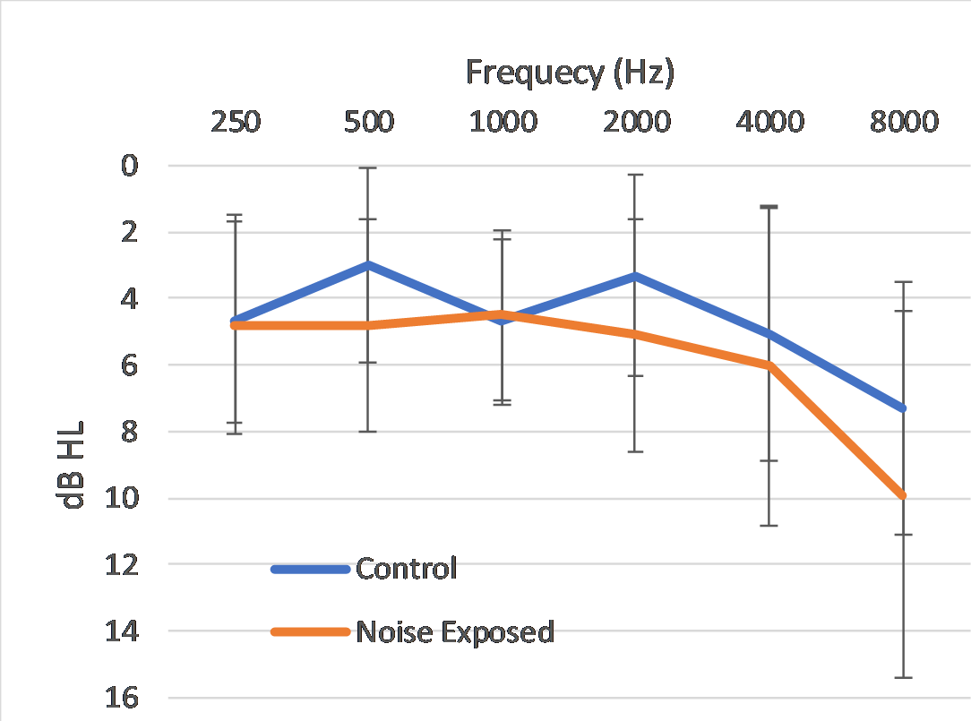

**Fig. 1** Mean air conduction thresholds of the control and noise exposed groups. Error bars indicate one standard deviation.

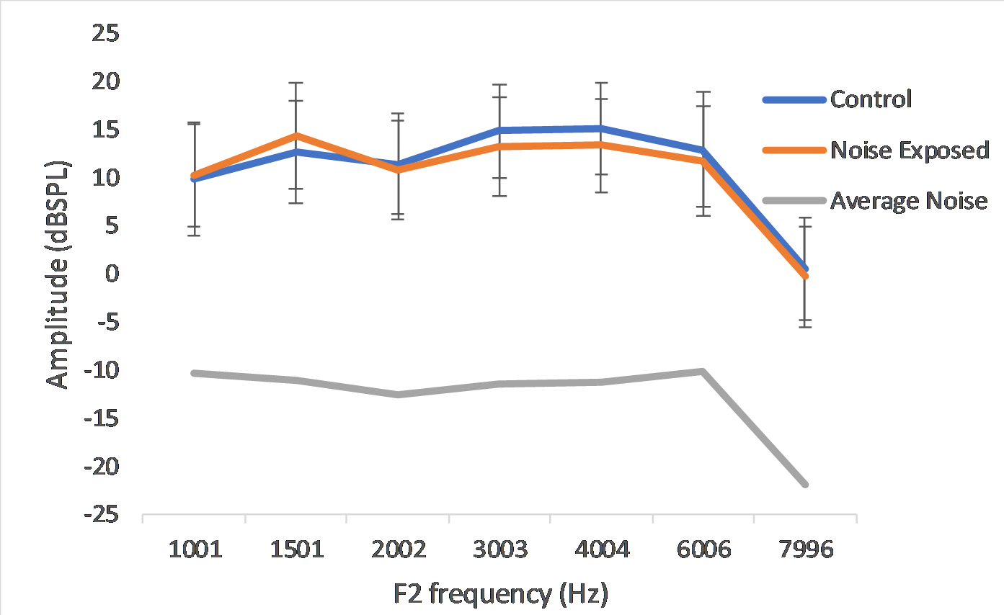

**Fig. 2** Distortion Product Oto-acoustic emissions in the two groups.

**Procedure**

*Speech Perception in Noise measurement (SPIN)*

Speech in Noise measurement was made using bi-syllabic word lists developed by Yathiraj and Vijayalakshmi, 2005 presented at 0 dB SNR. The ear (Right/Left) was chosen randomly and stimuli were presented through a Sennheiser HDA 200 headphones monaurally at 70 dB SPL. The subjects were instructed to repeat back what they heard and responses were scored. Total number of words correctly repeated was calculated and converted into a percentage.

*Psychoacoustic tests of gross temporal processing*

Gap detection thresholds Temporal modulation detection thresholds were measured in the same ear as SPIN using broadband noise. MATLAB 2014a was used for stimulus presentation and response acquisition. Both Gap detection test and Temporal modulation detection thresholds were measured using the maximum likelihood procedure ([Grassi & Soranzo, 2009](https://www.frontiersin.org/articles/10.3389/fpsyg.2014.00712/full#B10)) employing a three alternative forced choice technique. The transducer and the level used was the same as the SPIN procedure. Average of three trials was considered as the final threshold to control for any learning/practice effects. Modulation detection thresholds were measured at rates of 8Hz, 20Hz, 60Hz and 200Hz. The modulation index ‘m’ ranged from 0 (no modulation) to 1 (100% modulation) and was expressed in terms of 20 log10 m (dB).