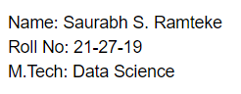

**Conclusion**

* Linear regression is commonly used for predictive analysis as we have used to predict housing price (dependent variable) based on 7 features (Independent Variable).
* Linear Regression attempts to fit the model for linear equation.
* After 300 iterations we can see that the model converges with mean square error (MSE).
* R-squared signifies the goodness of fit measure for Linear Regression models. It indicates percentage of variance in dependent variable that independent variables can explain correctly.
* If dependent and independent variables are having linear relation then R squared value would be closer to 1.
* Else it would be closer to 0, and the data would not have linear relation and hence we need to change try other models for convergence.

**Speed**

1. Gradient descent model trains the data in **0.09 secs**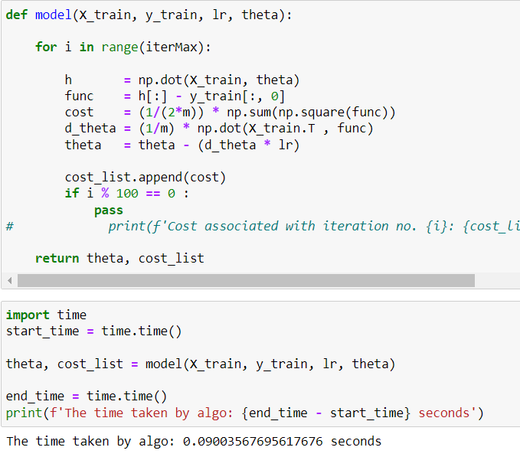
2. Normal equation model trains the data **in 0.012 secs**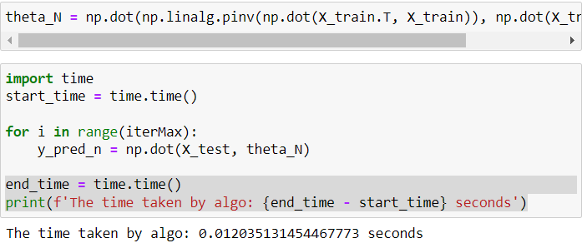
3. Sklearn model trains the data in **0.15 secs**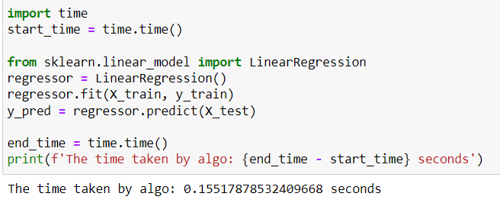

As we have done 2000 iterations in our gradient descent model still the time required to train the dataset is less than both normal equation and sci-kit learn . As by default sci-kit learn iterates only for 1000 iterations, it still takes a larger time to compute the model.

**Accuracy**

1. Gradient Descent

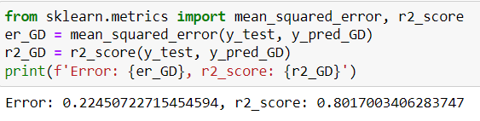

1. Normal Equation

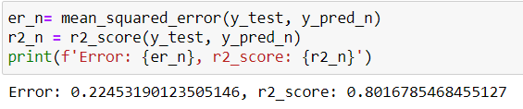

1. Sklearn

