Theater Festival Ticketing System
PRODUCT REQUIREMENTS DOCUMENT | Version 1.0 | 5 September 2026
Uttarpara Ganafubon auditorium
A production implementation specification for section based ticket sales, Razorpay payments, digital and physical passes, and controlled admission across a theater festival.

Recommended operating model
Sell a defined section, never a numbered seat. A Daily ticket admits one person to one selected performance. A Season ticket admits one person once to each explicitly included performance. Both use the same central admission ledger. Reserve capacity before payment and confirm only after verified capture.
Physical exchange replaces the digital entry credential while preserving the ticket and all admission history. Every gate checks the same online authority. Copies of a QR cannot create a second standard admission, although a stolen unused copy can be presented first.

Ownership and decision status
For the festival committee, venue operations, design and engineering teams, finance and gate supervisors. The committee owns commercial policy; the venue manager approves capacities; engineering owns integrity and recovery; finance owns reconciliation.
This is an implementation baseline with explicit proposed defaults. Confirm the surveyed capacity, official venue spelling/address, programme, ticket scope, refund terms and budget before public sales. All example quantities are illustrative, not asserted venue capacity.

Visual direction
Warm paper, deep maroon and restrained brass accents, inspired by Bengali theater programmes. Use professionally reviewed Bengali and English public copy, readable type and uncluttered forms. The sketches are design guidance, not a surveyed auditorium plan.

Guide and product outcomes
Part | Coverage
Product | Assumptions, zones, capacity, catalogue and customers
Commerce | Booking, payment verification, tickets and refunds
Admission | Physical exchange, anti-duplication and gate operations
Experience | Five wireframes covering auditorium, booking, admin, ticket and scanner
Engineering | Architecture, data model, APIs, transaction rules and implementation files
Delivery | Security, privacy, recovery, acceptance, roadmap and risks

Requirement language
MUST means required for launch. SHOULD means the recommended default, changeable through a recorded decision. Phase 2 items are explicitly deferred. Performance and recovery values are acceptance targets, not measurements of an existing system.

Success measures
Zero oversold performance pools and zero duplicate standard admissions in concurrency tests. Every captured payment becomes a confirmed booking or a tracked refund case. At least 95% of healthy-provider captures should expose tickets within 60 seconds. Every privileged change and gate decision must be traceable.

MVP boundaries
One auditorium and one active festival, with a schema for future festivals. No assigned seats, seat selection, resale marketplace, independent offline gates or native mobile apps. Counter and complimentary tickets, when enabled, must consume the same stock. Public access begins from a booking link on the existing website.

Core invariant
One ticket represents one person. One entitlement represents that ticket’s right to attend one performance. One entitlement can have at most one standard admission. Season tickets contain multiple entitlements; printing, downloading and replacing a ticket do not add entitlements.

Assumptions and configurable decisions
ID | Proposed rule | Confirmation
D01 | Venue name as supplied | Confirm official spelling and address
D02 | Daily means one performance | If all shows in a day, create explicit DAY_PASS coverage
D03 | Season covers a frozen show list | New shows are not automatically included
D04 | Season rows Front 4, Back 2, Balcony 2 | Back 4-row alternative remains configurable
D05 | Row labels are internal only | No individual seat number is sold or printed
D06 | One ticket per person per covered show | Quantity 3 creates three independent tickets
D07 | No standard re-entry | Intermission remains inside controlled premises
D08 | Digital entry until optional physical exchange | Committee may configure mandatory exchange
D09 | INR and Asia/Kolkata display | Integer paise; store timestamps in UTC

Use local row numbering from the front of each zone. Persist row ranges, quantities, mappings and versions; never hardcode two or four Back season rows. Whole-zone allocation to one category is supported, with the unused category disabled.
Proposed defaults: checkout hold 10 minutes; maximum 6 tickets per order; entry opens 60 minutes before curtain; late entry closes 15 minutes after curtain, subject to production policy. Record all as approved configuration before publication.
If Daily means a whole day, define explicit included performance IDs and reserve capacity for each, just as for Season. A label change alone cannot change admission scope. Sold scope, price and policy versions remain immutable snapshots. Season sales close before the first covered show by default; later sales require a new future-only coverage version and disclosed price.

Auditorium zoning
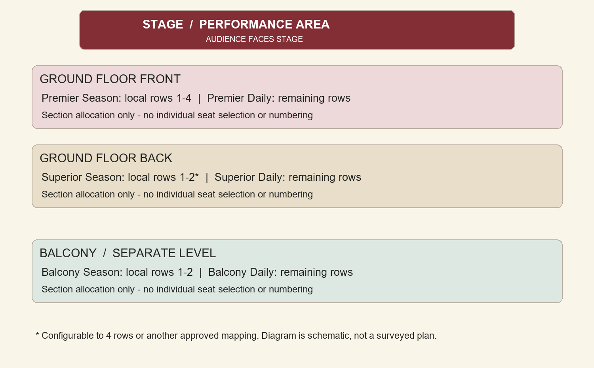
Figure 1 Schematic zoning and initial row allocation
The balcony is a separate level. Stairs, exits, aisle widths, accessible spaces and row capacities require a venue survey. The diagram does not establish safe capacity.
Map contiguous or multiple row ranges to the six categories. Entire Front may become Premier Season and entire Back Superior Daily. Optional left/right Front subzones can carry separate physical capacities while sharing a sale category. Do not assume the source’s two portions are necessarily left/right.
Reject overlapping row assignments for incompatible categories in the same performance. Row capacity caps sale quantity; a lower allocation is allowed. Signage and ushers enforce the sold boundary. First come, first served applies within the purchased allocation, not the entire auditorium.

Inventory and top up requirements

INV01 Capacity authority
For each performance and physical zone, approved capacity less safety blocks is the sellable ceiling. Category allocations plus unallocated reserve must not exceed it. Unknown capacities block publication. Accessible and companion allocations must be included in the venue-approved quantities.
For pool p: available = allocation - active holds - committed units. Preserve available >= 0 and allocation >= held + committed. PostgreSQL is authoritative; display caches are estimates. Admission does not decrement sale stock again.

INV02 Atomic holds
A checkout hold reduces availability. Confirmation converts held units to committed units, without a second decrement. Expiry releases held units exactly once. Lock pool rows before checking capacity. The expiry worker and payment fulfillment must serialize so neither double-releases nor oversells.

INV03 Season capacity
A season hold reserves one unit in every covered performance pool in one transaction. Lock pool IDs in sorted order and commit all or none. Season availability is the minimum available among covered pools, additionally limited by a configured product cap. Do not automatically release a season no-show unit for Daily sale.

INV04 Admin top ups
Top-up releases approved reserve or transfers unheld, uncommitted units from another category. Require source, delta, reason, actor and expected version. Preview all affected performances, then revalidate atomically on apply. A stale preview returns conflict. Never permit direct editing of the available count.
Increasing the physical ceiling requires a separately approved venue revision with evidence. Decreasing below held or sold commitments is rejected and routed to a remediation workflow. Sold mapping changes must preserve promised rights. A Season-to-Daily transfer cannot remove capacity reserved by existing passes.

Example
Illustrative Front ceiling 100: Season allocation 40, sold 20, held 2 gives 18 available. Daily allocation 60, sold 35, held 3 gives 22. Daily top-up of 10 needs unallocated reserve or a valid transfer. It cannot silently make the physical total 110.

Catalogue and simple administration

CAT01 Configuration
Separate Production (play name, troupe, synopsis, artwork, runtime, language and age guidance) from Performance (production, stage, date, start/end, entry window and status). Festival includes venue address, dates, contacts, terms and branding. Prevent stage overlaps including setup and clearing buffers.

CAT02 Products and price
Configure Premier Season, Premier Daily, Superior Season, Superior Daily, Balcony Season and Balcony Daily. Each product links type, coverage, mapping version, sale window and price. Show subtotal, fees, applicable tax and final total before payment. Finance must confirm tax and fee treatment; no statutory rate is assumed.
Price changes affect new quotes. Valid holds retain their stored price until expiry. Persist unit price, quantity, fee/tax amounts, currency and terms version on booking items. Season pricing is independent of Daily pricing. Discounts are Phase 2.

ADM01 Navigation and publication
Use Overview, Shows, Inventory, Orders, Ticket desk, Gate status and Reports. Default to the active festival. Search bookings by reference or verified contact. Highlight pending captures, refund exceptions, low stock and gate connectivity in plain language.
Draft -> validated -> published -> sales paused -> closed/cancelled. Publication requires approved capacity, mappings, prices, coverage, terms and support contacts. Sales pause must not disable valid admissions. Rescheduling retains performance identity and invokes notification and refund policy.

ADM02 Reporting and existing sales
Report allocated, held, sold, cancelled, available and admitted per show/category. Finance exports distinguish capture, fees, requested/completed refunds and settlement references. Complimentary and counter sales require explicit tender or zero-price authorization and the same inventory engine. Import any existing paper sales before online launch; no untracked legacy pass can bypass gates. Protect CSV exports from formula injection.

Customer identity booking and recovery

CUS01 OTP login
Accept mobile OR email and verify at least one channel before paid checkout. Alternate contact is optional. Normalize mobile to E.164 and email safely. Bind verified contacts uniquely to a customer; never merge accounts based only on an unverified match.
Proposed OTP controls: 6 digits, 5 minute expiry, 5 attempts, 30 second resend cooldown and 5 sends per destination/hour plus IP/device limits. Store keyed hashes, bind purpose and destination, invalidate on use and never log codes. Use neutral responses to prevent account enumeration.

CUS02 Checkout
Show title, troupe, exact time in IST, venue, category, availability, accessibility help and full Season coverage. Server validation controls stock and price. Keep useful form state when stock changes, explain the new availability and obtain a new quote when the hold expires.

CUS03 My tickets
OTP login retrieves only owned bookings with pending, confirmed, cancelled and refund status. Secure PDF download and resend reuse the active digital credential. Re-download never creates another ticket. After physical exchange, provide an exchange receipt and recovery instructions, not the active physical entry secret.
A closed browser or failed email cannot lose a confirmed booking. My tickets polls server status. Changing or linking contact requires proof of both account ownership and the new channel, or supervised recovery. Use secure HttpOnly session cookies, CSRF protection and session expiry.

CUS04 Assisted recovery
If both channels are lost, support checks purchase evidence and payment references without requesting card secrets. A supervisor logs verification and any replacement. Preserve admission history. Recycled phone numbers remain a risk: mask historical personal data and apply extra verification for older sensitive bookings.
Separate service delivery from optional marketing consent. Allow keyboard and screen reader use; do not rely on color for availability, errors or OTP status.

Booking page wireframe
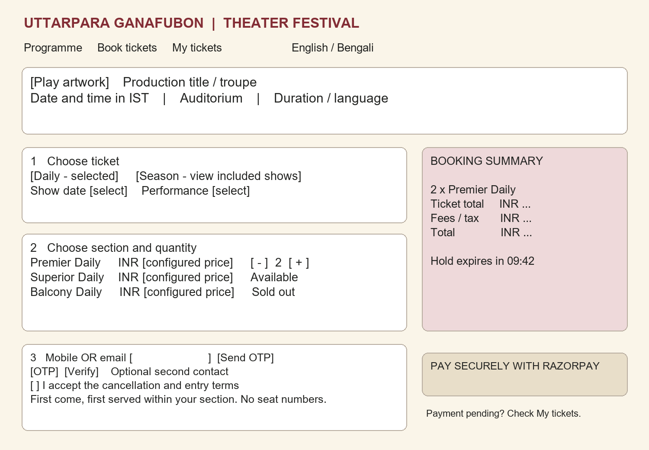
Figure 2 Public booking page and order summary
On mobile, stack the summary under selection and keep the total/pay action accessible without obscuring content. Use large targets and labelled OTP inputs. Public deep links can preselect festival or show; never place contact details or QR secrets in URLs.
Add Book tickets on the existing website linking to a dedicated booking subdomain. Keep a route back to the programme. Use Bengali and English language controls; fonts such as Noto Sans Bengali and Noto Serif Bengali require packaging and readability checks. All translated operational copy needs human review.

Payment verification and booking states

PAY01 Razorpay integration
Create the provider order on the backend from the stored paise amount, currency and booking reference. Use hosted Checkout so the application does not collect card data. Verify the checkout signature using the stored order ID. A browser success message is never authority to issue tickets. [S1]

PAY02 Capture and fulfillment
Require captured payment with matching provider order, payment ID, amount and currency. Verify webhook signatures over the exact raw body, persist the event before acknowledgement and deduplicate event IDs. Callback, webhook and reconciliation call the same idempotent fulfillment function. Handle out of order events without reversing a terminal state. [S1, S2]

PAY03 Late and uncertain payment
Authorized or initiated is still pending. When capture arrives after hold expiry, reacquire all required pools under lock. If unavailable, issue no ticket and create a refund-required case. Never oversell because payment arrived late. Show pending while provider status is uncertain.
Persist payment attempts before external calls. If order creation times out, reconcile the uncertain attempt before opening another checkout. Enforce unique provider payment IDs. If two payments capture for one booking, fulfill once and refund the excess. Do not assume an external API supports idempotency without checking its contract.

PAY04 State model
Booking: DRAFT -> HELD -> PAYMENT_PENDING -> CONFIRMED; expired unpaid holds become EXPIRED. A late capture becomes CONFIRMED only after reacquisition, otherwise REFUND_REQUIRED. Payment states CREATED, AUTHORIZED, CAPTURED, FAILED are separate from booking. Refund states REQUESTED, PROCESSING, SUCCEEDED, FAILED are separate again.
Reconcile active uncertain orders every 60 seconds, recent exceptions every 5 minutes, and finance totals daily. Retry with bounded backoff and a dead letter queue. Alert on captured payments unresolved for 5 minutes. PDF or notification failure retries delivery without undoing confirmation.

Booking and payment flow
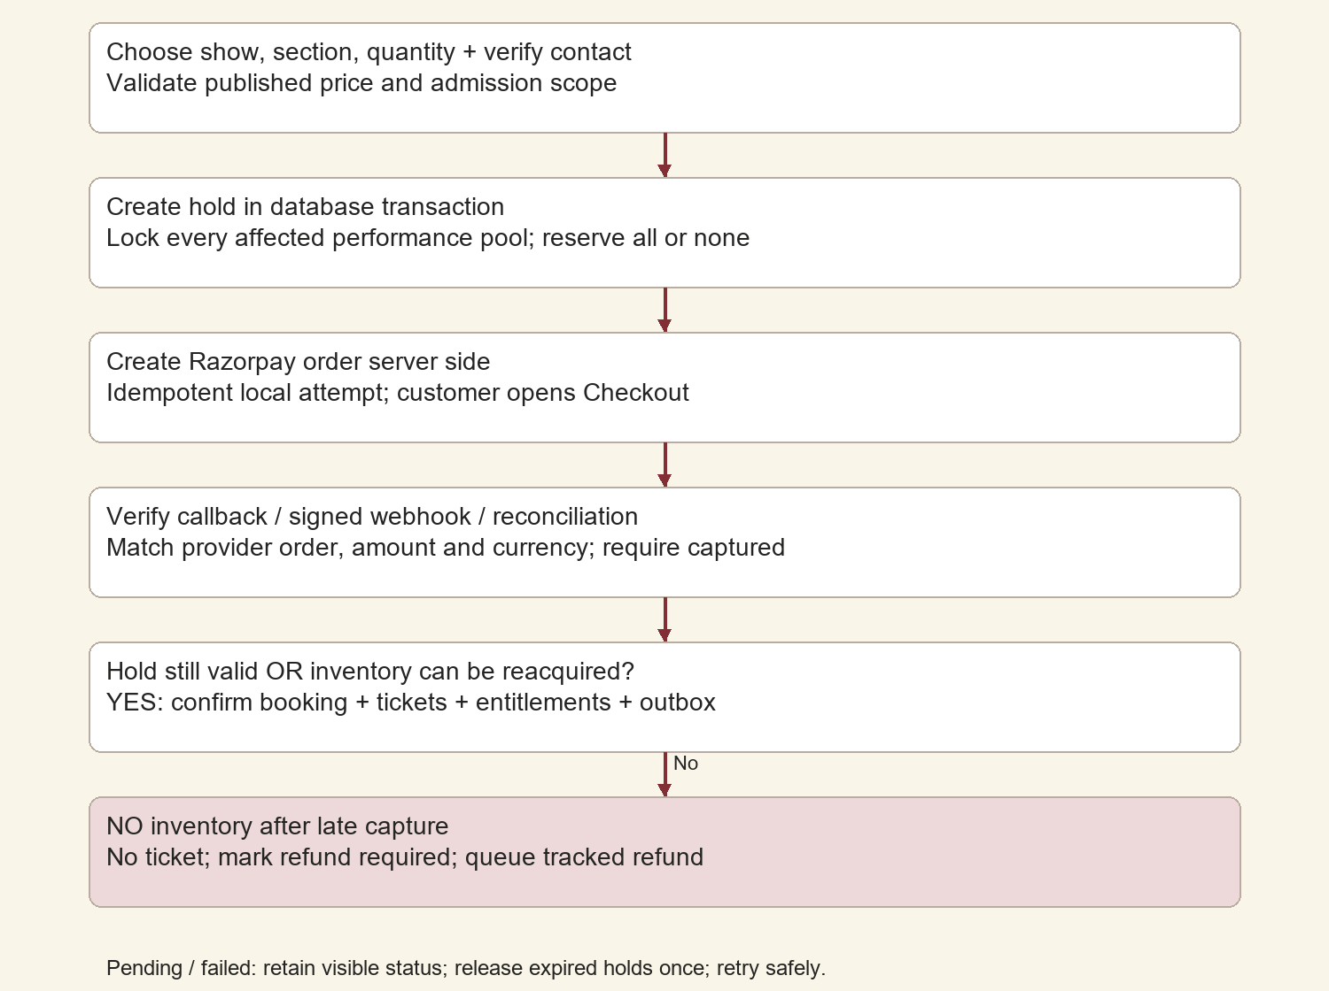
Figure 3 Booking and payment fulfillment
Fulfillment commits payment identity, allocation conversion, one ticket per person, covered entitlements and an outbox in one database transaction. Generate PDFs, send messages and call refunds after commit. No external network call runs while holding inventory locks.
User abandonment releases the hold once at expiry. A subsequent capture still follows the late-payment path. Replayed webhooks or browser retries cannot create additional tickets or inventory movements.

Digital tickets and physical issuance

TKT01 Contents and credential
Generate one PDF ticket per person, conveniently grouped for download. Include reference, festival, production or Season coverage, category/zone, date/time or validity, quantity 1, receipt reference, masked contact, entry terms, support and QR. Never print a seat number.
Use a cryptographically random 256-bit opaque QR token and format version with no personal data. Store a lookup hash and only the encrypted recoverable material needed to reproduce the active digital PDF. Keep secrets out of logs and analytics. The server lookup and ticket state establish authenticity, not visual appearance.

PHY01 Exchange workflow
At the desk, scan the digital ticket and verify the buyer through OTP or approved purchase evidence. Prepare a unique physical serial and inactive new token. Print and inspect the pass. At handover, atomically activate the physical credential, revoke the digital credential and log actor, serial and time. Exchange does not consume admission.
Physical issue states: PREPARED -> ISSUED or VOID. Controlled reprints use the same preparation reference; destroy spoiled stock. If activation acknowledgement is lost, recover the existing issue rather than issue again. Printing can occur locally, but activation requires the online authority.

PHY02 Lost pass
Supervisor recovery verifies ownership and reason, then revokes the old credential and activates a replacement in one transaction. Keep ticket ID and used entitlements unchanged. A replacement cannot reset admission. Customer re-download after exchange must not expose an extra physical pass.

PHY03 Published policy
Recommend digital admission until optional exchange. If physical exchange is mandatory, configure it per festival, disclose it before payment and reject digital entry at gates while accepting digital proof at the desk. Durable Season stock, color bands and serials supplement the server check.

Ticket wireframe
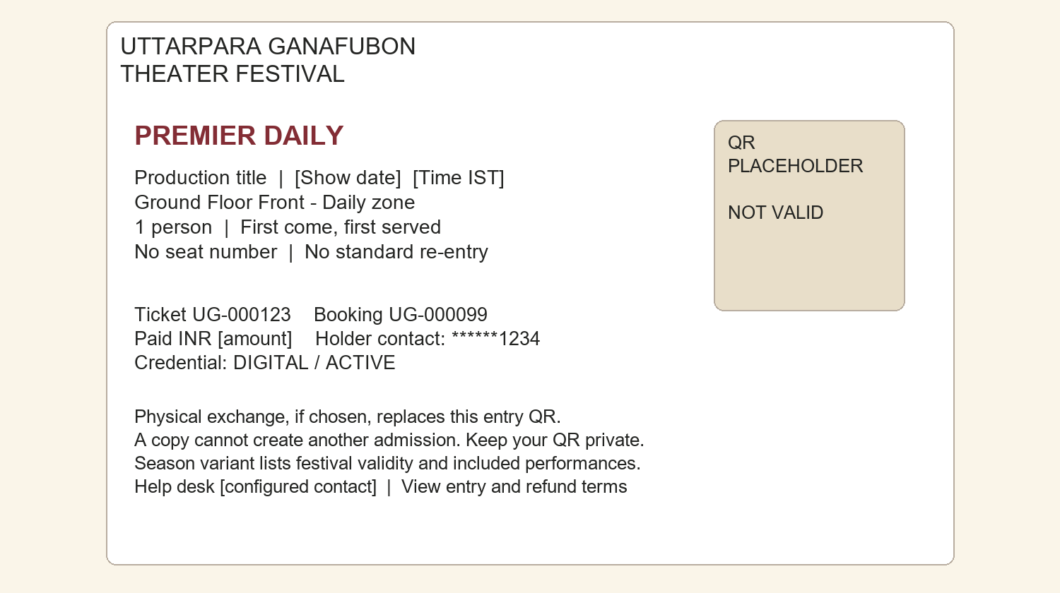
Figure 4 Ticket for one attendee
The QR is a non-functional placeholder. Production QR codes need a clear quiet zone and high contrast; start at 30 mm on paper and test actual printers, cameras and auditorium lighting. Avoid artwork inside the code.
Daily tickets show the exact performance; Season passes show validity and included-show reference. Three attendees receive three QR tickets so they can arrive separately. An order receipt is clearly marked as a receipt and cannot grant admission.

Gate validation and anti duplication

GATE01 Atomic admission
Staff select and confirm the performance and gate. Submit token, performance ID, device ID and unique request UUID. Authenticate staff and show/gate scope. Lock ticket and entitlement; recheck active credential, ticket state, coverage and server time. Insert admission with UNIQUE(ticket_id, performance_id). Commit before returning ADMIT.
Cancellation, credential replacement and admission share ticket/entitlement lock ordering. One concurrent scan wins. A repeat transport request with the same UUID returns the original receipt labelled as a retry; a fresh scan after admission returns ALREADY_USED with time and gate. UI must not admit again from a repeated receipt.

GATE02 Copy limitations
Screenshots and photocopies resolve to the same entitlement, so they cannot add a second standard admission. However, the QR does not identify the rightful human: a stolen unused copy may be used first. Keep codes private and require ownership checks at exchange. Optional Season holder-name checks may reduce sharing without collecting identity document copies.

GATE03 Season versus Daily
Daily has one entitlement. Season has one per included performance; using show A does not block show B, and repeat A is denied. Never reset a pass daily. Multiple shows on one date each require their own entitlement. Intermission stays inside the controlled perimeter; standard external re-entry is not allowed.

GATE04 Connectivity and exceptions
Offline or timeout is UNKNOWN or PAUSED, never green. Retry the same UUID to recover a committed result. Independent offline devices cannot guarantee cross-gate duplicate prevention. MVP requires venue Wi-Fi, separate mobile fallback, spare charged devices and a rehearsed pause procedure.
Manual lookup and supervisor admission remain online and use the same unique constraint. Supervisors may resolve unreadable tickets or ownership disputes but cannot erase history or bypass an already-used ticket. Accidental scan before entry is resolved against the existing admission with an incident record. Emergency evacuation and life safety take precedence.

Gate validation flow
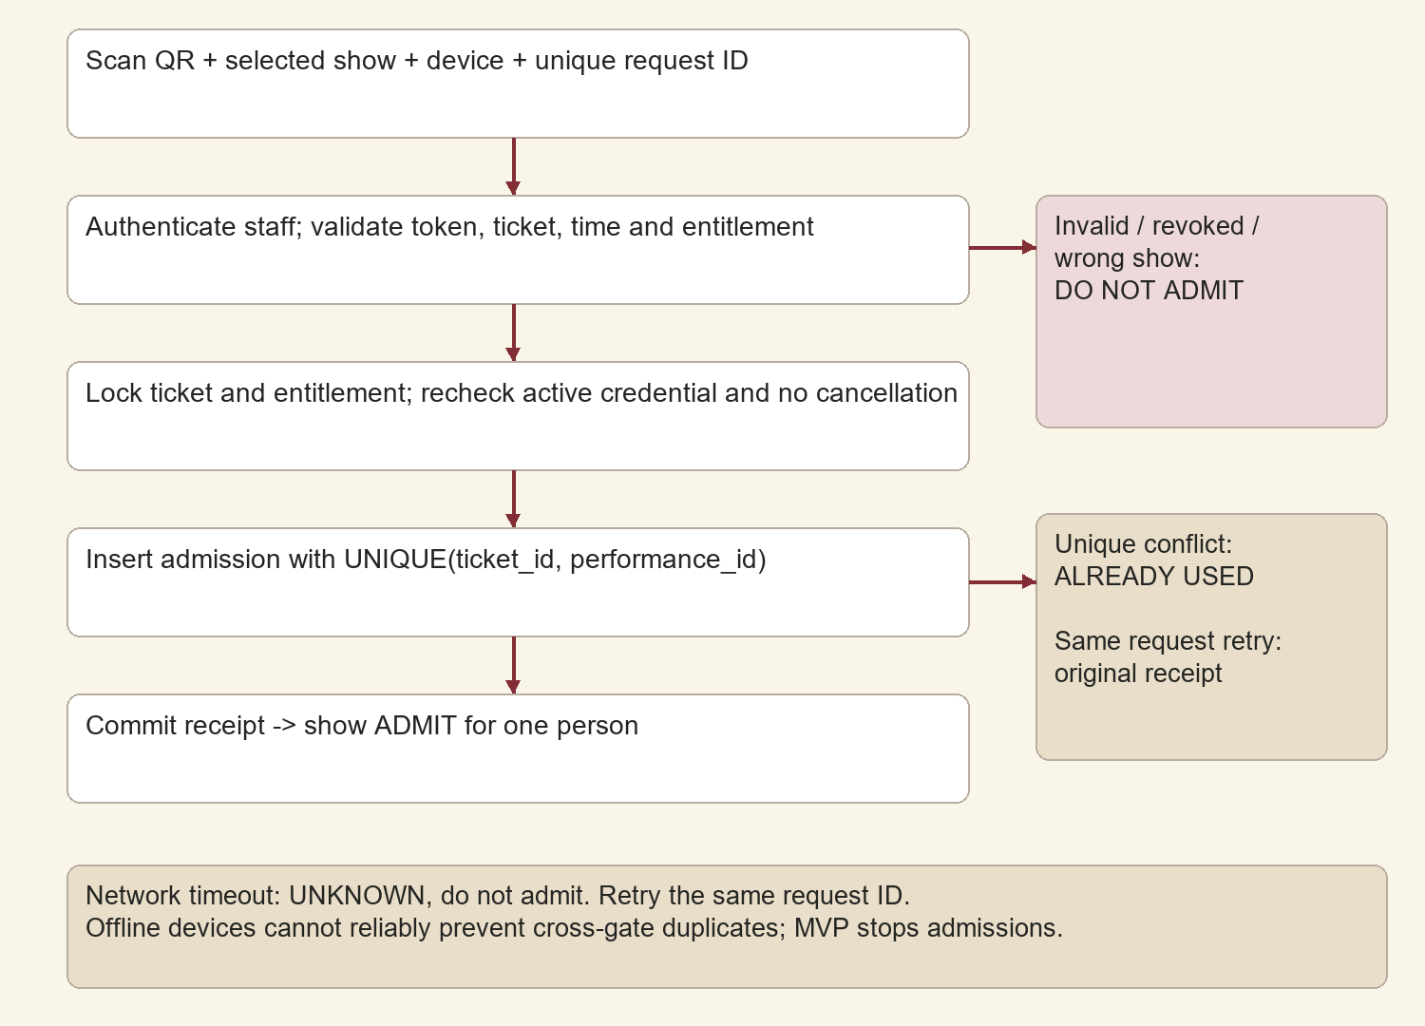
Figure 5 Admission validation and exception paths
Result codes: ADMITTED, ALREADY_USED, WRONG_SHOW, OUTSIDE_WINDOW, INVALID, REVOKED, CANCELLED, PHYSICAL_REQUIRED, NO_PERMISSION and RETRY_REQUIRED. Invalid tokens disclose no customer data. Return only the section and operational details staff need.
Receipts contain admission ID, request ID, show, gate and server timestamp. Keep the result visible until Scan next; debounce repeated camera reads. Stronger supervisor authentication and a reason are required for incident resolution.

Gate scanner wireframe
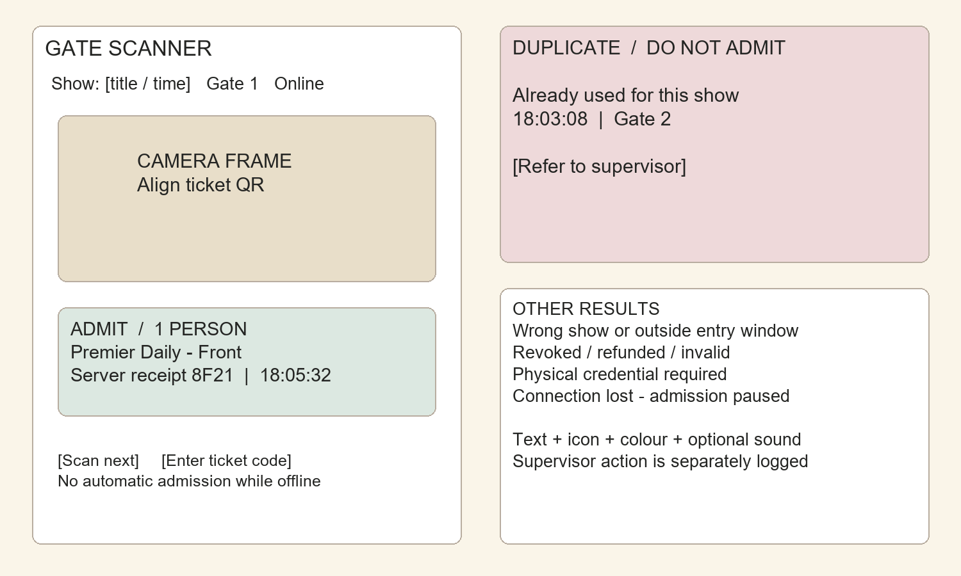
Figure 6 Admit and deny states
Use text, icons and optional sound or vibration for distinct results. Display connectivity and selected show prominently. Camera denial offers a staff-controlled ticket reference lookup with the same server checks.
Use portrait phone layouts, large result text and at least 44 px touch targets. Lock show assignment during the shift unless a supervisor changes it. Before doors open, test both networks, paper codes, cameras, printer stock and the pause procedure. Volunteers must distinguish lookup, exchange and admission.

Admin inventory wireframe
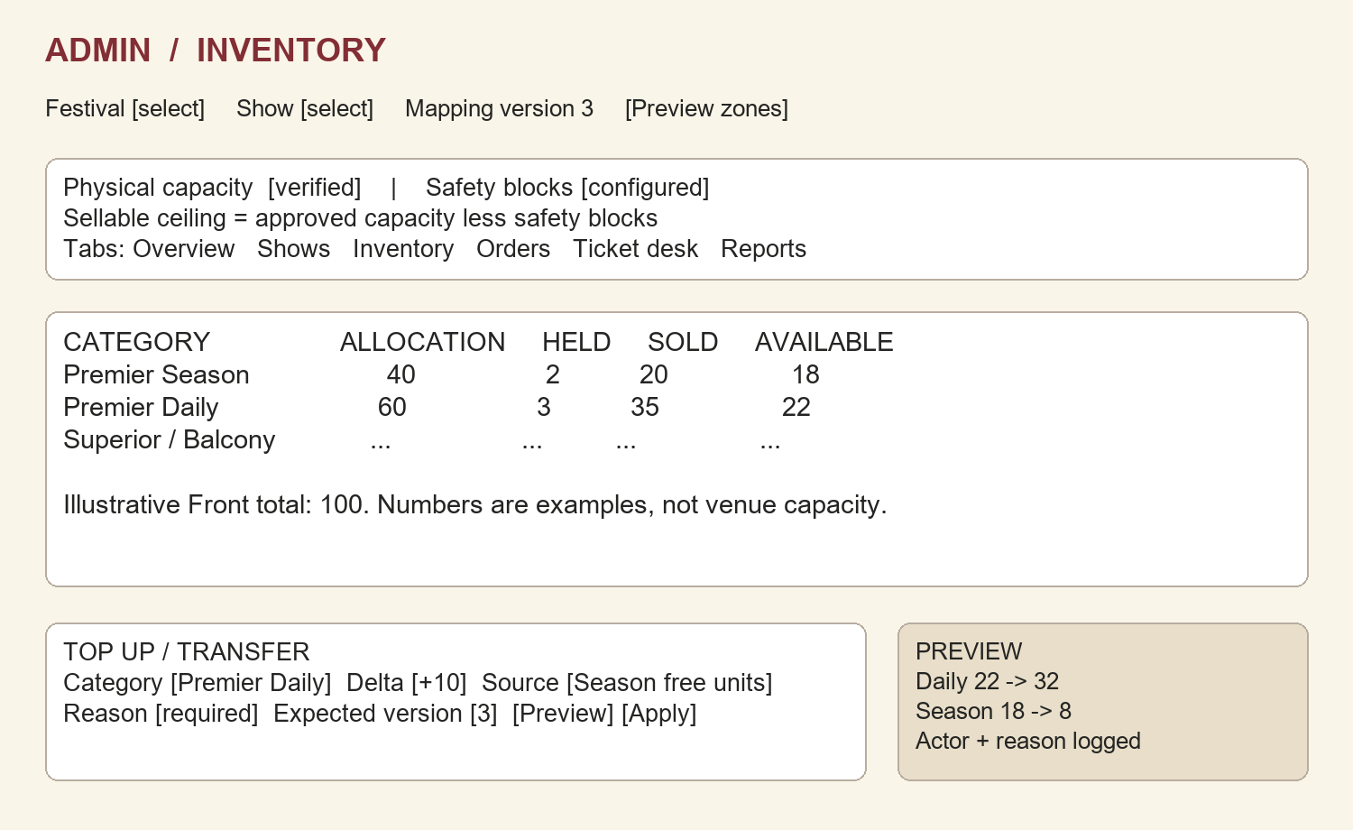
Figure 7 Inventory overview and top up preview
Held, sold and admitted are read-only counters. Show the capacity ceiling, mapping version and pending changes. The admin adjusts allocation with a reason and source, not the available counter.
Season top-up preview lists all affected performances and limiting capacity. Mapping edits show impacted sales and block unsafe changes. Export the movement ledger to explain who changed what and why. Replace the illustrative screen quantities with venue-approved values before publication.

Refunds cancellations and audit

REF01 Proposed policy
Public customer cancellation is disabled until the committee approves terms. If enabled, allow wholly unused Daily tickets before a configured cutoff. Unused Season passes may be cancelled before the first included show; partially used passes require finance review. Terms must disclose fees, cutoff and expected refund processing without inventing a provider guarantee.
Organizer cancellation of a Daily show follows its approved refund rule. A cancelled Season show uses per-show price weights or another formula disclosed and stored at purchase. Do not divide by a programme count that changes after sale. Rescheduling retains show ID and provides the agreed acceptance or refund window. [S3]

REF02 Safe processing
Lock ticket and entitlement on approval, block future entry and cancel eligible allocations once. Release only eligible future stock, never a used admission. Create a unique refund operation and call Razorpay after commit. Persist provider refund ID and reconcile uncertain responses before retry. A failed refund leaves the ticket cancelled with a finance alert, not silently reactivated.
A refund for one cancelled Season show revokes only that show entitlement; the pass and other shows remain active. Full-pass cancellation revokes all unused entitlements. Partial order cancellation names ticket IDs and preserves the rest. Total refunds cannot exceed captured value. Disputes suspend unused rights pending review. Daily finance reconciliation compares booking, capture, refund and settlement references.

AUD01 Audit and permissions
Log actor, role, time, request, entity, action, reason, before/after values, device and outcome for configuration, quantities, prices, refunds, issue, replacement, recovery and scans. Redact secrets. Use append-only application permissions and protected immutable exports.
Owner controls roles and approved capacity; inventory manager adjusts allocations; finance approves refunds; desk issues physical passes; scanners access assigned shows; supervisors resolve incidents. Use individual accounts and staff MFA. Owner approval is required for ceiling changes; a second approver is recommended for high-value refunds. No hidden reset-used-ticket action is allowed.

System architecture
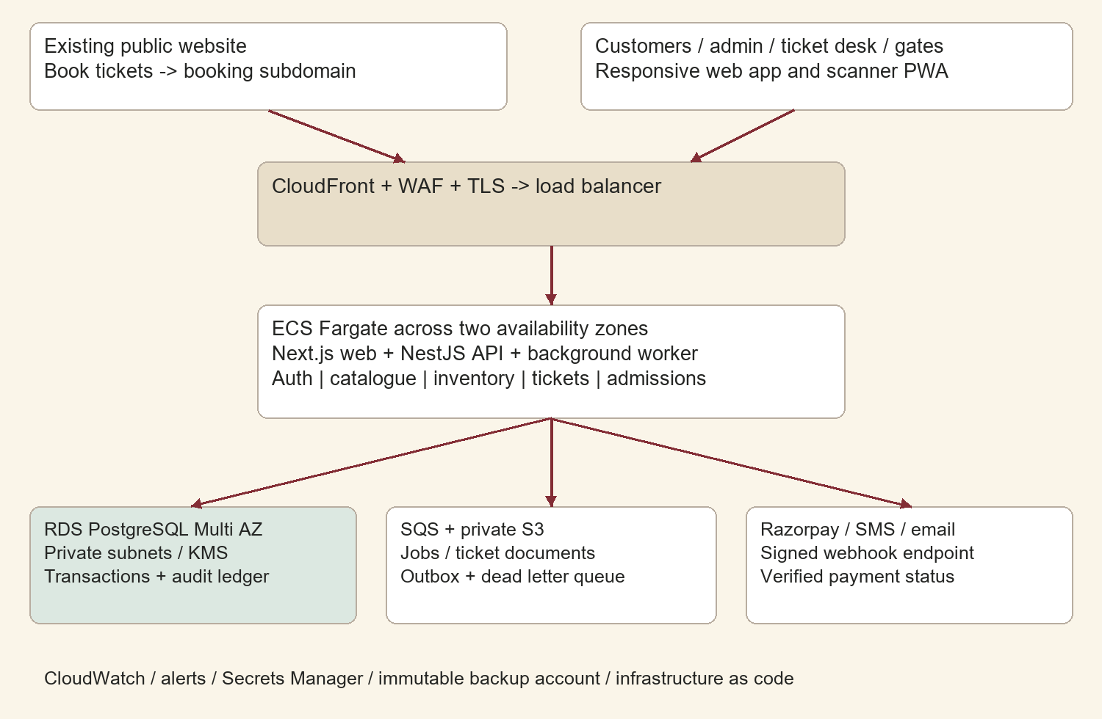
Figure 8 Deployment and service integration
Use a modular monolith, transactional PostgreSQL and asynchronous workers. Keep inventory and admission correctness in one transaction boundary. CloudFront caches programme content and assets only; ticket, payment and admission responses use no-store.
API tasks reach the database privately. Committed outbox records feed SQS; consumers tolerate duplicate delivery. SMS, email and document generation failures do not reverse fulfillment. No cache or queue is the stock or admission authority.

Hosting and recommended stack
Layer | Recommendation | Purpose
UI | Next.js, React, TypeScript | Responsive public, customer and staff routes
API / worker | NestJS, TypeScript | Domain modules and background processing
Data | RDS PostgreSQL Multi AZ | Transactions, locks, unique constraints
Data access | Prisma plus reviewed SQL | Migrations and explicit critical locking
Jobs / files | SQS, private S3, KMS | Outbox delivery, PDFs and encryption
Hosting | AWS Mumbai primary | Application across two availability zones
Operations | CloudWatch, Secrets Manager, Terraform | Alerts, secrets and repeatable deployment
Tests | Vitest, Playwright, k6 | Unit, browser and concurrent load tests

Recommend AWS production hosting for regional deployment, managed database availability and backup controls. Run at least two application tasks behind a load balancer across availability zones; scale workers separately. RDS Multi AZ improves availability but is not a backup or a guarantee of zero application downtime. [S4]
This costs more to operate than one server. A single self-managed VPS database is unsuitable as the production admission authority. If budget changes the choice, retain the transaction design and require comparable restore, durability and network tests.
Prepare a current Mumbai calculator estimate including tasks, RDS standby, load balancer, NAT/private endpoints, WAF, storage, backups, logs and data transfer. Add payment fees, SMS, domain, printing and support. No fixed cost quote is assumed; Fargate cost depends on requested resources and runtime. [S5]
Pin supported dependency versions and lockfiles at implementation. Separate staging and production data, keys and cloud environments. CI uses short-lived credentials, scanning, reviewed migrations and staged rollout. Keep schema changes backward compatible for safe application rollback.

Data model and relationships
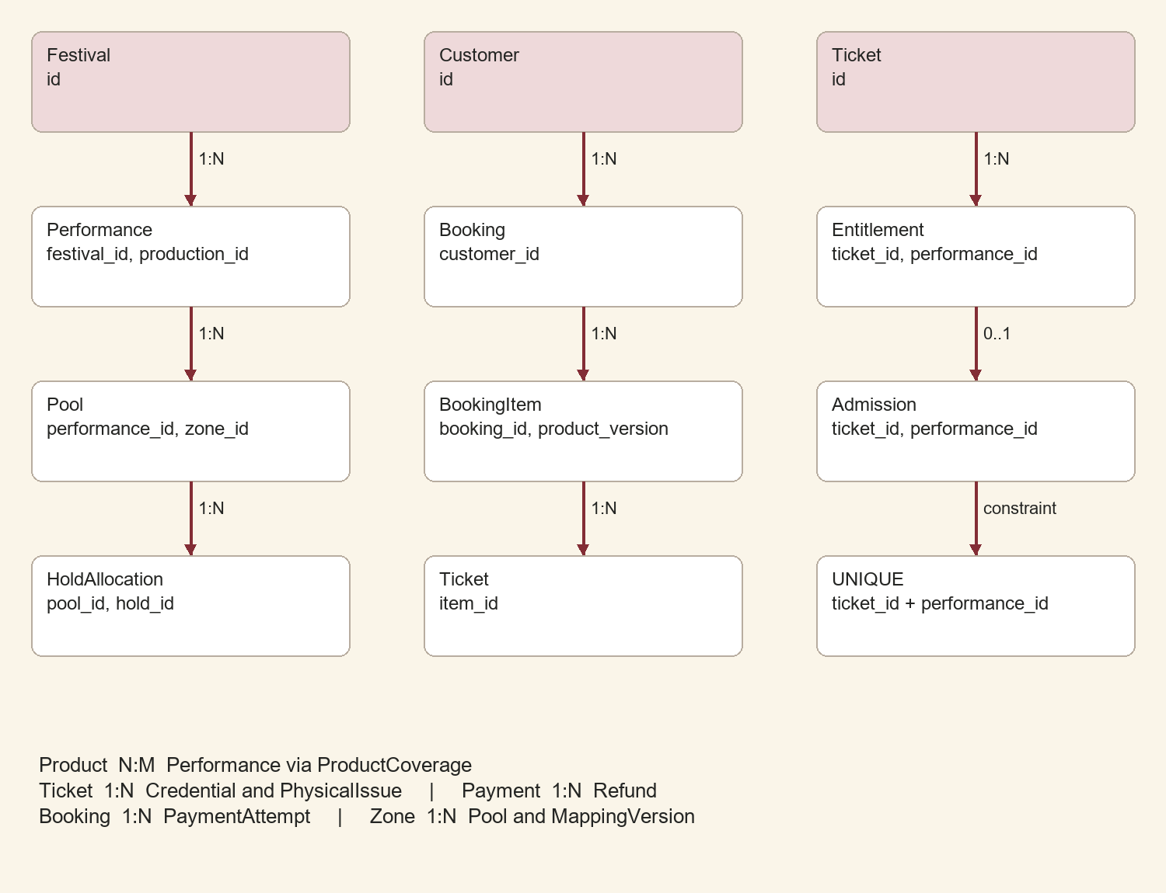
Figure 9 Core entity relationships
Use immutable UUID keys, created_at and relevant status/version fields. Monetary amounts are paise and timestamps UTC. Public references are separate from internal IDs. Restrict deletion of sold and financial records.
Festival 1:N Performance; Production 1:N Performance; Venue 1:N Zone; Zone 1:N MappingVersion; Performance 1:N Pool. Product N:M Performance through ProductCoverage. Customer 1:N Booking; Booking 1:N Item and PaymentAttempt. Item 1:N Ticket; Ticket 1:N Entitlement, Credential and PhysicalIssue; Entitlement 0:1 Admission. Payment 1:N Refund. Pool 1:N HoldAllocation and InventoryMovement.
Daily and Season are product types with coverage, not separate ticket systems. Entitlements reference committed pools so refunds release the correct stock. Admission references the ticket and performance of that entitlement.

Data dictionary and constraints
Entity | Required fields and constraints
Mapping | zone, version, row ranges, category, approval; no overlapping incompatible assignments
Pool | performance, zone, category, allocation, held, committed, version; unique dimensions; nonnegative counters
ProductCoverage | product version, performance, pool, price weight; unique product/performance; immutable sold scope
CustomerContact | customer, type, normalized contact, verified_at; unique verified binding
Booking / Item | customer, status, expiry, total, currency; product version, qty, price, fee, tax, terms version
HoldAllocation | hold, pool, quantity, expiry, state; unique hold/pool; atomic counter updates
PaymentAttempt | booking, provider order/payment IDs, amount, currency, state; unique provider IDs
Ticket / Entitlement | item, ordinal, state; ticket, performance, pool, state; unique item/ordinal and ticket/performance
Credential / Issue | ticket, token hash, version, type, revoked_at; unique serial and preparation ID; one active credential
Admission | ticket, performance, request ID, gate, actor, time; unique ticket/performance and request ID
Refund / Ledger | payment, operation ID, provider refund ID, amount, state; immutable inventory movements
Webhook / Outbox | unique provider event, raw body digest, processing state; job payload, attempts, next run

Index pool lookups, hold expiry, contact ownership, token hash, performance admissions and unresolved payments. Persist role/show/gate assignments, sessions and audit records separately. Enforce integer positive quantities.
Idempotency records include authenticated scope, key, input digest, result and expiry. Same key with different input returns conflict. Permanent financial and admission constraints survive request-cache expiry. A scheduled reconciliation compares pool counters against underlying allocations and pauses affected sales on any mismatch.

API and module structure
Method and route | Contract
GET /v1/festivals and /performances | Published catalogue only; public cache allowed
GET /v1/products/{id}/availability | Display estimate; hold decides actual stock
POST /v1/auth/otp/request and /verify | Rate limited, purpose-bound verification
POST /v1/holds | Customer, product version and qty; all covered pools
POST /v1/bookings/{id}/payment-order | Owning customer; recover uncertain attempt
POST /v1/payments/verify | Verify callback and provider state
POST /v1/webhooks/razorpay | Raw signed event; persist before 2xx
GET /v1/me/bookings and /tickets/{id}/download | Owner only; private short-lived download
POST /v1/physical-issues/prepare and /{id}/activate | Desk role; safe two-stage exchange
POST /v1/admissions | Scoped scanner; token, show, device, request UUID
POST /v1/admin/inventory/adjustments | Role, source, delta, reason, expected version
POST /v1/admin/tickets/{id}/replacement | Supervisor; verified ownership, reason
POST /v1/admin/refunds | Finance; selected tickets, amount and reason
GET /v1/admin/audit and /reports | Role scoped, paginated and export logged

Catalogue admin POST/PATCH routes cover festivals, productions, performances, products and mappings with explicit publish/pause commands. Do not expose unrestricted state edits. Money and stock mutations require Idempotency-Key.
Use versioned OpenAPI and schema validation. Standard errors: 400 invalid input, 401 unauthenticated, 403 denied, 404 inaccessible object, 409 stock/state/version conflict, 429 limited, 503 retryable failure. Scan business denial may be 200 with a non-ADMITTED code. All responses include request_id; never expose stack traces.
Modules: identity, catalogue, inventory, bookings, payments, tickets, physical-issue, admissions, refunds, notifications, audit and reporting. Authenticate every protected route and separately check ownership and show scope.

Critical transaction contracts

Reserve and fulfill
reserve(productVersion, qty):
BEGIN; lock covered pools in sorted ID order
assert every allocation - held - committed >= qty
insert hold allocations; increase held; COMMIT
fulfill(verifiedCapturedPayment):
BEGIN; lock booking, hold and pools consistently
if fulfilled: return existing tickets
if live hold: held -= qty; committed += qty
else: attempt to reacquire every covered pool
if unavailable: mark REFUND_REQUIRED; COMMIT; return
create tickets + entitlements exactly once
append outbox; set CONFIRMED; COMMIT

Admit
admit(token, performance, requestId):
authenticate staff and show scope
BEGIN; lock ticket then entitlement
if requestId exists: return original receipt
recheck active credential, valid state, show and time
INSERT admission with unique(ticket, performance)
COMMIT; return ADMITTED
on unique conflict: return ALREADY_USED
These are behavioral contracts, not complete code. Cancellation and replacement use the same ticket/entitlement lock ordering. Expiry and fulfillment use the same booking/hold/pool order. Avoid external calls while locks are held.
A ledger mismatch pauses affected sales and creates an assigned repair case. Do not silently overwrite counters. Daily financial reconciliation joins provider payments and refunds with bookings; every difference needs an owner and resolution history.

Proposed folder and file structure
theater-ticketing/
apps/
web/
app/(public)/festival/[slug]/page.tsx
app/(public)/book/[productId]/page.tsx
app/(customer)/my-tickets/page.tsx
app/(staff)/admin/inventory/page.tsx
app/(staff)/desk/page.tsx
app/(staff)/gate/page.tsx
components/{booking,ticket,scanner,admin}/
locales/{en,bn}.json
public/{fonts,festival-art}/
api/src/
modules/
identity/ catalogue/ inventory/ bookings/
payments/razorpay.adapter.ts
payments/fulfillment.service.ts
tickets/ physical-issues/ admissions/
refunds/ notifications/ audit/ reports/
common/{auth,errors,idempotency,validation}/
main.ts
worker/src/jobs/
expire-holds.ts reconcile-payments.ts
render-tickets.ts deliver-notifications.ts
process-refunds.ts export-audit.ts
packages/
database/{prisma/schema.prisma,migrations/,sql/}
contracts/{openapi.yaml,schemas/}
ui/ config/ observability/
tests/{unit,integration,e2e,concurrency,load}/
infra/terraform/{modules,environments/}
docs/{adr,runbooks,policies,zone-survey}/
.github/workflows/{ci.yml,deploy.yml}
.env.example package.json pnpm-lock.yaml
README.md SECURITY.md
Use controller, service, repository and schemas within modules. Keep Razorpay payloads behind an adapter and locking SQL reviewed. Never commit secrets, customer exports or production ticket documents. Runbooks cover outage, uncertain capture, refund failure, lost pass, printer failure, restore and compromised devices.

Security privacy and retention

SEC01 Controls
Require TLS, encrypted data/backups, least privilege, managed secrets and individual staff MFA. Revoke lost gate devices. Enforce ownership, show scope, input validation, CSRF protection, restrictive CORS and a tested Checkout-compatible CSP. Validate artwork uploads; prevent arbitrary executable content. Scan dependencies and patch supported versions.
Rate-limit OTP, token lookup and hold abuse using destination, account, device and IP with venue-aware limits. Never log QR tokens, OTPs, cookies, authorization headers or full contacts. Private document downloads require ownership and short-lived access. Test customer isolation and all privileged routes.

PRI01 Privacy
Collect verified contact, optional name and necessary booking records only. Avoid ID scans, biometrics and card details. Publish Bengali/English notices for purposes, processors, retention, rights and grievance contact. Optional marketing consent must be separate.
MeitY publishes the DPDP Rules 2025 and enforcement timeline. Review applicability and effective dates for the actual launch; do not assume all provisions are already in force. Assign privacy/grievance ownership, processor contracts, breach response and guardian-led booking where applicable. Obtain legal review of these implementation requirements. [S6]
Data | Proposed retention
OTP secret | 5 minutes; purge on use/expiry
Auth abuse metadata | 30 days with minimization
Ticket PDFs and recoverable QR | Festival end + 90 days; revoke/purge
Contact/support records | Festival end + 180 days unless dispute
Admissions / operational audit | 12 months; minimize personal identifiers
Financial records | Provisional 8 years; finance/legal confirm applicable period
Recovery backups | 35 day rolling window; deletion ages out

Honor documented legal holds without retaining unrelated data. Keep a deletion ledger and replay it after restore before opening service. Retain anonymous aggregate attendance where useful. Restrict and audit backup access.

Reliability monitoring and disaster recovery

NFR01 Test targets
Assume 1,000 concurrent browsers, 50 hold requests/second for a 5 minute burst and 20 gate devices totaling 20 scans/second; revise after demand estimation. Target admission server p95 below 500 ms and healthy-network end-to-end below 1.5 seconds. Catalogue response p95 below 1 second; mobile LCP below 2.5 seconds on the agreed profile.
Target 99.9% availability during sales/festival windows. Measure provider outages separately. Use bounded queues, database connection limits and load shedding. Prioritize gate traffic over reporting and bulk exports. Preserve integrity even when rejecting excess load.

OPS01 Alerts
Alert for scan error rate above 1% for 2 minutes, admission p95 above 1 second for 5 minutes, webhook lag above 2 minutes, captures unresolved after 5 minutes, any stock invariant violation, dead letters, refund errors, database saturation and backup failures. The engineer and gate supervisor own urgent incidents; finance owns payment exceptions.

DR01 Recovery design
Enable encrypted RDS point-in-time recovery for 35 days, daily snapshots and protected cross-account copies. Select and test an eligible secondary Indian region and copy arrangement. Confirm service and privacy compatibility. Multi AZ handles local failure; backups handle corruption and loss. Protect S3 versions and audit exports. [S4, S7]
Proposed targets: AZ failure RTO 15 minutes; logical database RPO 5 minutes/RTO 2 hours; regional disaster RPO 24 hours/RTO 8 hours using daily copies. Validate in drills. Lost recent admission records make gate reopening unsafe until reconciled; backup availability alone does not preserve one-ticket-one-entry.

DR02 Runbook
Pause sales/admission, isolate incident, restore into a new database, verify schema and invariants, reconcile provider captures and recent admissions against durable exports and gate receipts, replay deletion records, rotate compromised secrets and smoke test. If used-ticket history is uncertain, keep the affected show paused. The incident owner authorizes reopening. Test quarterly and before the festival.

MVP and delivery plan
MVP required | Phase 2
Six configurable categories and mappings | Visual row editor and multi-venue planning
Holds, safe top-ups, Season reservations | Waitlist and controlled no-show release
Razorpay verification and reconciliation | Promotions and enhanced settlement automation
OTP recovery and PDF tickets | Wallet passes and additional messaging channels
Physical issue and audited replacement | Specialized print hardware and holder verification
Concurrent online gate validation | Single-authority local gate server after rigorous design
Refunds, RBAC, MFA and audit | Advanced organizer analytics
Bilingual core flow, backups and monitoring | Richer discovery and localization

Indicative plan with two full-stack engineers and part-time design, QA and operations: 6 to 8 weeks after venue data and decisions. Week 1 confirms zoning/schema; weeks 2-3 cover identity/catalogue/stock; week 4 payments/tickets; week 5 desk/gates; week 6 refunds and resilience; weeks 7-8 rehearsal and fixes. This is a planning estimate, not a commitment.

Launch gates
Committee signs policies and programme. Venue signs capacity and installs signs. Finance completes Razorpay onboarding and a low-value live capture/refund check. Engineering passes integrity and restore tests. Security has no unresolved critical/high issues. Volunteers complete a two-gate rehearsal with actual phones and printed stock.
Confirm fallback internet, spare power, printer supplies, support roster and incident contacts. Reconcile pre-existing paper sales before publication. Freeze risky changes around each show. Deploy tested artifacts with monitored rollout and rollback; do not perform destructive migrations during admission.

Acceptance criteria for commerce
ID | Scenario | Pass condition
AC01 | Back Season mapping changes from 2 to 4 rows | Saved without code change; invalid overlap/capacity rejected
AC02 | Whole Front Season and Back Daily | Unused products disabled; correct public sections
AC03 | 100 requests compete for 10 units | At most 10 held/confirmed; never negative stock
AC04 | One Season covered pool has 2 units | At most 2 passes; all pools commit or none
AC05 | Hold expiry races capture | One conversion/release; late path works
AC06 | Top-up exceeds ceiling or stale version | Rejected; reason/conflict is clear and logged
AC07 | Duplicate/out-of-order webhook | One fulfillment and one inventory movement
AC08 | Forged callback or wrong amount | No confirmation; security event logged
AC09 | Late capture without stock | No ticket; tracked refund; customer status visible
AC10 | Browser closes and email fails | OTP recovers confirmed booking; delivery retry is safe
AC11 | Three tickets, one eligible cancellation | Only selected ticket revoked; other two valid
AC12 | OTP replay, expiry or attempt exhaustion | Rejected with rate limits and neutral responses
AC13 | Price edit during valid hold | Stored price honored; new quotes updated
AC14 | Refund accepted but reply lost | Reconciles existing refund; no duplicate amount

Use real PostgreSQL transactions for races and assert database invariants. Provider sandbox events cover signatures, retries and late capture. Complete an approved low-value live payment/refund check before launch. Happy-path screenshots alone are insufficient evidence.

Acceptance criteria for gates and operations
ID | Scenario | Pass condition
AC15 | Same QR scanned concurrently at two gates | One new admission; other ALREADY_USED
AC16 | Committed scan response is lost | Same request returns same receipt without extra admission
AC17 | Season used at A, then B, then A again | A and B each once; repeat A and uncovered C denied
AC18 | Physical exchange at two desks concurrently | One physical issue; digital revoked; history retained
AC19 | Lost used pass replaced | Old QR revoked; used show stays denied
AC20 | Refund and scan race | Serialized result; no entry after cancellation commits
AC21 | All gate connectivity lost | No green result; pause procedure applies
AC22 | Scanner accesses other show or admin mutation | Server authorization denies
AC23 | Customer downloads another customer ticket | No disclosure or enumerable private access
AC24 | Supervisor manual lookup/admission | Reason and actor logged; uniqueness enforced
AC25 | Restore lacks latest admission records | Reconcile before reopening; stop if unresolved
AC26 | Bengali mobile and camera fallback | Readable, accessible, no clipped labels or dead end
AC27 | Load and recovery drills | NFR/DR targets met or launch deferred
AC28 | Paper import, sale, refund and top-up reconciled | Ledger agrees; no untracked credentials

Product sign-off: committee. Capacity and physical flow: venue manager. Financial reconciliation: finance. Integrity and recovery: engineering. Volunteer readiness: operations. No unresolved defect may oversell, admit duplicates, expose tickets or break financial traceability.

Risks and outstanding decisions
Risk | Mitigation and owner
Unverified capacity or overlapping zones | Signed survey and safe mapping; venue manager
Daily scope misunderstood | Approve one-show wording or DAY_PASS coverage; committee
Stolen unused QR used first | Keep QR private, verify exchange, incident process; operations
Gate power/network outage | Two networks, charged spares, rehearsed pause; operations
Lost admission ledger after restore | Reconcile receipts; do not reopen blindly; engineering
Season rows changed after sale | Freeze sold versions and protect rights; inventory owner
Late capture and duplicate events | Idempotent fulfillment and refund fallback; engineering/finance
Override abuse | Individual MFA, scope, reason and audit; owner
Untracked physical sales | Controlled import/counter stock; ticket desk
OTP/contact takeover | Fallback contact and recovery checks; support
Cloud cost overrun | Current estimate and budget alerts; committee
Print or translation errors | Physical rehearsal and Bengali review; design/operations

Before sales open
Confirm venue identity/capacities, optional Front subzones, Back Season row count, Daily scope, Season coverage, physical exchange policy, transfer/name-check policy, accessibility/child entry, late-entry and re-entry policy, prices/taxes/fees, refund terms, hosting budget and support roster.
Record answers as approved configuration and policy versions. New shows may enter a sold Season only through explicit coverage change, capacity reservation, notifications and audit. Never resolve a commercial conflict with an undocumented code constant.

Sources and handoff
Sources checked 5 September 2026. Product defaults, targets and architecture are recommendations. Confirm current provider contracts and launch-date legal applicability during implementation.
[S1] Razorpay About Webhooks: asynchronous notifications and server verification. https://razorpay.com/docs/webhooks/
[S2] Razorpay Webhooks FAQs: verification and reliable event handling. https://razorpay.com/docs/webhooks/faqs/
[S3] Razorpay Refunds: check supported merchant refund behavior. https://razorpay.com/docs/payments/refunds/
[S4] AWS RDS Multi AZ: managed standby availability and failover. https://aws.amazon.com/rds/features/multi-az/
[S5] AWS Fargate pricing: use current regional resource/runtime estimates. https://aws.amazon.com/fargate/pricing/
[S6] MeitY Digital Personal Data Protection Rules 2025 and Enforcement Timeline. https://www.meity.gov.in/documents/act-and-policies/digital-personal-data-protection-rules-2025-gDOxUjMtQWa?pageTitle=Digital-Personal-Data-Protection-Rules-2025
[S7] AWS Backup Continuous backups and point in time recovery. https://docs.aws.amazon.com/aws-backup/latest/devguide/point-in-time-recovery.html

Source requirements
The supplied Theater Ticketing PRD conversation specifies customizable Front/Back/Balcony sections, FCFS without seat numbers, admin show/price configuration, QR authentication and physical tickets. It states two Back Season rows. The four-row alternative in the current request is a configurable decision, not a hardcoded override.

Implementation handoff
Start with the approved venue survey and decision register. Implement stock and admission constraints before checkout polish. Maintain OpenAPI, schema migrations, runbooks and a signed festival configuration alongside this PRD.

