Clean Water from Sun & Sand
Nordische Energy Systems Pvt. Ltd
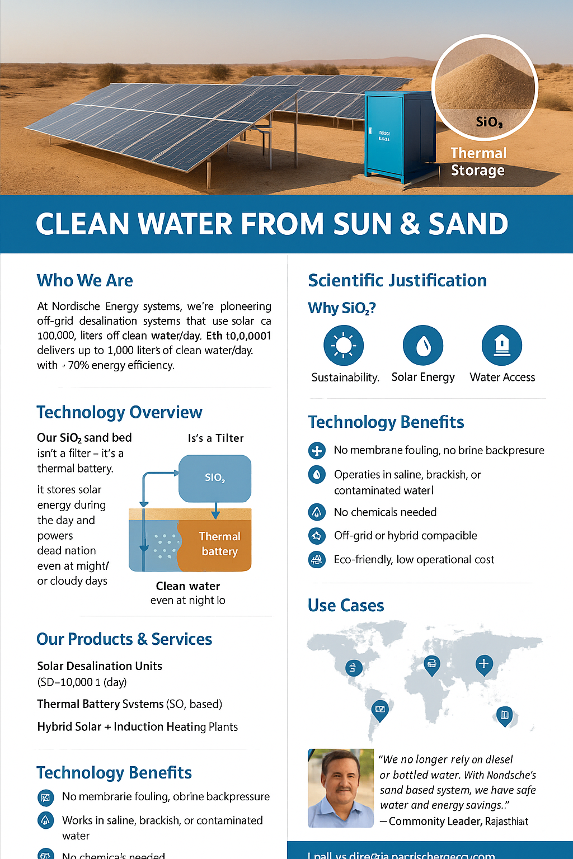

Who We Are
- At Nordische Energy Systems, we pioneer off-grid desalination systems that use solar heat and sand (SiO₂) as a thermal energy storage battery. Our technology delivers up to 10,000 liters of clean water/day with >70% energy efficiency, designed for dry, remote, and energy-constrained regions.

Mission Statement
- To develop accessible, scalable, and sustainable water purification technologies using natural thermal materials and renewable energy, enabling climate-resilient communities.

Technology Overview
- Our SiO₂ sand bed isn’t a filter – it's a thermal battery. It stores solar energy during the day and powers desalination even at night or on cloudy days.
✔ Zero chemicals
✔ Zero membranes
✔ Minimal maintenance

Scientific Justification
- Why SiO₂?
- High specific heat → Efficient heat storage
- Low thermal conductivity → Slow heat loss
- Low-cost, widely available material
Combined with vacuum evaporation and condensation, this allows water to boil and condense at lower temperatures → Lower energy input, high efficiency.

Our Products & Services
  - Solar Desalination Units (50–10,000 L/day)
- Thermal Battery Systems (SiO₂-based)
- Hybrid Solar + Induction Heating Plants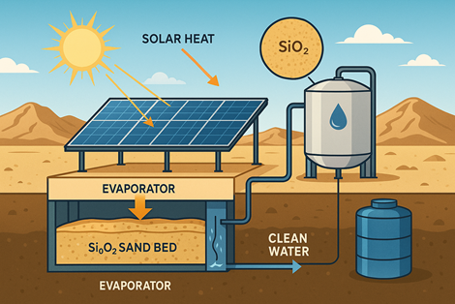

Contact Us
Nordische Energy Systems Pvt. Ltd.
No. 45/3, 1st Floor, Residency Road,
Gopala Krishna Road, Bangalore, Karnataka, India
📧 info@nordischeenergy.com
🌐 www.nordischeenergy.com

