**Topics: Descriptive Statistics and Probability**

1. Look at the data given below. Plot the data, find the outliers and find out $μ, σ, σ^{2}$

|  |  |
| --- | --- |
| **Name of company** | **Measure X** |
| Allied Signal | 24.23% |
| Bankers Trust | 25.53% |
| General Mills | 25.41% |
| ITT Industries | 24.14% |
| J.P.Morgan& Co. | 29.62% |
| Lehman Brothers | 28.25% |
| Marriott | 25.81% |
| MCI | 24.39% |
| Merrill Lynch | 40.26% |
| Microsoft | 32.95% |
| Morgan Stanley | 91.36% |
| Sun Microsystems | 25.99% |
| Travelers | 39.42% |
| US Airways | 26.71% |
| Warner-Lambert | 35.00% |

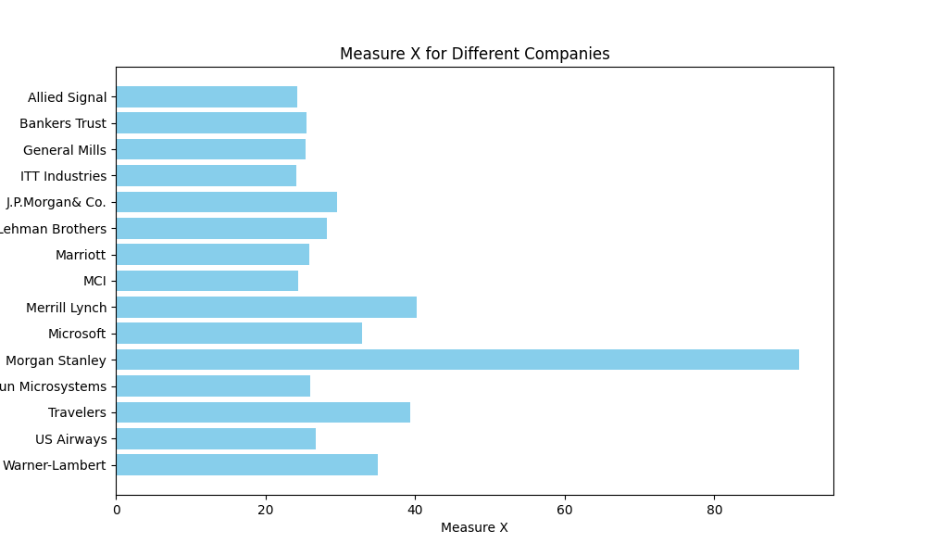

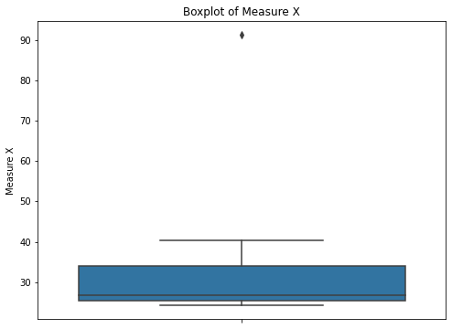

From above Plots we can say that we have only one outlier i.e., Morgan Stanley.

The Mean (μ) value of the given data is 33.27133333333333

The Standard Deviation (σ) value of the given data is 16.370812590976932

The Variance (σ^2) value of the given data is 268.00350488888887



Answer the following three questions based on the box-plot above.

1. What is inter-quartile range of this dataset? (please approximate the numbers) In one line, explain what this value implies.
2. The Inter-quartile range is 8 (Approx.) and the iqr value implies the difference between Q3 (upper quartile) & Q1 (lower quartile) value
3. What can we say about the skewness of this dataset?
4. From above boxplot we can say it is Right Skewed
5. If it was found that the data point with the value 25 is actually 2.5, how would the new box-plot be affected?
6. The new box-plot will have zero outlier.



Answer the following three questions based on the histogram above.

1. Where would the mode of this dataset lie?
2. The mode of the dataset lies at 5.
3. Comment on the skewness of the dataset.
4. The Skewness of the dataset is right skewed.
5. Suppose that the above histogram and the box-plot in question 2 are plotted for the same dataset. Explain how these graphs complement each other in providing information about any dataset.
6. From above histogram and the box-plot in question 2 are plotted from the same dataset and we can say that the data ranges from 0 to 25 and most of the data lies between 0 to 20 & 25 is the only one outlier in the above plots.
7. AT&T was running commercials in 1990 aimed at luring back customers who had switched to one of the other long-distance phone service providers. One such commercial shows a businessman trying to reach Phoenix and mistakenly getting Fiji, where a half-naked native on a beach responds incomprehensibly in Polynesian. When asked about this advertisement, AT&T admitted that the portrayed incident did not actually take place but added that this was an enactment of something that “could happen.” Suppose that one in 200 long-distance telephone calls is misdirected. What is the probability that at least one in five attempted telephone calls reaches the wrong number? (Assume independence of attempts.)
8. The probability that at least one in five attempted telephone calls reaches the wrong number is approximately 0.0247, or about 2.47%.
9. Returns on a certain business venture, to the nearest $1,000, are known to follow the following probability distribution

|  |  |
| --- | --- |
| x | P(x) |
| -2,000 | 0.1 |
| -1,000 | 0.1 |
| 0 | 0.2 |
| 1000 | 0.2 |
| 2000 | 0.3 |
| 3000 | 0.1 |

1. What is the most likely monetary outcome of the business venture?

A) The most likely monetary outcome of the business venture is 2000

1. Is the venture likely to be successful? Explain
2. Whether the venture is likely to be successful depends on the definition of success. If success means achieving a positive return, then since the probabilities of positive returns (0, 1000, 2000, 3000) sum up to 0.7, the venture has a 70% chance of being successful.
3. What is the long-term average earning of business ventures of this kind? Explain
4. Long-term average earnings of business ventures of this kind is 800.0

In the provided probability distribution By multiplying each outcome by its probability and summing up these values:

Average earnings = (-2000 * 0.1) + (-1000 * 0.1) + (0 * 0.2) + (1000 * 0.2) + (2000 * 0.3) + (3000 * 0.1)

Average earnings = (-200) + (-100) + (0) + (200) + (600) + (300)

Average earnings = 800

So, the long-term average earnings of business ventures of this kind are $800. This means that, on average, an investor can expect to earn $800 over the long run for each venture of this kind.

1. What is the good measure of the risk involved in a venture of this kind? Compute this measure
2. The Good measure of this risk involved in a venture of this kind is by calculating standard deviation of the data and the standard deviation of the risk involved is 1469.6938456699068.