# Orion flavors

# Created on January 23 2021

# Table of Contents

1.0. HOME

2.0. MENU

3.0. ABOUT ORION

# 1.0. HOME

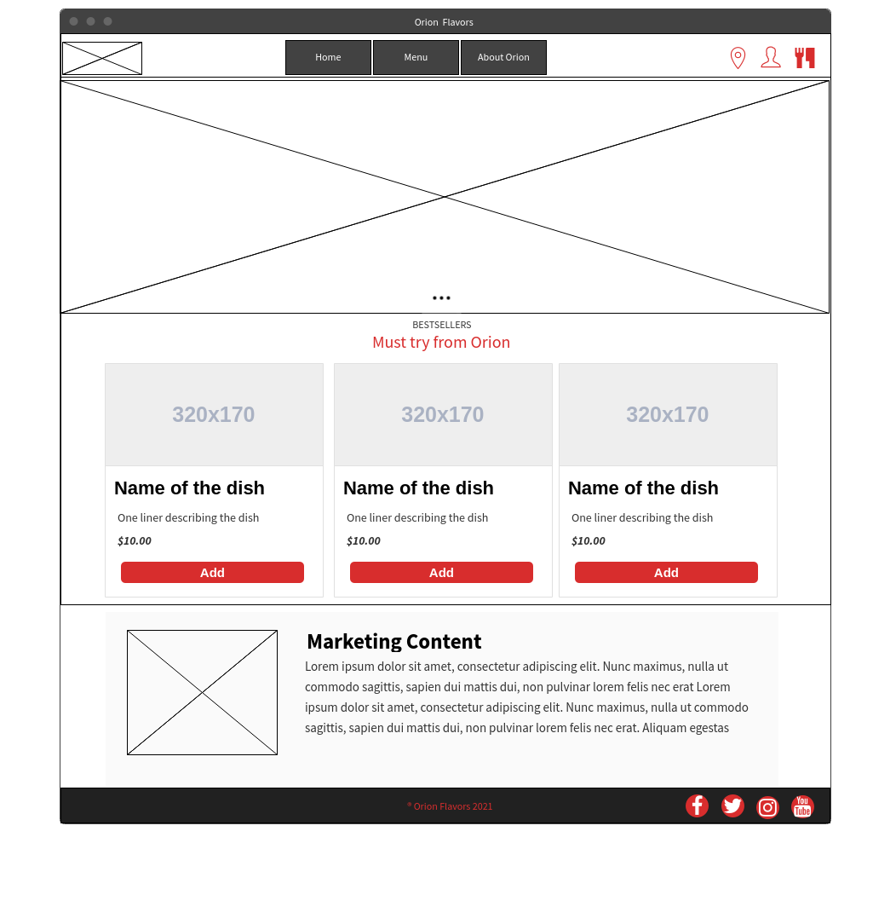

# 2.0. MENU

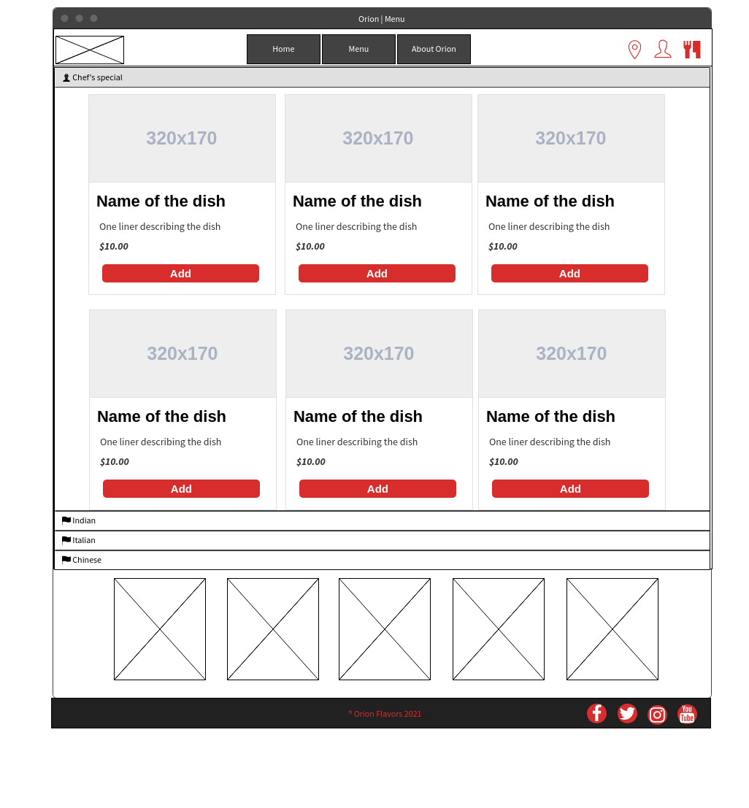

# 3.0. ABOUT ORION

