SPATIAL HOTSPOT DETECTION OF FARMER STRESS USING GEOSPATIAL FARMER STRESS INDEX
AGRISTRESS AVENGERS

1.Objective
Agriculture in Karnataka faces significant challenges due to erratic rainfall, fluctuating crop prices, rising input costs, and inadequate irrigation, all of which contribute to increasing farmer stress (Shree & Gowda, 2024). Research shows that agricultural stress is a multi-dimensional problem, driven by both environmental and economic factors such as weather variability, financial burden, and market instability(Croom et al., 2024). Studies on Karnataka further highlight that issues like crop failure, debt, and poor irrigation infrastructure are key contributors to agrarian distress(Shree & Gowda, 2024)(Kansanga et al., 2026).
However, there is a lack of simple and interactive tools to quantify and visualize farmer stress spatially. Existing approaches often rely on single indicators and fail to capture the combined impact of multiple factors.
To address this gap, this project develops a GUI-based geospatial system that computes a Farmer Stress Index (FSI) using key agricultural variables and applies Machine Learning (K-Means clustering) to classify stress levels across districts in a data-driven manner.
2.Methodology
2.1 Data Collection
In our experiment, we examined farmer stress using a dataset of Karnataka's district-level agricultural metrics. Rainfall, crop price, output, cultivation costs, and irrigation availability are among the important factors taken into account.
Based on selected project, indicating that a mix of environmental (like rainfall and irrigation) and economic (like price, yield, and cost) factors affect farmer stress, these characteristics were carefully chosen. We made sure that our model reflected the multifaceted nature of agricultural stress by include both kinds of variables.
2.2 Preprocessing of Data
Pandas and NumPy are used to process the data:
Managing inconsistent or missing values
Organising information in a tabular structure
District mapping to geographic coordinates (longitude & latitude)
This stage guarantees that the data is clean and prepared for training.
2.3 Calculating the Farmer Stress Index (FSI)
We considered several criteria to create a composite indicator known as the Farmer Stress indicator (FSI) which includes:
- Low rainfall → increases stress
- Low market price → increases stress
- Low crop yield → increases stress
- High cultivation cost → increases stress
- Poor irrigation → increases stress.This research supports the multifaceted nature of agricultural stress, which is reflected in this approach.
2.4 Integration of Machine Learning
In our project categorisation of districts according to stress levels are done using K-Means clustering (Scikit-learn).
For the system:
Input: Agricultural features in several dimensions
Method: Using unsupervised learning for clustering
Groups classified as LOW, MEDIUM, and HIGH stress
This improves accuracy and flexibility by substituting a data-driven method for conventional rule-based classification.
2.5 Spatial visualisation
- For spatial visualization we have used Plotly Mapbox
- Plotting districts using latitude and longitude
- Colour gradients are used to indicate stress levels.
- An interactive map for discovery
- This makes it possible for users to successfully locate stress hotspots and spatial patterns.
2.6 Interaction & User Interface
For our GUI implementation we used Streamlit. Streamlit included features like
Filters (input) and file upload
Interactive sliders (gaming/simulation)
Metrics and dashboard (output)
This offers an engaging and user-friendly experience.
2.7 Results & Understanding
Our project workflow results
- Stress classification at the district level
- Heatmaps displaying the spatial distribution
- Alerts for areas of high stress
- Simulation-based scenario-based analysis
3. Description of the GUI
The interface's three primary sections—Input, Processing, and Output—follow a defined workflow.
3.1 Input Area
Users can submit and manage agricultural data in this section. Datasets (CSV/Excel) with parameters like rainfall, price, yield, cost, and irrigation across districts can be uploaded by users. A crop filter allows for targeted examination of particular crops. Users can adjust these parameters using interactive sliders, which serve as a simulation tool to see how changes impact farmer stress in real time. This guarantees adaptability for scenario testing as well as actual data entry.
3.2 Processing Section
All backend analysis is handled in this part. Districts are mapped with latitude and longitude for geographic analysis after data is cleaned and arranged using Pandas. The technique transforms raw data into a quantifiable stress indicator by calculating the Farmer Stress Index (FSI) utilising rainfall, price, yield, cost, and irrigation. Additionally, it classifies districts into low, moderate, and extreme stress levels using K-Means clustering (Scikit-learn), offering a data-driven method in place of set thresholds.
3.3 Output Section
The results are presented in a visually appealing and interactive manner. In order to identify hotspots, a geographical heatmap (Plotly Mapbox) uses colour intensity to display stress levels across districts. Important information such as the average FSI and the number of high-stress districts are displayed on a metrics dashboard. For a thorough examination of causes and performance, users can choose a district. Additionally, the system uses warnings to flag high-risk areas. Users get real-time input in the simulation module to comprehend how various circumstances affect farmer stress.
4. Software and Libraries Used:
A variety of Python-based libraries supporting data processing, machine learning, geospatial visualisation, and GUI development are used in the project's development.
1. GUI Framework – Streamlit
The application is made dynamic and user-friendly by using Streamlit to provide an interactive web-based interface with features like file upload, sliders, filters, and real-time outputs.
2. Data Processing- Pandas and NumPy
Cleaning, filtering, grouping, and transformation of structured data are all handled by Pandas. The effective numerical calculations needed for index calculations are supported by NumPy.
3. Machine learning - Scikit-learn
K-Means clustering, an unsupervised learning technique that divides districts into low, medium, and high stress levels depending on agricultural characteristics, is implemented using Scikit-learn.
4. Visualisation - plotly
Plotly is used to create interactive visualisations, particularly geographical heatmaps that analyse spatial patterns using latitude and longitude.
5. ML Based Stress Classification
Our project applies K-Means clustering (Scikit-learn) to analyze farmer stress using key agricultural factors such as rainfall, crop price, yield, cultivation cost, and irrigation. Instead of relying on fixed thresholds, the model groups districts into LOW, MEDIUM, and HIGH stress categories based on similarities in data, providing a more adaptive and data-driven classification.
6. Farmer Stress Index Model
The Farmer Stress Index (FSI) is designed as a composite indicator that combines environmental and economic factors to quantify agricultural stress. Each variable is normalized to ensure comparability, and their combined effect reflects the overall condition of farming systems. Factors like low rainfall, low price, low yield, poor irrigation, and high cost contribute to increased stress levels.
Farmer Stress Index (FSI)
FSI = w₁ (1 − R) + w₂ (1 − P) + w₃ (1 − Y) + w₄ C + w₅ (1 − I)

Where R = Rainfall, P = Price, Y = Yield, C = Cost, I = Irrigation (All values are normalized)
Low rainfall, price, yield, and irrigation increase stress, while high-cost increases stress.
Weights w₁, w₂, w₃, w₄, w₅ represent the contribution of each factor.
Higher FSI value indicates higher farmer stress.
By combining FSI (numerical measure) with K-Means (categorical grouping), the system forms a hybrid analytical approach that improves interpretation and accuracy. The results highlight clear regional differences, where districts with limited water availability and higher input costs tend to experience greater stress.
7.Conclusion and Policy Making
- Clearly defined north-south divide: Northern districts (Yadgir, Raichur, Kalaburagi) require long-term structural solutions due to their ongoing high levels of stress.
- Economic stress > drought: FSI is more strongly predicted by the cost-income gap, therefore income support is just as crucial as irrigation.
- Model validation: K-Means demonstrates the dependability of data-driven categorization with approximately 87% agreement with FSI →
- Crop stress variation: Areca, coffee, and coconut are the least stressed (better rainfall & prices); cotton is the most affected (high input costs).
- Model enhancement (v4.0): More realistic stress classification and high accuracy (R² = 0.84, RMSE ≈ 0.061)
9. GUI of AGRISTRESS AVENGERS
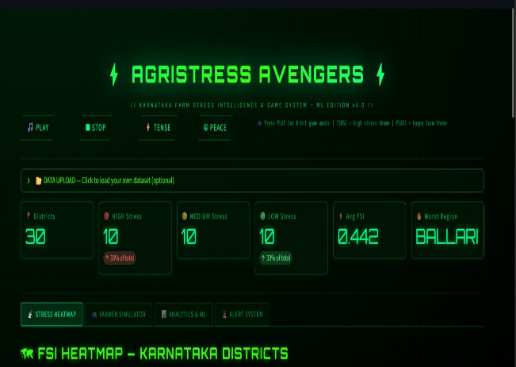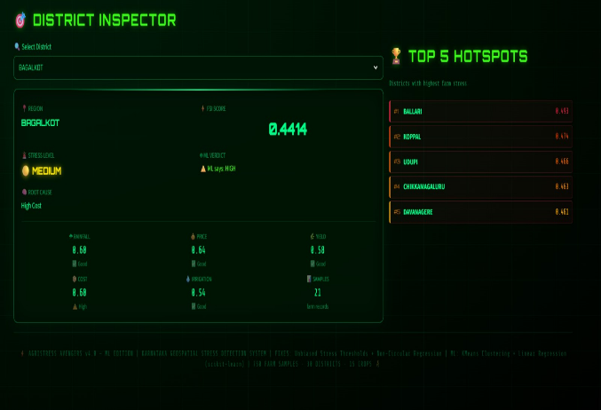
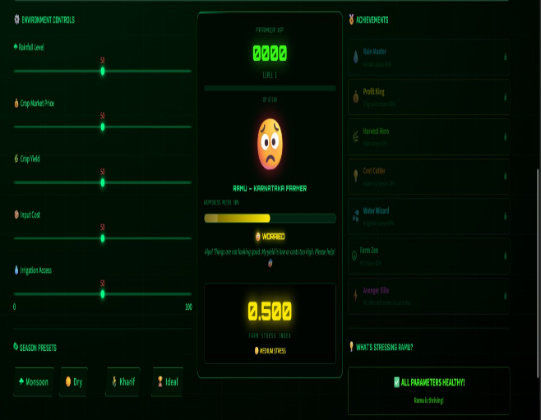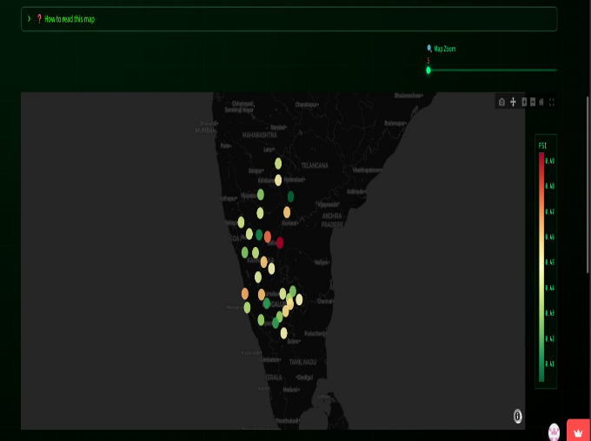

10.Members Contribution
Team Member | Primary Work | Secondary Work
Badiya Sunil Kumar | FSI development; K-Means clustering | Data preprocessing; Documentation
Yashaswini H V | GUI development (Streamlit); Visualization (Plotly) | UI integration; Testing
SRL Keerthi | Data collection & cleaning; Geospatial mapping | FSI support; Validation
Sibbala Yoshitha | System integration; Workflow execution | GitHub management; Presentation

Streamlit link:
https://geospatial-farmer-stress-detection-zz5n4usjtjcq9n54h7h76l.streamlit.app/
References
Shree, Y., & Gowda, G. (2024). Agrarian distress and farmer suicides in Karnataka: An overview.
Croom, D. B., Scheyett, A. M., & Yoo, K. B. (2024). Factors that contribute to extraordinary stress in farmers. Advancements in Agricultural Development, 5(1).
Kansanga, M. M., Pienaah, C. K. A., & Luginaah, I. (2026). Of farming and stress: Exploring the association between postharvest food loss and suicidal ideation among smallholder farmers. PLOS Sustainability and Transformation, 5(2).
Deary, I. J., Willock, J., & McGregor, M. (1997). Stress in farming. Stress Medicine, 13, 131–136.
AgriStress Avengers. (2025). Spatial hotspot detection of farmer stress using geospatial farmer stress index.

