Test Stand Question: Can we find the thrust and torque constants for a particular motor?

To fly a quadrotor aircraft autonomously we need to be able to calculate the thrust and torque that each motor is producing.

Where

Tests with no load:

Thrust: the force with which the motor pulls
Torque: the force with which the motor tries to spin whatever it is attached to.
Measuring Thrust
The frame is in an L shape, with the motor mounted at the long end of the L. As the motor pulls on it's mounting it creates a torque in the L. This is then transmitted to the base, where there is a pressure sensor. This sensor can directly read the motor force.

By building a suitable test stand we should be able to measure the thrust, torque, and RPM of each motor as it is running. Combined with the constants of rotor diameter and air density, we can calculate the K_{T} and K_{Q} constants. These constants are specific to each motor and don't change.

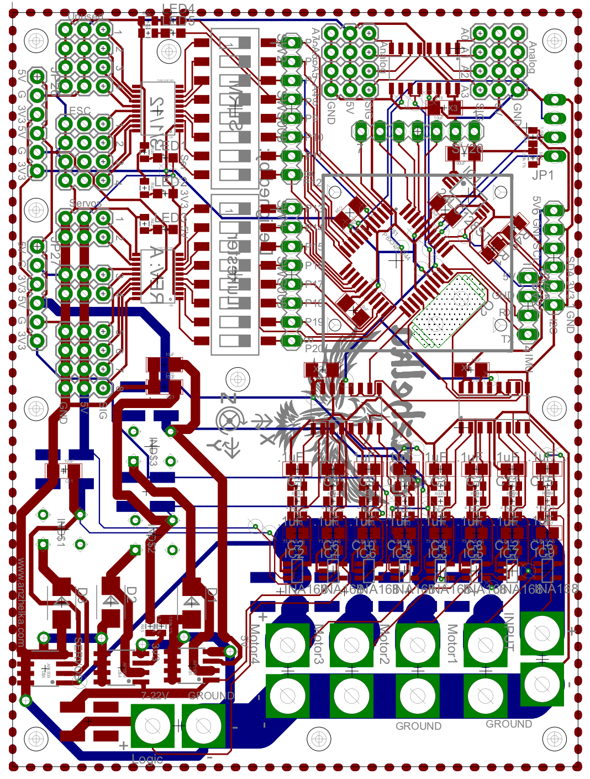
Measuring Torque
The motor is mounted to a shaft that is aligned with the motor shaft. The mounting shaft has a lever arm attached that presses down due to the motor torque. This lever arm then presses on a pressure sensor, and the torque can then be calculated.

System Components
Pressure Sensors: two FlexiForce pressure sensors. These sensors vary resistance in proportion to the pressure on the sensing surface.
Eagle Tree Brushless RPM Sensor: These sensors read the control pulses sent to the motor and generate PWM signal representing RPM.
INA169 and Voltage Divider: This chip measures the current drawn by the motor, and the voltage divider measures the motor input voltage.

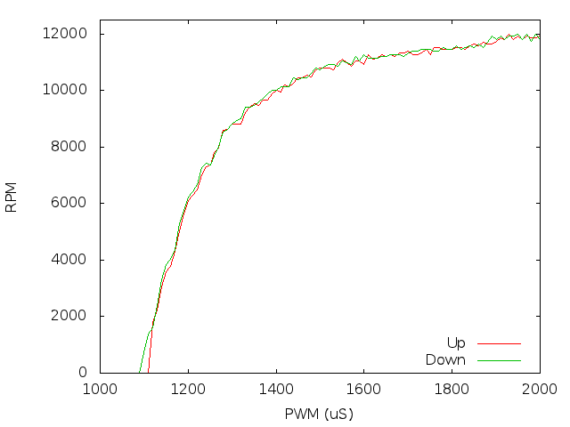
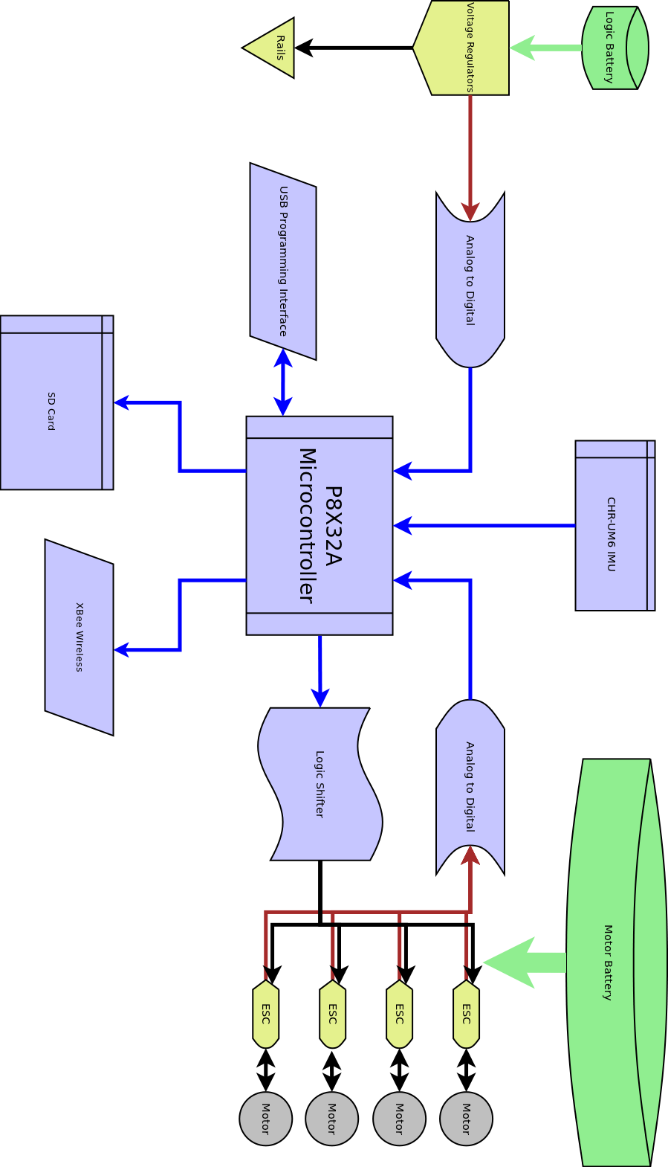
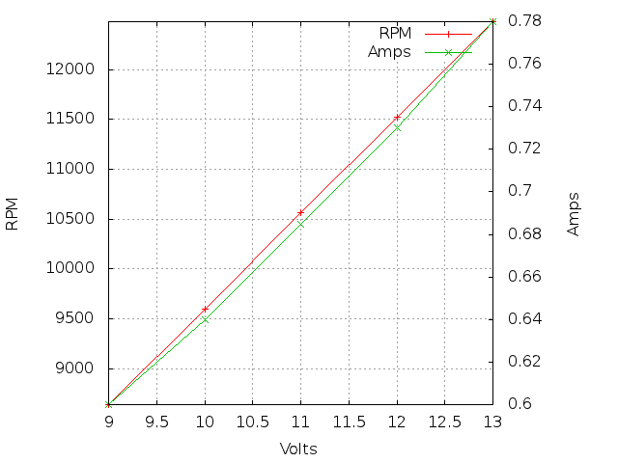

About Us
This project is being developed by Luke De Ruyter and Cody Lewis, both from the University of California, Riverside. Building an autonomous quadrotor is their senior capstone engineering project.

Resources
http://blog.anzhelka.com/
http://code.anzhelka.com/

The Project
We are working on developing an open source Propeller based autonomous quadrotor. The project is being developed from the ground up. We have built or are building all of the hardware and software necessary to achieve stable flight.

The PCB
The PCB has been custom designed to support all of the features needed to fly. It features a Propeller microcontroller, logic rail buck regulators, 24 channels of ADC, 24 channels of 5v to 3.3v level shifting, voltage and current sensing for motors and logic rails, mounting holes for SD card, IMU, Quickstart, and BoE formfactor.

Acknowledgement
Machining: Dale Holtkamp, Gene Sherman , W9FGO
Algorithms: Frank Lewis, Emanuel Stingu
Design: Dr. Liang, Dr. Kastner, Tom Wypych , Dr. Chomko
Workshop: Elmar Palma

