**MQ-7 Semiconductor Sensor for Carbon Monoxide**

Technical Parameters

Model : MQ-7

Sensor Type : Semiconductor

Standard Encapsulation : Plastic cap

Target Gas : carbon monoxide

Detection range : 10～500ppm CO

Standard Circuit Conditions:

Loop Voltage(Vc) : ≤10V DC

Heater Voltage(VH) : 5.0V±0.1V AC or DC (High tem. ）

1.5V±0.1V AC or DC (Low tem. ）

Heater Time(TL) : 60 S±1S（High tem. ），

90 S±1S（Low tem. ）

Load Resistance (RL) : Adjustable

Sensor character under standard test conditions:

Heater Resistance(RH) : 29Ω±3Ω（room tem. ）

Heater consumption(PH) : ≤900mW

Sensitivity(S) : Rs (in air)/Rs(in 150ppm CO)≥5

Output Voltage (Vs) : 2.5V～4.3V (in 150ppm CO)

Concentration Slope (α) : ≤0.6(R300ppm/R50ppm CO)

Standard test conditions:

Tem. Humidity 20℃±2℃；55%±5%RH

Standard test circuit Vc:5.0V±0.1V；

VH (High tem. ）： 5.0V±0.1V；

VH （Low tem. ）： 1.5V±0.1V

Preheat time Over 48 hours

**CIRCUIT DIAGRAM: --**

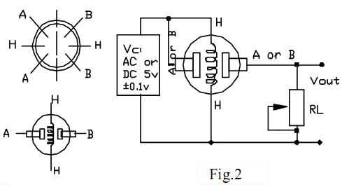

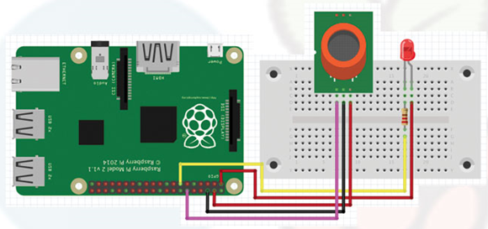

**CODES: --**

import RPi.GPIO as GPIO, time

# Declaramos

GPIO.setmode(GPIO.BCM)

GPIO.setup(18, GPIO.IN)

GPIO.setup(27, GPIO.OUT)

# Cuerpo del código

try:

while True:

if GPIO.input(18):

print("Sin problemas")

time.sleep(0.2)

if GPIO.input(18)!=1:

print("GASSSSSS")

GPIO.output(27, False)

time.sleep(0.1)

GPIO.output(27, True)

# Cerramos el script

except KeyboardInterrupt:

print "See you later in #artDuino"

GPIO.cleanup()