**Class:** Final Year (Computer Science and Engineering)

**Year:** 2021-22 **Semester:** 1

**Course:** High Performance Computing Lab

# Practical No. 5

**Exam Seat No:**

1. 2018BTECS00007 – Shubham Ramdas Mali

# Problem Statement 1:

Implement blocking and non-blocking MPI send & receive to demonstrate Nearest neighbour exchange of data in a ring topology.

# Screenshot 1:

# 

**Information 1:** Ring topology blocking send and receive with 15 processes.

# Problem Statement 1.2:

IImplement a MPI program to give an example of non-blocking send and receive in ring totpology.

# Screenshot 2:

# 

**Information 2: Non-blocking send and receive between ring topology processes. Problem Statement 2:**

IImplement a MPI program to give an example of non-blocking send and receive between four processes.

# Screenshot 3:

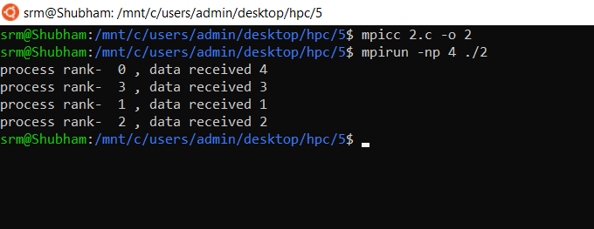

**Information 3: Non-blocking send and receive between 4 processes.**

**Problem Statement 3:**

Write a MPI program to find the product of all the elements of an array A of size n using m number of processes. The two sums then are added to get the final result.

# Screenshot 4:

# 

**Information 4: Product of array elements using MPI**