**Practical No. 7**

**Study and implementation of CUDA C basic functions**

Name: Shubham Ramdas Mali

PRN: 2018BTECS00007

Batch: B4

1. **Setup the environment requirements for execution of CUDA**

**C program.**

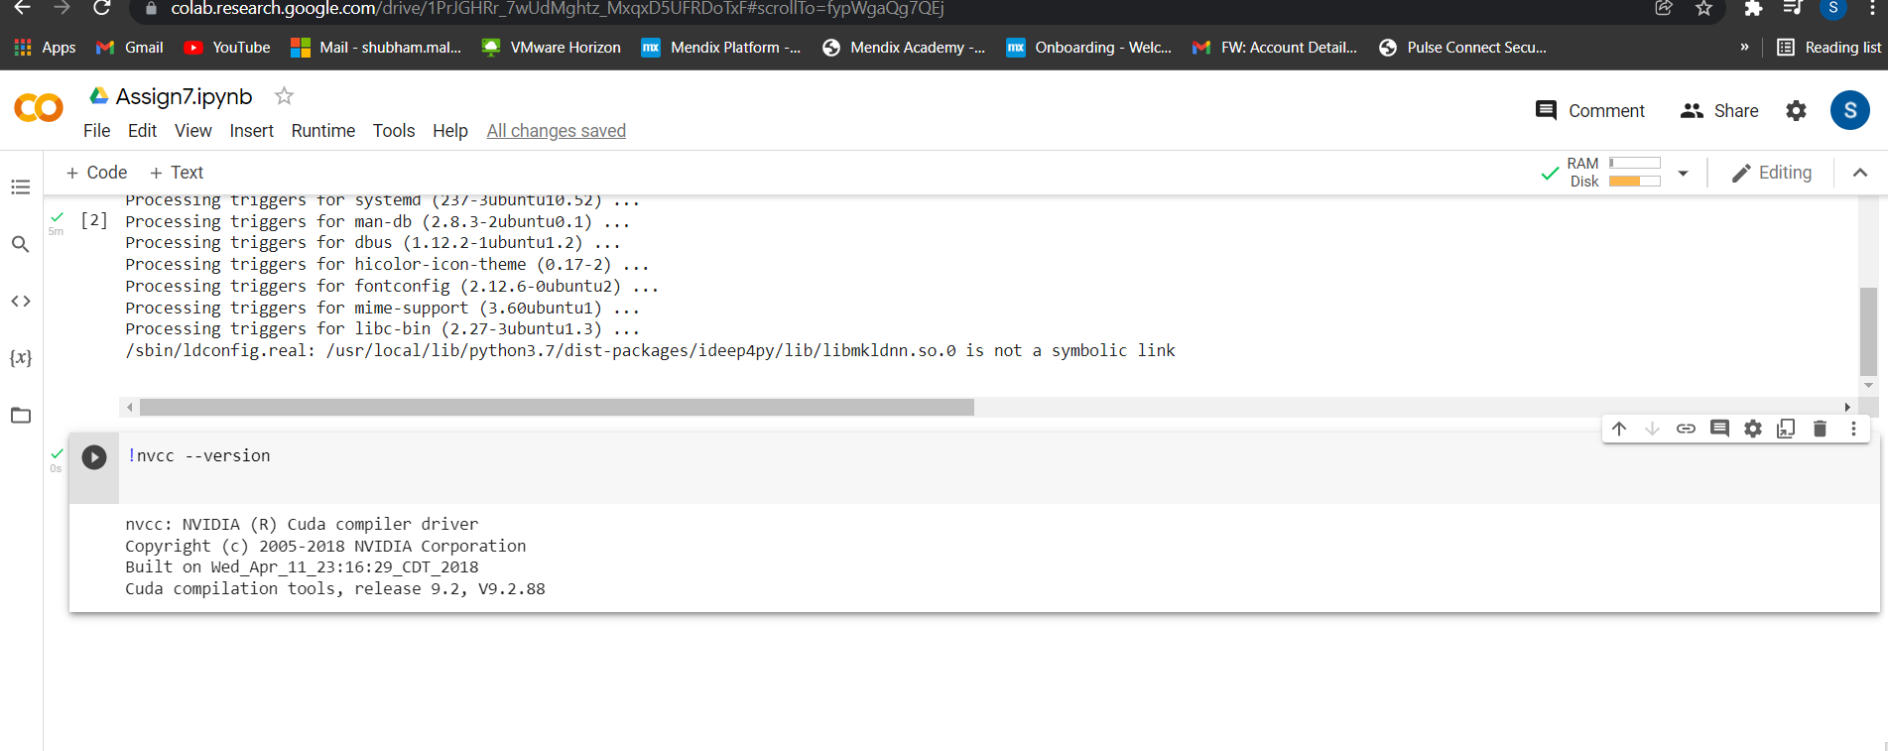

1. **Execute the attached Program1 and understand the output.**

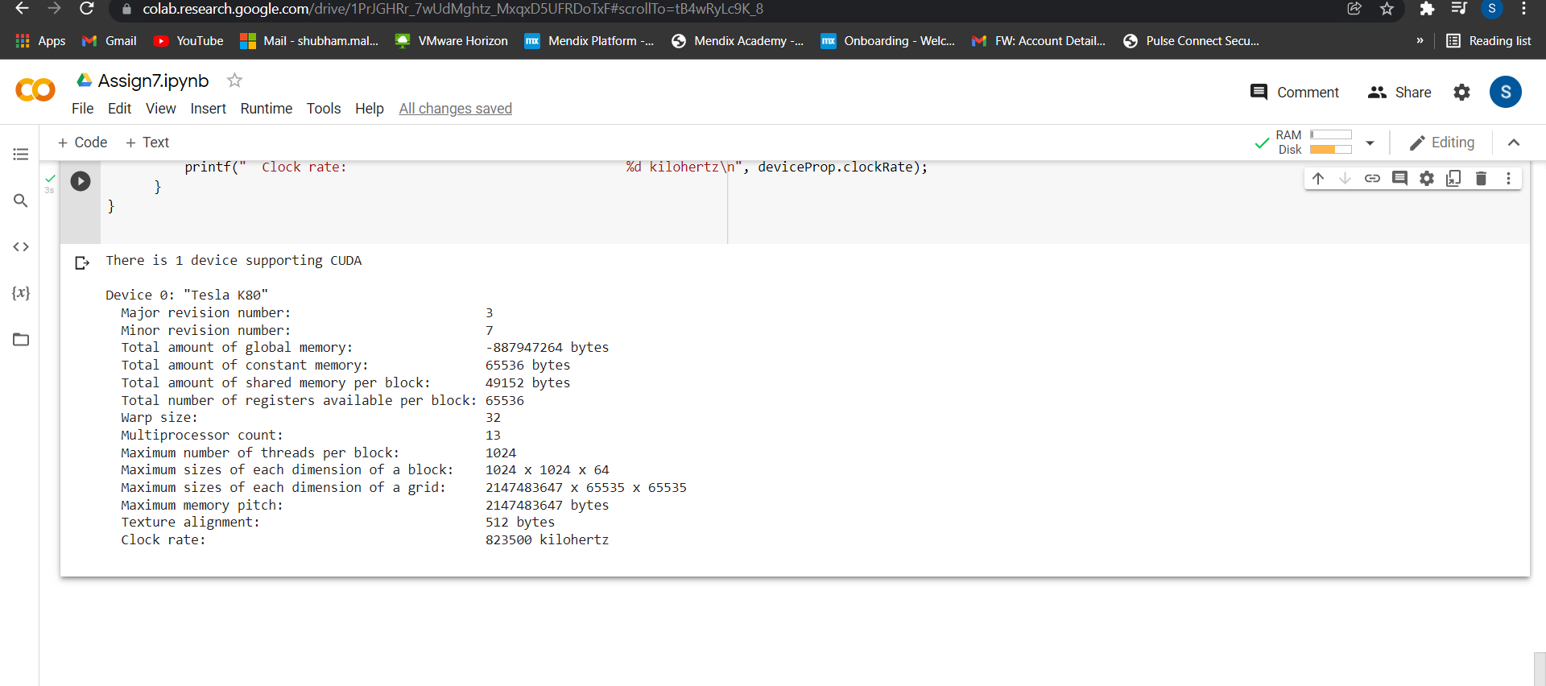

1. **Write a CUDA C program to perform the addition of two vectors of arbitrary size.**

%%cu

#include<stdio.h>

#include<stdlib.h>

__global__ void arradd(int *md, int *nd, int *pd)

{

int myid = threadIdx.x;

pd[myid] = md[myid] + nd[myid];

}

int main()

{

int size = 10 * sizeof(int);

int m[10], n[10], p[10], *md, *nd, *pd;

int i=0;

for(i=0;i<10;i++)

{

m[i] = i;

n[i] = i;

p[i] = 0;

}

cudaMalloc(&md, size);

cudaMemcpy(md, m, size, cudaMemcpyHostToDevice);

cudaMalloc(&nd, size);

cudaMemcpy(nd, n, size, cudaMemcpyHostToDevice);

cudaMalloc(&pd, size);

dim3 DimGrid(1,1);

dim3 DimBlock(10,1);

arradd<<< DimGrid,DimBlock >>>(md,nd,pd);

cudaMemcpy(p, pd, size, cudaMemcpyDeviceToHost);

for(i=0;i<10;i++)

{

printf("\t%d",p[i]);

}

cudaFree(md);

cudaFree(nd);

cudaFree(pd);

}

