**Class:** Final Year (Computer Science and Engineering)

**Year:** 2021-22 **Semester:** 1

**Course: High Performance Computing lab**

**ESE Exam**

**24/11/2021 01.00 PM – 04.00 PM**

**Exam Seat No : 2018BTECS00007**

Name : Shubham Ramdas Mali

Exam Seat Number : 2018BTECS00007

**Problem Statement 1**

**Statement:** **Implement bubble sort using OpenMP.**

**Screenshot 1:**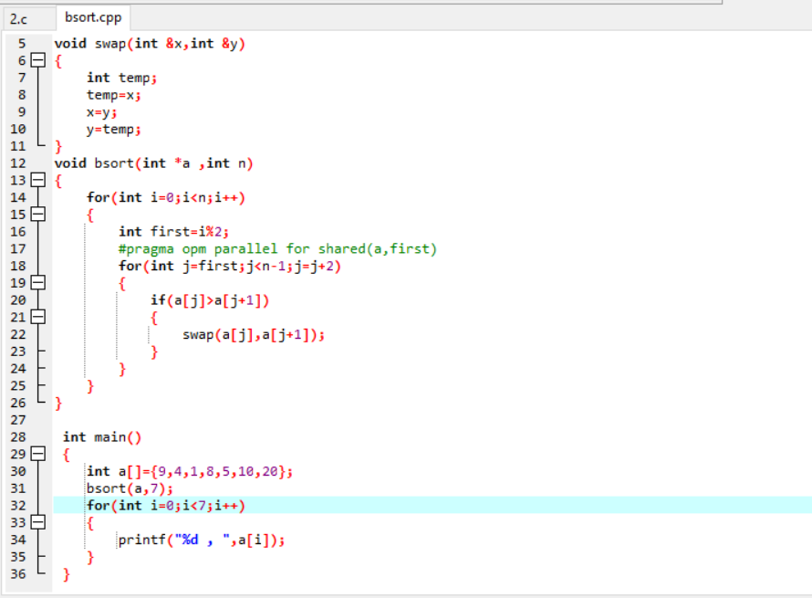

**Information 1: Bubble sort openmp code**

**Screenshot 2:**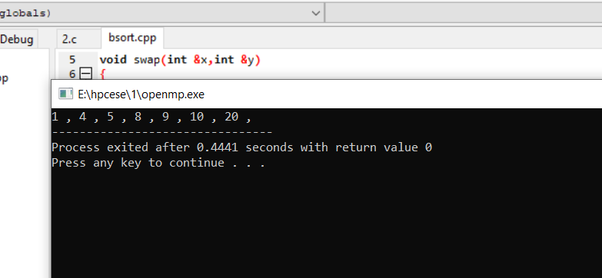

**Information 2:Output as the sorted array**

**Problem Statement 2**

**Statement:** **Implement MPI program using all to all broadcast.**

**Screenshot 1:**

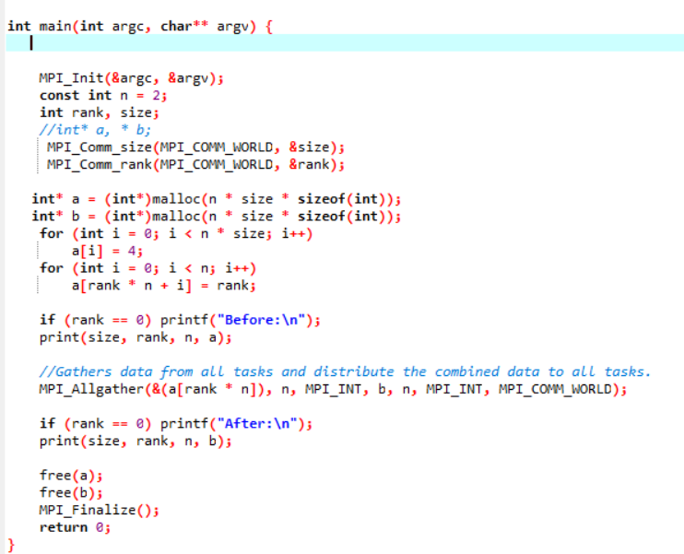

**Information 1:All to all broadcast using mpigather**

**Screenshot 2:**

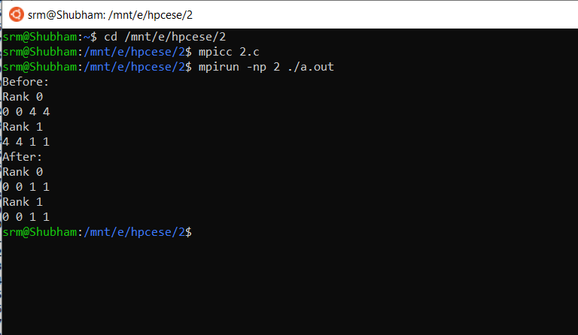

**Information 2: output for the 2 threads**

**Technologies Used:**

**GitHub Link:** **https://github.com/srm6867/HPCLAB**