**College of Applied Business and technology**

Gangahity, Chabahil, Kathmandu, Nepal

(Affiliated to Tribhuvan University)

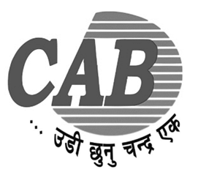

**Laboratory Report**

**of**

**DATA WAREHOUSING AND DATA MINING (CSC - 410)**

**Submitted by:** **Submitted to:**

**Name:** Arnav Sharma **Instructor: Tekendra Nath Yogi**

**Roll No:** 103

**Semester:** Seventh

**Faculty:** Science and Technology

**Level:** Bachelor

**Program:** CSIT