**Task 1**

**Preparing Lab Environment**

1. Installing VMware Workstation

For the installation of VMware Workstation, I visited the official webpage of VMware and downloaded the *.bundle file that was used for installing VMware on a Ubuntu 22.04 LTS machine.

`

1. Creating Virtual Machine of Linux (Alma Linux 9).

For the creation of a Virtual Machine of Alma Linux 9, the following steps were taken:

1. Firstly, the option for creation of a new virtual machine was selected, and a new Virtual Machine Wizard opened.

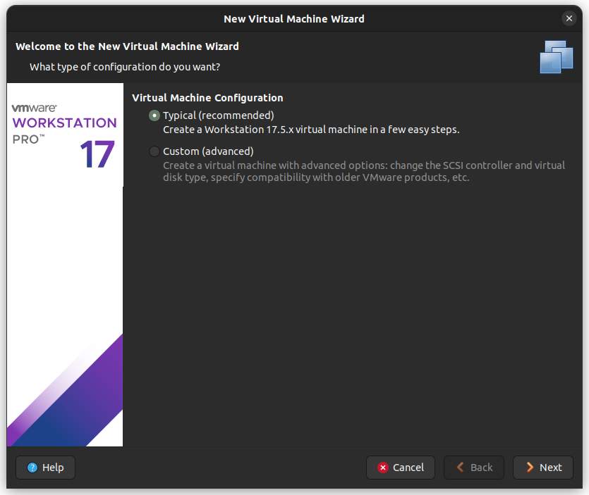

1. Then, the typical installation was selected, and the option stating I will install the operating system later was also selected.

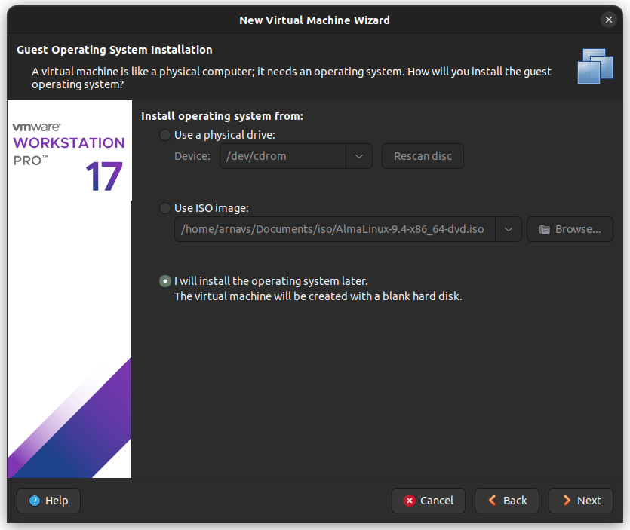

1. Alma Linux 64-bit was chosen as the guest operating system and then the location for virtual machine was selected.

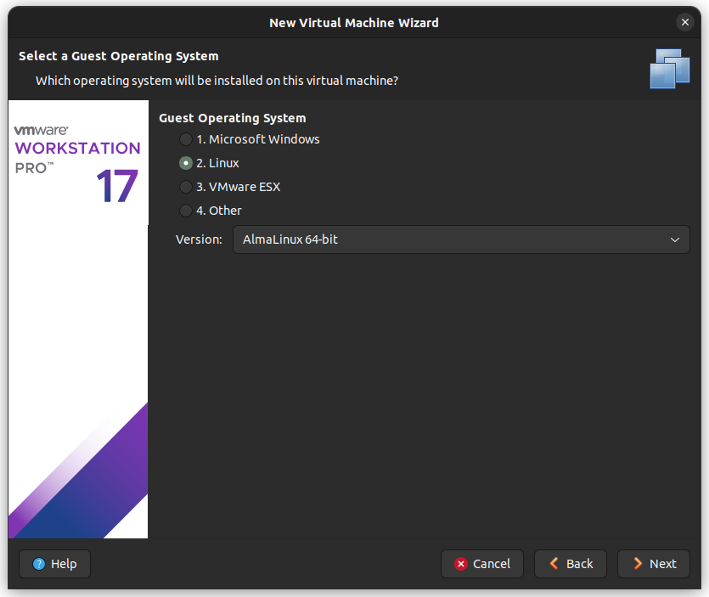

1. After that, the virtual machine storage type was chosen as multiple files and after verifying the installation details, the wizard was closed.
2. After that, the virtual machine was edited to use the ISO of Alma Linux for the boot.

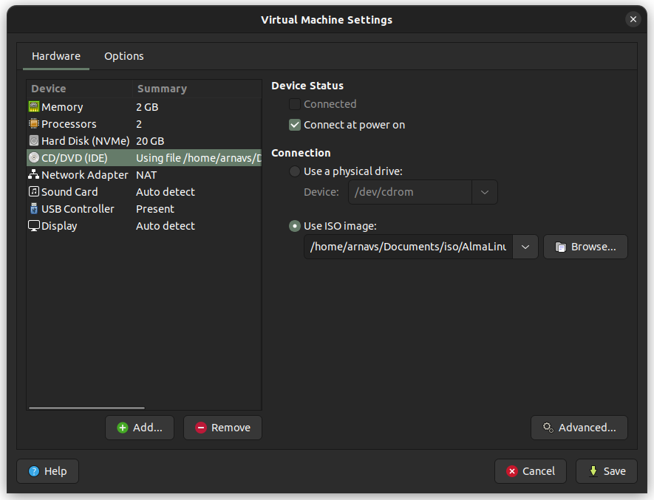

1. Then the machine was powered on and the option to install AlmaLinux 9.4 was selected.

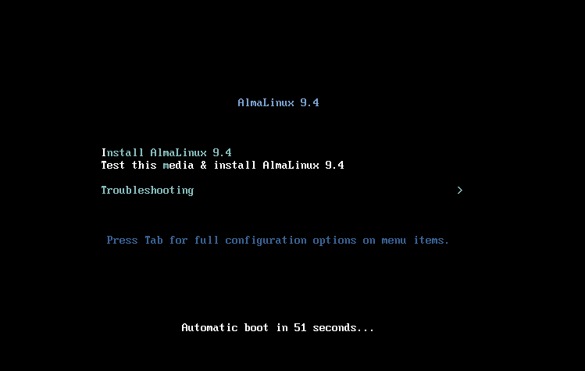

1. After that, the installation summary appears, after chechking and verifying all the details, the installation was started.

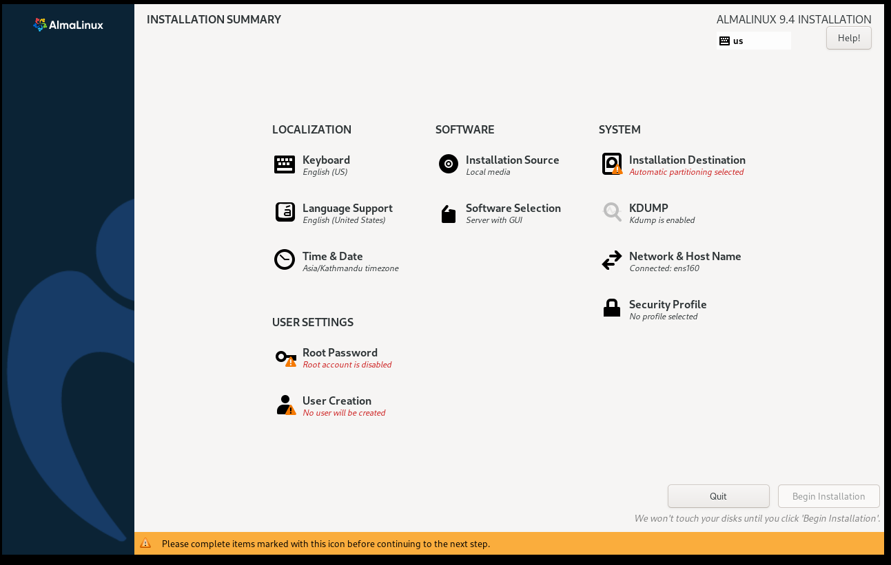

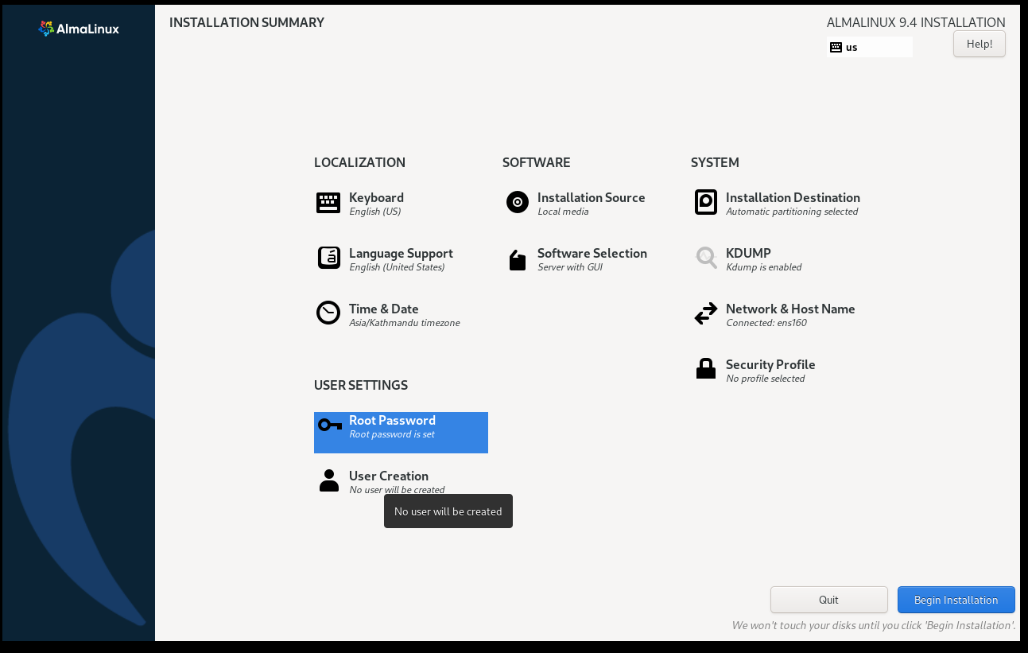



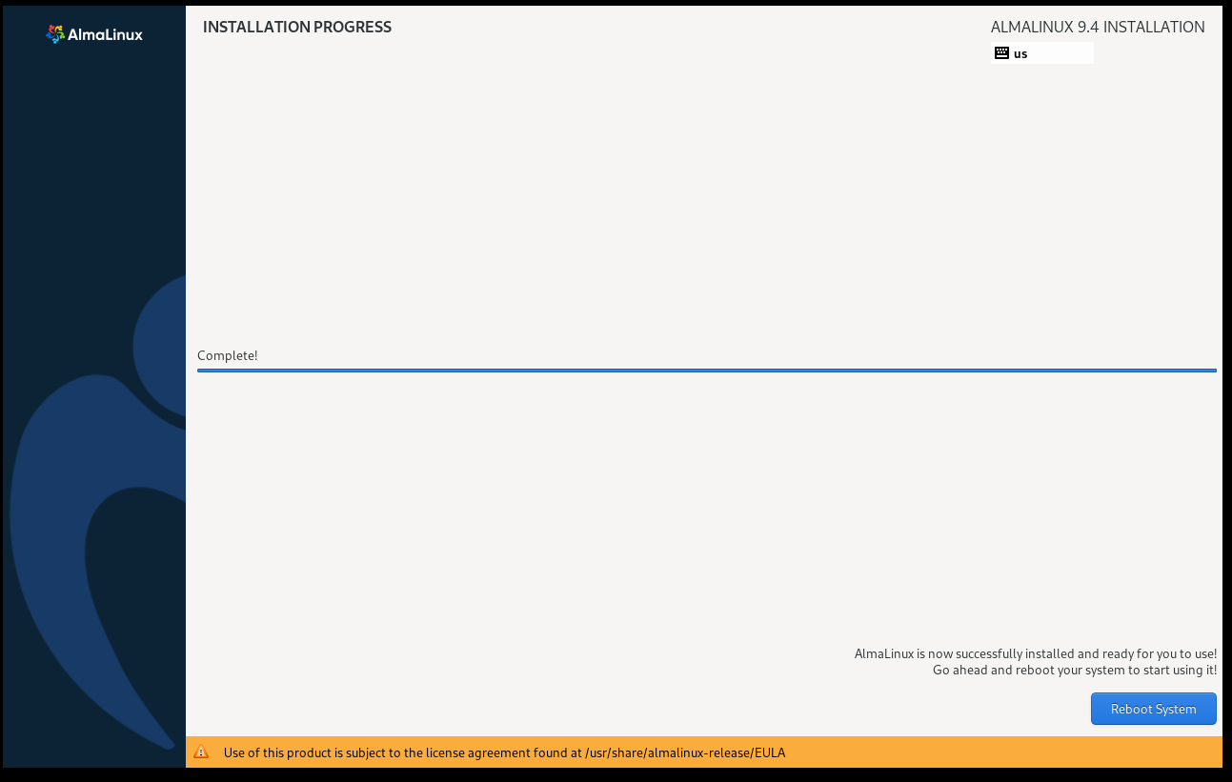

1. Then, on reboot, we are prompted to create a user for the machine, after which the installation is completed.

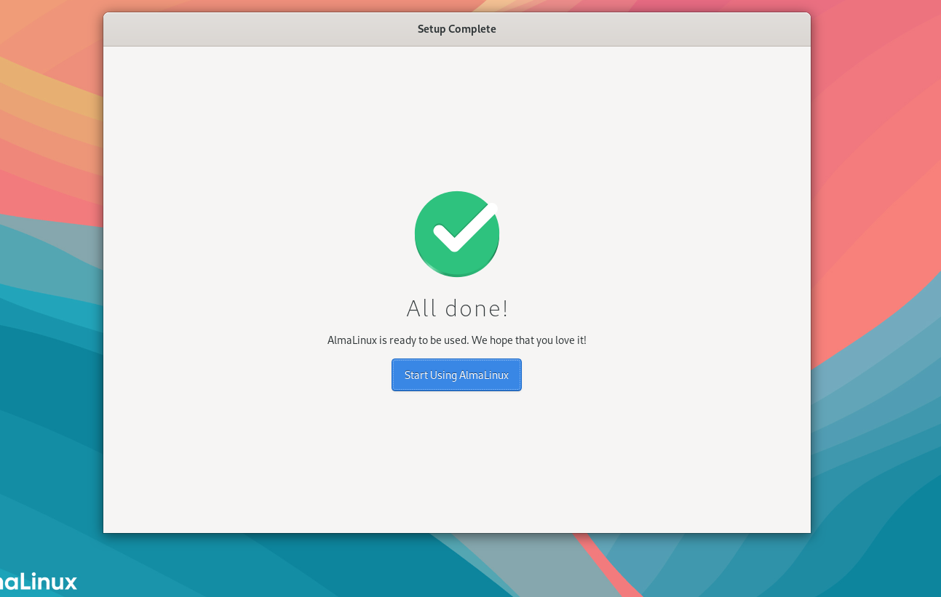

1. Assign hostname of the virtual machine to arnav.ns.local.

To assign the hostname in Linux to a user defined one a simple command is used:

hostnamectl set-hostname <new_hostname>

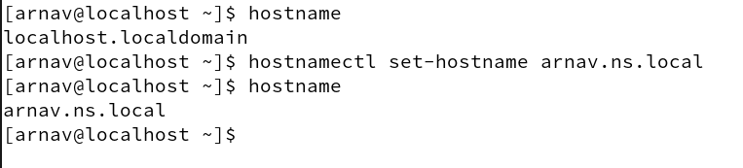

The change will be visible properly after a system reboot.

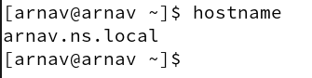

1. Configure your network with static IP address.

A static IP address is a fixed, unchanging IP assigned to a device or machine in a network, as opposed to a dynamic IP that can change over time. It is often used in scenarios where consistent access is required, such as servers, printers, or virtual machines, as it ensures a device remains reachable at the same address. Configuring a static IP helps streamline communication, avoid conflicts, and improve network management, especially in environments that rely on stable, long-term connections.

To configure static IP address, multiple methods can be used such as changing the network interface file, using the nmcli command line and nmuti as well. Here, nmcli method is used.

To configure the static IP, three main things must be observed, network gateway, network mask and network interface used for the virtual machine.

These can be done easily using the commands, ‘route -n’ to get the gateway and mask for the network connection, ‘nmcli connection show’ to get the network interface device and finally ‘hostname -I’ to get the IP address of the machine initially.

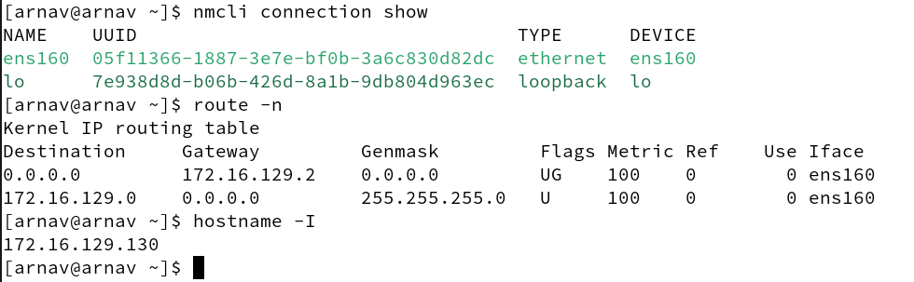

After this, we can use the following command to set the static IP address:

nmcli connection modify <connection_name> ipv4.method manual ipv4.addresses <static_ip_address>/<prefix> ipv4.gateway <gateway> ipv4.dns <dns1>,<dns2> ipv6.method ignore

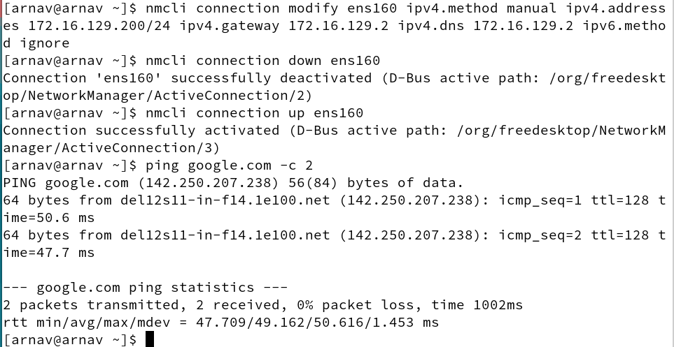

After setting the static IP the connection was refreshed by powering the device on and off, and the connection was checked using ping command.

1. Map your static IP address to your hostname in configuration file at /etc/hosts.

Initially, the hosts file contains mapping to the internal network only as:

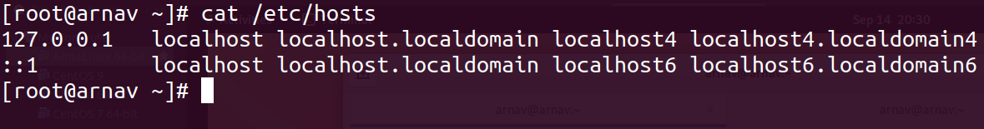To map the IP address to the hostname, the file was edited, and the new host was added.

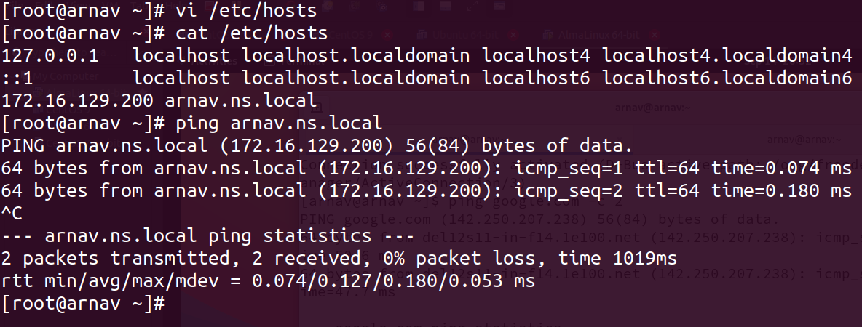

Then to verify the added host, the new hostname was pinged, and we can verify that our static IP was the address pinged.