**Task 2**

**Users, Groups and Permission**

1. Create a user named student.

To create a new user in Linux, a simple command ‘adduser <name>’ is used. After the creation of new user, they are listed in the ‘/etc/passwd’ file. After creation of user the password token must also be set for the user, which is done by the command ‘passwd <name>’, after which the p which the hash of the entered password and the aging information for the user is stored in the file ‘/etc/shadow’.

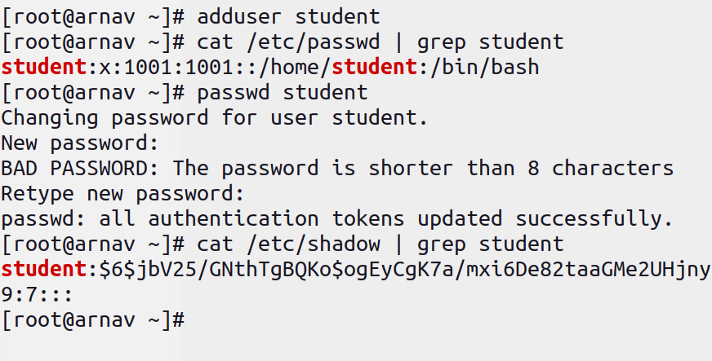

1. Login from the student user and then create files and folders according to the following structure. (where d refers to directory and f refers to file)

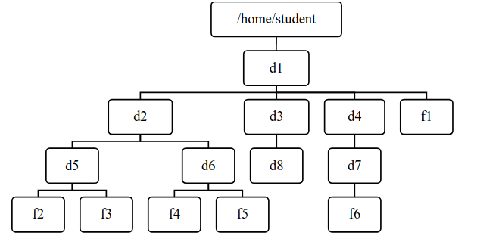

To login from the user student a simple command ‘su student’ is used, since we were previously working from the root user, we were not asked to enter the password for the user student.

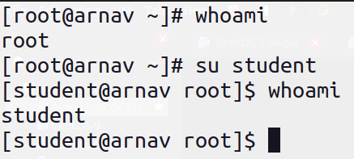

After that for creation of the folder a command ‘mkdir <name>’ is used and to create a new empty file a command ‘touch <name>’ is used. The use of ‘-p’ flag with the ‘mkdir’ command adds the parent directory if not present as well.

For the creation of the specified structure we can perform the following operations:

mkdir -p /home/student/d1/{d2/{d5,d6},d3/d8,d4/d7}

touch /home/student/d1/{f1,d2/d5/{f2,f3},d2/d6/{f4,f5},d4/d7/f6}

After which to verify the creation of the structure, we used the ’tree’ command as:

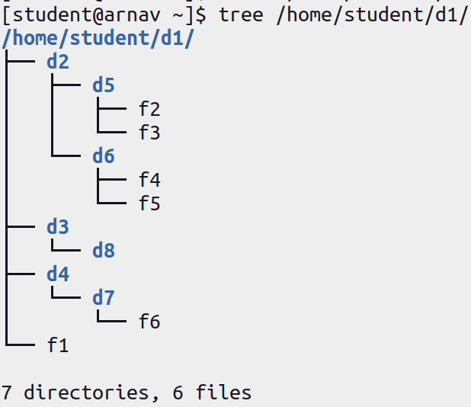

1. Change the permission of the file f1 so that the owner will get full permission, group member will get read and execute permission and others will get read-only permissions.

To change the permission of any file a simple command ‘chmod <new permission> <filename>’ is used. To view the permission for any file a flag ‘-l’ is used with ‘ls’ as ‘ls -l’. The permission is listed in the form of:

tuuugggooo

Where, the first bit t refers to the type of file, which may be a file denoted by ‘-’, a directory denoted as ‘d’, links as ‘l’ and so on. The next three bits refer to the permission for the user who owns the file, the next three bit for the users in the group of the file owner, and finally the last three bit refers to the permission for other users.

Here, for the d1

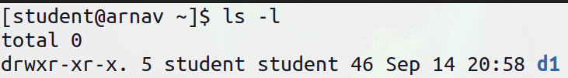

The item is a directory, owned by the user student and belonging to group student. The owner has permission to read, write and execute the directory, the group has permission to read and execute the directory and others also have permission to read and execute.

Now to change the permission of file f1:

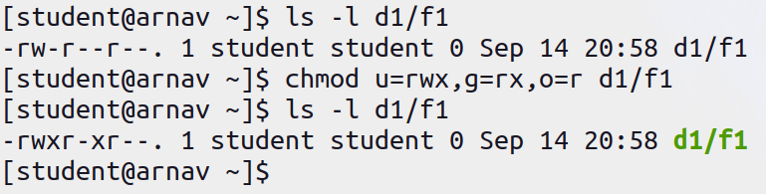

1. Change permission of the file f2 such that the owner’s and group members will get read and write permission, but others will get no permission.

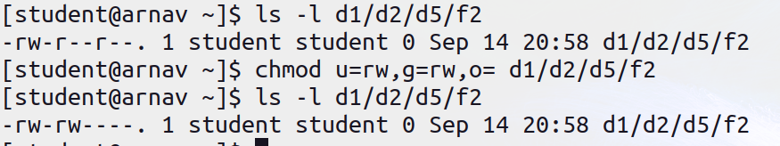

1. Change permission of directory d3 such that all categories of users will get full permissions.

