**Task 3**

**User and Group Administration**

All tasks below are based on the following structure.

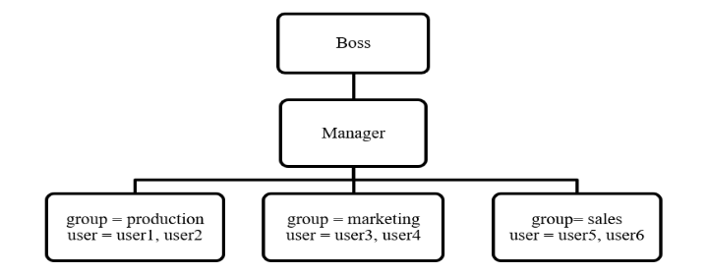

1. Create group for each department (production, marketing, sales)

First, the command to add a group is ‘groupadd <name>’, which can be verified by viewing the file ‘/etc/groups’.

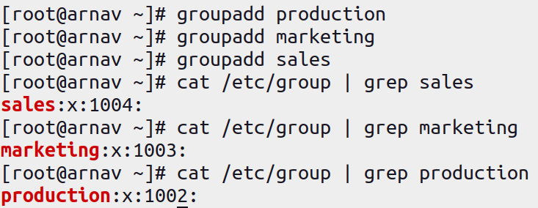

1. Create user account (user1, user2, user3, user4, user5, user6, manager, boss) for each employee assigning them respective group.

To add a user to a defined group, we can use flag ‘-G’ while creating a user as ‘useradd -G <group_name> <name>’.

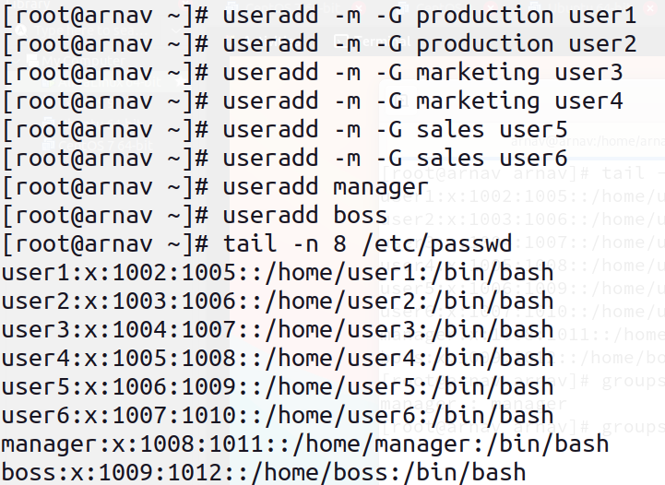

To check the defined groups that a specific user belongs to, we can use the command ‘groups <user_name>’.

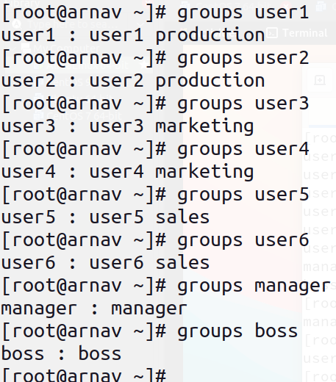

1. Create common directory (/root/production, /root/marketing and /root/sales) for each department.

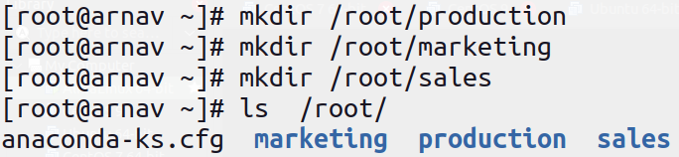

1. Change ownership of group directories such that boss will become the owner and the respective groups will be group owner.

To change the ownership of a file and directory, we use the simple command ‘chown <owner>:<group> <item_name>’, which can be visible by using the command ‘ls -l’.

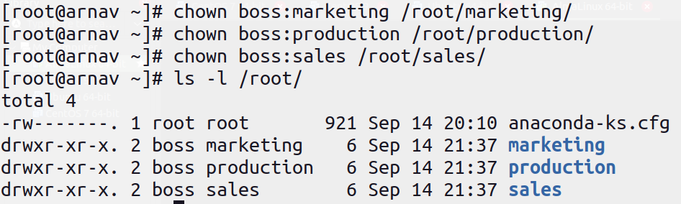

1. Change the permission of the group directories such that only the owner and group member will get full permission and other will not get any permission.

Only the owner (boss) and group members have full permissions (read, write, execute), and others have no permissions.

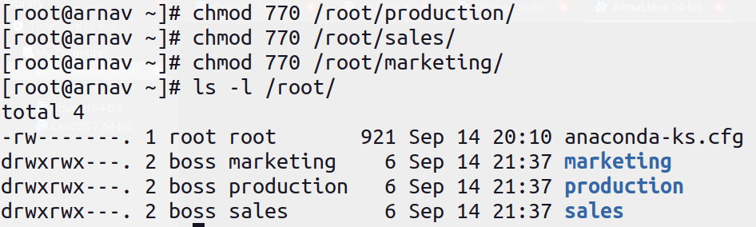

1. Set SGID and sticky bits on the departmental directories.

SGID ensures that files created in the directory inherit the group of the directory, and the sticky bit ensures that only the owner of a file can delete it.

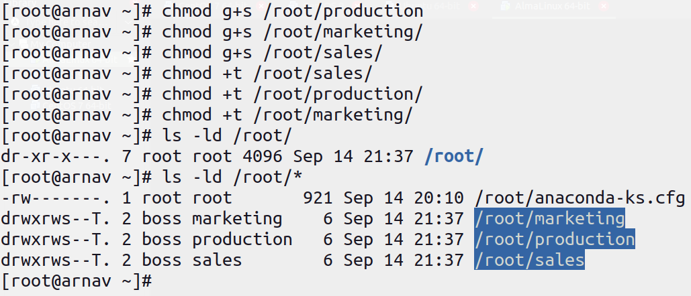

1. Assign special permission (ACL) to anonymous called david such that it can see what’s inside the common directory for sales group i.e., /root/sales.

