**Task 4**

**Firewall configuration in Linux**

1. Install firewalld package as well as start and enable firewall services.

To install any package in Alma Linux, simple command ‘yum install <package_name>’ is used.

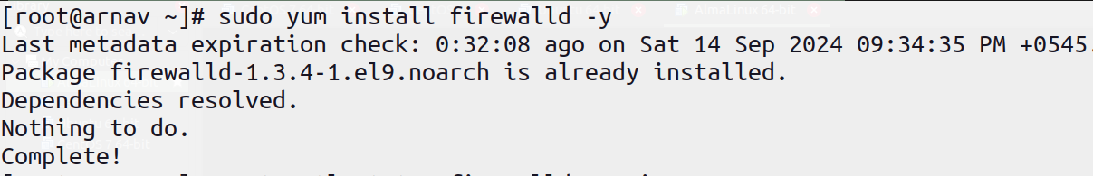

To enable, and start the package, ‘systemctl’ command is used in conjunction with the service name as:

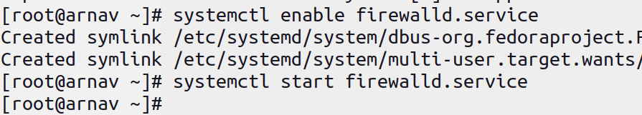

Which can be viewed by ‘systemctl status <serive_name>’.

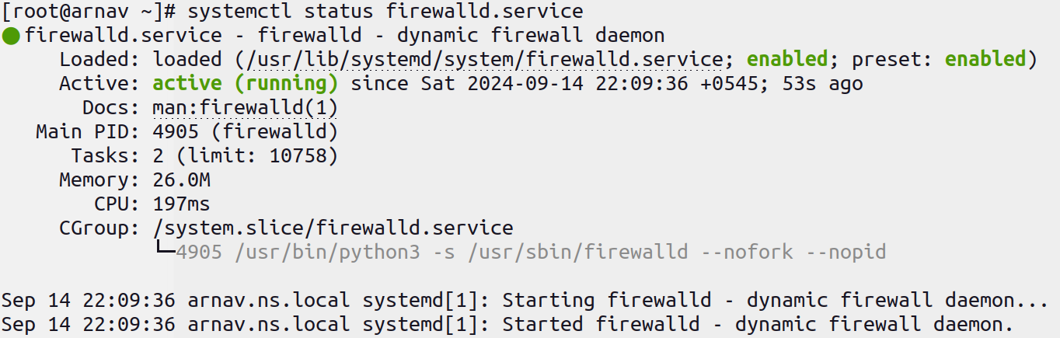

1. Add the following services and ports to allow packets through the firewall. [Service = http, smtp port = 25 /tcp, 25/udp, 110/tcp]

To add anything to the firewall, we use the ‘firewall-cmd’ command interface. To add a service, we use the command ‘sudo firewall-cmd --permanent --add-service=<name>’ and similary for ports we use ‘sudo firewall-cmd --permanent --add-port=<port>/<protocol>’.

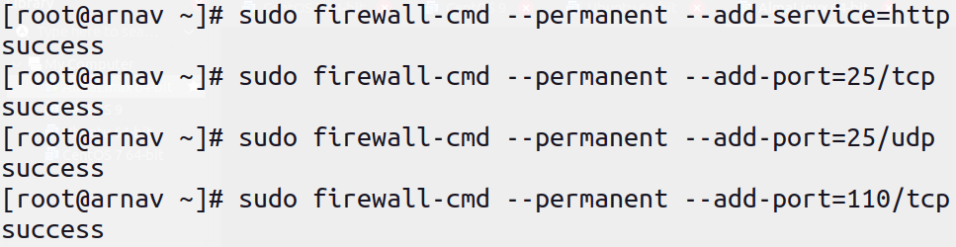  
For the changes to take place, first we need to reload the firewall, then we can view the permissions in firewall by listing all using ’firewall-cmd --list-all’, which lists all the permissions in the default, and active zone.

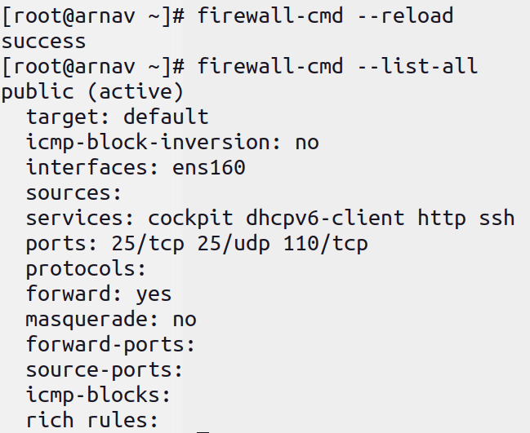

1. Remove the following services and ports to block packets through the firewall.[Service = smtp port = 25 /tcp, 25/udp]

To remove any service or port the flag ‘--remove-service=<name>’ or ‘--remove-port=<port>/<protocol>’ is used in conjunction with ‘firewall-cmd’.

