**Task 6**

**Configuring SSH Server to allow/deny SSH login from selected hosts only**

1. Configure OpenSSH server to deny all hosts except the host machine.

To configure OpenSSH server to deny all hosts except the host machine itself, we can simply add a entry named ‘AllowUsers’ in the /etc/ssh/sshd_config file. This entry overrides any and all other configuration and allows ssh into the machine from the user and address defined in the entry only.

Here, I have not defined any user and limited the address for AllowUser to 127.0.0.1, so all users trying to ssh with that address were allowed, but all other tried were stopped.

First, I updated the sshd_config file by adding the following entry at the bottom of the file as:

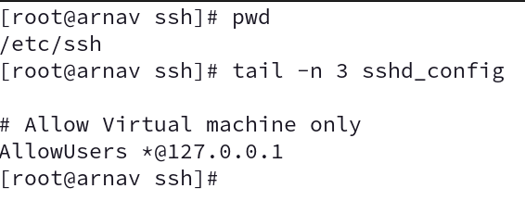

Then, we try to ssh into the machine from the host device itself as:

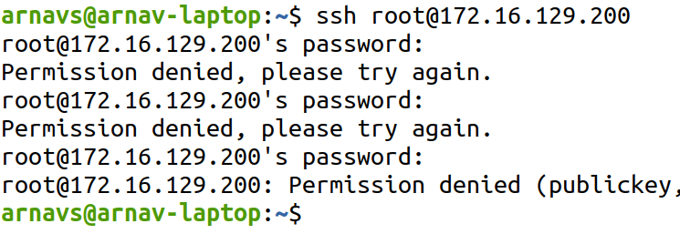

But from inside the virtual machine itself:

