**Task 7**

**Configuring SSH Server for direct SSH login by generating and publishing private and public key**

1. Generate SSH key pair (public and private) in local host.

To generate SSH key pair in localhost, we can simply use the command, ‘ssh-keygen’, and then define the file where we want to save the keys as well as provide passphrases if needed.

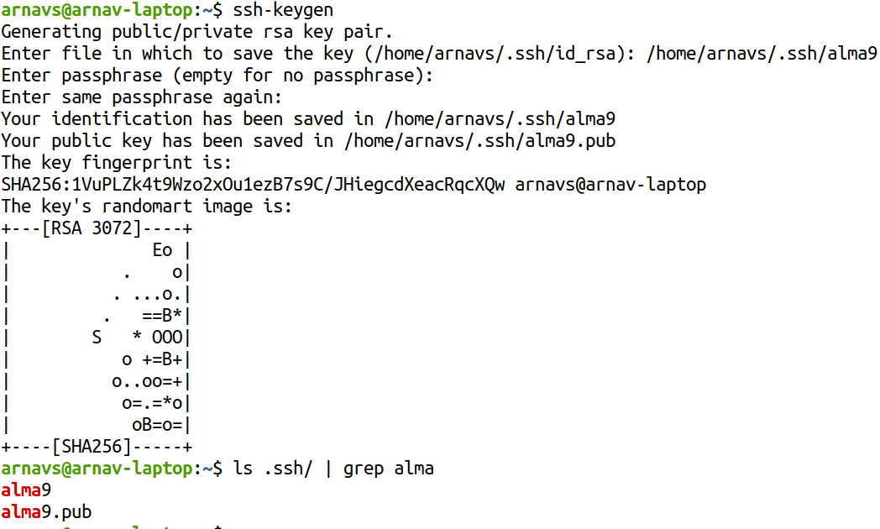

1. Send a copy of the public key to the ssh server in which you want to direct login.

Now, to send the public key to the Alma Linux instance to start direct login, we can simply use the command ‘ssh-copy-id -i public_key user@server’.

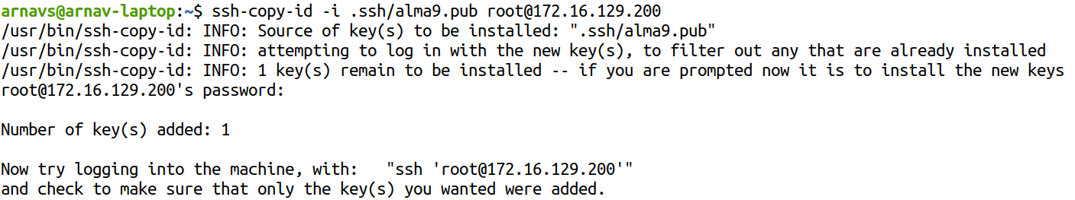

Then, we try to login via ssh, we get

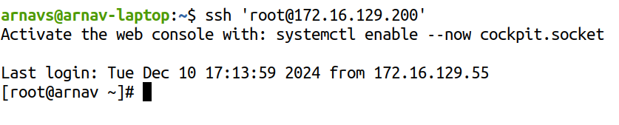In this way, we can configure our server for direct SSH using private and public keys.