**Task 8**

**Secure Network Copy using “SCP”**

1. Copy remote file into the local system

To copy any file to-and from a server using ssh, we can simply use the command line tool ‘scp’, its syntax is as ‘scp source destination’, and copies the file and resources found at source to destination.

Here, I copied the file named server from my remote server into local path as:

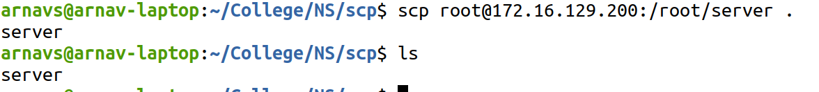

1. Copy local files to the remote host

To copy the file into the remote host, similar command is used, but we must make sure that the user we are logging into the server during scp has permission to work in that specific directory.



So, we can use ‘scp’ command to copy files to and from a remote server using ssh as base.