**Task 9**

**Security Enhanced Linux (SE Linux)**

1. Check the current status of SE Linux

To check the current status of SE Linux, we can simply use the command ‘getenforce’, which then gives the status of SE Linux.

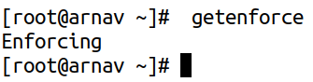

We can also use the command ‘sestatus’, to check the status of SE Linux as:

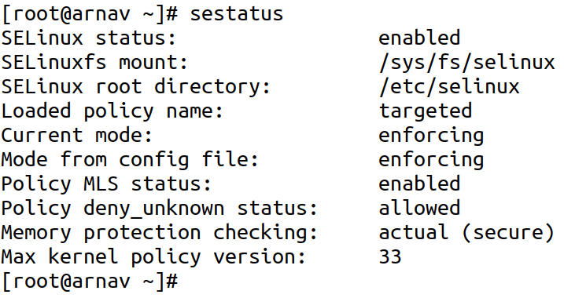

1. Configure the server to enable (enforcing) SE Linux

If the server is not enforcing SE Linux, we can enforce it by editing the file /etc/sysconfig/selinux, and then changing the context of SE Linux to enforcing as:

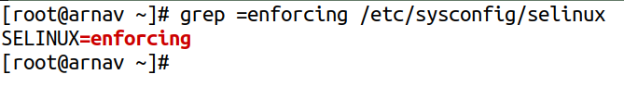

1. Configure SELinux for a custom HTTP port 8090 and custom SSH port 4455.

First, to add a custom HTTP port into SE Linux, we can use the ‘semanage’ command to add a new port into the SE Linux state. For this, we need the tag which denotes which action the port enabled via SE Linux is enabled to take, for example, ‘ssh_port_t’ for SSH and ‘http_port_t’ for HTTP. We also need to add the new custom port as TCP port into the SE Linux status.

To add custom HTTP port 8090 into SE Linux context, we can simply use the command, ‘sudo semanage port -a -t http_port_t -p tcp 8090’, which adds a custom port 8090 for HTTP into SE Linux.

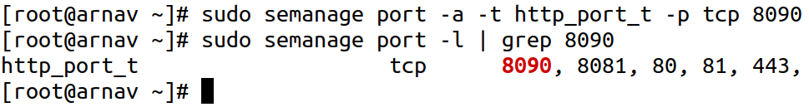Then, to add custom SSH port 4455 into SE Linux, we can simply use the command, ‘sudo semanage port -a -t ssh_port_t -p tcp 4455’, which adds a custom port 4455 as ssh_port_t (which is SE Linux tag for SSH).

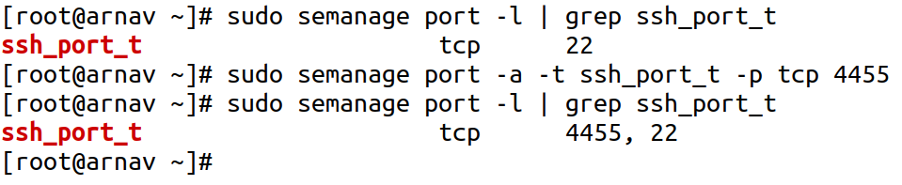

1. Change SELinux context of /mysite to httpd_sys_content_t using semanage and chcon respectively.

We can use the commands ‘semanage’, and ‘chcon’ to change the SE Linux context of any file or directory. For the purpose of this lab, we create a folder named ‘mysite’ at / and add a sample index.html file in it.

Then, we add the context of ‘httpd_sys_content_t’ in it, which is the default context of /var/www/html, the root directory of Apache web server. We can do this as:

Initailly, we have the directory and its content as:

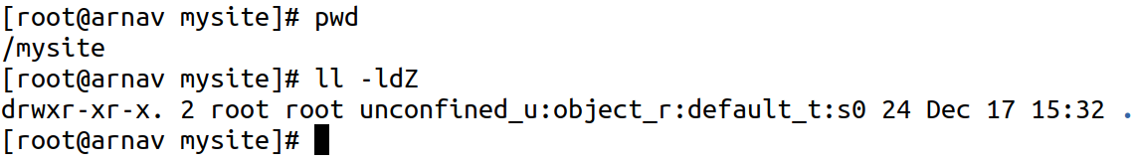

Then, we first use the command, ‘semanage fcontext -a -t httpd_sys_content_t "/mysite(/.*)?"’ which assignsthe context of the folder /mysite and all of its content. After that, running the ‘restorecon -Rv /mysite’ command applies the new context to the directory.

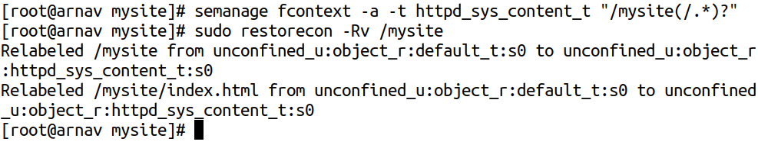

We can also use the chcon command to directly change the SE Linux context of the directory as well, which can be performed by using the command, ‘sudo chcon -R -t httpd_sys_content_t /mysite’, which would directly assign the SE Linux context to the content of that path.

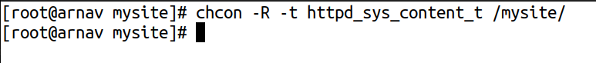We can again test this by running the command ’ls -ldZ’ to check the SE Linux context as:



1. Change the SELinux context of /mysite2 using reference context of /var/www/html.

We can also change context of one directory directly by using another path or directory by using it as a reference using the command ‘chcon’ as ‘sudo chcon --reference=/var/www/html -R /mysite2’.

