**Course : Software Quality and Testing**

**Semester : Spring 2020-21**

**Section : D**

## **Project title :** Developing a Test Plan for a AIUB Bank ATM Systems

**Group members :**

|  |  |
| --- | --- |
| **Name** | **Id** |
| 1. **S.R.M. Bahauddin Shishir** | **18-38327-2** |
| 1. **MD. Nayem Khan** | **18-38193-2** |
| 1. **Amrin Ara** | **18-36206-1** |
| 1. **Abeda Sultana** | **17-33879-1** |
| 1. **MD. Shamiur Rahman** | **18-36591-1** |

**Test Plan Identifier :**

ASAB_MTP_1.0

**Reference :**

Given requirements documents

**Introduction:**

This is a master test plan for AIUB Bank ATM System to be developed by Datasoft, Inc. Here, the software for automated teller machine (ATMs) will be tested to ensure that the it is working competent and accurate by following all the requirements which is given. In this test plan document, all areas for testing procedure will be discussed and analyzed.

**Test Items:**

* The system should be implemented in all ATM machines with proper functionality.
* The system should detect if the ATM card is valid or not. If valid, the system enable customers to perform three types of transactions

1. Withdrawal of funds
2. Query of account balance
3. Transfer of funds from one bank account to another account in the same bank

* The system consider an ATM card usage valid if it meets the following conditions:

1. The card issued by an authorized bank
2. The card is used after the start date (i.e. the date when the card was issued)

iii) The card is used before the expiration date (i.e. the date when the card expires)

iv) The card has not been reported lost or stolen by the customer, who had been issued that card

v)The customer provides correct personal identification number (PIN), which matches the PIN maintained by the system

* For a stolen or lost card insertion, the system must confiscate the ATM card. Also show a apology message for confiscating the card.
* The system should not allow more than three attempts to enter the correct pin. If user fails to provide correct pin for the third time, system will confiscate the card.
* After satisfactory validation of the customer PIN, the system will give three options: withdrawal transaction, or query transaction, or transfer transaction to choose.
* For withdrawal transaction, the system prompt the customer to enter account number and amount to be dispensed.
* After user input for withdrawal transaction, the system will determine the followings:

1. Sufficient funds exist in the requested account

ii) Maximum daily limit has not been exceeded

iii) Sufficient funds available at the local cash dispenser.

* If a withdrawal transaction is approved, the requested amount of cash will be dispensed and the system will print a receipt which includes transaction number, transaction type, amount withdrawn, and account balance and eject the card.
* If a customer selects query transaction, the system prompt the customer to enter account number and if it is approved than the system prints a receipt which includes transaction number, transaction type, and account balance and eject the card.
* If a customer selects transfer transaction, the system will prompt the customer to enter ‘from account number’, ‘to account number’, and ‘amount to be transferred’.
* The system should check if there are enough funds available in the ‘from account’, which are being requested for transfer to the ‘to account’.
* If the transfer transaction is approved, a receipt will be printed and the card will be ejected. The information printed on the receipt includes transaction number, transaction type, amount type, and account balance.
* The system will cancel any transaction if it has not been completed or if the customer presses the Cancel button.
* The customer records, account records, and debit card records will be maintained at the server and will not be the responsibility of the system.
* The system will enable an ATM operator to shutdown or start up an ATM for routine maintenance.
* The system will enable an ATM operator to add cash to the cash dispenser.
* The system will not be responsible for opening or closing of accounts, and to create, update, or delete customer and debit card records. These tasks are performed elsewhere by the bank.
* The system will be linked with the bank server through communication systems, which are beyond the scope of the current system. It is assumed that this facility is always available.
* The system will not be responsible for the maintenance of the hardware devices of the ATM or network facilities.

**Software Risk Issues:**

1. Large amount of bugs will be found if the software is made within a short period of time.
2. If the software is implemented without being tested then it will fail along with financial loss.
3. Small bug within the software may transfer money to different account so it should be made carefully.
4. Software wont work properly if there is error in the test report.
5. Power loss during transaction may cause incomplete transaction.

**Features to be tested:**

* New software system functionality of ATMs
* ATM card usage valid or not
* Confiscate lost or stolen card
* Confiscate the card for more than three wrong attempts
* System prompt the user to choose transaction type
* Withdraw transaction :

-Prompt customer to give account number and amount

-Fund availability checking in requested account

-Maximum daily limit checking

-Fund availability checking at local cash dispenser

-Print a receipt with proper information

* Query transaction :

-Prompt customer to give account number

-Print a receipt with proper information

* Transfer transaction :

-Prompt the customer to input ‘from account number’,’to account number’, ‘amount’

-Check if enough funds available in ‘from account’

-Print a receipt with proper information

* System cancel incomplete transaction

**Feature not to be tested:**

Due to time shortage and low budget, some of the features wont be tested in this cycle. Rather, these features will be tested in the next cycle or in maintenance period.

* Display apology message after confiscating card.
* Maintain records at the server.
* System enables ATM operator to start up or shut down an ATM machine for routine maintenance.
* The system wont be responsible for opening or closing accounts.
* System enables ATM operator to add cash to the dispenser.
* The system will be linked with the bank server through communication systems.
* The system will not be responsible for the maintenance of the hardware devices of the ATM or network facilities

**Approach :**

In this project, there is less need of repeated testing or simultaneous testing so manual testing will be done in most cases. Since, this is a short term project with a low budget so manual testing will be preferable and more beneficial overall to the bottom line of the project. Moreover, this system needs to be user friendly as common users will use this system. Automated tests can quickly detect errors in the code, but they can't predict how users will interact with a feature or how well they will navigate the program. Therefore manual testing is the right choice and it will be done in unit testing, integration testing and system testing. But it should be kept in mind that manual testing is not expected in parts where a test suit has been specified previously.

Besides manual testing, in some cases automated testing will be used. When compared to other features of an application, some features have a higher chance of failing. This is why automated testing will be used to test high-priority features because it provides more test coverage than manual testing. In certain cases, the complexities of a specific technology and platform prevent a software tester from completing testing without using automated tests. This occurs when the cost of manual testing is significantly higher than that of automated testing, or when the testing scenarios are not particularly complex. In such cases, automated testing will be used. Besides, for performance testing, load testing, volume testing and stress testing, automated testing will be used. If a testing suit is previously defined, than automated testing will be used over regression testing. But it should be kept in mind that the automated testing process will be analyzed manually.

**Item Pass/Failed criteria :**

100% defect free system is impossible so some test items will pass and others will fail. For this test plan system, if a test item fill up 98% of the criteria then it will be considered as passed. Otherwise the test item will fall into failed criteria.

**Test Deliverables :**

•Test Plan

•Test Case

•Test Suit

•Execution Log

•Summary Report

•RTM(Requirements Traceability Matrix )

•Defect Log

•Test Results

•Test Evaluation Report

**Remaining test tasks :**

- Rest of the features to be tested in the next cycle.

- Create a bug report for each detected bug.

- Feature testing to add new features or modify existing features.

- Create test plan for each testing levels like unit test plan, integration test plan, system test plan and acceptance test plan.

**Environmental needs :**

Automated test tools:

-JIRA

-Testim

-Selenium

Hardware:

-Printing machine

-ATM machine

Project management software:

-Instagantt

**Staffing & Training needs:**

Staff needs:

Testing team will consist of total 10 members. 4 programmers will be assigned to develop the code and also to do the unit testing and integration testing. And 6 test engineers will be assigned to perform system testing. Among them 2 will be senior test engineer and 4 will be junior test engineer. All 10 members will be good at manual testing and the senior test engineers should be expert at using automated testing tools. Additionally, 1 programmer and 1 test engineer will be kept as backup. At any emergency situation they will continue the work.

Training needs :

Junior test engineers will be trained up by the senior test engineers to work efficiently. If they are weak at using automated testing tools, senior test engineers will train them up. Their works and performance will be noted down for improvement.

**Responsibilities:**

**Senior Management:**

- Senior management will monitor the project and can ask anyone about the progress.

**Test lead :**

- Form up the team and monitor them.

- Develop test plan document.

- Instruct the team members about the work.

- Notify work progress to senior management.

- Look over the work and suggest team members how to improve.

- Make schedule for the development team and test team.

**Development team:**

- Develop the software.

- Notify the testing team about development.

- Do unit testing and integration testing along with development.

**Testing team :**

- Identify all test items and features to be tested.

- Do system testing.

- Do manual and automated testing.

- Do integration testing if needed.

**Schedule :**

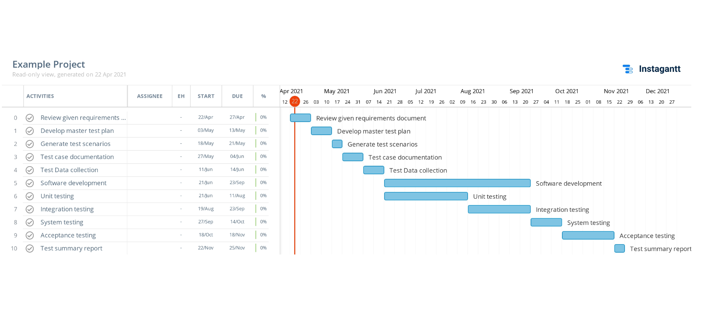

**Planning Risks and Contingencies :**

**Time Risk**: Project may not be finished within the time.

Plan : Schedule should be followed strictly so that no work remains due.

**Budget Risk**: The project may exceed the budget to finish if the estimation goes wrong.

Plan : Monitor the expenditure strictly. Use automation tools as planned.

**System Development Risk :** Development team may fail to develop the system properly.

Plan : Set general meeting in every two weeks to know the progress. Also guide them properly.

**Low quality risk :** New test engineers may find it difficult and the project quality is at risk of being low.

Plan : Senior test engineers will train them properly and instruct them how to use automated tools.

**Risks While Operating**: Less communication, shortage of resources can lead to test failure.

Plan : All the test deliverables will be done by the schedule time and test engineers will co operate each other.

**Approvals :**

|  |  |  |  |
| --- | --- | --- | --- |
| **Name** | **Designation** | **Sign** | **Date** |
| MD. Shamiur Rahman | Project manager | Shamiur | 21 April |
| S.R.M. Bahauddin Shishir | Test Lead | Shishir | 21 April |
| MD. Nayem Khan | It director | Nayem | 21 April |
| Amrin Ara | Development head | Amrin | 21 April |
| Abeda Sultana | Senior Test engineer | Abeda | 21 April |

**Glossary:**

MTP – Master Test Plan

ASAB - ATM System for AIUB Bank

STR – Software Test Report

QA – Quality Assurance

SQA – Software Quality Assurance