CISCO MODELING LABS · BEHAVIORAL VALIDATION
Stretched Firewall HA
Dual-site Active/Standby failover — lab validation results
2 FTD pairs across East & West · FTDv 7.7 / FMC 10.0.1 · 25 ms interconnect · TRex + iperf3 under load · 2026-09-09

Summary
Cross-site stateful failover holds at 25 ms. A planned failover moves the active unit between sites in about 5 seconds and established sessions survive, with no measurable degradation from 3 ms to 40 ms of round-trip latency. Latency is not the risk. The real exposures are the shared interconnect, where a full cut puts both pairs into split-brain, and edge-router failure, which blackholes a site until routing detects it. Both have concrete mitigations, given in the findings.
~5 s  Planned failover — active moves site | 0  Established sessions dropped (state link up)
3–40 ms  Failover time flat across this range | ~16 s  Router-failure outage after mitigation (from minutes)

The design being validated
The internet edge is built as two FTD Active/Standby pairs, each split across the two colocation sites. Pair A runs active in East with its standby in West and fronts the East-homed services; pair B is the mirror image, active in West. Both sites carry live traffic in steady state because each hosts one pair's active unit. the enterprise's public space is divided into a pair A portion and a pair B portion; each portion is advertised from both sites, unprepended at its home site and AS-path prepended at the other, so each ISP delivers a portion to its home site. The colocation layer 2 interconnect carries every stretched VLAN.
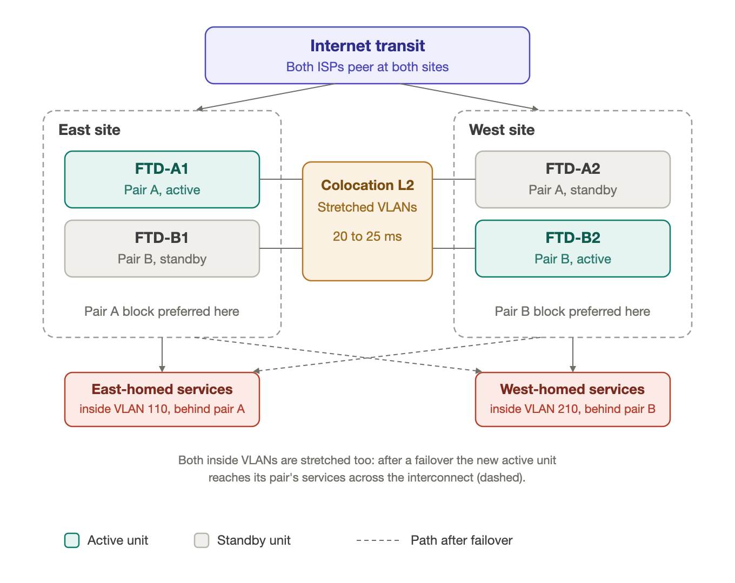
Figure 1. Two sites, two split failover pairs, per-pair ingress preference, colocation L2 interconnect.
Per site, two Catalyst 8500 routers (one per ISP, eBGP up and iBGP between them) feed an outside layer 2 domain carrying both pairs' outside VLANs, one unit from each pair, and an inside layer 2 domain carrying both pairs' inside VLANs plus all four HA VLANs. Both domains extend to the peer site over the interconnect, which in production is a single 802.1Q trunk circuit. Each pair owns four VLANs — outside, inside, failover, and state — and the pairs share nothing: no VLAN, subnet, public block, or gateway. Failover and state are kept on separate links so state replication can be lost without losing the failover heartbeat.
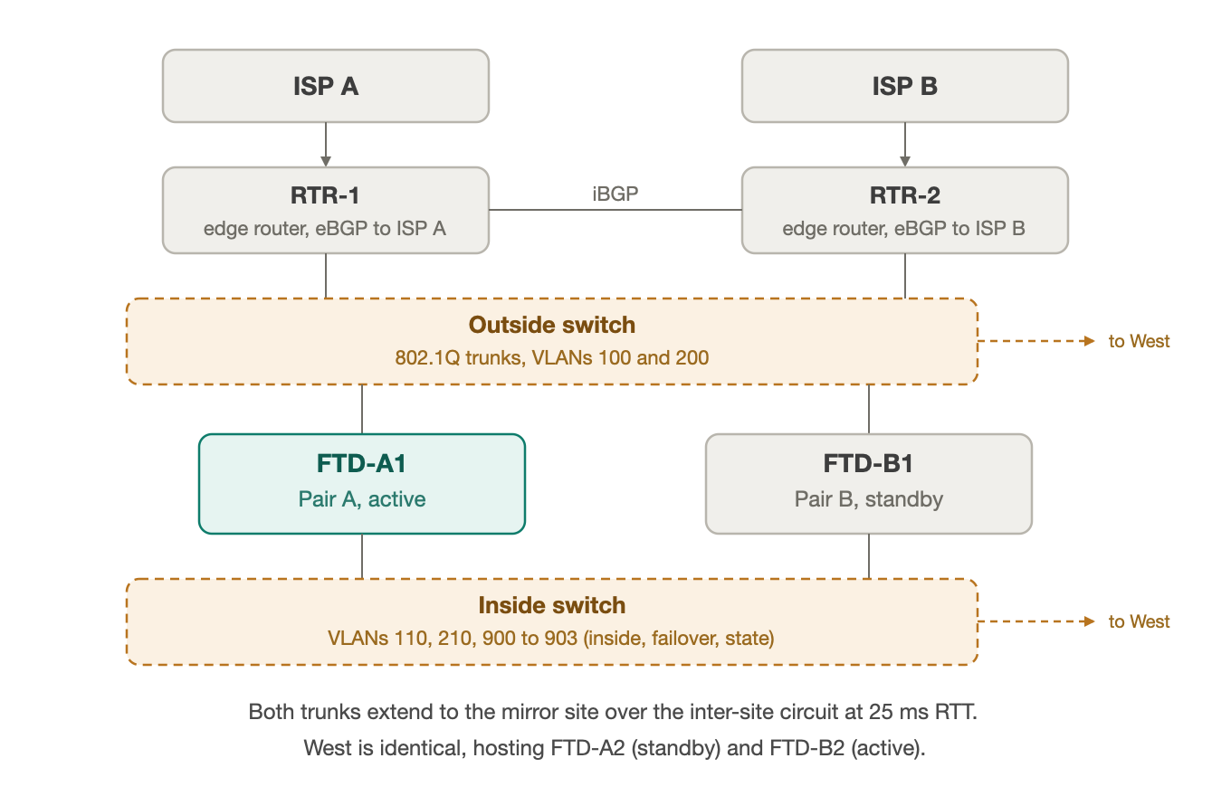
Figure 2. Per-site connectivity (East shown; West is the mirror image).
Why it needs validating. Cross-site Active/Standby was selected over clustering, which the 20-to-25 ms round trip rules out, and over site-local models that cannot preserve sessions across a site loss. Its known cost is concentration of risk on the inter-site circuit: it carries both pairs' data VLANs, both pairs' failover and state links, HSRP hellos, and spanning tree. The lab was built to reproduce that shared-fate topology at a measured 25 ms and observe how failover, session preservation, split-brain, and inbound path movement actually behave, rather than argue them on paper.

Test results
Nine scenarios, each run with live HTTP load and a long-lived session through pair A. “Session” shows whether that held connection kept its state across the event or reset.
Test | Scenario | Result | Detect | Session | What it means
T1 | Baseline health | stable | — | held | Both pairs Active/Standby, state sync current, no flapping.
T2 | Planned failover | pass | 5.2 s | survived | Active role moved East→West; brief throughput dip as Snort rebuilt inspection.
T3 | Failover, state link down | by design | 4.8 s | reset | Without state sync the session dropped — the value of the state link, shown directly.
T4 | Failover link only cut | pass | none | held | No split-brain: hellos also cross the data interfaces, so the standby stayed standby.
T5 | Full interconnect cut | risk shown | 16.8 s | held* | Split-brain on both pairs — the realistic single-circuit failure. *This flow's path never crossed the cut.
T6 | Site failure (East off) | pass | 1.2 s | survived | Pair A recovered to West; ~30–40 s to full traffic. Pair B untouched.
T7 | Latency sweep 3–40 ms | pass | ~4.7 s | survived | Failover time and survival unchanged across the range. Latency is not the risk.
T8 | Degraded link 1% / 5% loss | pass | none | held | No false failover at either loss rate; detection tolerates a lossy circuit.
T9 | Edge-router failure | mitigated | — | reset→held | Default timers blackholed the site; fast BGP detection cut it to ~16 s (see below).
Behavioral results on virtual platforms (FTDv in Cisco Modeling Labs); demonstrate behavior, not hardware FTD performance or capacity. No figure here is sizing evidence.

The two results that decide the design
Failover versus latency. Planned failover was repeated at five round-trip times — roughly 3, 6, 10, 25 and 40 ms. Detection stayed near 4.7 seconds and every session survived. The line is flat, which is the finding: within this range latency does not degrade planned stateful failover, because the state link that crosses the WAN syncs well inside Cisco's 250 ms ceiling.
Edge-router failure. Powering off one edge router, measured by routing-failure-detection setting:
Routing failure detection | Inbound outage | Connections lost
Default timers, no BFD | no recovery | 4,475
BFD on eBGP only | ~100 s | 2,653
BGP timers 3/9 everywhere | ~16 s | 193 | recommended
Firewall HA does not cover the routers. With default BGP timers the site blackholed for minutes because routing never detected the dead router; the firewalls were healthy the whole time. Fast detection is the fix.

Findings & recommendations
Confirmed Latency is not the problem
Planned failover preserved sessions at every latency to 40 ms. 25 ms is a sound design point for cross-site Active/Standby.
Risk One circuit means split-brain
A full interconnect cut drove both pairs active at once. Everything rides one inter-site path today. Procure diverse physical circuits and place the failover and state VLANs on the second path.
Mitigated Pair firewall HA with fast routing detection
An abrupt edge-router loss blackholed the site on default timers. Aggressive BGP timers (and BFD where the platform honors fall-over) cut the outage to about 16 seconds.
Design note Keep failover and state on separate links
With the state link cut, the next failover reset every session; with it up, sessions survived. Separate links let one fail without the other.

Appendix A — VLAN plan
Eight VLANs, four per pair. All eight are stretched across both sites over the colocation layer 2 interconnect.
VLAN | Name | Pair | Purpose
100 | OUTSIDE-A | A | Pair A outside / public; HSRP group 10 gateway (active in East)
110 | INSIDE-A | A | Pair A inside / private
900 | FAILOVER-A | A | Pair A failover heartbeat link
901 | STATE-A | A | Pair A stateful failover (session replication)
200 | OUTSIDE-B | B | Pair B outside / public; HSRP group 20 gateway (active in West)
210 | INSIDE-B | B | Pair B inside / private
902 | FAILOVER-B | B | Pair B failover heartbeat link
903 | STATE-B | B | Pair B stateful failover (session replication)

Appendix B — Addressing plan
Ranges shown are the lab's documentation stand-ins (RFC 5737 public, RFC 1918 private) for the enterprise's real address space. The production prefix split between the two pair portions is a low-level design item.
Segment | Range (lab) | Notes
Pair A public (VLAN 100) | 203.0.113.0/26 | enterprise public space, pair A portion
Pair B public (VLAN 200) | 203.0.113.64/26 | enterprise public space, pair B portion
Pair A inside (VLAN 110) | 10.10.0.0/24 | Private, behind pair A NAT
Pair B inside (VLAN 210) | 10.20.0.0/24 | Private, behind pair B NAT
Pair A failover / state | 192.168.90.0/30, 192.168.91.0/30 | HA links (900 / 901)
Pair B failover / state | 192.168.92.0/30, 192.168.93.0/30 | HA links (902 / 903)
ISP transit links | 198.51.100.0/24 | eBGP to both providers
Simulated internet clients | 192.0.2.0/24 | Lab traffic sources

