Here is the csv template I created: https://cisco.box.com/s/9xsq3uotatfzpv0tvviqs2k1aweqp1du

Whatever script is created should be aware that the template has a heading row – number 1.

Here is an example of a single XML profiling policy: <https://cisco.box.com/s/kgex0hfl4y0l2jajfvlu61eqt7y4q4tn>

Here is an example of an XML file with multiple profiles in it: <https://cisco.box.com/s/6ichyudt6dtxnnpzxywi6vj7tjqq07ye>

For items under Column A in the template, it should populate the top-most policy name as pictured-below and be a string:

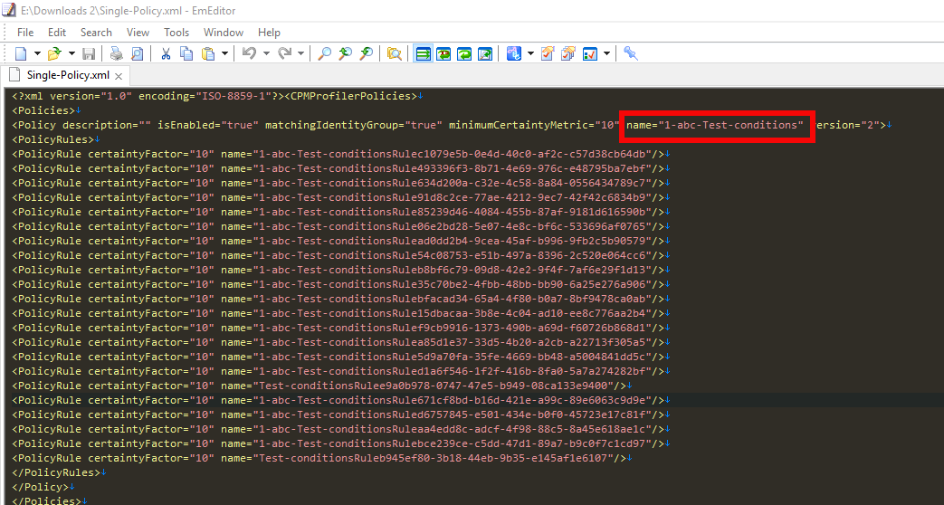

For Column B, it should populate under the minimum certainty factor of the entire policy here and should be numeric only:

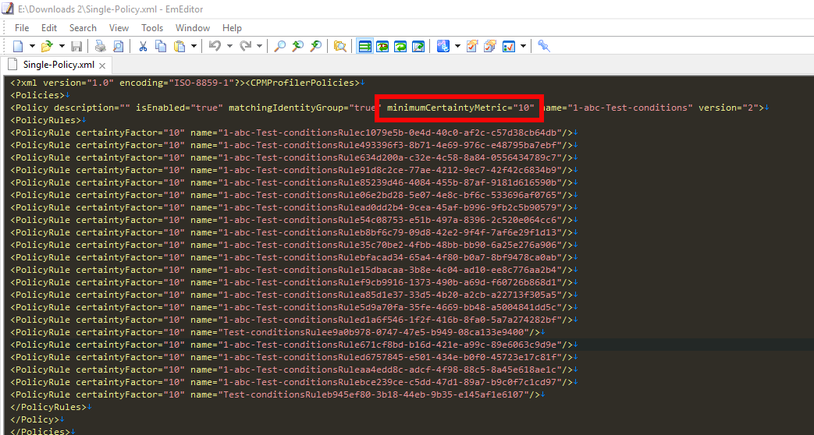

If columns C-D are filled in, the script should add Policy Rules and Check Attribute lines for the following:

**<PolicyRule certaintyFactor="***<Insert-Numeric-Value-From-Column-E>****"* name="***<Insert-Name-From-Column-A>****-*Rule-1"/>**

**<Check attributeName="OUI" attributeValue="***<String-From-Column-E>*" **description="MAC OUI** *<String-From-Column-C>* *<String-From-Column-E>*" **name="***<Insert-Name-From-Column-A>***-Condition-1**" **operator=**"*<String-From-Column-C>"* **type="Mac"/>**

If columns F-G are filled in, the script should add Policy Rules and Check Attribute lines for the following:

**<PolicyRule certaintyFactor="***<Insert-Numeric-Value-From-Column-H>****"* name="***<Insert-Name-From-Column-A>****-*Rule-2"/>**

**<Check attributeName="dhcp-parameter-request-list" attributeValue="***<String-From-Column-G>*" **description="DHCP dhcp-parameter-request-list** *<String-From-Column-F>* *<String-From-Column-G>*" **name="***<Insert-Name-From-Column-A>***-Condition-2**" **operator=**"*<String-From-Column-F>"* **type=**"**DHCP"/>**

If columns I-K are filled in, the script should add Policy Rules and Check Attribute lines for the following:

**<PolicyRule certaintyFactor="***<Insert-Numeric-Value-From-Column-K>****"* name="***<Insert-Name-From-Column-A>****-*Rule-3"/>**

**<Check attributeName="dhcp-class-identifier" attributeValue="***<String-From-Column-J>*" **description="DHCP dhcp-class-identifier** *<String-From-Column I>* *<String-From-Column-J>*" **name="***<Insert-Name-From-Column-A>***-Condition-3**" **operator=**"*<String-From-Column-I>"* **type=**"**DHCP"/>**

If columns L-N are filled in, the script should add Policy Rules and Check Attribute lines for the following:

**<PolicyRule certaintyFactor="***<Insert-Numeric-Value-From-Column-N>****"* name="***<Insert-Name-From-Column-A>****-*Rule-4"/>**

**<Check attributeName="User-Agent" attributeValue="***<String-From-Column-M>*" **description="IP User-Agent** *<String-From-Column L>* *<String-From-Column-M>*" **name="***<Insert-Name-From-Column-A>***-Condition-4**" **operator=**"*<String-From-Column-L>"* **type=**"**IP"/>**

If columns O-Q are filled in, the script should add Policy Rules and Check Attribute lines for the following:

**<PolicyRule certaintyFactor="***<Insert-Numeric-Value-From-Column-Q>****"* name="***<Insert-Name-From-Column-A>****-*Rule-5"/>**

**<Check attributeName="host-name" attributeValue="***<String-From-Column-P>*" **description="DHCP host-name** *<String-From-Column O>* *<String-From-Column-P>*" **name="***<Insert-Name-From-Column-A>***-Condition-5**" **operator=**"*<String-From-Column-O>"* **type=**"**DHCP"/>**

If columns R-T are filled in, the script should add Policy Rules and Check Attribute lines for the following:

**<PolicyRule certaintyFactor="***<Insert-Numeric-Value-From-Column-T>****"* name="***<Insert-Name-From-Column-A>****-*Rule-6"/>**

**<Check attributeName="cdpCacheCapabilities" attributeValue="***<String-From-Column-S>*" **description="CDP cdpCacheCapabilities** *<String-From-Column R>* *<String-From-Column-S>*" **name="***<Insert-Name-From-Column-A>***-Condition-6**" **operator=**"*<String-From-Column-R>"* **type=**"**CDP"/>**

If columns U-W are filled in, the script should add Policy Rules and Check Attribute lines for the following:

**<PolicyRule certaintyFactor="***<Insert-Numeric-Value-From-Column-W>****"* name="***<Insert-Name-From-Column-A>****-*Rule-7"/>**

**<Check attributeName="cdpCacheDeviceId" attributeValue="***<String-From-Column-V>*" **description="CDP cdpCacheDeviceId** *<String-From-Column U>* *<String-From-Column-V>*" **name="***<Insert-Name-From-Column-A>***-Condition-7**" **operator=**"*<String-From-Column-U>"* **type=**"**CDP"/>**

If columns X-Z are filled in, the script should add Policy Rules and Check Attribute lines for the following:

**<PolicyRule certaintyFactor="***<Insert-Numeric-Value-From-Column-Z>****"* name="***<Insert-Name-From-Column-A>****-*Rule-8"/>**

**<Check attributeName="cdpCachePlatform" attributeValue="***<String-From-Column-Y>*" **description="CDP cdpCachePlatform** *<String-From-Column X>* *<String-From-Column-Y>*" **name="***<Insert-Name-From-Column-A>***-Condition-8**" **operator=**"*<String-From-Column-X>"* **type=**"**CDP"/>**

If columns AA-AC are filled in, the script should add Policy Rules and Check Attribute lines for the following:

**<PolicyRule certaintyFactor="***<Insert-Numeric-Value-From-Column-AC>****"* name="***<Insert-Name-From-Column-A>****-*Rule-9"/>**

**<Check attributeName="cdpCacheVersion" attributeValue="***<String-From-Column-AB>*" **description="CDP cdpCacheVersion** *<String-From-Column AA>* *<String-From-Column-AB>*" **name="***<Insert-Name-From-Column-A>***-Condition-9**" **operator=**"*<String-From-Column-AA>"* **type=**"**CDP"/>**

If columns AD-AF are filled in, the script should add Policy Rules and Check Attribute lines for the following:

**<PolicyRule certaintyFactor="***<Insert-Numeric-Value-From-Column-AF>****"* name="***<Insert-Name-From-Column-A>****-*Rule-10"/>**

**<Check attributeName="hrDeviceDescr" attributeValue="***<String-From-Column-AE>*" **description="SNMP hrDeviceDescr <***String-From-Column AD>* *<String-From-Column-AE>*" **name="***<Insert-Name-From-Column-A>***-Condition-10**" **operator=**"*<String-From-Column-AD>"* **type=**"**Snmp"/>**

If columns AG-AI are filled in, the script should add Policy Rules and Check Attribute lines for the following:

**<PolicyRule certaintyFactor="***<Insert-Numeric-Value-From-Column-AI>****"* name="***<Insert-Name-From-Column-A>****-*Rule-11"/>**

**<Check attributeName="lldpCacheCapabilities" attributeValue="***<String-From-Column-AH>*" **description="LLDP lldpCacheCapabilities <***String-From-Column AG>* *<String-From-Column-AH>*" **name="***<Insert-Name-From-Column-A>***-Condition-11**" **operator=**"*<String-From-Column-AG>"* **type=**"**LLDP"/>**

If columns AJ-AL are filled in, the script should add Policy Rules and Check Attribute lines for the following:

**<PolicyRule certaintyFactor="***<Insert-Numeric-Value-From-Column-AL>****"* name="***<Insert-Name-From-Column-A>****-*Rule-12"/>**

**<Check attributeName="lldpCapabilitiesMapSupported" attributeValue="***<String-From-Column-AK>*" **description="LLDP lldpCapabilitiesMapSupported <***String-From-Column AJ>* *<String-From-Column-AK>*" **name="***<Insert-Name-From-Column-A>***-Condition-12**" **operator=**"*<String-From-Column-AJ>"* **type=**"**LLDP"/>**

If columns AM-AO are filled in, the script should add Policy Rules and Check Attribute lines for the following:

**<PolicyRule certaintyFactor="***<Insert-Numeric-Value-From-Column-AO>****"* name="***<Insert-Name-From-Column-A>****-*Rule-13"/>**

**<Check attributeName="lldpSystemDescription" attributeValue="***<String-From-Column-AN>*" **description="LLDP lldpSystemDescription <***String-From-Column AM>* *<String-From-Column-AN>*" **name="***<Insert-Name-From-Column-A>***-Condition-13**" **operator=**"*<String-From-Column-AM>"* **type=**"**LLDP"/>**

If columns AP-AR are filled in, the script should add Policy Rules and Check Attribute lines for the following:

**<PolicyRule certaintyFactor="***<Insert-Numeric-Value-From-Column-AR>****"* name="***<Insert-Name-From-Column-A>****-*Rule-14"/>**

**<Check attributeName="sysDescr" attributeValue="***<String-From-Column-AQ>*" **description="SNMP sysDescr <***String-From-Column AP>* *<String-From-Column-AQ>*" **name="***<Insert-Name-From-Column-A>***-Condition-14**" **operator=**"*<String-From-Column-AP>"* **type=**"**Snmp"/>**

If columns AS-AU are filled in, the script should add Policy Rules and Check Attribute lines for the following:

**<PolicyRule certaintyFactor="***<Insert-Numeric-Value-From-Column-AU>****"* name="***<Insert-Name-From-Column-A>****-*Rule-15"/>**

**<Check attributeName="AD-Operating-System" attributeValue="***<String-From-Column-AT>*" **description="ACTIVEDIRECTORY_PROBE AD-Operating-System <***String-From-Column AS>* *<String-From-Column-AT>*" **name="***<Insert-Name-From-Column-A>***-Condition-15**" **operator=**"*<String-From-Column-AS>"* **type=**"**ACTIVEDIRECTORY_PROBE"/>**

If columns AV-AX are filled in, the script should add Policy Rules and Check Attribute lines for the following:

**<PolicyRule certaintyFactor="***<Insert-Numeric-Value-From-Column-AX>****"* name="***<Insert-Name-From-Column-A>****-*Rule-16"/>**

**<Check attributeName="device-platform" attributeValue="***<String-From-Column-AW>*" **description="ACIDEX device-platform <***String-From-Column AV>* *<String-From-Column-AW>*" **name="***<Insert-Name-From-Column-A>***-Condition-16**" **operator=**"*<String-From-Column-AV>"* **type=**"**ACIDEX"/>**

If columns AY-BA are filled in, the script should add Policy Rules and Check Attribute lines for the following:

**<PolicyRule certaintyFactor="***<Insert-Numeric-Value-From-Column-BA>****"* name="***<Insert-Name-From-Column-A>****-*Rule-17"/>**

**<Check attributeName="device-type" attributeValue="***<String-From-Column-AZ>*" **description="ACIDEX device-type <***String-From-Column AY>* *<String-From-Column-AZ>*" **name="***<Insert-Name-From-Column-A>***-Condition-17**" **operator=**"*<String-From-Column-AY>"* **type=**"**ACIDEX"/>**

If columns BB-BD are filled in, the script should add Policy Rules and Check Attribute lines for the following:

**<PolicyRule certaintyFactor="***<Insert-Numeric-Value-From-Column-BD>****"* name="***<Insert-Name-From-Column-A>****-*Rule-18"/>**

**<Check attributeName="lldpSystemName" attributeValue="***<String-From-Column-BC>*" **description="LLDP lldpSystemName <***String-From-Column BB>* *<String-From-Column-BC>*" **name="***<Insert-Name-From-Column-A>***-Condition-18**" **operator=**"*<String-From-Column-BB>"* **type=**"**LLDP"/>**

If columns BE-BG are filled in, the script should add Policy Rules and Check Attribute lines for the following:

**<PolicyRule certaintyFactor="***<Insert-Numeric-Value-From-Column-BG>****"* name="***<Insert-Name-From-Column-A>****-*Rule-19"/>**

**<Check attributeName="lldpChassisId" attributeValue="***<String-From-Column-BF>*" **description="LLDP lldpChassisId <***String-From-Column BE>* *<String-From-Column-BF>*" **name="***<Insert-Name-From-Column-A>***-Condition-19**" **operator=**"*<String-From-Column-BE>"* **type=**"**LLDP"/>**

If columns BH-BJ are filled in, the script should add Policy Rules and Check Attribute lines for the following:

**<PolicyRule certaintyFactor="***<Insert-Numeric-Value-From-Column-BJ>****"* name="***<Insert-Name-From-Column-A>****-*Rule-20"/>**

**<Check attributeName="sysContact" attributeValue="***<String-From-Column-BI>*" **description="SNMP sysContact <***String-From-Column BH>* *<String-From-Column-BI>*" **name="***<Insert-Name-From-Column-A>***-Condition-20**" **operator=**"*<String-From-Column-BH>"* **type=**"**Snmp"/>**

If columns BK-BM are filled in, the script should add Policy Rules and Check Attribute lines for the following:

**<PolicyRule certaintyFactor="***<Insert-Numeric-Value-From-Column-BM>****"* name="***<Insert-Name-From-Column-A>****-*Rule-21"/>**

**<Check attributeName="sysLocation" attributeValue="***<String-From-Column-BL>*" **description="SNMP sysLocation <***String-From-Column-BK>* *<String-From-Column-BL>*" **name="***<Insert-Name-From-Column-A>***-Condition-21**" **operator=**"*<String-From-Column-BK>"* **type=**"**Snmp"/>**

If columns BN-BP are filled in, the script should add Policy Rules and Check Attribute lines for the following:

**<PolicyRule certaintyFactor="***<Insert-Numeric-Value-From-Column-BP>****"* name="***<Insert-Name-From-Column-A>****-*Rule-22"/>**

**<Check attributeName="sysName" attributeValue="***<String-From-Column-BO>*" **description="SNMP sysName <***String-From-Column-BN>* *<String-From-Column-BO>*" **name="***<Insert-Name-From-Column-A>***-Condition-22**" **operator=**"*<String-From-Column-BN>"* **type=**"**Snmp"/>**

If there are multiple rows, they should create multiple profiles in the same XML file like the below example:

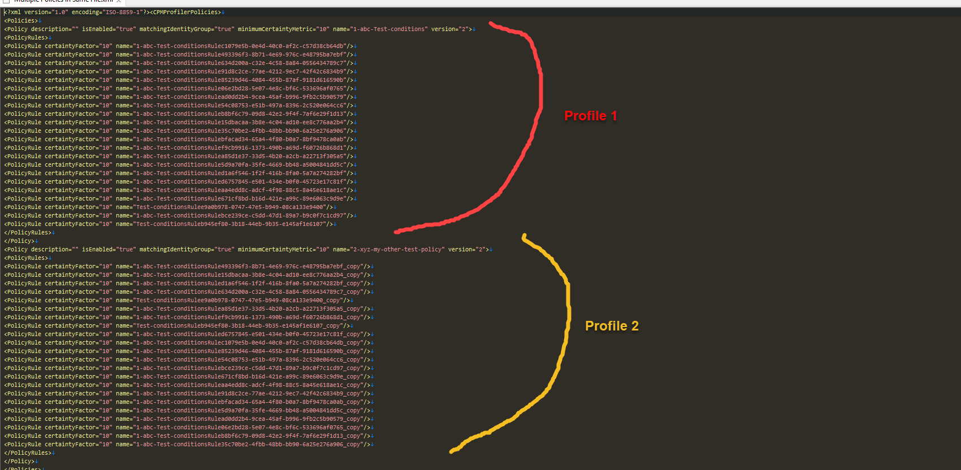

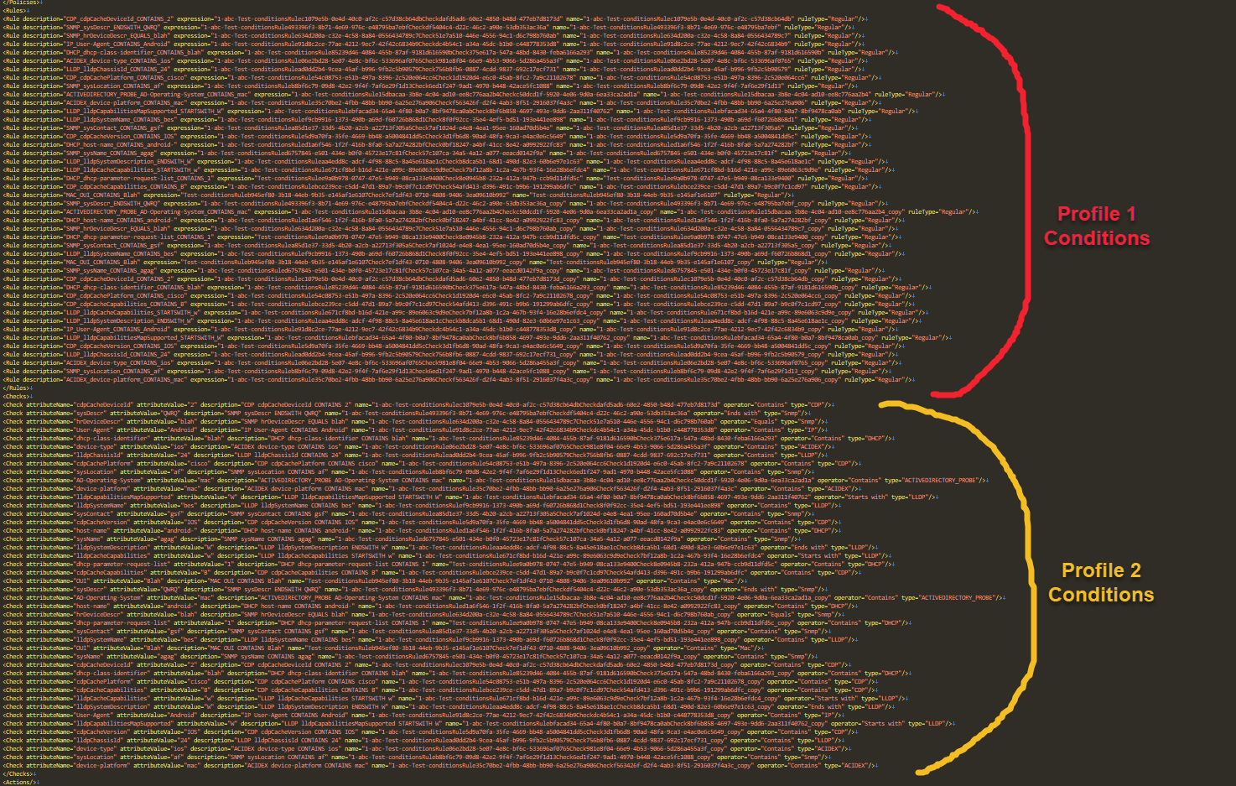

You can see from the multiple profile XML linked above.