**DOCSPOT PROJECT REPORT**

**1. INTRODUCTION**

**1.1 Project Overview**

The project titled "DocSpot – Seamless Doctor Appointment Booking System" aims to simplify the process of booking doctor appointments through an online platform. The system allows patients to register, browse doctors by specialty or location, book appointments, and manage their schedules efficiently. Doctors can view and update their availability, while administrators oversee the overall functioning of the platform.

This system eliminates the need for phone calls and in-person visits for booking appointments, thereby saving time and improving healthcare accessibility.

**1.2 Purpose**

The purpose of this project is to provide a user-friendly digital solution that connects patients with healthcare professionals efficiently. It ensures:

* Easy access to medical services
* Reduced waiting times
* Better appointment management for both patients and doctors
* Improved healthcare delivery through technology

**2. IDEATION PHASE**

**2.1 Problem Statement**

Patients face significant challenges when trying to book appointments with doctors due to long wait times, unavailability of slots, and lack of transparency in scheduling.

How Might We:

How might we allow patients to book doctor appointments quickly and conveniently from anywhere?

**2.2 Empathy Map Canvas**

Says:

“I wish I could book a doctor’s appointment without calling.”

Thinks:

“Why can’t I see available slots online?”

Feels:

Frustrated, anxious about missing appointments

Does:

Tries to call clinics during office hours, searches online for availability

**2.3 Brainstorming**

During the brainstorming session, the team explored ideas such as:

* Online calendar integration
* AI-based doctor matching
* Real-time notifications for cancellations
* Integration with telemedicine platforms

**3. REQUIREMENT ANALYSIS**

**3.1 Customer Journey Map**

The customer journey includes the following key stages:

* Awareness: User learns about the app.
* Registration/Login: New users sign up; existing users log in.
* Searching for a Doctor: Filters by specialty, location, and availability.
* Booking an Appointment: Select date/time and upload documents.
* Confirmation & Notification: Gets confirmation via email/app notification.
* Post-Visit Follow-up: Receives summary and prescriptions digitally.

**3.2 Solution Requirement**

Functional Requirements:

* User Registration and Login (Patient & Doctor)
* Browse Doctors by Filters
* Book/Cancel/Reschedule Appointments
* Upload Medical Documents
* Appointment Confirmation System
* Admin Dashboard for Monitoring

Non-Functional Requirements:

* Fast loading time (<2 seconds)
* Secure data handling (HIPAA compliance)
* Mobile-responsive design
* High uptime (99.9%)

**3.3 Data Flow Diagram**

Level 0 DFD:

External Entities: Patient, Doctor, Admin

Processes: Registration, Booking, Approval, Notification

Data Stores: Users DB, Appointments DB, Doctor Profiles DB

**3.4 Technology Stack**

* Frontend: React.js / Flutter (for mobile)
* Backend: Node.js / Django
* Database: MongoDB / PostgreSQL
* Authentication: Firebase Auth / JWT
* Hosting: AWS / Firebase Hosting

**4. PROJECT DESIGN**

**4.1 Problem-Solution Fit**

The proposed solution addresses the problem of inefficient and time-consuming appointment booking by providing a centralized, digital platform accessible from any device.

**4.2 Proposed Solution**

A web and mobile application where:

* Patients can search, book, and manage appointments
* Doctors can accept/reject bookings and update availability
* Admins can approve new doctors and monitor system usage

**4.3 Solution Architecture**

Architecture Type: Client-Server Model

Layers:

* Presentation Layer: Web/Mobile UI
* Business Logic Layer: API server using RESTful services
* Data Layer: Database and cloud storage

**5. PROJECT PLANNING & SCHEDULING**

5.1 Project Planning

Agile Methodology was used with sprints of 6 days each:

Sprint-1: 16 June 2025 - 18 June 2025:User Authentication

Sprint-2: 19 June 2025 – 20 June 2025: Doctor Discovery & Booking

Sprint-3: 21 June 2025 - 23 June 2025: Profile Management

Sprint-4: 24 June 2025 - 26 June 2025: Payment Integration & Reviews

**6. FUNCTIONAL AND PERFORMANCE TESTING**

**6.1 Performance Testing**

**Tools Used:**

* JMeter for load testing
* Postman for API response testing

**Test Scenarios:**

* Simulated 100 concurrent users
* Measured API response time (<1.5 sec)
* Checked database query performance

**7. RESULTS**

* Application handled peak load smoothly
* Average response time: 1.2 seconds
* No crashes or timeouts recorded

7.1 Output Screenshots:

HOME PAGE :

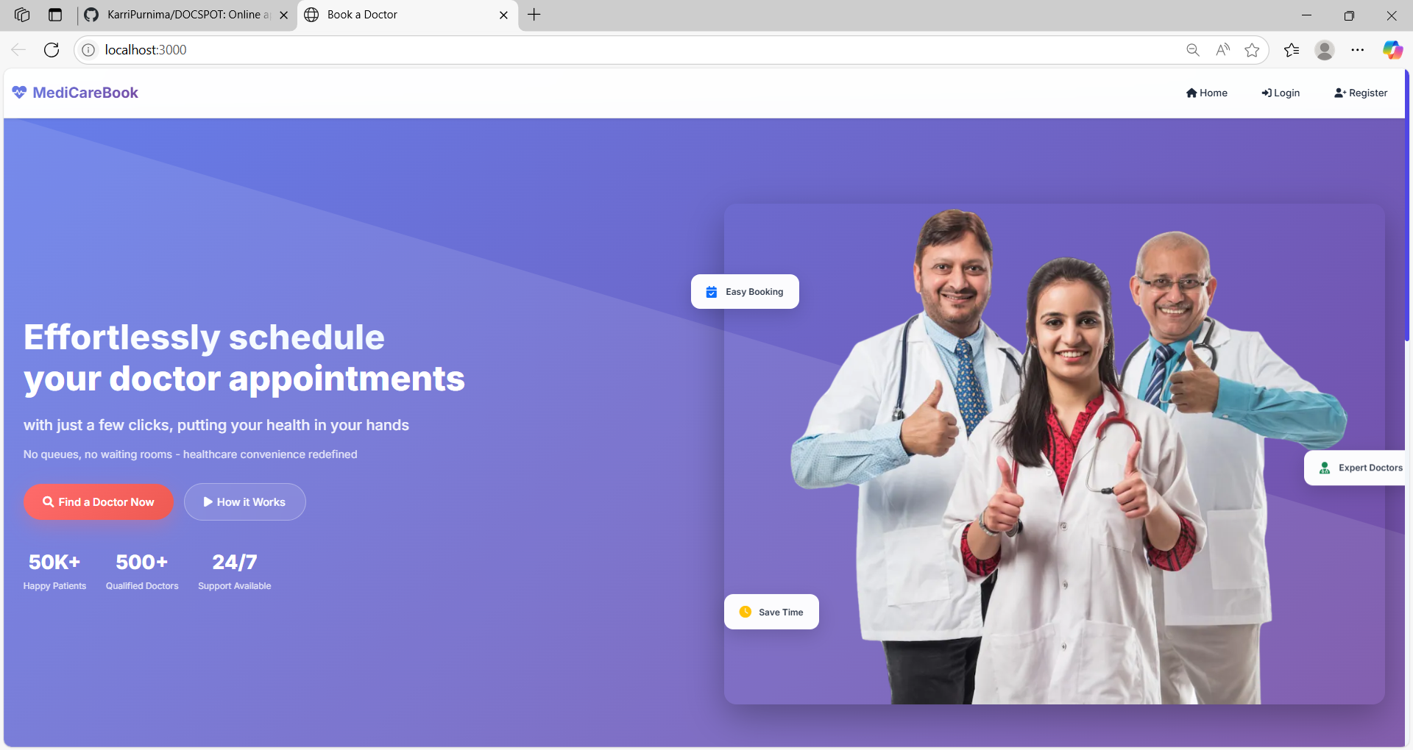

LOGIN PAGE:

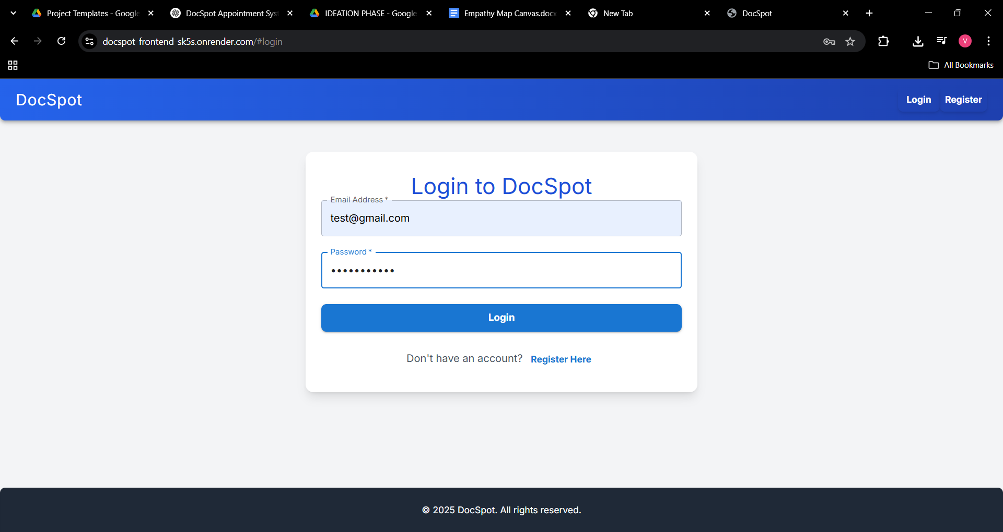

REGISTER PAGE :

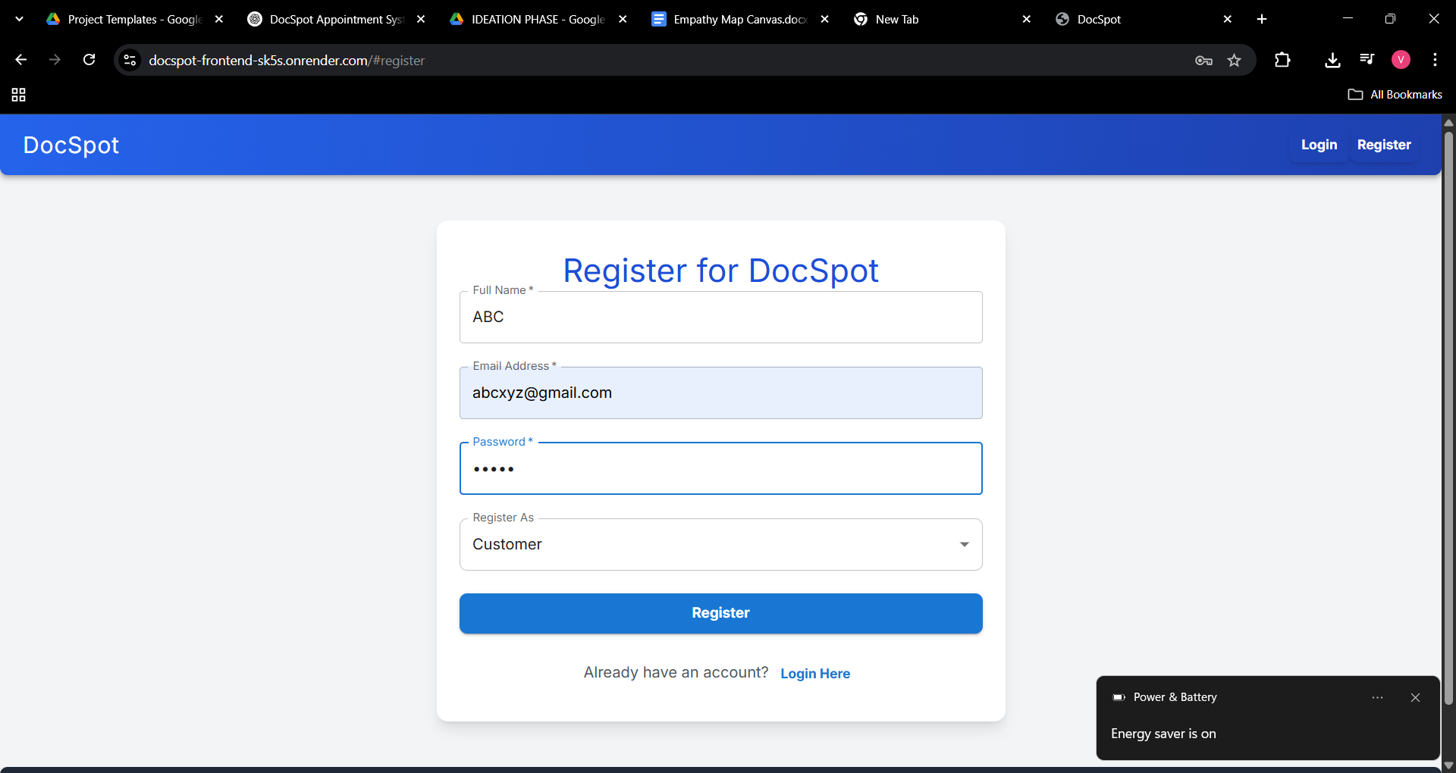

DASHBOARD:

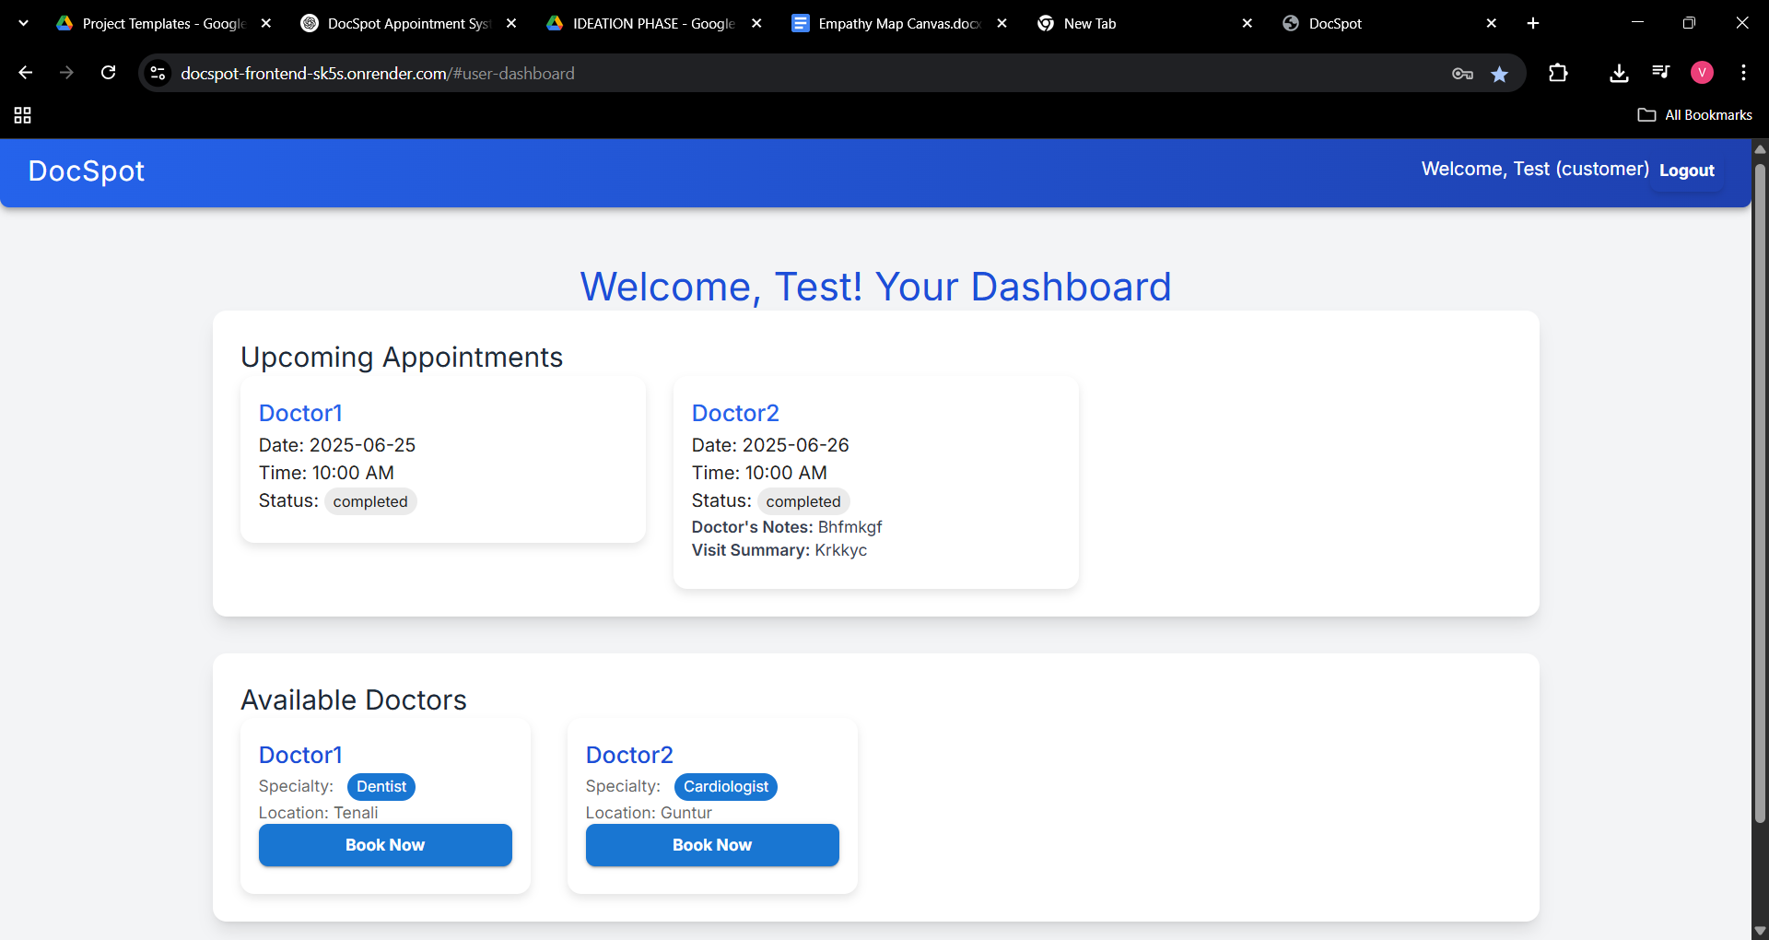

**8. ADVANTAGES & DISADVANTAGES**

Advantages:

* Saves time
* Reduces manual work
* Improves patient experience
* Easy to use

Disadvantages:

* Requires internet access
* Initial setup cost
* Learning curve for older users

**9. CONCLUSION**

The DocSpot project successfully provides a digital solution for booking doctor appointments seamlessly. By leveraging modern technologies and Agile development practices, the system improves efficiency, reduces delays, and enhances user satisfaction.

**10. FUTURE SCOPE**

* Integration with teleconsultation features
* AI-based symptom checker
* Multi-language support
* Wearable health device integration
* Hospital network expansion

**11. APPENDIX**

Source Code:

[https://github.com/KarriPurnima/DOCSPOT](https://github.com/YalakaturiNarendra/DocSpot-MERN)