**Created by: Rajmohan Sakkarai**

**Employee Id: 863706**

**Assignment: Microservice Assignment1**

1. **Get All Products:**

**i)PostMan Result:**

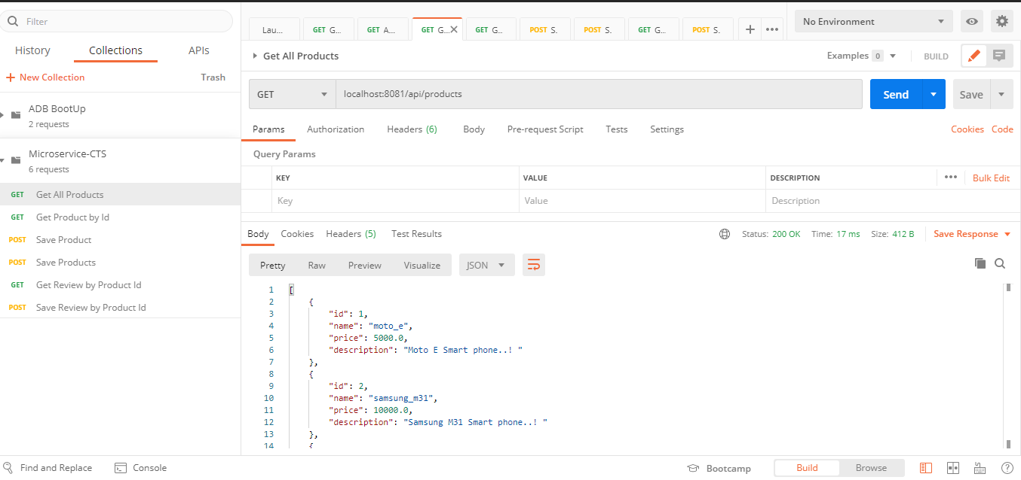

**ii)Mongo DB Result:**

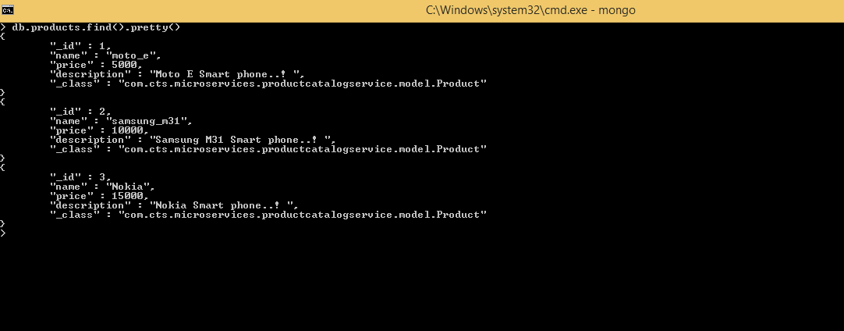

Iii) **Code:**

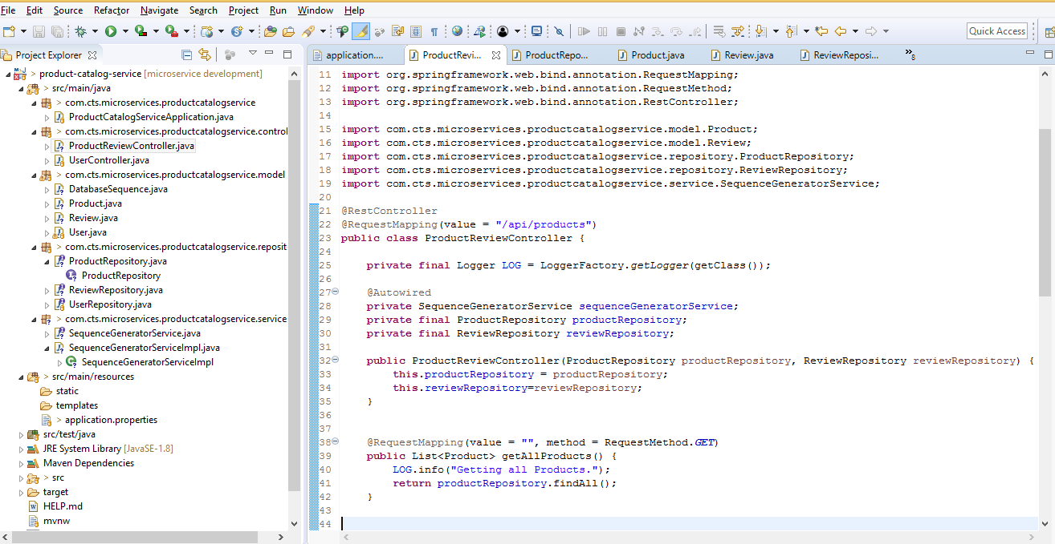

**2.Get One Product:**

**i)PostMan**

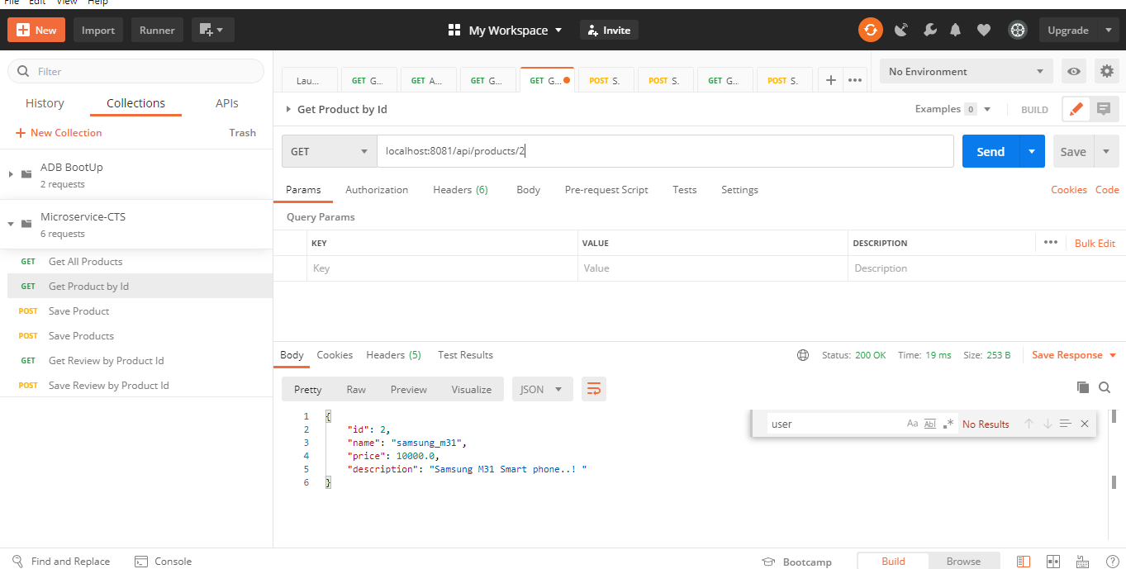

**ii) MongoDb:**

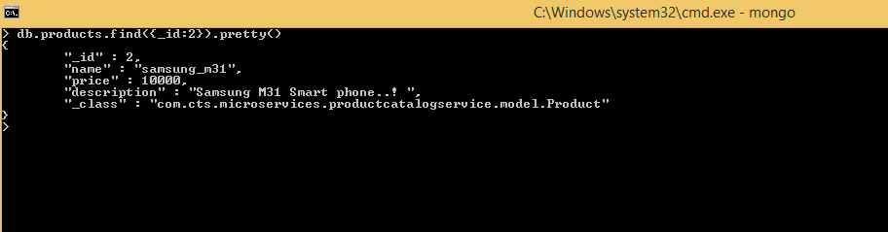

**iii) Code:**

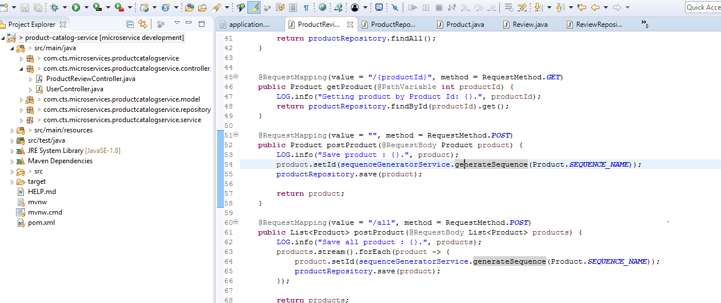

**3.Save one Product and Save Multiple Products:**

**i)PostMan:**

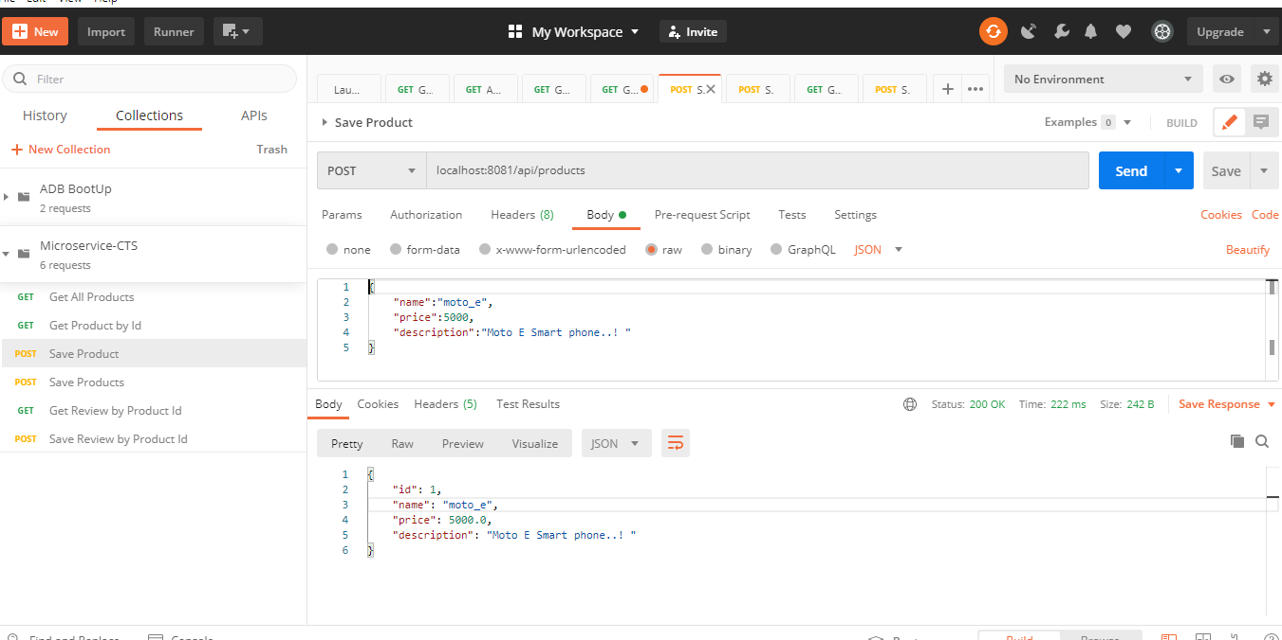

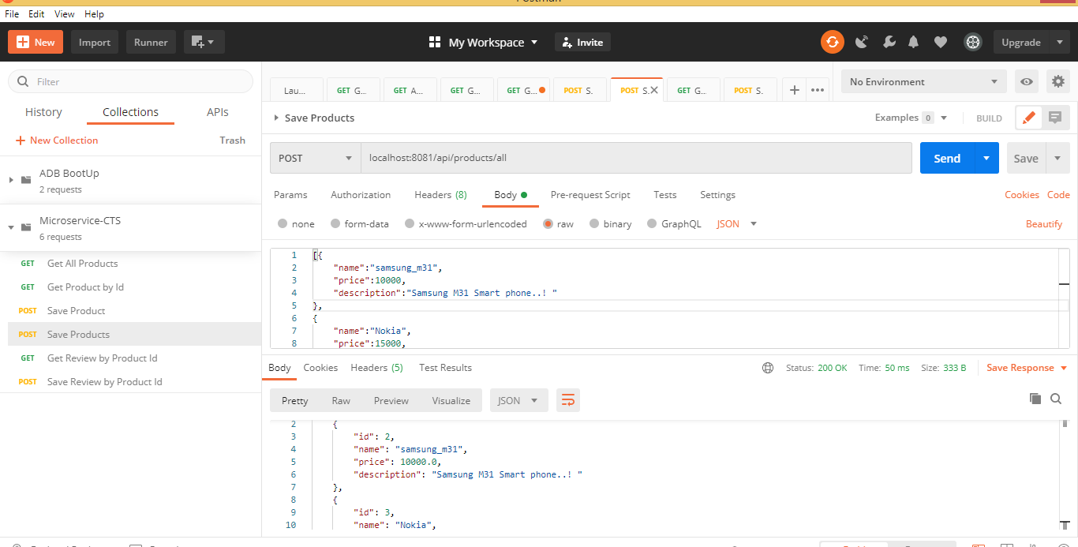

**ii) Code:**

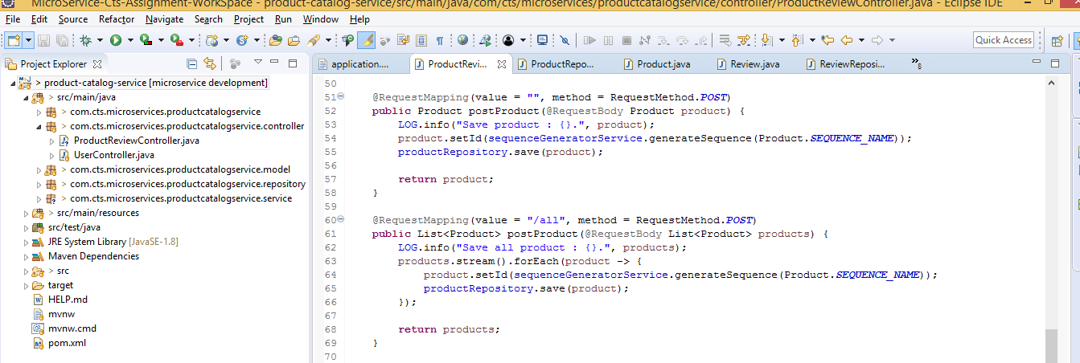

**4)Get Review:**

**i)PostMan:**

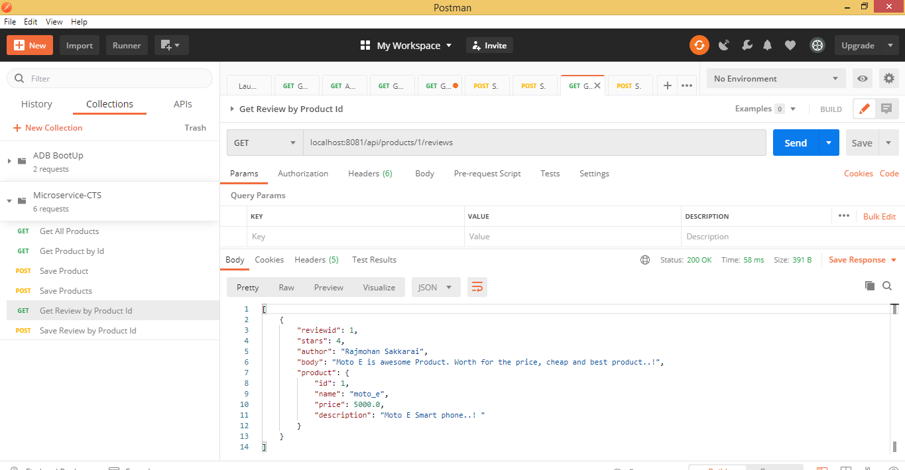

**ii)Mongo DB:**



**iii) Code:**

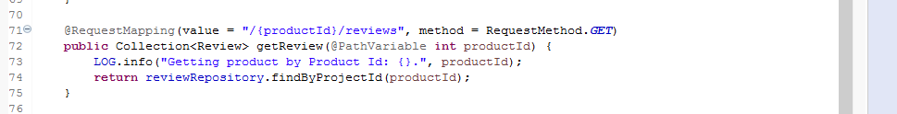

**5.Save Review:**

**i)PostMan:**

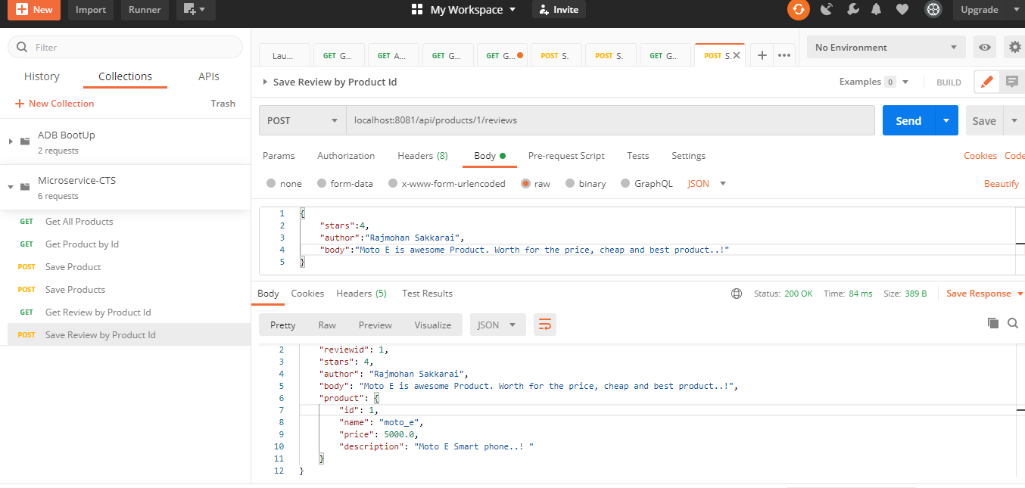

**ii)MongoDB:**

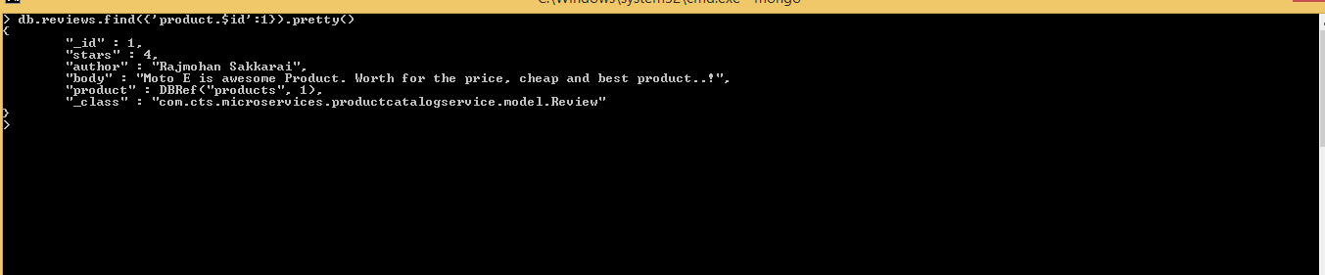

**iii)Code:**

