**Xceptor-MLP Powered by eClerx**

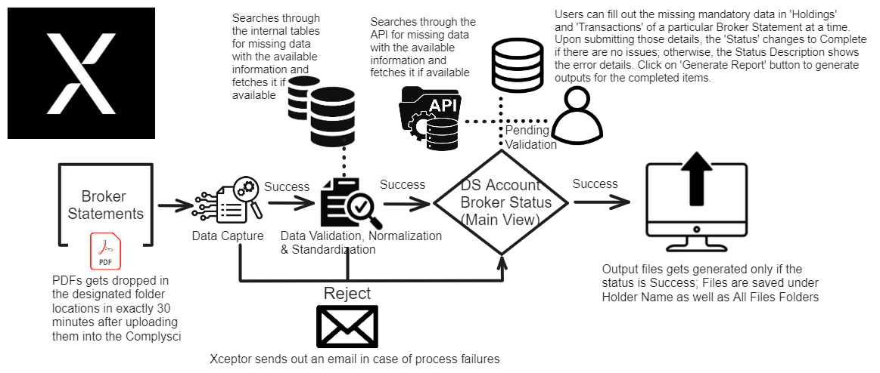

Editable: <https://excalidraw.com/#json=mV6dwGry94p8sZyxSLQLL,jrPie-gzMo03Cpn_5oApfw>

Read-Only: <https://excalidraw.com/#json=k3XcPeJMKVJ9QuVqgRxGG,psTucSfFlFTX15Ec8InBow>

Complysci (is part of the COMPLY portfolio of firms, which includes ComplySci, RIA in a Box, NRS and illumis.)

ComplySci’s scalable and sophisticated platform enables firms of all sizes to accurately and effectively monitor and mitigate compliance risks associated with employee trade monitoring, MNPI, and more.

<https://www.comply.com/products/complysci#:~:text=ComplySci's%20scalable%20and%20sophisticated%20platform,monitoring%2C%20MNPI%2C%20and%20more>.

Every morning a broker accounts file gets dropped at the designated folder location which includes list of the broker details which would be later used in for validation with the broker statements’ extracted data.

Firstly, before the broker statement PDF file reaches Xceptor application. To kick off the process, the Compliance team must manually upload the desired broker statement PDF file into Complysci.

Note: Ensure that the necessary configurations have been made in the Complysci application, only the ones that have been configured to ingest into Xceptor will generate the output PDF which then gets used as an input by Xceptor.   
  
Complysci drops the broker statement PDF file in an agreed filename format at the designated folders (ASIA/EMEA).

i.e., Account Id~BrokerName~ MMYY~MMYY~Vn.pdf; wherein, MMYY~MMYY represents statement from month and to month, and ‘n’ represents the version number.

In case of process failures, Xceptor sends out an email notification along the error description and input attachment.

The broker statement PDF file could be either Holdings only or Transactions only or both, these criteria varies across the brokers and it could be inconsistent for some. Hence, Input Formats have been configured separately for Holdings and Transactions.

Also, the MPs have been configured to look for Broker Names alone. This results in one file triggering multiple MPs one after the other (as multi-processing works among the folders not within).

For instance, if the dropped file is a Holdings ONLY file, as mentioned earlier both the MPs gets triggered one after the other but the Input Formats have been configured in such a way that ONLY the appropriate data, in this case Holdings data would reach the next level (Internal Format) and rest of the data gets discarded in between through the series of enrichments such as Calculation, Filter, Reference data Lookup and Split Repeating Groups majorly but not just limited to only the mentioned.

Split Repeating Groups have been deliberately used in here to create dummy last row of data and let the data pass through the filters and reach the Consolidated Main View Data Set in case of No Holdings/Transactions.

The Data Validation, Normalization & Standardization rules in the Internal Formats include various other rules such as comparing the values with the broker accounts data (account number), statement period issue (Partial match/No match/Complete), hire date check (hire data must be > holdings/transactions date), mandatory fields not blank, Holdings submit check, Transactions submit check, status and status description etc.

At first, the data gets into the Main DS with status as pending validation and status description as pending for its twin (H/T) . The Status and status description auto-updates to complete only when both the Holdings and Transactions data is present in the Data Sets with all the necessary/mandatory information.

The output files would get generated only if status is complete and status description matches complete*.

The Main view consists of the key fields data extracted from the broker statements as well as the data fetched from Broker Accounts File. This DS is linked with the DS_Holdings and DS_Transactions via Linked Data Sets feature allowing to create a comprehensive view of the whole data.

As soon as the data gets into the DS Holdings/Transactions tables, a query works on the back-end to fetch the data via API, if any of the mandatory fields are missing.

The business users can fill out the missing mandatory data in 'Holdings' and 'Transactions' of a particular Broker Statement at a time. Upon submitting those details, the 'Status' changes to Complete if there are no issues; otherwise, the Status Description shows the error details. Click on 'Generate Report' button to generate outputs for the completed items.

The users’ entered data would not only get stored at that particular item level (H/T) but also across the items matching the same criteria in both the DSs.

To enable this both the Xceptor actions as well as triggers have been created. Triggers would automatically change the status check to green both internally (H/T level) and Main View level, in case of criteria fulfillment; whereas, Status Description and filling the data across the items would be done by Xceptor. The actions have also been added to generate the outputs, if the Status and Status Description are fulfilled.

This data also gets stored internally for future reference, so, the same thing doesn’t need to be repeated.

The business users came up with a requirement that they wanted to see all the entries of the broker statements irrespective of their execution results which means that they wanted to see even the failed ones in the Main view.

To accomplish this, I created a triggered on the dbo.XCInputMessageBatchLogError and the query included dbo.XCInputMessageBatchLog table on a right join to include details like MessageLogId, Filename and InsertedTime. But, there’s a catch here, this pushes duplicates as well, as every file would trigger multiple MPs.

To tackle this, a trigger has been created to not push the ones with the same error title and filename that are already existing in the Main View.

A few other triggers have been created to manipulate the deleted items such as moving them to separate tables for backup purposes and create a custom “Audit Log” entries on the Main View Data Item level if any items from either Holdings or Transactions are deleted.