LAB – 2

**Introduction:**

The Lab assignment is regarding deep learning concepts. Here we learn about artificial neural networks and different models used in them. Artificial neural networks basically imitate the human brain. Deep learning has applications like image recognition, text classification and many more which are not achieved effectively through machine learning.

**Objective:**

The main objective of the concepts is to achieve highest possible accuracy and very minimal loss by applying the models.

**Approaches:**

The lab focuses on learning different models like linear regression, logistic regression, Convolutional Neural Networks, LSTM using tensorflow and keras library.

**1.** To start with the first question is regarding linear regression and the code is as follows

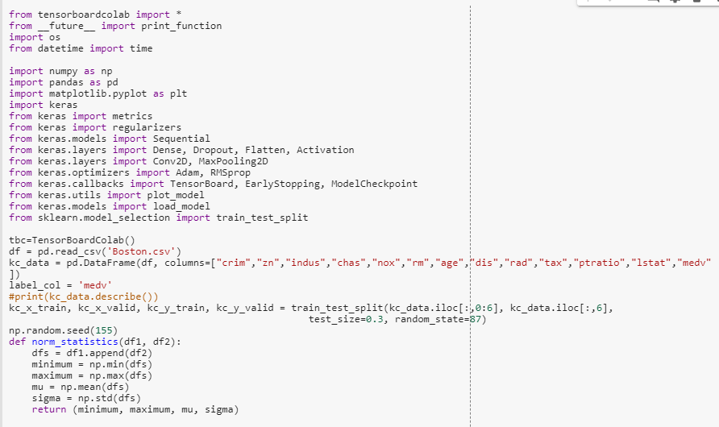

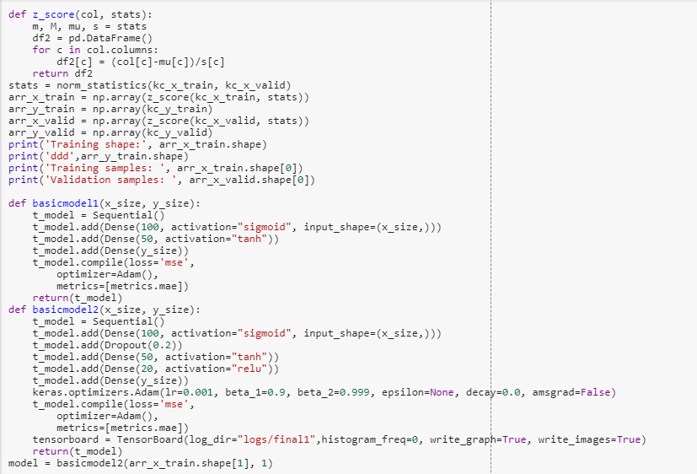

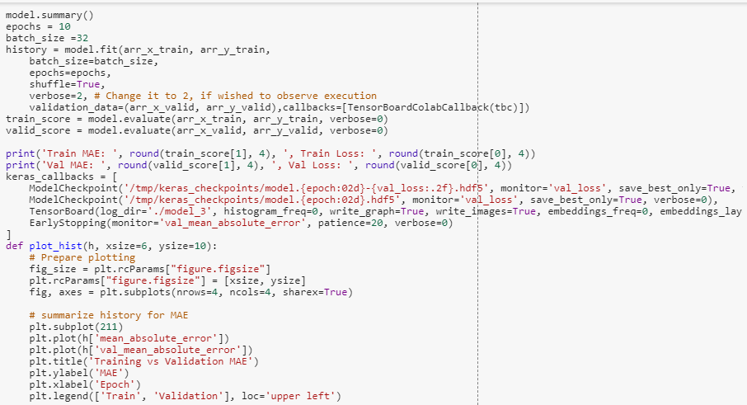

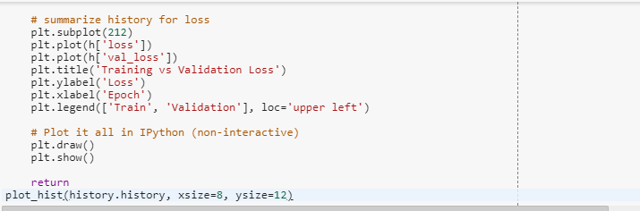

The results in google colab are as follows

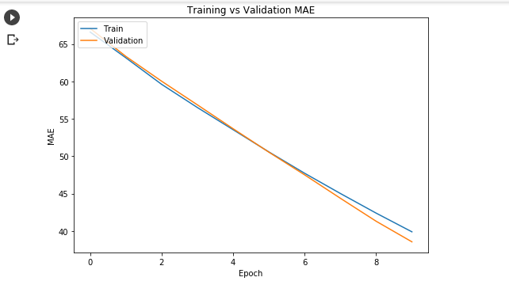

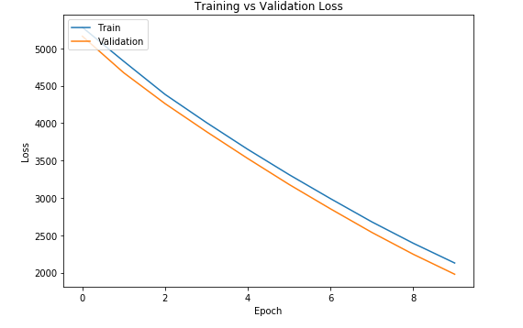

1. Graph in tensor board

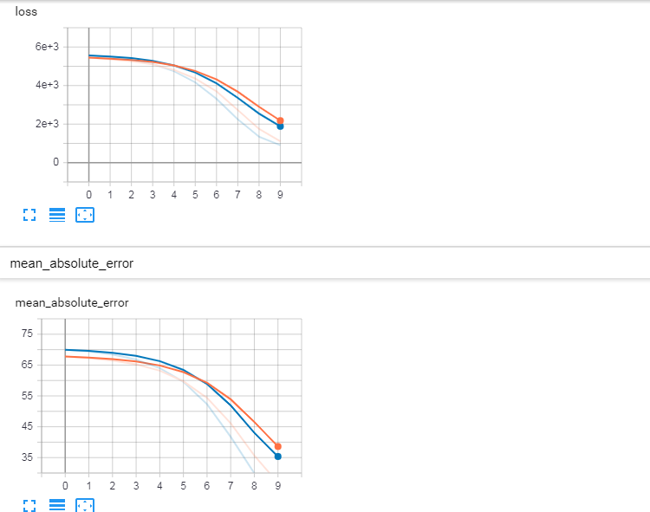

b. Changing the parameters effect on graph

1. The change in the learning rate does not have any change on the graph.

2. As the batch size is increased the loss and the mean absolute error also increase. As the batch size is decreased the loss and MAE decrease.

3. When the optimizer is changed it rises a type error as per my code.

4. When the activation function is changed the loss and the MAE change. When the activation function is sigmoid or tanh the MAE and loss are quite high whereas when the activation function is to relu the MAE and loss obtained are the least.

**2.** The code for logistic regression is as follows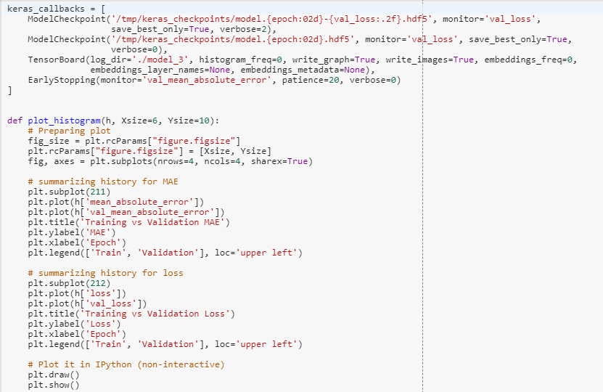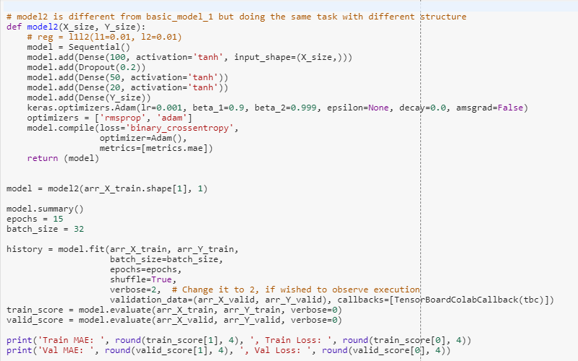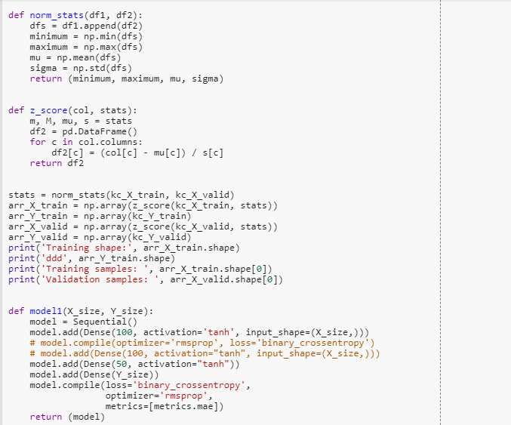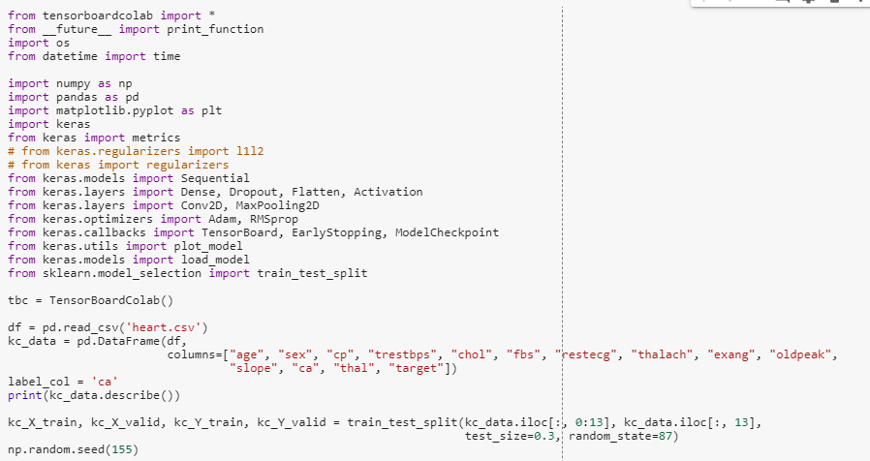

The following results are obtained on google colab

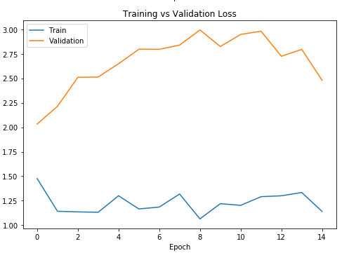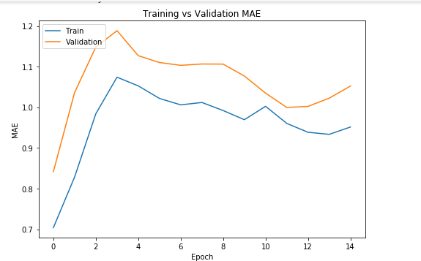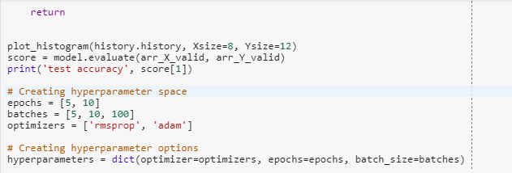

2a. and 2b. The output plot for loss ad MAE in tensorboard

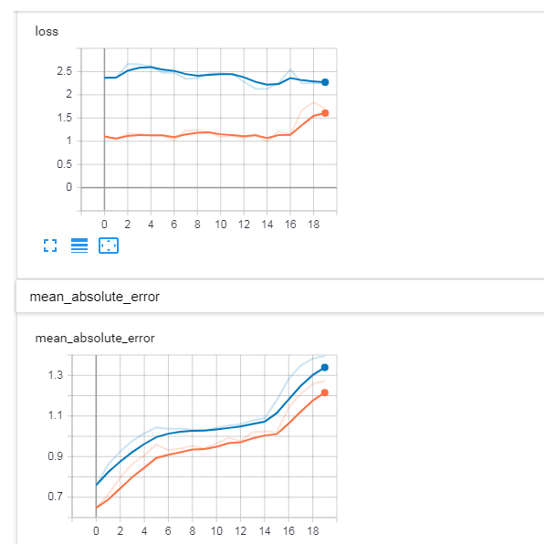

2C. The accuracy obtained is 1.05

2d. As the hyperparameters values are increased the accuracy also increases.

**3.** The code for the CNN model on spam text classification is as follows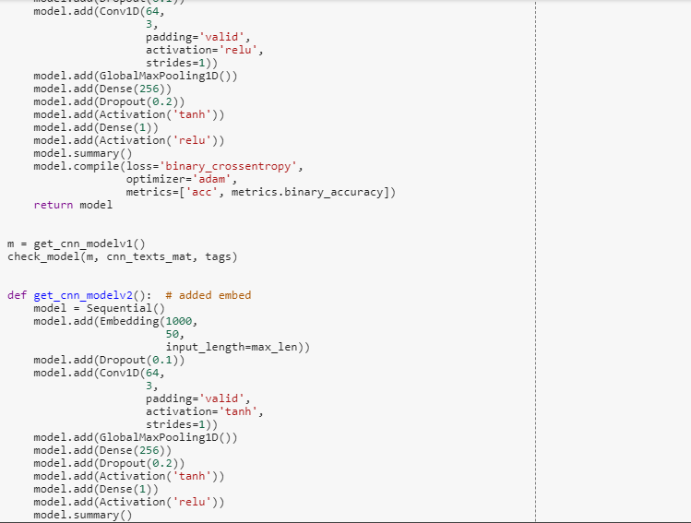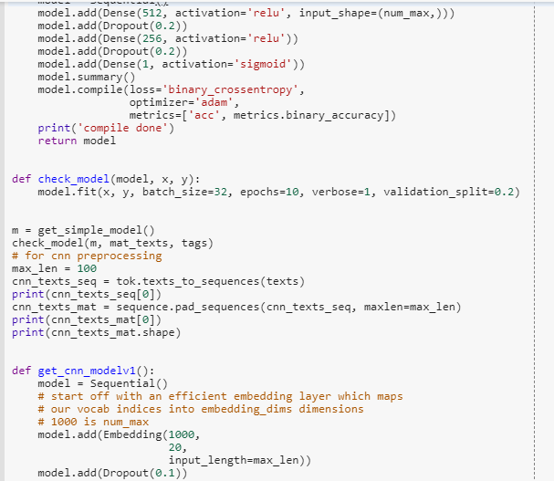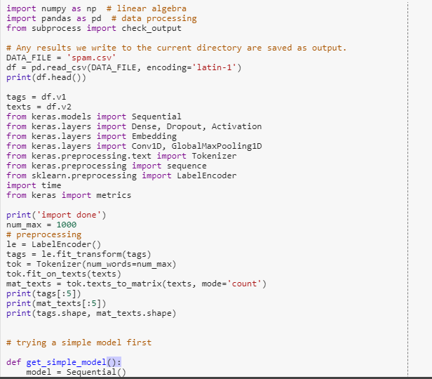

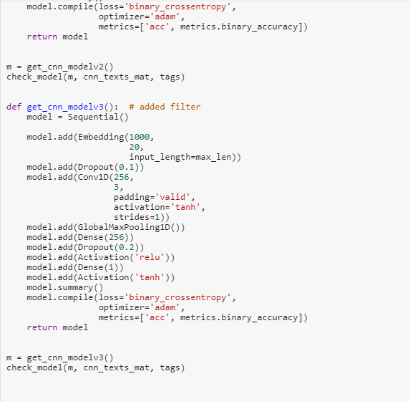

The output for the code is as follows

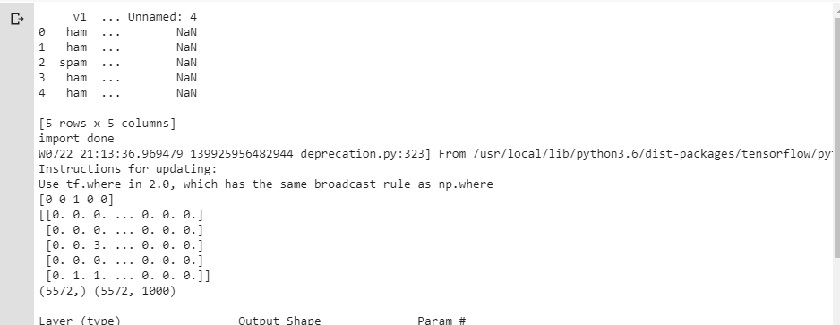

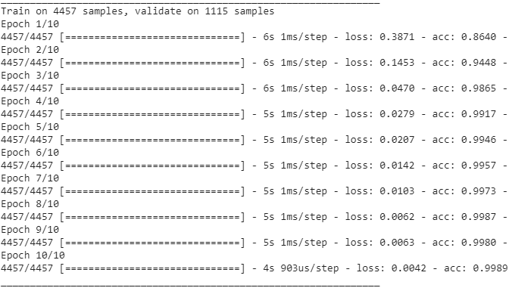

**4.** The LSTM implementation on Spam data is as follows

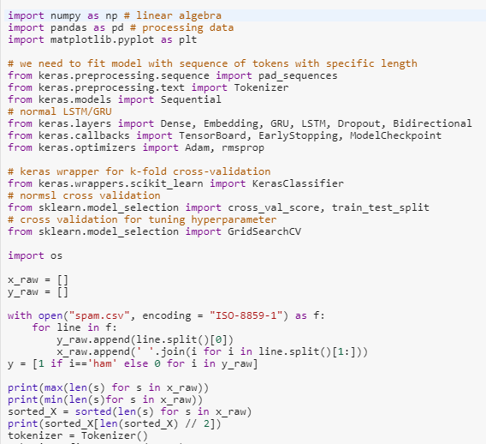

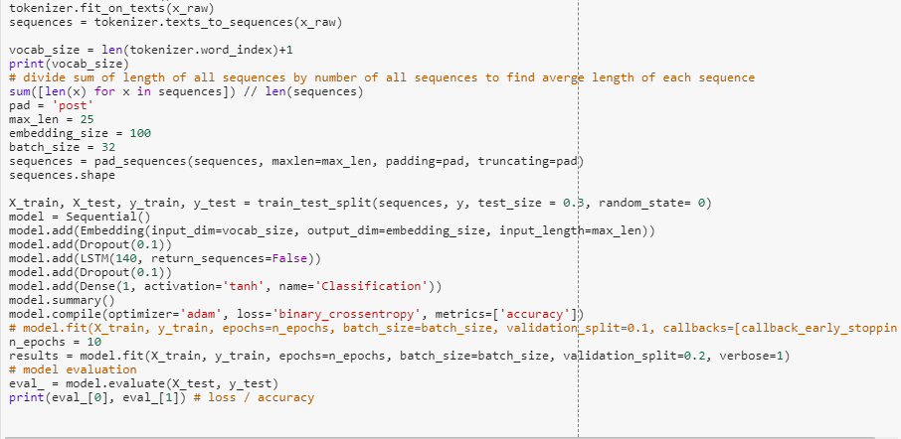

The output for the code is as follows

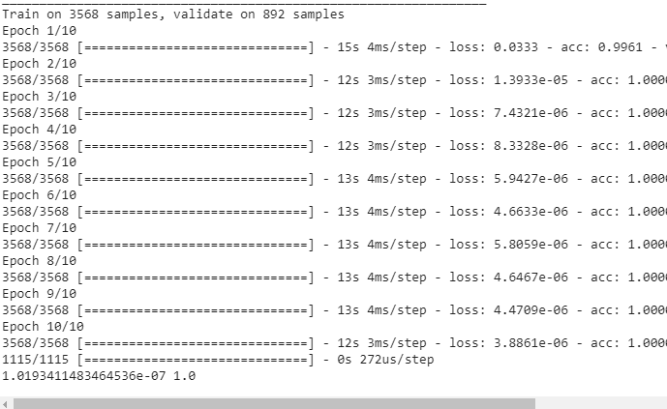

**5.** The comparison between CNN and LSTM for spam data

The accuracy obtained for CNN is 99% and the loss is 0.42 as per my code. The accuracy for LSTM is 100% and the loss is 1.01 at the end of the same number of epochs. Inspite of the accuracy being 100% LSTM is not recommended because the loss is high whereas CNN is a better model as per my code since the loss is less when compared and the accuracy is good.

**6**. The Image classification using CNN model code is as follows using MNIS dataset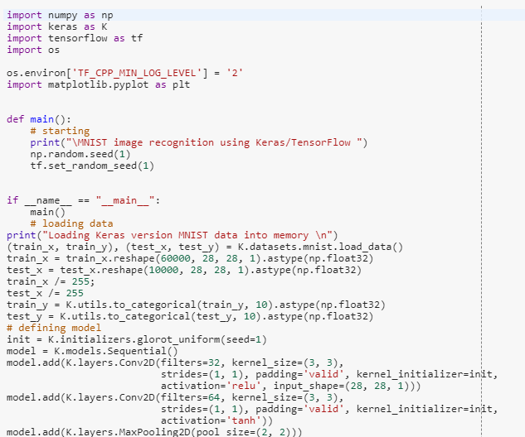

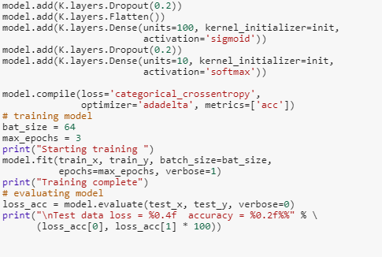

The output for the code is as follows

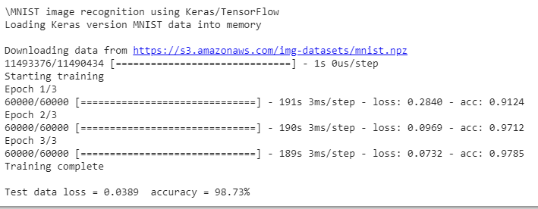

**Workflow:**

The dataset is first imported and the data in it is read from the respective csv file.

Then the model is defined, trained and evaluated for accuracy and loss.

**Datasets:**

MNIST

heart.csv

spam.csv

Boston.csv

**Evaluation and Discussion:**

The best model depends on the parameters given in the code. The accuracy and loss are obtained different for different parameters. The best model should have high accuracy and low loss.

**Conclusion :**

The lab work for second module has thus been completed successfully as per requirements.