1.2.1) After you conduct a coin-flipping simulation, a graph of the _______ will be centered very close to 0.50. Choose from (A)–(D).
A. Process probability
B. Sample size
C. Number of heads
D. Proportion of heads

1.2.3) The p-value of a test of significance is (Choose one):
A. The probability, assuming the null hypothesis is true, that we would get a result at least as extreme as the one that was actually observed
B. The probability, assuming the alternative hypothesis is true, that we would get a result at least as extreme as the one that was actually observed
C. The probability the null hypothesis is true
D. The probability the alternative hypothesis is true

1.2.4) Suppose a researcher is testing to see if a basketball player can make free throws at a rate higher than the NBA average of 75%. The player is tested by shooting 10 free throws and makes 8 of them. In conducting the related test of significance we have a computer applet do an appropriate simulation, with 1,000 repetitions, and produce a null distribution. This distribution represents:
A. Repeated results if the player makes 80% of his shots in the long run
B. Repeated results if the player makes 75% of his shots in the long run
C. Repeated results if the player makes more than 75% of his shots in the long run
D. Repeated results if the player makes more than 80% of his shots in the long run

1.2.9) Suppose a friend of yours says she is a 75% free-throw shooter in basketball. You don't think she is that good and want to test her together evidence that she makes less than 75% of her free throws in the long run. You have her shoot 40 free throws and she makes 26 (or 65%) of them. Which of A - E is an appropriate way to set up the hypothesis, in symbols, for this test?
A. $H_{0}: \hat{p}=0.75, H_{a} :\hat{p}<0.75$
B. $H_{0}:π=0.75, H_{a} :π<0.75$
C. $H_{0}: \hat{p}=0.65, H_{a} :\hat{p}<0.65$
D. $H_{0}:π=0.65, H_{a} :π<0.65$
E. $H_{0}:π<0.75, H_{a} :π=0.75$

1.2.14) Explain the meaning of each of the following symbols.
A. $H_{0}$
B. $H_{a}$
C. $\hat{p}$
D. $π$
E. $n$

1.2.20) It has been stated that spinning a coin on a table will result in it landing heads side up fewer than 50% of the time in the long run. One of the authors tested this by spinning a penny 50 times on a table and it landed heads side up 21 times. A test of significance was then conducted with the following hypotheses.
$$H_{0}:π=0.50 {, H}_{a}:π<0.50$$
a. Describe what the symbol $π$ stands for in this context.
b. Use an applet to conduct a simulation with at least 1,000 repetitions. What is your p-value? Based on your p-value is there strong evidence that the probability the spun coin will land heads up is less than 0.50?
c. Suppose you focused on the proportion of times the coin landed tails up instead of heads up. How would your hypotheses be different? What would you do differently to calculate your p-value?

1.3.1) Which standardized statistic (standardized sample proportion) gives you the strongest evidence against the null hypothesis?
A. z = 1
B. z = 0
C. z = –3
D. z = 1.80

1.3.5) Identify these statements as either true or false.
a. A p-value can be negative.
b. A standardized statistic can be negative.
c. We run tests of significance to determine whether pˆ is larger or smaller than some value.
d. As a p-value gets smaller, its corresponding standardized statistic gets closer to zero.

1.3.8) Suppose a friend of yours says she is a 75% free-throw shooter in basketball. You don't think she is that good and want to test her together evidence that she makes less than 75% of her free throws in the long run. You have her shoot 40 free throws and she makes 26 (or 65%) of them. Based on this information, you make the null distribution shown. What is the value of the standardized statistic for your friend?
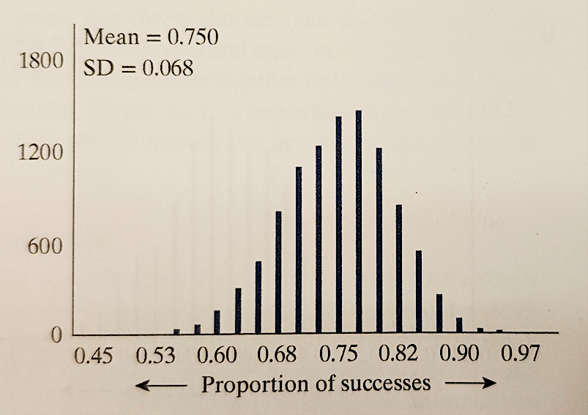
A. -1.47
B. -0.13
C. -0.10
D. 1.47
E. 4.77

1.3.21) Recall the lady tasting tea. When presented with eight cups containing a mixture of milk and tea, she correctly identified whether tea or milk was poured first for all eight cups. Is she doing better than if she were just guessing?
A. Define the parameter of interest in the context of the study and assign a symbol to it.
B. State the null hypothesis and the alternative hypothesis, using the symbol defined in part A.
C. What is the observed proportion of times the lady correctly identified what was poured first into the cup? What symbol should you use to represent this value?
D. Suppose that you were to generate the null distribution of the sample proportion of correct answers, that is, the distribution of possible values of sample proportion of correct identifications if the lady always guesses. Where would you anticipate this distribution would center? Also, do you anticipate the SD of the null distribution to be negative, positive, or zero? Why?
E. Use an applet to generate the null distribution of sample proportion of correct identifications and use it to deter- mine the standardized statistic.
F. Interpret the standardized statistic in the context of the study. (Hint: You need to talk about the value of your observed statistic in terms of standard deviations assuming ______ is true.)
G. Based on the standardized statistic, state the conclusion that you would draw about the research question of whether the lady does better than randomly guess.

