MALIS Course

1st Lab Session's Report

by Fabian Sperrle (and Simone Rossi)

Exercise 1: Chromosome genetic operators
Leave the programs in your directory. Make sure that you have given read access to your files.
Copy here the content of the file Exercise1.txt showing the results of the mutation and the crossover operators.
Mutation test 0:
Chromosome: fitness= 0.00, cities: 3 0 1 2 5 4
Chromosome: fitness= 0.00, cities: 5 2 1 0 3 4
^ ^
Mutation test 1:
Chromosome: fitness= 0.00, cities: 5 1 4 2 0 3
Chromosome: fitness= 0.00, cities: 5 1 4 2 3 0
^ ^
Mutation test 2:
Chromosome: fitness= 0.00, cities: 5 0 4 2 3 1
Chromosome: fitness= 0.00, cities: 5 0 1 3 2 4
^ ^
Mutation test 3:
Chromosome: fitness= 0.00, cities: 1 3 4 0 5 2
Chromosome: fitness= 0.00, cities: 1 0 4 3 5 2
^ ^
For each example, indicate what are the boundaries of the segment selected by the operator.
Crossover test 0:
Chromosome: fitness= 0.00, cities: 2 4 3 5 0 1
Chromosome: fitness= 0.00, cities: 4 0 1 3 2 5
Chromosome: fitness= 0.00, cities: 2 4 3 5 0 1
^ ^
Crossover test 1:
Chromosome: fitness= 0.00, cities: 1 2 4 5 0 3
Chromosome: fitness= 0.00, cities: 0 4 1 5 2 3
Chromosome: fitness= 0.00, cities: 1 2 0 4 5 3
^ ^
Crossover test 2:
Chromosome: fitness= 0.00, cities: 0 3 5 1 2 4
Chromosome: fitness= 0.00, cities: 2 4 0 3 1 5
Chromosome: fitness= 0.00, cities: 0 3 5 1 2 4
^ ^

Crossover test 3:
Chromosome: fitness= 0.00, cities: 1 3 0 5 2 4
Chromosome: fitness= 0.00, cities: 1 2 4 3 0 5
Chromosome: fitness= 0.00, cities: 1 3 2 4 0 5
^ ^

Exercise 2: Population evolution on a circle
Leave the programs in your directory. Make sure that you have given read access to your files.
Copy here the content of the file Exercise2.txt showing the evolution of the shortest route.
Mutation rate: 0.100, Population size: 100
Generation: 0, population size: 100, Round-trip length: 4211.529, best 4211.529
Generation: 2, population size: 100, Round-trip length: 4014.163, best 4014.163
Generation: 4, population size: 100, Round-trip length: 3921.574, best 3921.574
Generation: 5, population size: 100, Round-trip length: 3887.931, best 3887.931
Generation: 7, population size: 100, Round-trip length: 3578.630, best 3578.630
Generation: 8, population size: 100, Round-trip length: 3245.055, best 3245.055
Generation: 14, population size: 100, Round-trip length: 3023.252, best 3023.252
Generation: 18, population size: 100, Round-trip length: 2782.878, best 2782.878
Generation: 161, population size: 100, Round-trip length: 2722.339, best 2722.339
Generation: 280, population size: 100, Round-trip length: 2687.989, best 2687.989
Generation: 773, population size: 100, Round-trip length: 2652.466, best 2652.466
Generation: 935, population size: 100, Round-trip length: 2605.641, best 2605.641
Generation: 979, population size: 100, Round-trip length: 2494.739, best 2494.739
Generation: 1160, population size: 100, Round-trip length: 2486.925, best 2486.925
Generation: 1572, population size: 100, Round-trip length: 2421.128, best 2421.128
Generation: 2580, population size: 100, Round-trip length: 2330.108, best 2330.108
Generation: 8034, population size: 100, Round-trip length: 2264.071, best 2264.071
Generation: 12095, population size: 100, Round-trip length: 2145.979, best 2145.979

Insert here the image showing the best route obtained.
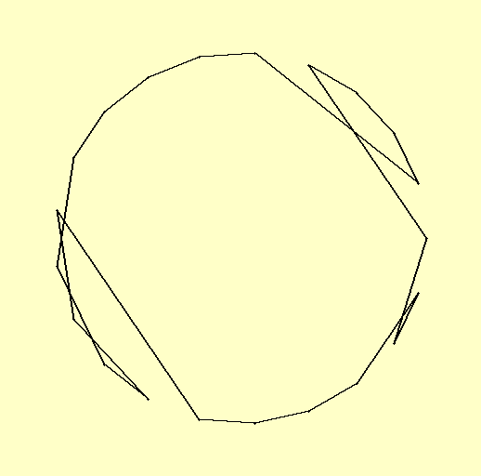

Exercise 3: Population evolution on cities in France
In this exercise, run the experiments 3 times (with different random starting points) for each set of parameter values and provide all 3 results.

Mutation rate
With a population size of 100, show the table of results for the values of the mutation rate 0.01, 0.1, 0.5.
Mutation rate: 0.010, Population size: 100
Generation: 0, population size: 100, Round-trip length: 3903.119, best 3903.119
Generation: 1, population size: 100, Round-trip length: 3572.600, best 3572.600
Generation: 5, population size: 100, Round-trip length: 2895.750, best 2895.750
Generation: 36, population size: 100, Round-trip length: 2881.509, best 2881.509
Generation: 46, population size: 100, Round-trip length: 2862.239, best 2862.239
Generation: 47, population size: 100, Round-trip length: 2807.888, best 2807.888
Generation: 63, population size: 100, Round-trip length: 2798.227, best 2798.227
Generation: 72, population size: 100, Round-trip length: 2768.794, best 2768.794
Generation: 84, population size: 100, Round-trip length: 2605.916, best 2605.916
Generation: 149, population size: 100, Round-trip length: 2460.133, best 2460.133

Mutation rate: 0.100, Population size: 100
Generation: 0, population size: 100, Round-trip length: 3985.028, best 3985.028
Generation: 1, population size: 100, Round-trip length: 3871.910, best 3871.910
Generation: 2, population size: 100, Round-trip length: 3595.405, best 3595.405
Generation: 4, population size: 100, Round-trip length: 3451.201, best 3451.201
Generation: 8, population size: 100, Round-trip length: 3266.275, best 3266.275
Generation: 13, population size: 100, Round-trip length: 3166.498, best 3166.498
Generation: 14, population size: 100, Round-trip length: 3128.027, best 3128.027
Generation: 20, population size: 100, Round-trip length: 3060.620, best 3060.620
Generation: 27, population size: 100, Round-trip length: 2956.360, best 2956.360
Generation: 89, population size: 100, Round-trip length: 2876.393, best 2876.393
Generation: 92, population size: 100, Round-trip length: 2794.264, best 2794.264
Generation: 121, population size: 100, Round-trip length: 2767.926, best 2767.926
Generation: 169, population size: 100, Round-trip length: 2758.579, best 2758.579
Generation: 172, population size: 100, Round-trip length: 2734.445, best 2734.445
Generation: 176, population size: 100, Round-trip length: 2670.452, best 2670.452
Mutation rate: 0.500, Population size: 100
Generation: 0, population size: 100, Round-trip length: 3871.509, best 3871.509
Generation: 1, population size: 100, Round-trip length: 3503.807, best 3503.807
Generation: 4, population size: 100, Round-trip length: 3463.610, best 3463.610
Generation: 7, population size: 100, Round-trip length: 3380.351, best 3380.351
Generation: 10, population size: 100, Round-trip length: 3319.448, best 3319.448
Generation: 16, population size: 100, Round-trip length: 3057.791, best 3057.791
Generation: 18, population size: 100, Round-trip length: 2930.497, best 2930.497
Generation: 29, population size: 100, Round-trip length: 2831.175, best 2831.175
Generation: 38, population size: 100, Round-trip length: 2733.929, best 2733.929
Generation: 39, population size: 100, Round-trip length: 2703.172, best 2703.172
Generation: 40, population size: 100, Round-trip length: 2562.535, best 2562.535
Generation: 41, population size: 100, Round-trip length: 2553.726, best 2553.726

Population size
With a mutation rate of 0.1, show the table of results for the values of the population size 10, 50, 100 and 500. Discuss the results of your experiment.
Mutation rate: 0.100, Population size: 10
Generation: 0, population size: 10, Round-trip length: 4414.501, best 4414.501
Generation: 2, population size: 10, Round-trip length: 3971.543, best 3971.543
Generation: 8, population size: 10, Round-trip length: 3905.512, best 3905.512
Generation: 10, population size: 10, Round-trip length: 3786.988, best 3786.988
Generation: 13, population size: 10, Round-trip length: 3615.406, best 3615.406
Generation: 16, population size: 10, Round-trip length: 3506.090, best 3506.090
Generation: 23, population size: 10, Round-trip length: 3450.920, best 3450.920
Generation: 24, population size: 10, Round-trip length: 3310.430, best 3310.430
Generation: 25, population size: 10, Round-trip length: 3189.898, best 3189.898
Generation: 28, population size: 10, Round-trip length: 3168.004, best 3168.004
Generation: 34, population size: 10, Round-trip length: 3110.600, best 3110.600
Generation: 42, population size: 10, Round-trip length: 3032.316, best 3032.316
Generation: 46, population size: 10, Round-trip length: 3031.944, best 3031.944
Generation: 48, population size: 10, Round-trip length: 3024.358, best 3024.358
Generation: 49, population size: 10, Round-trip length: 2888.361, best 2888.361
Generation: 52, population size: 10, Round-trip length: 2724.913, best 2724.913
Generation: 61, population size: 10, Round-trip length: 2680.519, best 2680.519
Generation: 63, population size: 10, Round-trip length: 2652.539, best 2652.539
Generation: 424, population size: 10, Round-trip length: 2627.142, best 2627.142

Mutation rate: 0.100, Population size: 50
Generation: 0, population size: 50, Round-trip length: 3945.181, best 3945.181
Generation: 2, population size: 50, Round-trip length: 3891.951, best 3891.951
Generation: 3, population size: 50, Round-trip length: 3810.119, best 3810.119
Generation: 4, population size: 50, Round-trip length: 3534.894, best 3534.894
Generation: 5, population size: 50, Round-trip length: 3489.676, best 3489.676
Generation: 7, population size: 50, Round-trip length: 3452.882, best 3452.882
Generation: 11, population size: 50, Round-trip length: 3410.784, best 3410.784
Generation: 12, population size: 50, Round-trip length: 3368.623, best 3368.623
Generation: 17, population size: 50, Round-trip length: 3201.522, best 3201.522
Generation: 33, population size: 50, Round-trip length: 3064.784, best 3064.784
Generation: 37, population size: 50, Round-trip length: 2968.031, best 2968.031
Generation: 39, population size: 50, Round-trip length: 2713.266, best 2713.266
Generation: 196, population size: 50, Round-trip length: 2545.950, best 2545.950

Mutation rate: 0.100, Population size: 500
Generation: 0, population size: 500, Round-trip length: 3772.639, best 3772.639
Generation: 1, population size: 500, Round-trip length: 3694.446, best 3694.446
Generation: 4, population size: 500, Round-trip length: 3561.710, best 3561.710
Generation: 5, population size: 500, Round-trip length: 3286.185, best 3286.185
Generation: 8, population size: 500, Round-trip length: 3203.179, best 3203.179
Generation: 9, population size: 500, Round-trip length: 3055.150, best 3055.150
Generation: 15, population size: 500, Round-trip length: 3017.601, best 3017.601
Generation: 16, population size: 500, Round-trip length: 2993.802, best 2993.802
Generation: 19, population size: 500, Round-trip length: 2855.928, best 2855.928
Generation: 24, population size: 500, Round-trip length: 2824.820, best 2824.820
Generation: 27, population size: 500, Round-trip length: 2735.690, best 2735.690
Generation: 36, population size: 500, Round-trip length: 2600.984, best 2600.984
Generation: 88, population size: 500, Round-trip length: 2599.045, best 2599.045
Generation: 235, population size: 500, Round-trip length: 2589.682, best 2589.682

Best route
Indicate here the best route in France found in your experiments, and insert the corresponding image here.
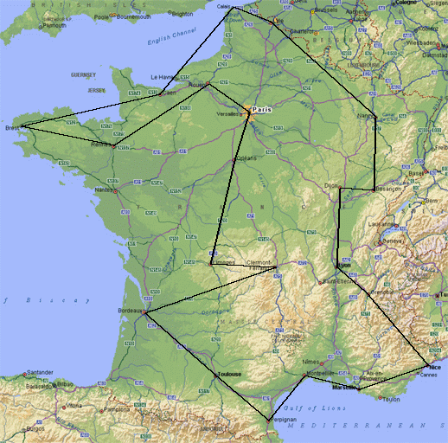

Mutation rate: 0.010, Population size: 500
Generation: 0, population size: 500, Round-trip length: 3478.641, best 3478.641
Generation: 4, population size: 500, Round-trip length: 3411.597, best 3411.597
Generation: 5, population size: 500, Round-trip length: 3190.979, best 3190.979
Generation: 11, population size: 500, Round-trip length: 3048.765, best 3048.765
Generation: 19, population size: 500, Round-trip length: 3041.871, best 3041.871
Generation: 21, population size: 500, Round-trip length: 3037.924, best 3037.924
Generation: 24, population size: 500, Round-trip length: 3005.194, best 3005.194
Generation: 27, population size: 500, Round-trip length: 2935.267, best 2935.267
Generation: 28, population size: 500, Round-trip length: 2898.590, best 2898.590
Generation: 34, population size: 500, Round-trip length: 2839.540, best 2839.540
Generation: 38, population size: 500, Round-trip length: 2753.974, best 2753.974
Generation: 105, population size: 500, Round-trip length: 2597.891, best 2597.891
Generation: 274, population size: 500, Round-trip length: 2531.942, best 2531.942
Generation: 296, population size: 500, Round-trip length: 2525.050, best 2525.050
Generation: 445, population size: 500, Round-trip length: 2499.558, best 2499.558
Generation: 567, population size: 500, Round-trip length: 2457.669, best 2457.669
Generation: 596, population size: 500, Round-trip length: 2443.641, best 2443.641
Generation: 617, population size: 500, Round-trip length: 2398.090, best 2398.090
Generation: 703, population size: 500, Round-trip length: 2338.532, best 2338.532
Generation: 717, population size: 500, Round-trip length: 2261.106, best 2261.106
Generation: 2061, population size: 500, Round-trip length: 2170.061, best 2170.061
Generation: 3233, population size: 500, Round-trip length: 2136.813, best 2136.813
Generation: 3239, population size: 500, Round-trip length: 1997.687, best 1997.687

With #gen=50000

