Eye Gestures Design Proposal
Russ Bielawski, Justin Paupore, Joe Romeo

Executive Summary
Write me Later!

Purpose
There are a number of physical ailments which might hinder a person from using a computer normally, including cerebral palsy, muscular sclerosis, ALS and paralysis. The inability for sufferers of these ailments to use a keyboard and mouse is the crux of the problem. With the importance of computers in modern life, enabling suffers of a physically debilitating disability or paralysis to use traditional computing devices can significantly improve quality of life.
With the proliferation of cameras and small computing devices, eye tracking devices have been created to allow computers to be controlled using ones eyes. This enables a reasonable, non-traditional interface to a traditional computer. Piggybacking on the success of eye-controlled computing accessories, we have begun work on the Eye Gestures glasses, a novel, wearable, wireless, eye-tracking peripheral for controlling a tablet (or smartphone) using “gestures”, signaled by deliberate, specific eye movement patterns.
We believe that tablets represent a promising computing device for the physically disabled. The existing simplicity of controls in tablets and smartphones allows a natural translation from “eye gestures” to touch gestures currently employed in tablets and smartphones. With the current generation of tablets and smartphones having even improving speech to text capabilities, tablets could become the de facto computing device for the physically disabled.
Our Eye Gestures wearable medical peripheral will be built by packing small, low power electronics and camera(s) onto everyday sunglasses, eye glasses or eye goggles. A camera will face the operators eye and track its movement. Deliberate eye gestures will be used to perform actions. The glasses will be weight balanced, wireless and run off of a reasonably long-life battery. Though perhaps a little goofy looking, with electronics enclosures on either side, svelte looks are not the purpose of Eye Gestures, empowerment of the user is.
The basic eye gestures which will be supported are a “swipes” in the four cardinal directions (or eight) and a select operation. If possible, the Eye Gestures glasses will enable even more gestures for more complex and powerful control of the tablet or smartphone device. An example of such extra gestures could be clockwise and counterclockwise circles to go forward and backward in an application (a common operation). Eye Gestures will be used in conjunction with a modified Android tablet.

Design

Conceptualization
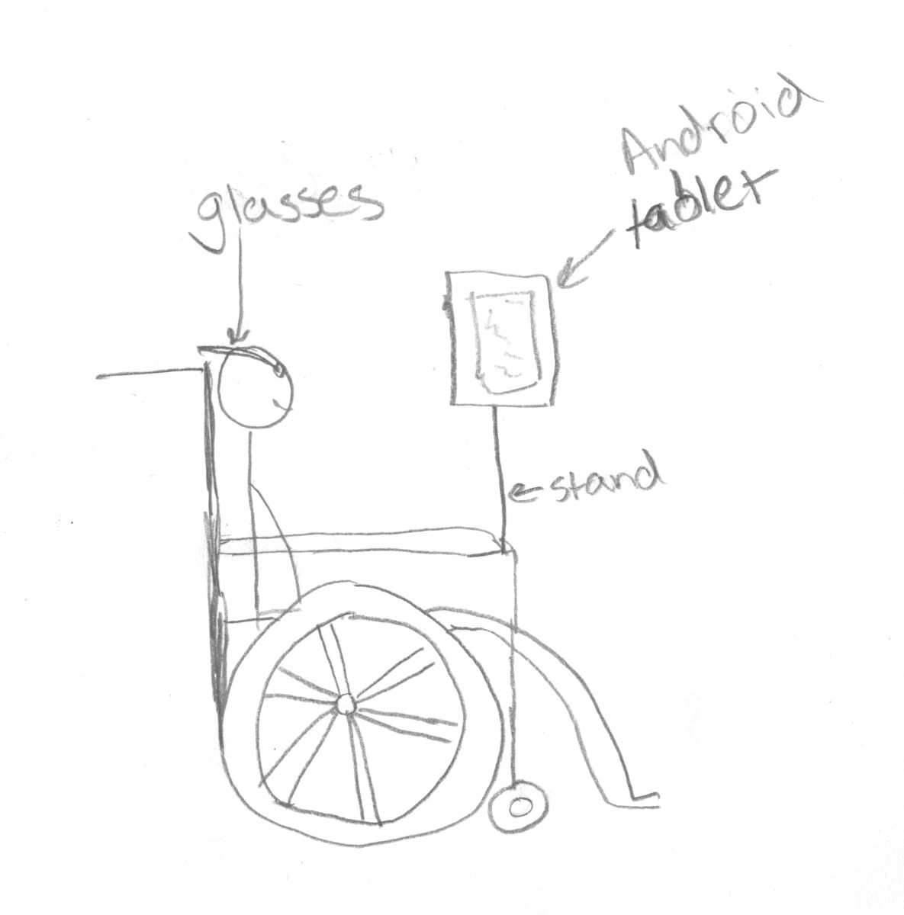Illustration 1: Conceptual drawing of Eye Gestures glasses is use by a theoretical client. Eye Gestures glasses will be cordless and run on battery power.
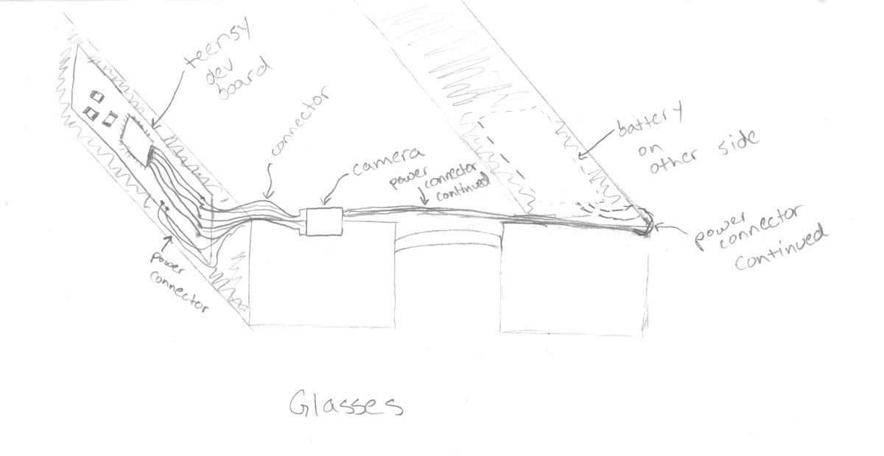Illustration 2: Artist's Rendering of an Eye Gestures Device

Design Overview
Our Eye Gestures system architecture is split across two devices, the glasses and the tablet device. Part of the engineering challenge of designing a low-power, wearable medical peripheral is the trade-off between processing power, feature-set and power consumption. Should the glasses perform processing on the images before transmitting data to the tablet? Should the glasses merely pump all camera data out on a network interface to the tablet where the data is processed?
The first design we considered involves placing the processing power into the glasses. In this design, computer vision algorithms would run on the processor or DSP on the glasses. In such an example, achieving low power goals are much more difficult (or long life operation requires a much larger battery or more frequent charges). Also, more powerful parts (such as an OMAP-based embedded solution) introduce more complexity in hardware design and add weight.
Our second design is to offload as much data as possible to the phone. In this scenario, much lower-power parts with less processing capabilities are used to build the glasses device. The primary job of the in-device processing is data collection, compression and transmission to the tablet, where the computer vision and/or image processing calculations are performed. Even in this design, there remains some question as to how much pre-processing the in-glasses computing should do.
We have decided that the lower power we can make the glasses, the better, to enable longer battery life and a more pleasant user experience. As those are our two big design goals for the glasses themselves, the option to process minimal data in the glasses makes the most sense.
Our current power budget is based on a worst case model. The core of the Teensy 3.0 (our Cortex-M4 based prototyping module) consumes 155mA in the worst case, and the remainder of our components consume around 150mA as well (40 mA for our TCM8230MD camera, 30 mA for Bluetooth, 20 mA for the IR LED, and ~50 mA for the rest of the design, conservatively). With a targeted 850mAh Li-Poly battery, this provides for about 2.5-3 hours of continuous operation, which is not great but acceptable.
One final note is that our design might be improved with an FPGA. This idea has not been fully researched, and as such, we are proceeding with the design without an FPGA for now.

Detailed Design
At this stage in our design, some choices are now rather obvious. Others remain questionable, despite our complete design around our choices for now. We'll start with the more concrete design choices and move to less finalized parts of the design.
After considering our options for connecting the glasses to the tablet, we have chosen to use Bluetooth. Bluetooth is almost an obvious choice due to it's ubiquity in tablets and smartphones, it's low power requirements and it's simplicity (say, compared to the complexity of WiFi). For our computer vision and image processing tasks, we have chosen to target OpenCV. OpenCV's strength are maturity, ability to be partially optimized for the platform, existence of performance optimizations for popular platforms, large support system, large feature-set and C language implementation, which is likely to run on just about any hardware.
As for inputs and outputs, let's view our system as two pieces, the glasses and the code running in the Android tablet. The glasses have the camera as input and bluetooth as output. There are no other outputs. A Li-Poly battery shall power the glasses. Our Android device takes the data from the glasses over bluetooth as it's input and outputs actions in the operating system or demo application.
Our hardware process involves prototyping on an ARM Cortex-M4, a Teensy 3.0, which is an ARM port of Arduino in a small form factor. It allows rapid prototyping based on the Arduino platform with a much more powerful Cortex-M4 at the center. This forms the heard of the glasses.
The current design involves merely collecting, compressing and transmitting data in the glasses. All other processing will be done in the tablet itself. This may not be ideal, as it could incur too much communication overhead to be really low power. More processing in the glasses and less communication is a balance we need to strike architecturally.
We have had to sacrifice extremely low-power operate and some weight to meet the tight timeline of our development schedule. Using parts that are known to work and can be more easily integrated into our hardware means that we can meet the timing. The loss is of course in the mentioned features (namely very long life operation between charges).

Way Forward

Timeline
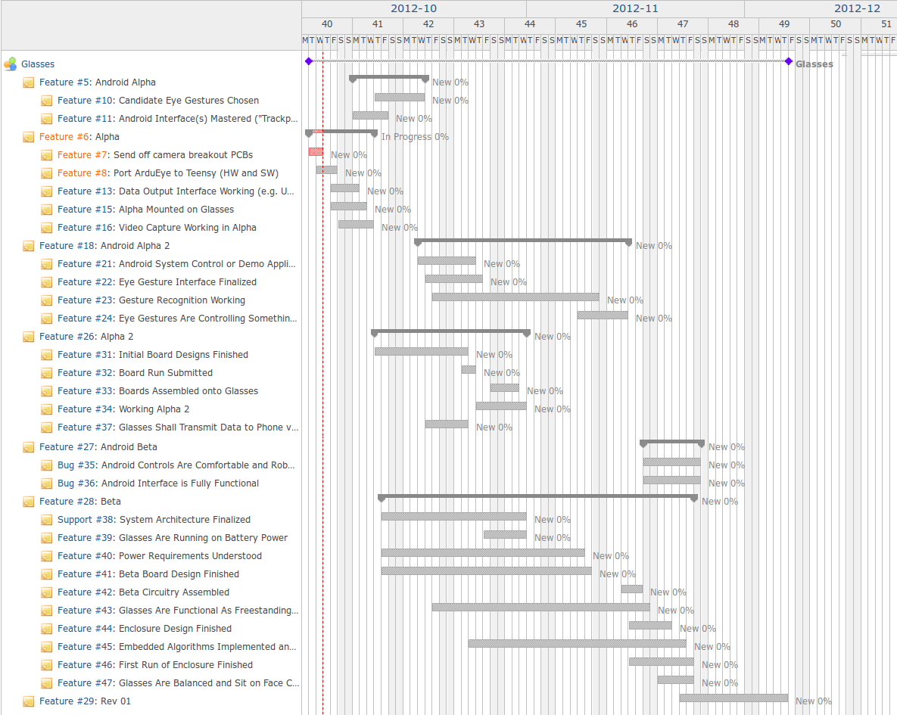Illustration 3: A detailed Gantt chart for the Eye Gestures project. This schedule includes many different points to reevaluate risk and change direction if necessary to keep the project on schedule.

Risk Aversion
Our project has some risks, but we think that we can overcome them or plan around them if necessary. The first and largest risk is that our project is quite aggressive timeline. In creating our Gantt chart, we estimated some 700+ man hours for this project. Although, this is probably a reasonable amount of work (if we have estimated correctly), snags could cause unforseen delays to our tight timeline. Much of our project is based around building a low power sensing device. So, power efficiency and elegance of the device can be traded off for time if necessary.
Another risk is that it is unclear that our solution will yield a low power device at all. In some sense, this risk is larger, as it has no clear cut solution. Unfortunately, mitigating this risk does not have an easy answer. This is the inherent risk in a an undertaking such as the Eye Gestures device. This risk is minimized by the high calibre individuals who surround our team at the University of Michigan.

Budget and Materials
For our Cortex-M4 based design, we have put together a relatively thorough BOM.
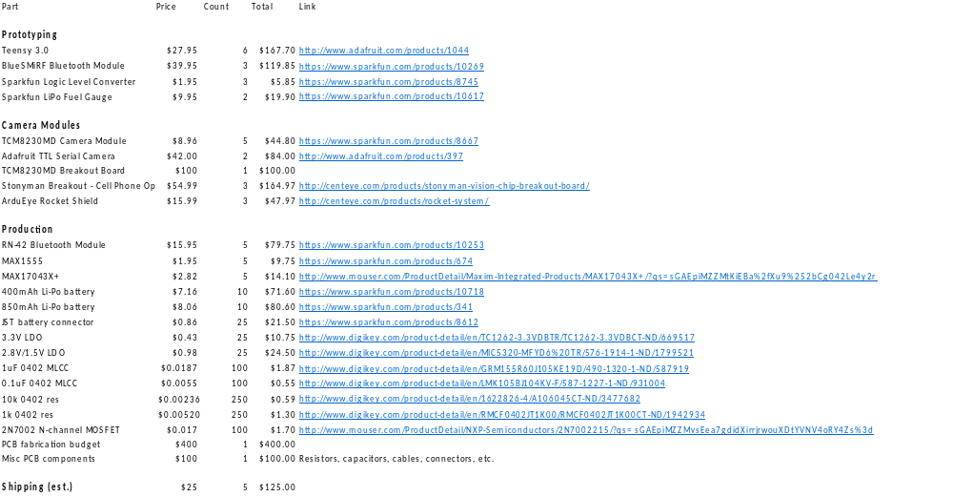Illustration 4: BOM for the Cortex-M4 based design of the Eye Gestures glasses. The BOM includes prototyping and production costs.

Demonstration
When we demonstrate the Eye Gestures glasses at the Demo day at the end of the semester by showing a working product. The glasses will showcase themselves, being cordless and wearable. With a tablet running our Android code, we will show Eye Gestures in action. We have no special needs.

Conclusion
We have presented the design of our wearable medical computing peripheral, Eye Gestures. Our Eye Gestures device will enable those with physical disabilities like Cerebral Palsy, MS, ALS or parallelization to use an Android tablet running our software. The tablet represents a user friendly, yet powerful device with much of the same capabilities of a traditional computing. Combined with ever increasing speech to text capabilities, tablets look to be a great device for the disabled.
We have presented a design based around a low power Cortex-M4 processor, with a solution to get a prototype quickly. Due to the nature of the arduino environment and its ease of use, we feel that the speed of the prototyping phase is a major boon to our success in this difficult project.
We have presented our design, schedule and the associated risks. We have addressed those risks with mitigation strategies. Our current design, although not completely solidified, is a suitable backup if it cannot be improved (especially w.r.t. very long life operation on battery). Due to our risk mitigation strategies, we will be able to achieve our goals within our stated timeline.
Appendix A: Design/Engineering Criteria
Here you will list the criteria for a successful design and how important each criterion is. You are laying out
how you will know if your design is successful. This should be divorced from implementation issues. That is, things like “C5515 processor communicates with base station” wouldn’t be a design criterion, but “vehicle’s status reliably communicated to base station at highway speeds” would be. This may include cost, power/energy or other things. But it should be about the design not the implementation. Criteria are ideally stated in very few words.
Next, you are to indicate the importance of each criterion. You are to label each criterion as either “fundamental” (the project wouldn’t be useful without meeting the criterion), “important” (the product would be functional but not nearly as useful) or “optional” (nice, but not needed for the basic functionality).

You also will indicate what you expect and hope to do. You should indicate if meeting that criterion is
something you will accomplish even if the project is scaled back, expect to accomplish or if it is a stretch goal.
Obviously there should be some correlation with importance, but you need to be realistic in what you think you
can do. Starting off by trying to do too much or too little can both cause extra work.
Appendix B: Group Agreement
TODO

