EET 3030 Embedded Controllers
Laboratory Report

Lab 2
Combinational Logic Circuits

Presented
By

Spencer Rosenvall
W01351365

Fall 2018

Electronics Engineering Technology
Department of Engineering Technology
College of Engineering, Applied Science and Technology
Weber State University

Introduction and Overview

Design and simulate predetermined digital circuit according to instructions from lab 1 for EET3030. This consists of creating schematic diagrams using a variety of gates, inputs, and outputs and testing the schematic with a University Program VWF, which in turn, provides data to analyze wave forms from simulated data.
Circuit is expected to change outputs of 4 different logic gates based on different combinations of 3 inputs, resulting in same wave form.
Equipment and Parts
Laptop, Quartus II software.

Theory
Digital circuit flow, analysis, and construction.

Design Calculations
- Write the code.
- Compile the code.
- Create University Program WVF.
- Run Functionality and Time Simulations.
- Repeat for circuit portion of assignment.

Schematic Diagram of the Circuits
Inputs and Outputs for lab_2sim:
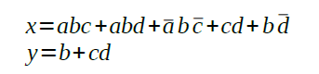
Figure 1
Inputs: a, b, c
Outputs: x, y

Inputs and Outputs for lab2_circuit:
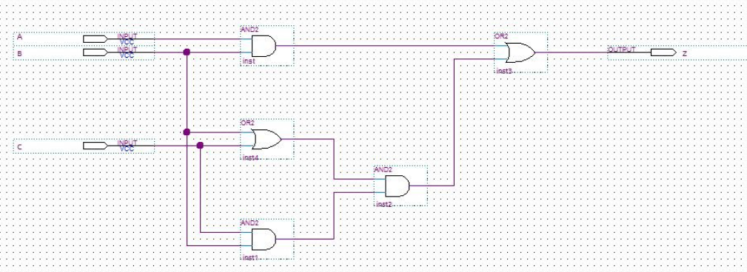

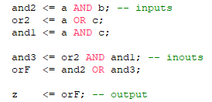
Figure 2

Inputs: a, b, c
InOuts: and1, and2, and3, or1, or2
Outputs: z

Results
Lab2_sim:
The results for the lab2_sim are represented by the graphic below. Graphic shows results from simulations of BOTH Functionality and Timing simulations. Circuit is behaving according to design. Logic gates open and close based off the configurations of the three inputs according to figure 1.

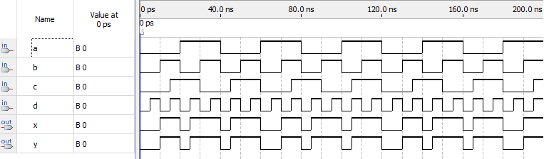

lab2_circuit:

The results for the lab2_circuit are represented by the graphic below. Graphic shows results from simulations of BOTH Functionality and Timing simulations. Circuit is behaving according to design. Logic gates open and close based off the configurations of the three inputs according to figure 2. Everytime orF gave a 1, the output Z did too.
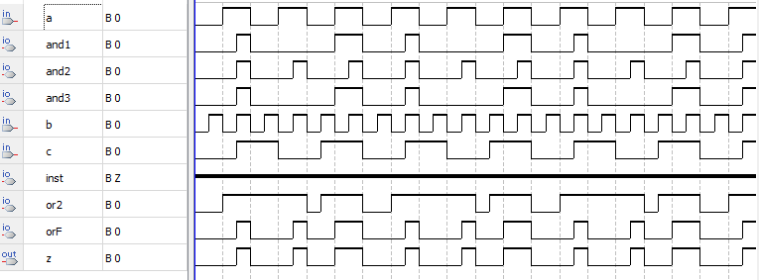

Conclusion
It was my first time writing code in VHDL. I didn't think it was very hard. It's very similar to Verilog, so it was pretty easy to catch on. The main thing I learned how to do through this assignment was to use a the “nodeFind” button:
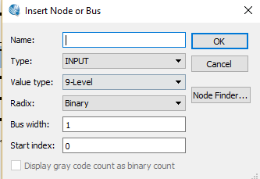
This saved me a lot of time because I could immediately import all my I/O's from my code to the simulation file.
I had two problems during this lab and they were both code related. The first was that the entity title needs to be the same as the title of the file. The second was that the last variable in port doesn't have a semi-colon. That one threw me in a loop.

