EET 3030 Embedded Controllers
Laboratory Report

Lab 3
D and JK Flip-Flops Desing Using VHDL
Using Altera Quartus II v 15.0

Presented
By

Spencer Rosenvall
W01351365

Fall 2018

Electronics Engineering Technology
Department of Engineering Technology
College of Engineering, Applied Science and Technology
Weber State University

Introduction and Overview

Design and simulate predetermined flip-flop circuit according to instructions from lab 3 for EET3030. This consists of coding inputs, and outputs and testing the schematic with a University Program VWF, which in turn, provides data to analyze wave forms from simulated data.
Circuit is expected to change behave correspondingly to D and JK flip-flops, respectively.
Equipment and Parts
Laptop, Quartus II software.

Theory
JK and D flip-flops, analysis, and construction.

Design Calculations
- Write the code for D flip-flop.
- Compile the code.
- Create University Program WVF.
- Run Functionality and Time Simulations.
- Repeat for JK flip-flop portion of assignment.

Schematic Diagram of the Circuits
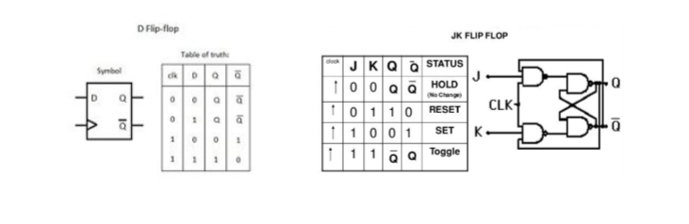
INPUTS: D, CLK OUTPUTS: Q, notQ INPUTS: J,K, CLK OUTPUTS: Q, notQ
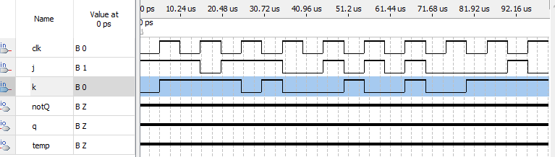
JKFF -
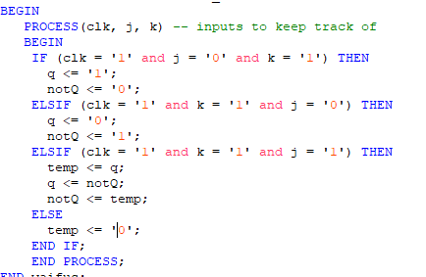

DFF-

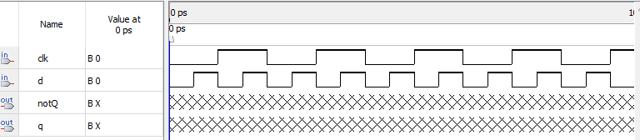

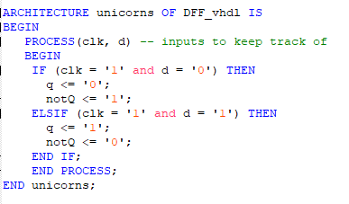
Results
DFF_sim and JKFF_sim: For both my simulations, I received the following error even though it compiled great. I have looked extensively for what could cause the error online but could not find anything helpful. Every time I would try to simulate it would throw something like: “Error: (vsim-3601) Iteration limit reached at time x us”.

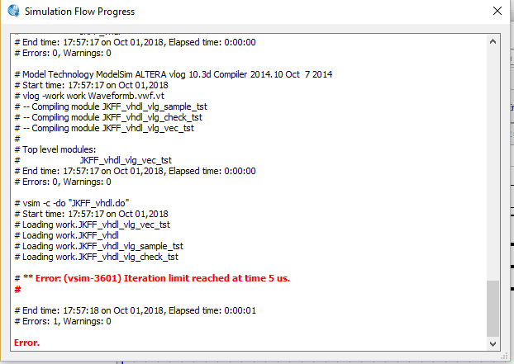

Conclusion
It was my first time writing code in VHDL. I didn't think it was very hard. It's very similar to Verilog, so it was pretty easy to catch on. The main thing I learned how to do through this assignment was to use a the “nodeFind” button:

This saved me a lot of time because I could immediately import all my I/O's from my code to the simulation file.

That was my major problem this assignment. I think everything else went well. It was interesting to see what a flip flop was and the two different types. I don't really understand why you would want to use one, but maybe that's just the web developer in me.

