EET 3030 Embedded Controllers
Laboratory Report

Lab 5
4 Bit Adder Design Using VHDL
Using Altera Quartus II v 15.0

Presented
By

Spencer Rosenvall
W01351365

Fall 2018

Electronics Engineering Technology
Department of Engineering Technology
College of Engineering, Applied Science and Technology
Weber State University

Introduction and Overview

Design and simulate four-bit-adder circuit according to instructions from lab 5 for EET3030. This consists of coding inputs, and outputs and testing with FPGA.
Circuit is expected to change behave correspondingly to 4 bit adder, respectively.
Equipment and Parts
Laptop, Quartus II software, FPGA.

Theory
4 bit adder, analysis, and construction.
7 Segment Displays
Boolean Addition

Design Calculations
- Write the code a single 4 bit adder, use Cout as Cin for other three adders, respectively.
- Compile the code.
- Test Code on FPGA.
- Verify circuit functionality and hex representations.

Schematic Diagram of the Circuits
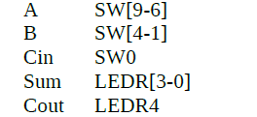

INPUTS: A9 – A6, B4 – B1, Cin OUTPUTS: Sum, Cout
Logic / Code
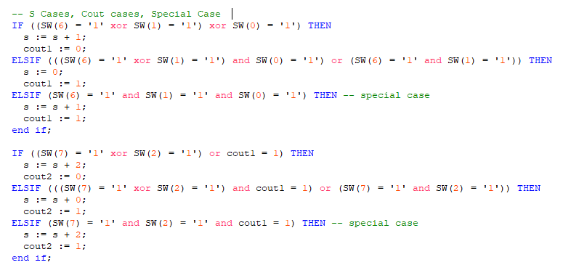
For each pair of switches.

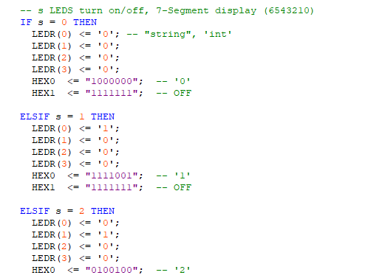
7 Segment Display representations of Sum.

Results

4 Bit Adder: The adder worked for the most part. I could add combinations and handle most of them correctly on the fpga display. One problem that I had was when both first A and B switches were one as well as Cin 1. This didn't function correctly though I though I had handled that case. I'm not sure of why that case didn't work as expected.

Conclusion
I actually learned a lot about a Four-Bit-Adder. I never had learned about one before in my previous digital systems class at SLCC. We covered a MUX and Flip-Flop, but never a Four-Bit-Adder. The coding was good practice to see how to use an if statement and then to assignment the different configurations of booleans to a value. I also learned how to better program the FPGA.

